Case Study: ICERs
 Important
Please note that you can download PDF and Microsoft Word versions of this case study using the links on the right.

Case 1 Description
You seek to explore different drug strategies to treat HIV infection. Single agent therapy with retrocyclovir at 200mg per day has a mean discounted lifetime cost of $20,000 and results in a quality-adjusted life expectancy of 70 years. Single agent therapy with retrocyclovir at 400mg per day has a mean discounted lifetime cost of $22,000 and a quality adjusted life expectancy of 65 years (given the increased incidence of side effects with the higher dose). Another drug, centroflexavir (which comes only in one dose of 250 mg/day) has a mean total lifetime cost of $10,000 and a quality-adjusted life expectancy of 50 years. The combination of centroflexavir with low-dose retrocyclovir has a mean-life time cost of $40,000 and an average quality adjusted life expectancy of 80 years, while the combination of centroflexavir with high-dose retrocyclovir has a mean lifetime cost of $35,000 and a quality-adjusted life expectancy of 75 years.
Newer ARTs are also available and their lifetime costs/QALYs are detailed below:
Cost and QALY Outcomes for ARTs
 | Cost | QALY
ART 1/2 | 11,000 | 63.4
ART 1 | 15,525 | 73.52

Instructions
Perform a cost-effectiveness analysis of the treatment options using QALYs as the measure of health effects. Which strategy would you choose and why, if the willingness-to-pay threshold is $50,000 per quality-adjusted life year?
Treatment | Costs | QALYs
Do nothing | 36,000 | 43.8
ART 1 | 15,525 | 73.52
ART 1/2 | 11,000 | 63.4
Retro 200 | 20,000 | 70.0
Retro 400 | 22,000 | 65.0
Centro | 10,000 | 50.0
Centro / Retro 200 | 40,000 | 80.0
Centro / Retro 400 | 35,000 | 75.0
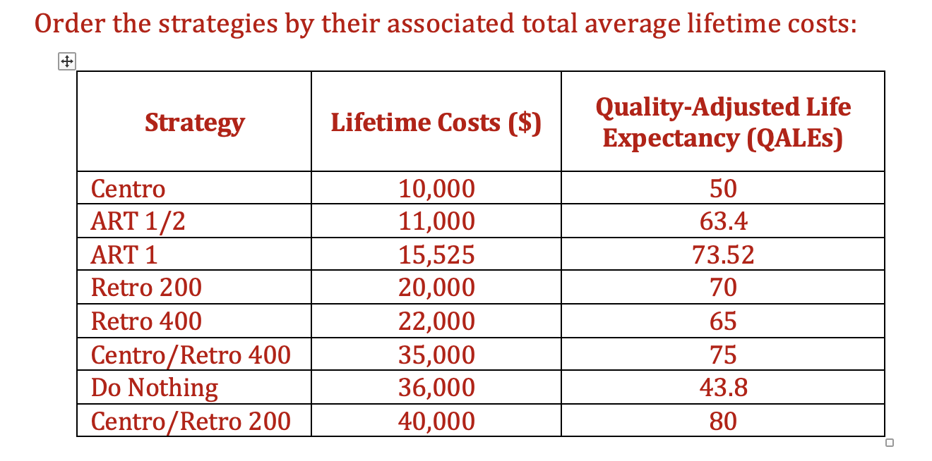
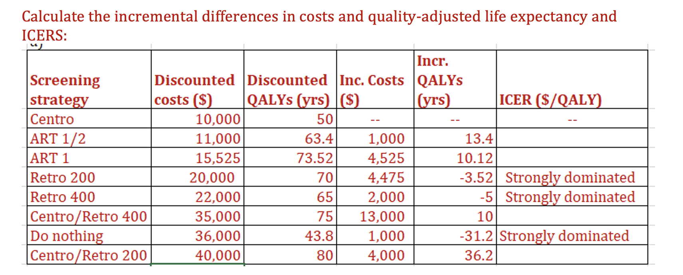

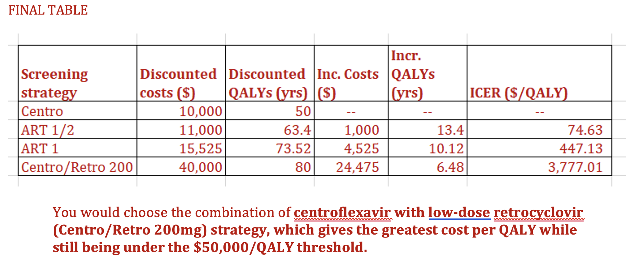
Treatment Options
Strategy | Discounted Costs | Discounted QALYs | Incremental Costs | Incremental QALYs | ICER ($/QALY)

ICER Calculation Table 1
Strategy | Discounted Costs | Discounted QALYs | Incremental Costs | Incremental QALYs | ICER ($/QALY)

ICER Calculation Table 2
Strategy | Discounted Costs | Discounted QALYs | Incremental Costs | Incremental QALYs | ICER ($/QALY)
: ICER Calculation Table 3 {tbl-colwidths=“[20,20,20,20,20,20]”}

Case 2 Description
You are interested in performing a cost-effectiveness analysis of different cancer screening recommendations for anal squamous intraepithelial lesions and anal cancer in men.
Below is a table of the costs and quality-adjusted life years gained associated with different screening strategies over a six-year time span.

Instructions
Calculate incremental cost-effectiveness ratios for each strategy and determine which screening strategy you would choose if, as a decision maker, you were prepared to pay $50,000/QALY (using discounted quality-adjusted life years)
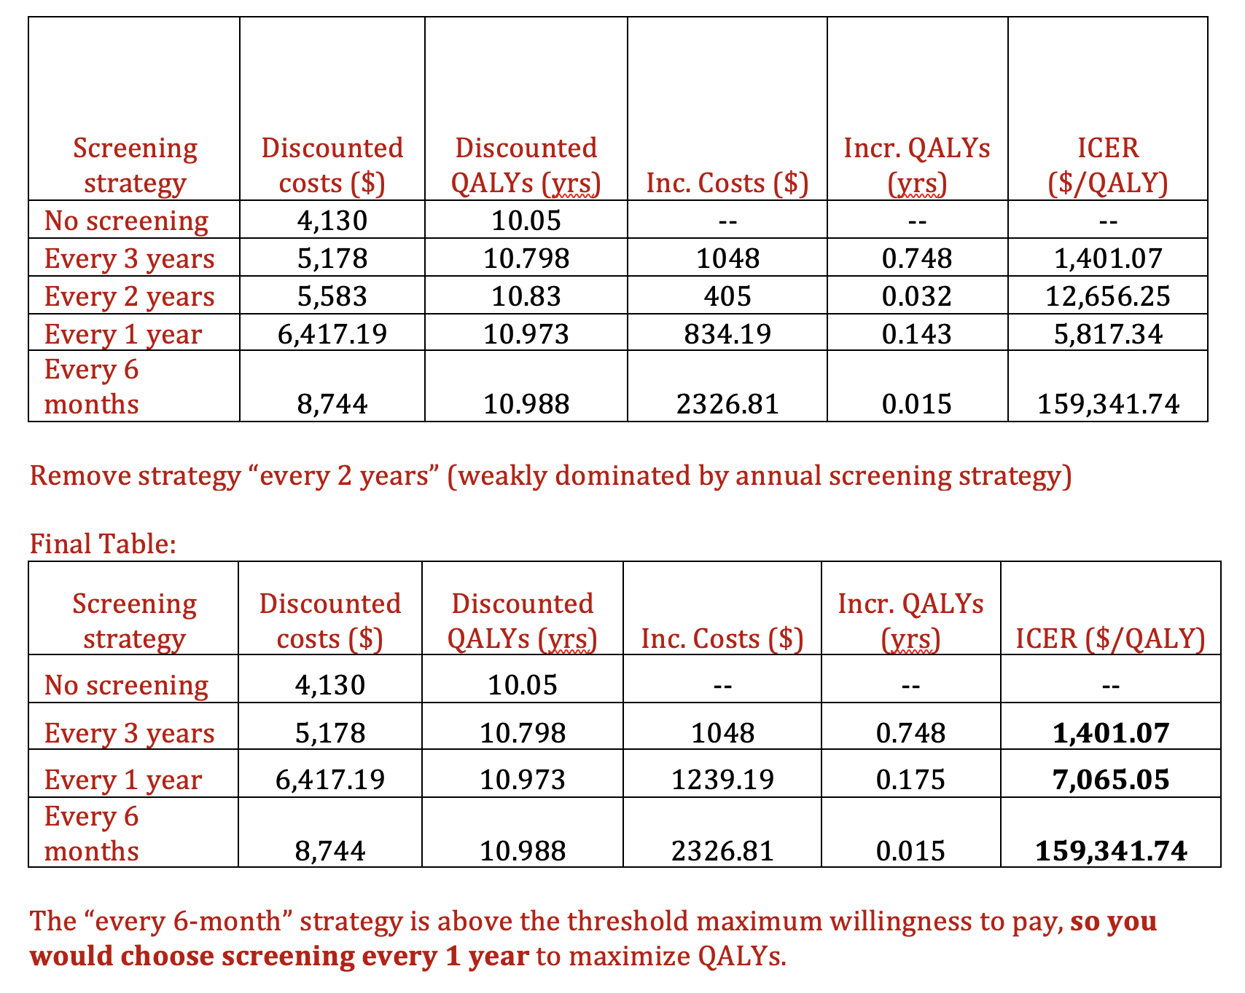
Cost and QALY Outcomes, by Strategy
Screening Strategy | Discounted QALYs | Discounted Costs ($2022)
No screening | 10.05 | 4,130
Every 3 years | 10.798 | 5,178
Every 2 years | 10.830 | 5,583
Every 1 year | 10.973 | 6,417
Every 6 months | 10.988 | 8,744

ICER Calculation Table 1
Strategy | Discounted Costs | Discounted QALYs | Incremental Costs | Incremental QALYs | ICER ($/QALY)

ICER Calculation Table 2
Strategy | Discounted Costs | Discounted QALYs | Incremental Costs | Incremental QALYs | ICER ($/QALY)

