Firework Injury Decision Tree

Introduction and Overview of Decision Problem
In Colombia, the issue of firework-related injuries, particularly during festive seasons, remains a significant public health concern. Fireworks, while culturally ingrained and a source of celebration, pose substantial risks, especially to children. This has led policymakers to consider various strategies to mitigate these risks and enhance public safety.
The decision problem we will consider revolves around analyzing approaches to reducing injuries and fatalities caused by fireworks. Two primary strategies under consideration are (1) a complete ban on fireworks and (2) heavy regulation, such as restricted sales licenses and stringent enforcement.
A complete ban aims to eliminate the root cause of injuries by prohibiting the sale, storage, and use of fireworks. This approach seeks to protect public health directly but may face resistance due to its impact on cultural traditions and the livelihoods of vendors.
On the other hand, heavy regulation involves implementing strict controls over the sale and use of fireworks. This strategy includes measures such as issuing sales licenses only to authorized vendors, enforcing age restrictions, and conducting public education campaigns about the dangers of fireworks. This approach aims to reduce injuries while allowing for controlled, safe use of fireworks.
Our case studies will explore these strategies through two decision modeling approaches. This case study will utilize a decision tree model to evaluate the immediate outcomes and costs associated with each strategy.
Later, we will employ a Markov cohort model to examine the long-term health and economic impacts, considering factors such as injury rates, healthcare costs, and compliance levels.
By analyzing these models, we aim to provide a comprehensive assessment of the most cost-effective and sustainable approach to reducing gunpowder-related injuries in Colombia today.

Model Inputs and Parameters

Injury Rates
Your colleagues have compiled the following data on gunpowder injuries by year in Colombia. We will construct a decision tree model based on injuries in the most recent year reported (2022).
Year | Cases | Population | Rate.per.100.000
2017 | 1,778 | 47,419,000 | 3.75
2018 | 1,477 | 48,259,442 | 3.06
2019 | 1,378 | 49,269,676 | 2.80
2020 | 1,504 | 50,407,437 | 2.98
2021 | 1,694 | 51,177,378 | 3.31
2022 | 1,510 | 51,682,692 | 2.92

Injury Types and Consequences
We will assume that reported injuries fall into three major categories:
- Minor Or Moderate Injury: First-degree burns, which may cause pain, redness, and minor swelling. This category also includes second-degree burns that cover a more significant portion of the body and involve blisters, pain, and potential infection risk
- Major Injury: third-degree burns or severe trauma that affects deeper tissues and can lead to significant complications.
- Fatal Injury
 | There are very likely many minor and moderate injuries that go unreported in official statistics. For this case study, we will assume that severe injuries are 30% of reported injuries.
Description | Base Case Value | Parameter Name
Probability of Injury | 0.0000292 | p_injury
Probability Injury is Severe | 0.30 | p_severe
Probability Injury is Mild or Moderate | 0.7 = 1 - p_severe | 1 - p_severe
Probability Injury is Fatal | 0.0046 | p_fatality
We will also assume that a small percentage (15%) of individuals with mild/moderate injuries experience long-term consequences (i.e., 85% recover), while the majority (90%) of those with severe injuries do not fully recover and experience long-term complications.
Description | Base Case Value | Parameter Name
Probability of Recovery: Mild/Moderate Injury | 0.85 | p_recover_mildmod
Probability of Recovery: Major Injury | 0.1 | p_recover_severe

Strategies and Impact
When the mayor of Bogota banned the sale of fireworks in 1995, fireworks-related burns fell by 62%, from 204 in the 1994-1995 Christmas season to 77 during the 1995-1996 season. We will assume a similar 60% relative risk reduction under the “Ban” scenario.
By comparison, we will assume that stricter regulation will reduce firework injuries by just 20%. We will examine the sensitivity of our findings to these assumpions later in the case study.

Exercises

1.1. Build a “Status Quo” Strategy
Construct a decision tree in Amua for a “Status Quo” strategy. Your tree should work through the following chance nodes:
- Injury vs. No Injury
- Fatal injury vs. non-fatal injury
- Mild/Moderate vs. Severe injury
- Full recovery vs. Recovery with injury sequelea
Please use the parameter names and values supplied above in the construction of your tree.
 Important
Often, when you add branches to a tree in Amua, the tree will become very crowded (see below). To “clean up” your tree, you can click the “OCD” (Organize Current Display) button and Amua will re-organize the layout for you!
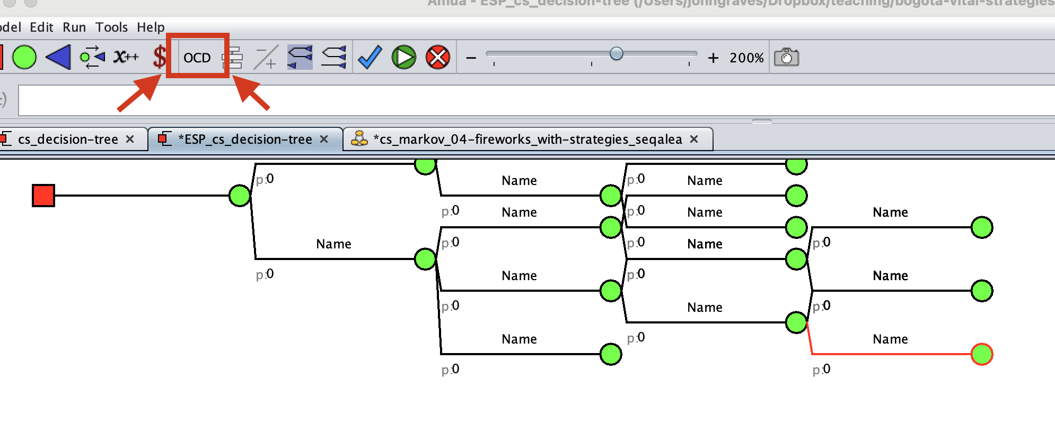

1.2. Add Outcomes
Amua defaults to cost outcomes. Please remove the cost outcome and define a new primary outcome based on injury. In other words, the outcome “payoff” should be 1.0 if an injury occurs, and 0 otherwise.
 Tip
You can edit the outcomes by clicking Model Properties Analysis:
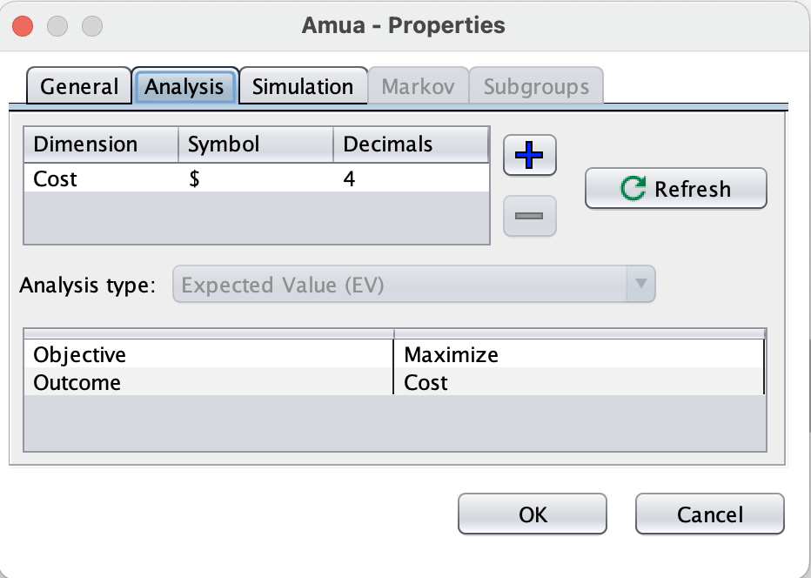

1.3. Ensure Your Model Calibrates to Observed Injury Totals
Run your initial decision tree using a cohort size of 51,682,692 (2022 population of Colombia). Verify that the total number of firework injuries closely matches the reported total of 1,510.
 Tip
You can enter the cohort size by clicking Model Properties Simulation:
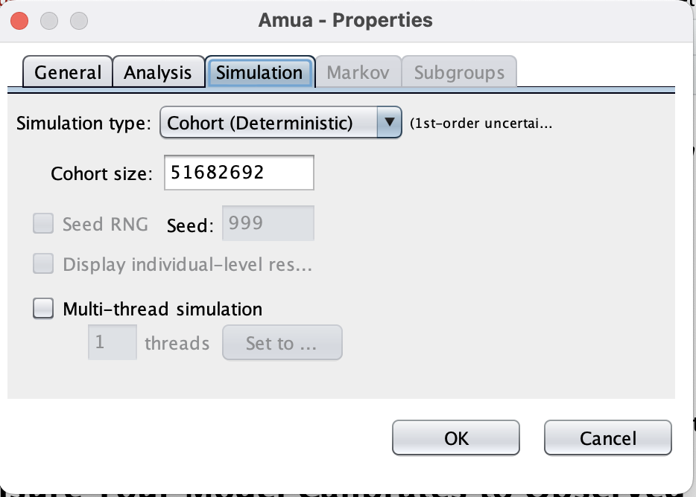

2.1. Include Additional Policy Scenarios
Create a duplicate version of your “Do Nothing” tree to construct separate branches for the “Ban” and “Regulate” scenarios. Under each, the probability of injury should be modified by a relative risk reduction parameter with values set based on the text above and the table below.
Description | Base Case Value | Parameter Name
Relative risk reduction: probability of injury under “Ban” policy scenario | 0.40 | rr_ban
Relative risk reduction: probability of injury under “Regulate” policy scenario | 0.80 | rr_regulate

 Tip
You can copy and paste the “Do Nothing” branch by right-clicking on the first chance node and selecting “Copy.” You can then paste a copy of the entire tree structure on the red decision node .

2.2. Add Additional Outcomes
Add additional outcomes based on each injury type (mild/moderate, severe, fatal). Use your decision tree to project injuries overall and by type under each strategy.
Run the model and use the results to fill out the table below. Each cell should have calculated counts of the number of each type of injury under each strategy.
Strategy | Any Injury | Mild/Moderate | Severe | Fatal
Do Nothing
Ban Fireworks
Regulate Fireworks

Cost Outcomes
Next, add in cost outcomes under the following assumptions.
 Tip
You will need to add costs as an outcome by clicking Model Properties Analysis

Description | Base Case Value | Parameter Name
Cost of mild or moderate injury | COP 2,000,000 | c_moderate
Cost of severe injury | COP 40,000,000 | c_severe
Cost of fatal injury | COP 0 | c_fatalily
Cost of mild/moderate sequelae | COP 1,000,000 | c_seq_mildmod
Cost of severe sequalae | COP 4,000,000 | c_seq_severe

By what percentage does each policy strategy reduce overall costs of firework injuries in Colombia?

Source: “Antanas Mockus: The Prohibition of Fireworks in Bogotá Sequel,” Harvard Kennedy School Case Study. Available fromhttps://case.hks.harvard.edu/antanas-mockus-the-prohibition-of-fireworks-in-bogota-sequel/

