***Research plan and results***

***Easter eggs explorebreda.nl***

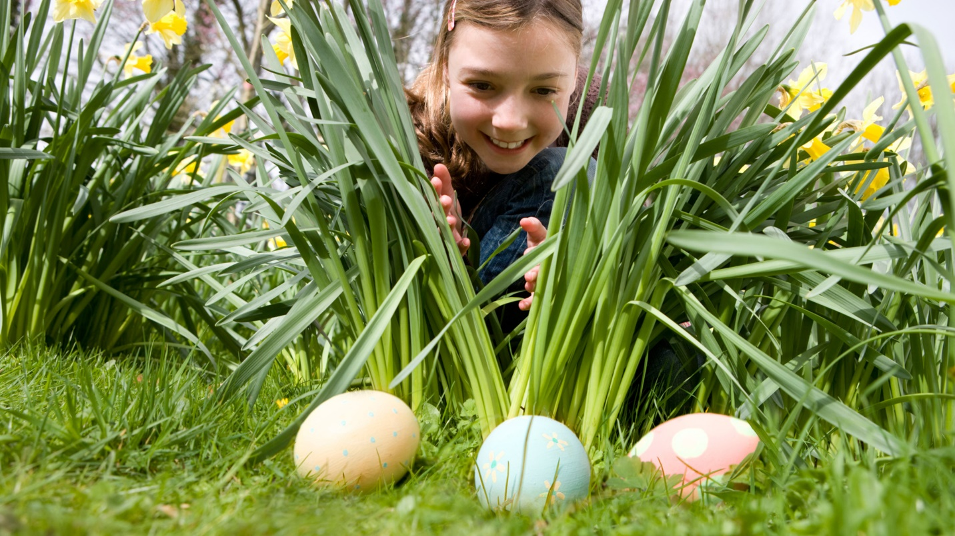

*Shirine, Bryan*

*Table of Contents*

*Introduction* 3

*Research objective and method* 3

*Research questions* 3

*Conclusion* 13

# ***Introduction***

This project, conducted in collaboration with Good News, a digital agency, focuses on researching the impact of Easter eggs on the Explorebreda.nl website to better attract students. Explorebreda.nl serves as a comprehensive guide for visitors to discover the best of Breda. Our goal is to understand student perspectives on Easter eggs and how these hidden features can enhance their engagement with the site. This research document presents the findings from our investigation into this specific audience, examining their reactions to Easter eggs and their online behavior. By gaining insights into their preferences, we aim to create a more engaging and effective platform that captures their interest and encourages exploration of Explorebreda.nl.

# 

# ***Research objective and method***

The goal of this research is to understand student perceptions of Easter eggs on the Explore Breda website. To effectively incorporate Easter eggs, we need to gather insights from our target audience. The research question is, "How do students feel about discovering Easter eggs on the Explore Breda website?" By exploring this question, we can determine how to design and implement these hidden features to enhance user engagement and enjoyment. We will also investigate which types of Easter eggs students find most appealing and whether they are interested in a specific idea for a mini-game. This research will be conducted through a survey distributed via Google Forms. The survey responses will be visualized in graphs, making it easy to identify common trends and preferences among the participants.

# ***Research questions***

42 people have filled in this survey, while 3 people that stumbled upon the survey were not students. These are the questions and results.

Are you a student?

By asking this question we will be sure that we are taking information from the right audience, if the person taking the survey is not a student the survey will automatically end.

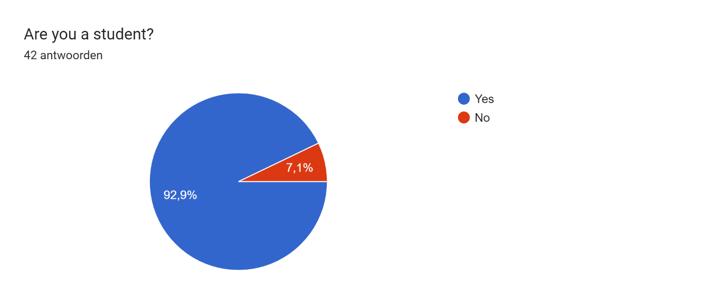

39 people answered the rest of the survey.

How often do you visit websites for educational purposes?

By asking this question we will know if our audience is interested in the content of the website we are promoting.

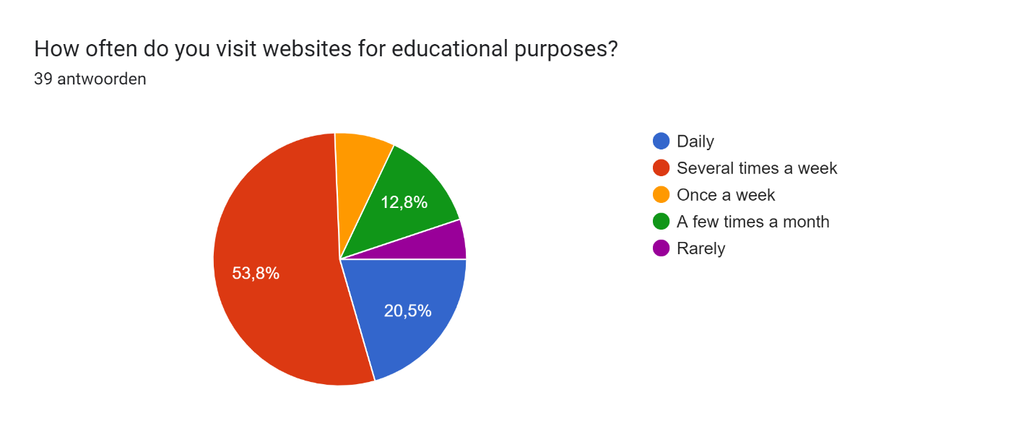

53,8% of the students that answered the survey visit websites for educational purposes several times a week.

How often do you visit websites in your free time for entertainment?

With this question we can find out whether there is a possibility that they would visit our website to engage with the Easter eggs.

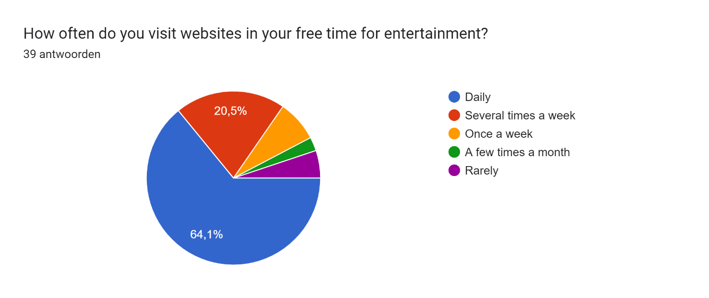

64,1% daily visit websites in their free time for entertainment.

Are you familiar with the concept of Easter eggs in a website or software?

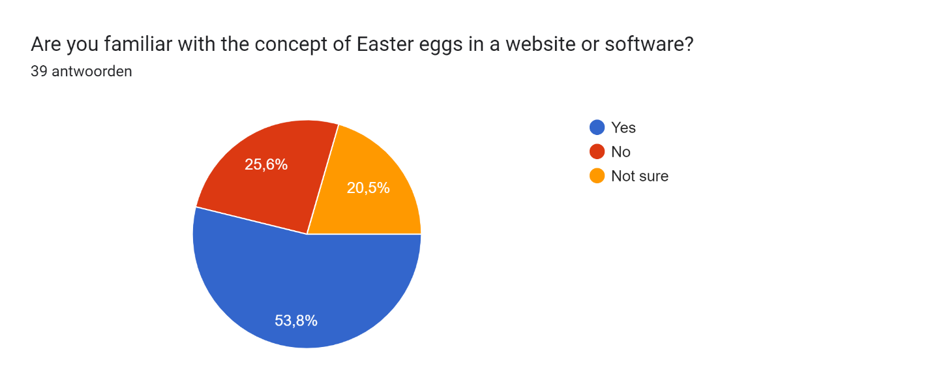

53,8% are familiar with the concept of Easter eggs.

Have you ever discovered an Easter egg on a website or in software?

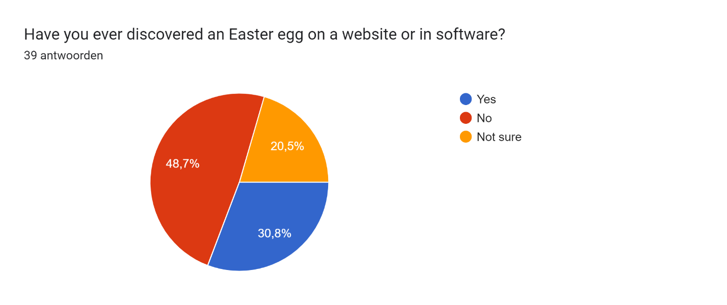

48,7% has never come across an Easter egg, while 30,8% have.

If yes, can you describe an Easter egg u have found?

We got many answers in which many were references to google Easter eggs, in which a lot are graphic animations.

How do you feel about finding Easter eggs on websites?

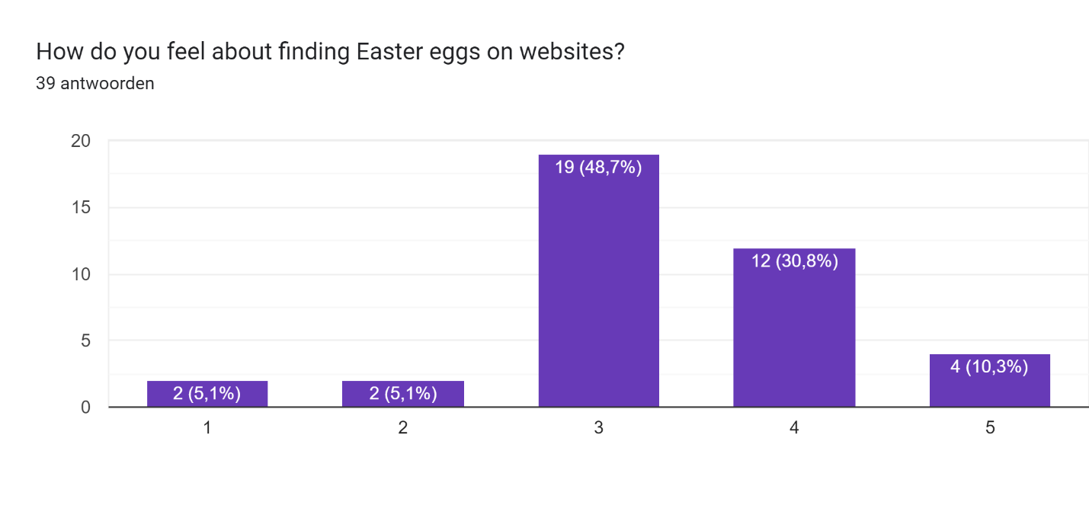

48,7% feels neutral about finding Easter eggs on a website, while 41,1% feels excited or very excited about Easter eggs.

Do you think Easter eggs enhance your experience on a website?

By asking this question we find out how our audience feels about Easter eggs on a website.

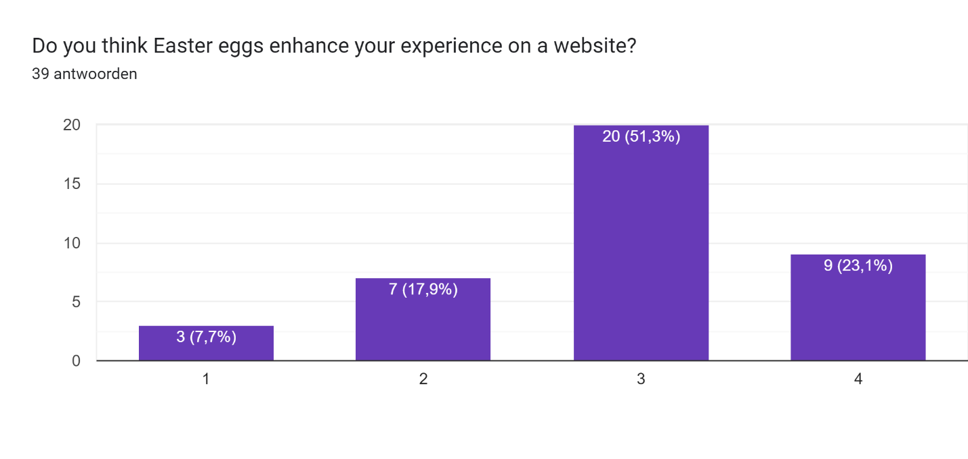

74,4% agrees more than disagrees that Easter eggs enhance their experience on a website.

What type of Easter eggs do you prefer?

By asking this question we will know what kind of Easter egg is interesting to our audience.

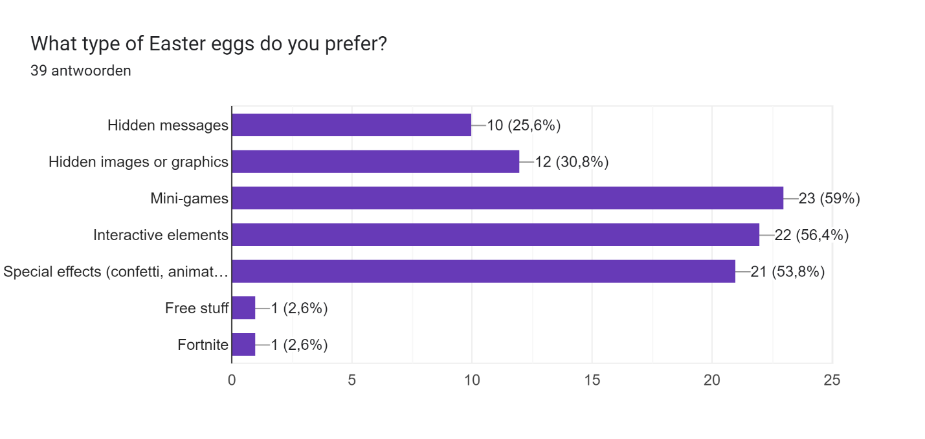

59% of the participants prefers mini-games, 56,4% also prefers interactive elements and 52,8% also prefers special effects.

How often do you think Easter eggs should appear on a website?

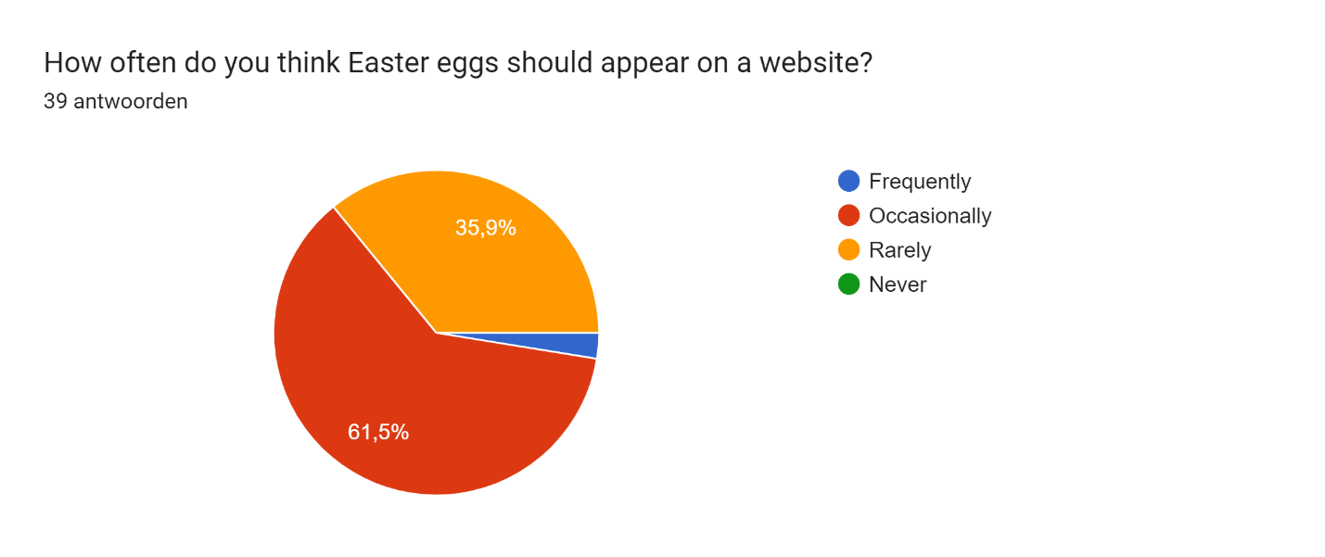

61,5% would like an Easter egg to appear occasionally on a website.

Do you have any suggestions for types of Easter eggs that would be fun or interesting?

Adding sounds to animation, special effects, an Easter egg regarding a special day like women’s day etc.

How familiar are you with the game Wordle?

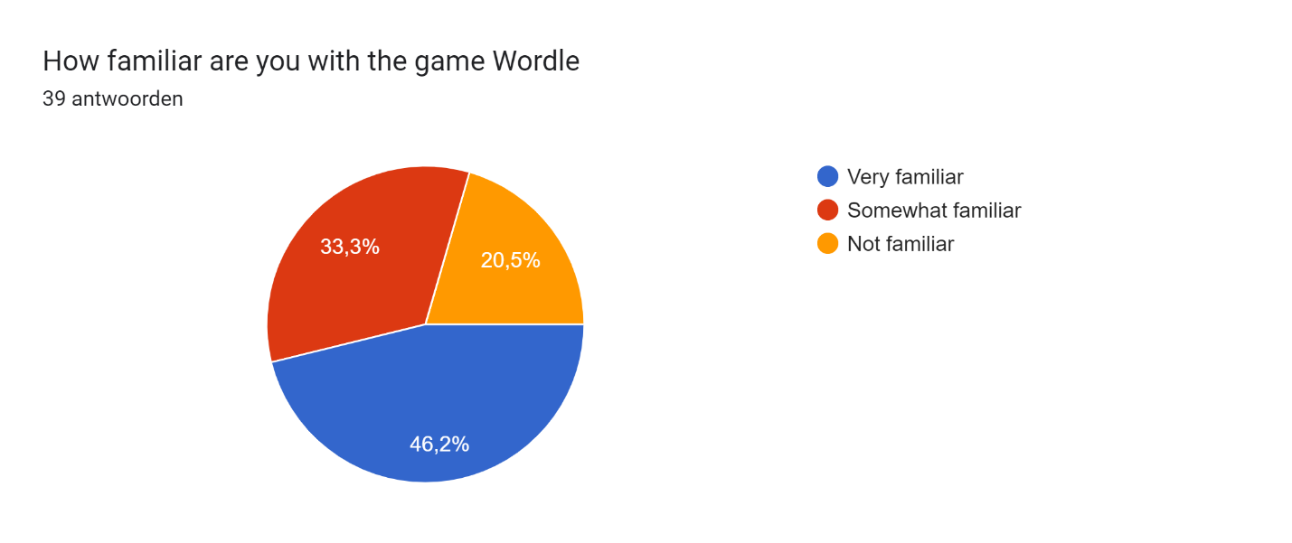

46,2% is very familiar with the game Wordle.

How interested would you be in a Wordle-style mini-game themed around Breda on our website?

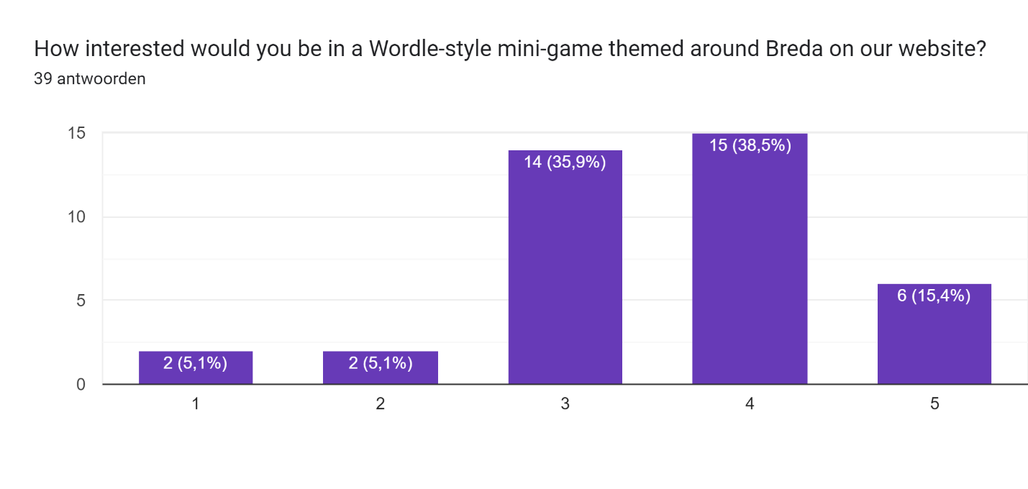

35,9% feels neutral about it, while 53,9 would be interested or very interested in a Wordle mini-game themed around Breda.

How appealing is the idea of earning points by playing the Wordle mini-game?

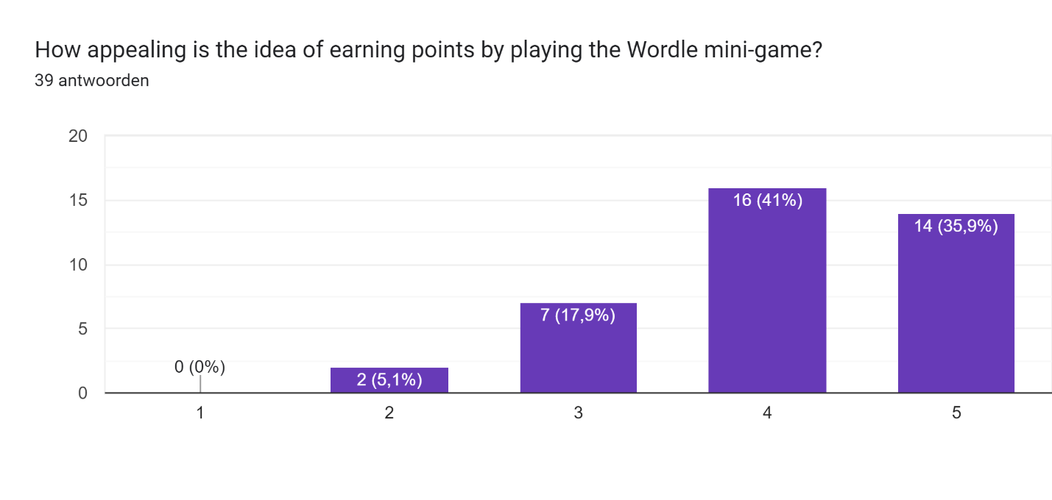

76,9% thinks the idea of earning points by playing the wordle mini-game is very appealing.

How likely are you to play the Wordle mini-game to earn points for discounts or rewards?

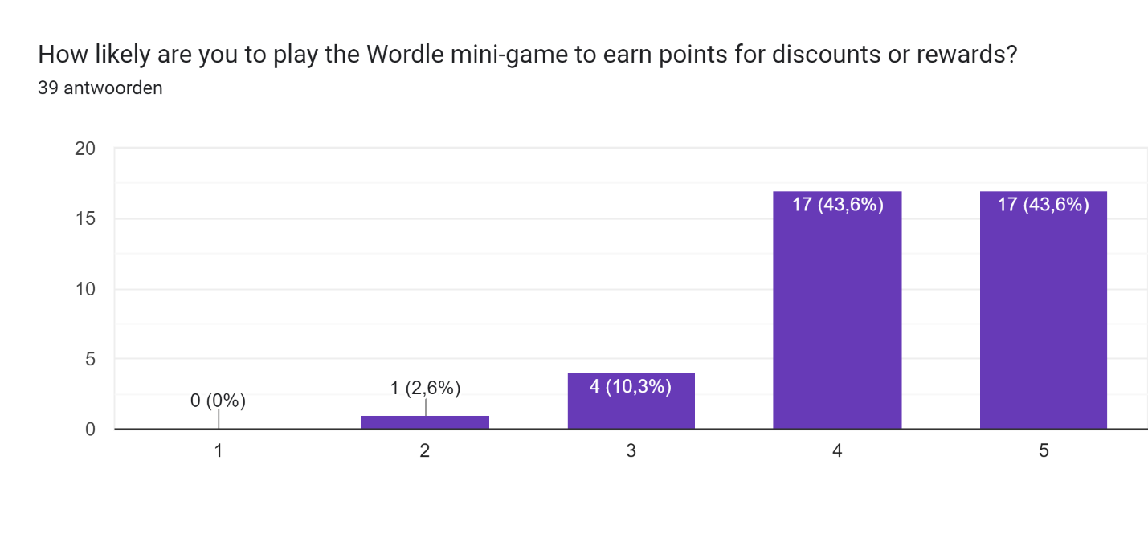

87,2% of participants is likely to very likely to play the Wordle mini-game to earn points for discounts or rewards.

What types of rewards or discounts would you be most interested in?

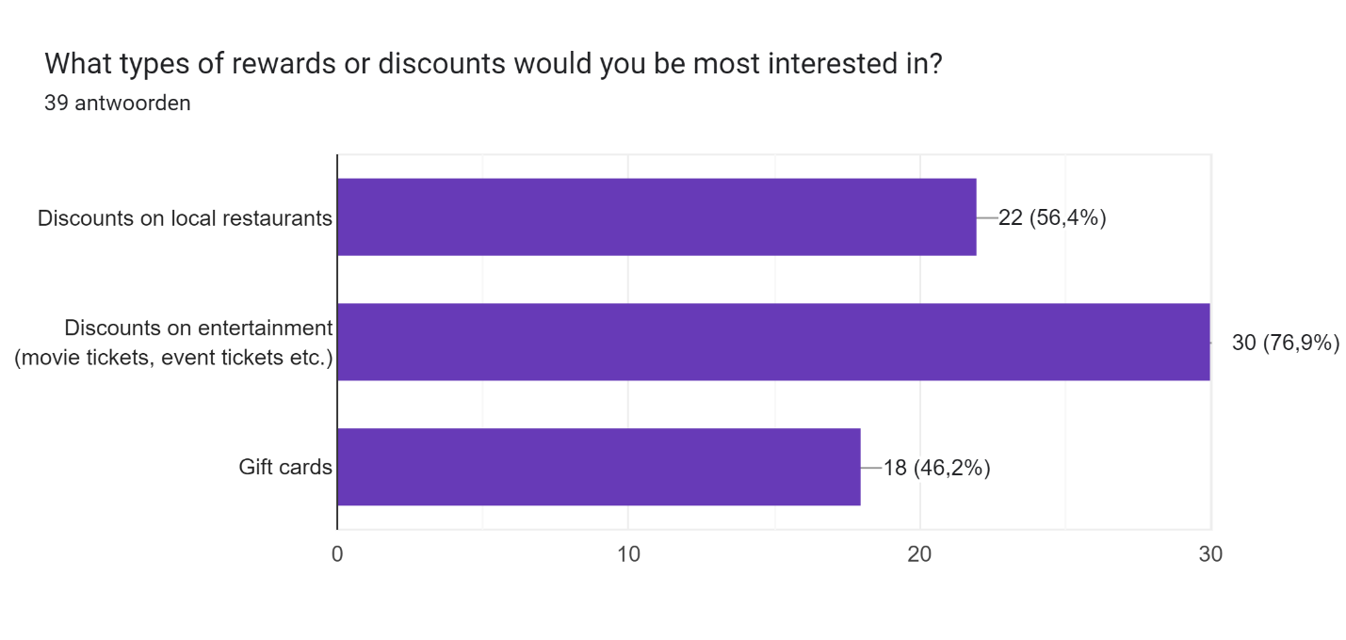

76,9% would be interested in discounts on entertainment, and 56,4% would be interested in local restaurants.

Do you have any suggestions for how we could improve this mini-game concept?

Adding a certain theme, having a time limit for the availability, add comedy, special effects and music.

# ***Conclusion***

1. We will be making a Wordle-style mini-game about Breda that will be available on one of the crosses on the home page. In this game we will be using words that are related to Breda. There will be a counting system for your points that will be saved locally. You can hand in the codes for discounts.
2. There will be a Simon says-style mini-game that will be activated by one of the crosses and then continue using all three of the crosses to play the game. When lost, the colors of the crosses will return back to normal and the game resets.
3. When pressing the other cross, the song “explorebreda.nl” of the other project will start playing, whereas there will be special effects visible. This will end when the song stops or the user presses the cross again.