**User testing**

**Portfolio**

**Product under test:**

I will be user testing my portfolio for this semester.

**Test objectives:**

The objective of this usability test is to evaluate the user experience of my portfolio. I aim to identify any usability issues related to navigatiion clarity, button visibility, scrolling awareness, readability and overall user interaction.

**Participants:**

It was tested with four users who fit within my target audience. This audience includes individuals who are pursuing the same field of study as I am or those who have knowledge in this area.

**Methods:**

* Participants will individually navigate through the portfolio website.
* They will be given a set of tasks to perform.
* Participants will be encouraged to think aloud during the test to provide insight into their thought process and experiences.
* I will take notes during these interaction and any encounterd issues.
* After each task, I will ask questions to gather feedback and insights.

**Tasks:**

* Find the learning outcomes.
* See if they can find the pdf of the project.
* Go back to learning outcomes.

**Task 1:**

I asked the participants if they could find the learning outcomes and go to them.

All 4 participants scrolled down and found the learning outcomes windows and clicked on them.

After they completed the task, I asked them some questions:

**Q1: Was it clear that you had to scroll to find the learning outcomes or was it hard?**

**P1:** “yes I would say it was clear, there was nothing really apart from the learning outcomes text, so it was obviously that I had to scroll.”

**P2:** “it was not that clear, but the first thing you do on a website when you do not see a lot of content you scroll.”

**P3:** “yes it was clear, I always scroll when I get on a page”

**P4:** “yes, for me I always scroll down. But maybe I would add an indicator for people that don’t. “

**Q2: Do you think I should add an indicator for the users to scroll?**

***All of the 4 participants said yes to this question.***

**Q3: was it clear that you had to click on the learning outcome window to go to the page of that learning outcome?**

**P1: “**Yes”

**P2:** “yes, when you go pass through it with the cursor it turns into a pointer”

**P3:** “yes”

**P4:** “yes, it looks like a big button”

**Task 2**

After they landed on the learning outcomes page and went through it briefly, I asked them if they could find the PDF.

When they found the pdf, I asked them some questions

**Q1: Was it easy to find the pdf or was it not clear that there was a pdf?**

**P1:** “not really, I did not even know that I had to click the window at all and that there was a pdf”

**P2:** “I did not notice that you had to click the window at first, but after you told me to look for the pdf, it was clear because are of the clickable things are floating.”

**P3:** “Yes, the first thing I clicked was the pdf window, but I did this out of curiosity since its one of the first things you see. I did not know that it was for a pdf though.”

**P4:** “yes, the window for the pdf is the same as the first windows to go to the learning outcomes and also it has written that it’s a pdf for that learning outcome.”

**Q2: Should I specify more clearly that the user needs to click the window to go to the pdf/ that there is a pdf there? If yes, how could I specify this more clearly?**

**P1:** “yes you should, maybe add an arrow or something saying “click for pdf”

**P2:** “yes, add a text more clearly that there is a pdf and that you should click it”

**P3:** “yes, maybe add a button in the window is it looks more clickable”

**P4:** “yes, add a bigger text indicating there is a pdf there and that they should click.

**Task 3:**

For this task I asked the participants if they could go back to the learning outcomes page were all the learning outcomes are

After they did the task, I asked the participants some questions.

**Q1: Was it easy or clear how to go back to the learning outcomes page?**

**P1:** “yes, I just had to click on the learning outcomes tab in the nav bar for it to take me back”

**P2:** “yes, the tab to go back is in the nav bar”

**P3:** “yes, even though I clicked first on the home tab thinking it would take me back. Seeing the learning outcome tab in the nav bar makes more sense to click it.”

**P4:** “yes, I just clicked to on the learning outcomes button in the nav.”

**Q2: Should I add an arrow also to indicate that you can click the arrow to go back?**

***All 4 participants said yes to this question.***

**Conclusion:**

With the feedback from this user testing, I figured out that I needed to fix the learning outcome page by making it clearer that you must scroll down to find all the 5 learning outcomes. It was also clear to me that I needed to fix the window that would take the user to the pdf of the project with more detailed description.

For the learning outcome page, I added an animated arrow indicating that the user should scroll to see more content

**Before:**

**After:**

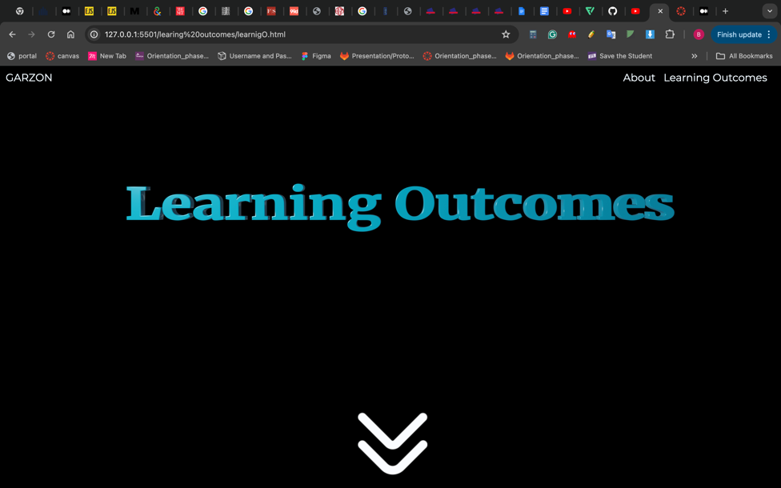

I also added a “learn more” button on each window that takes you to the pdf with more detailed.

**Before:**

**After:**

