Idea:

* 1 player
  + Has inventory, health, oil, rocks
* NPC
  + Has items to trade
* Monster
  + Can be killed, drops oil, money, rock

1. Starting point
2. Meet an NPC
3. Fight a monster
4. A trap

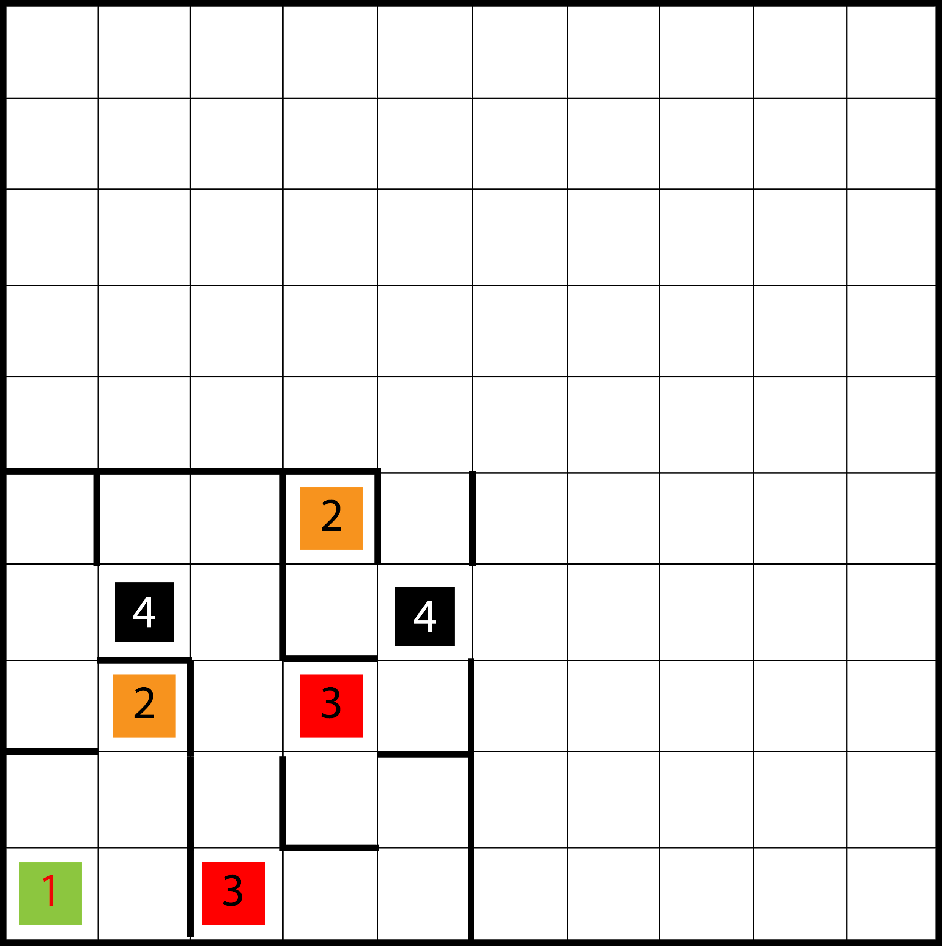

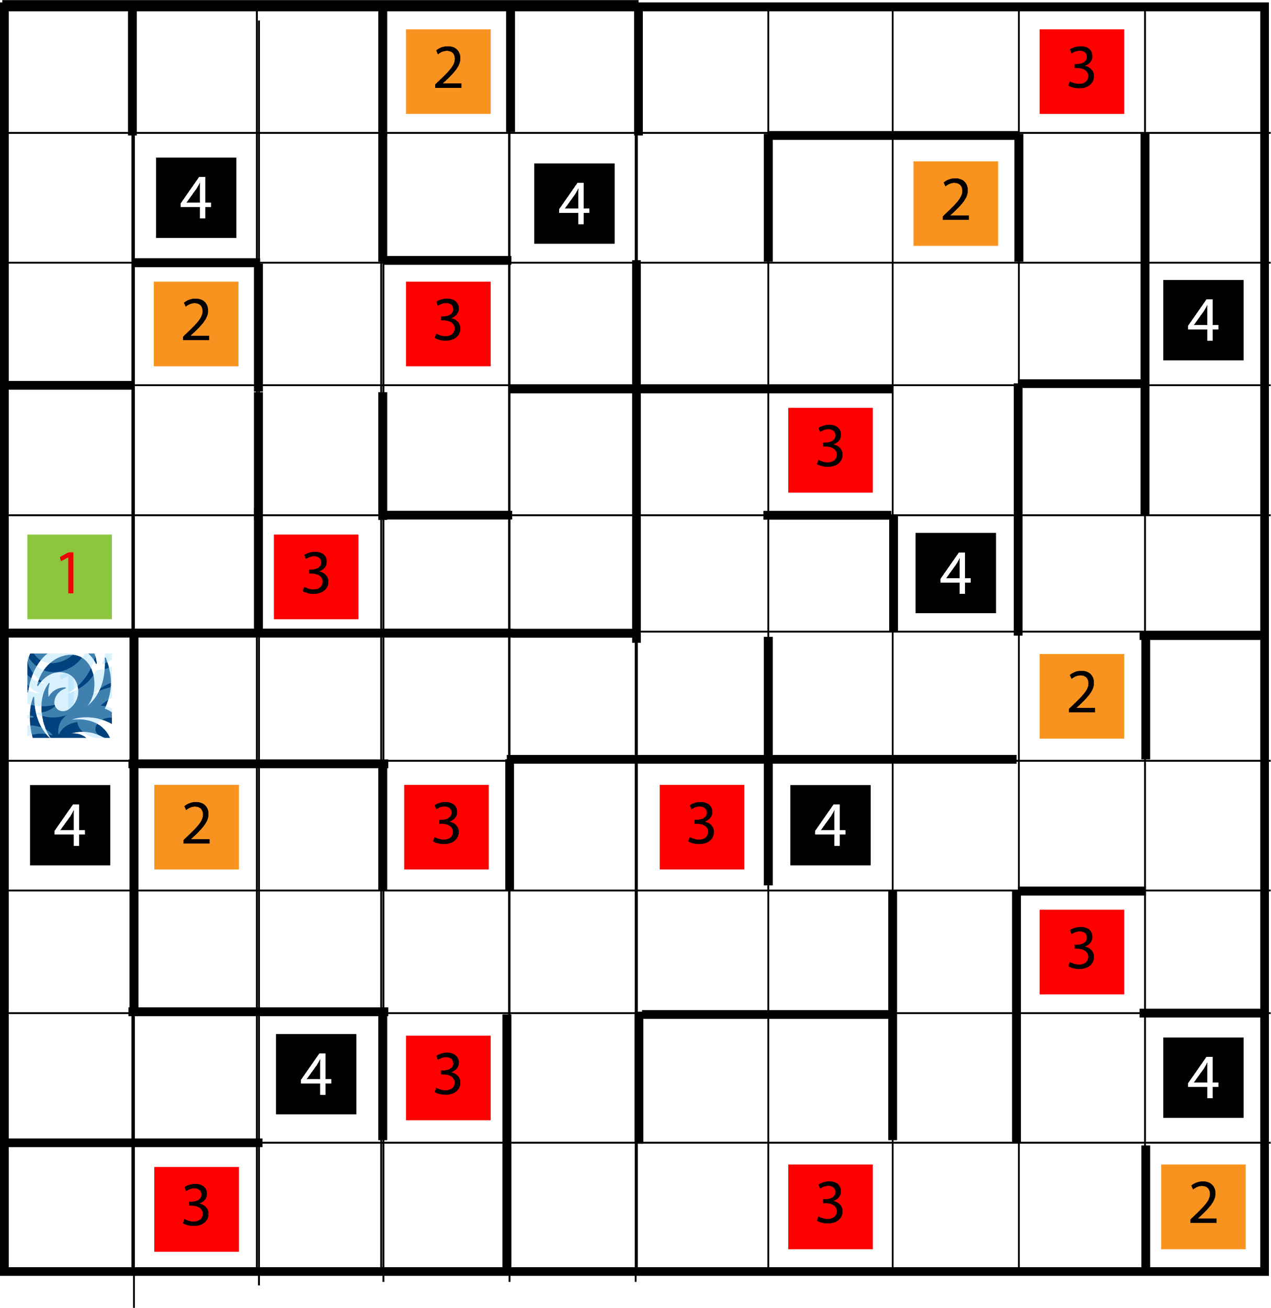

Story

**The beginning of the game.**

You open your eyes. It is not your room anymore. You are outside, surrounded by hedges and a complete darkness. The only source of light is an oil lamp that lies in front of you. You get up and take it.

1. Go north
2. Go east

//change on the map

The darkness is so thick you can almost feel it. The lamp gives a dim light, so you cannot see much. You start thinking that it is as dark as your humor.

1. Go east/go north
2. Go back

//change on the map

1. Go north
2. Go back

**Approaching the first NPC**

After a while you notice a silhouette in front of you. Hopefully it is someone that could tell you anything about this odd place. Shouldn’t assume anything negative, even if they look super creepy, right?

1. Interact
2. Go back

Oh, so you were what I assumed was a firefly. How do you find yourself in this peculiar place? Mh, you are not really talkative, are you? Well, then. Welcome to Dream Realm. As you have already noticed, it is really dark. You might want to keep that lamp on, cause the creatures that live in here, might want to feed on you when it goes off. Don’t worry though. Just remember to add some oil when you find it. If you’d like to, I can sell you some.

1. Trade
2. Leave
   1. Go west
   2. Go back
3. Can I ask you something?
   1. What is this place?

I do not think I can give you the exact answer. It is incredibly bizarre, and thus, I think it cannot be defined.

* 1. How do I get out of here?

You need to find your own way. Although, you might want to try and ask the others.

* 1. What kind of creatures can I encounter here?

Even though they have bodies, they are like nightmares. They will feed on your body and soul. If you try and kill them, they may once again appear and hunt you.

Lovely.

//change on the map

1. Go north
2. Go back

//change on the map

**Approaching the first trap**

Click, click. What is this sound? It comes from the eastern side. The noise is quite funny. Almost... Mechanical? You wonder why there would be anything machine-like. You turn to examine the source of the sound. There is an enormous rusty machine standing in your way. It does not look safe nor useful. It seems impossible to walk next to it, although, if you tried you might get crushed by all the moving parts. Maybe you could try and destroy it, like you do with everything in your life? You can spot some gears shining in the middle of it. Could a simple rock and strength of your amazing muscles solve the problem?

1. Throw a rock at it. What could go wrong?
2. Squeeze next to it. How hard could it be?
3. Go north
4. Go back

The rock hit the gears and the rusty parts just fell apart (just like you when puberty hit you) unblocking the path.

1. Go north
2. Go east
3. Go back

As you tried to squeeze next to the dangerously looking machine, your clothes got into the motor and your body got shattered. Good job.

You Died

_____ _____

/ \ / \

, | ' |

I __L________ L__

O====IE__________/ ./___>

I \. ./

` \. ./

\ /

'

Congratulations!

**When there is no possibility of moving anywhere but back.**

It seems that you have reached a dead end. Go back.

1. Go back.
2. Go north
3. Go east
4. Go back

//go in whatever directions

.

.

.

**When approaching the first monster.**

Even though there was nothing more than hedges around you, you could feel a certain smell, reminding you of a quagmire you have got lost in when you were a child. As you were moving forward, the odour was getting stronger. Then the dim light from your lamp lit something. A creature, twice as tall as you, was the source of the odd smell. It looked as if it was made out of sludge. As it made a terrifying high pitched sound, the odour you had smelled before, hit you. While you stayed stunned, the monster glided/slided towards you and spat some kind of stinky mucus that felt searing on your skin. The creature looked as if it wanted to attack again. You should try to defend yourself. As you thought that some kind of an object to fight the monster with would be helpful, a sword appeared in your hand.

Regular attacks:

1. Try to cut through the monster’s chest. Maybe it does have a heart on the contrary to you?
2. Attempt to cut off the monster’s legs. Legless opponent sounds like something you could fight.
3. Throw the sword at the monster's head hoping that you aim properly and won’t lose your weapon.
4. Pirouette/Spin while blindly flinging the blade around like a sane person you are.
5. Just try to harm the monster with the sword somehow, cause you are so scared you can barely move.
6. Run away like a coward you are.

Special attacks:

1. Try to tickle it to death with hands you create with the power of your mind. You brute.
2. Create a fireball and throw it at the monster, might make it evaporate? Or create a sculpture out of it. That might be your chance to become a creepy artist.
3. Try and dismember the monster’s body parts with the power of your mind to show off how almighty you are at the moment and start to wonder who the real monster is right now.

**If the monster kills you:**

You died. As a hero we didn’t deserve. But also as one we didn’t need.

_____ _____

/ \ / \

, | ' |

I __L________ L__

O====IE__________/ ./___>

I \. ./

` \. ./

\ /

'

**If you kill the monster:**

**(a few options so there is not only one message to appear after this happens)**

1. Congratulations! You have defeated the nightmare creature! Now you probably would like to run away cause it may reappear and seek revenge.
2. Nice one! You have defeated one monster! Only countless more to go! Keep that going!
3. Defeating that monster was super impressive. Wow. Just wow.

**When you approach other traps:**

1. There is a wall of ivy in front of you. Although, it seems that there is a path beyond it. Who knows what kind of wonders does it lead to? You might want to explore it.
   1. Defeat it with rocks. Just do it.
   2. Just run through it. It should tear under the impact.
2. Who would expect that it would actually work? Maybe in the Dream Realm everything is possible but you haven’t possessed all the required skills to achieve all that yet?
3. Why would you think that running through a poison ivy is a good idea? Why? You got poisoned and died.

Congratulations! You have invented a new kind of stupid!

_____ _____

/ \ / \

, | ' |

I __L________ L__

O====IE__________/ ./___>

I \. ./

` \. ./

\ /

'

2. There are huge spikes on the ground in front of you separating you from following parts of the maze. You might try to jump over them, even though it seems quite risky. However, you notice that there is some kind of a pressure plate behind the spikes. You can try and throw a stone at it hoping that it would lower the obstacles.

1. Try to jump over them, you champ.
2. Throw a stone at the pressure plate.
3. There is a thin line between heroism and stupidity. You crossed it. And died.

_____ _____

/ \ / \

, | ' |

I __L________ L__

O====IE__________/ ./___>

I \. ./

` \. ./

\ /

'

1. Luckily for you this worked. Hopefully, this good energy won’t leave you.

**When you approach other monsters:**

1. The maze does not appear to be an entirely friendly or peaceful place. You have already encountered some of its creations. Yet, it does not seem to have an end. How big is this place? Where does the way lead? Is this all some kind of a game? These terrifying thoughts were disrupted by a sudden and sharp pain in your ankle. It has been bitten. By some kind of a horned animal. It looks like a dog, but it has a really long tail ended with a dagger like spike. You might want to fight back. Just in case it wants to attack again.

Regular attacks/special attacks/retreat

1. You’d think that you might get a moment of peace but you realise you are wrong when you get hit by a stick. Or two. Or five. Why would a tree attack you? Probably because it can. The tiny pieces can get into your eyes and the big ones may bruise your skin. You better fight back.
   1. Regular attacks/special attacks/retreat

**When you approach other NPCs:**

1. Hello, wanderer. I hope you are well, although, by looking at you I can assume that you have encountered some of this place’s nightmarish creations. But you are alive! Should not be that gloomy, enjoy your life as long as you can. In the meantime, would you like to buy anything?
   1. Trade
   2. Leave
   3. Can I ask you something?
      1. Is there an exit somewhere?

Yes. However, it might be impossible for me to guide you towards it, as it changes its location. Just try not to give up.

* + 1. Are there any other people I could talk to?

Only other sellers. Unless you’d like to try to talk to the nightmares.

You die

_____ _____

/ \ / \

, | ' |

I __L________ L__

O====IE__________/ ./___>

I \. ./

` \. ./

\ /

'

Player

O

/|\

/ \

/U\

+

Empty field

Enemy

[_]  
 |”|

) (

Dead enemy

x.x

^

^^^

Exit

/*\

| |

]_[

NPC

@

{ }

[_]

@

(*)

}_{

Trap