**Lintag, Geremy D.  
Umiten, Marc Anthony C.**

**Group 9**

**Problem 5: Code and Proof**

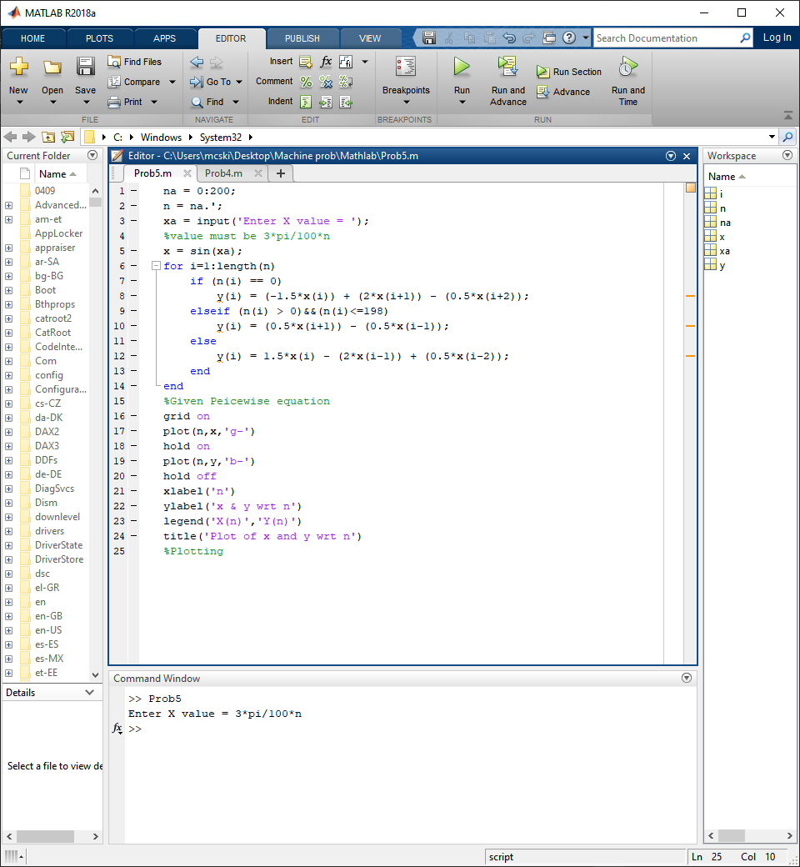**Matlab**

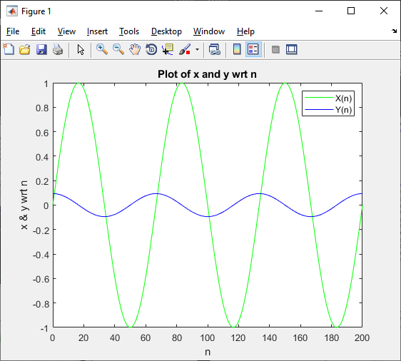**Graph**