МІНІСТЕРСТВО ОСВІТИ ТА НАУКИ УКРАЇНИ
Національний технічний університет України
Факультет інформатики та обчислювальної техніки
«Київський політехнічний інститут імені Ігоря Сікорського»
Кафедра інформаційних систем та технологій

Звіт
з лабораторної роботи № 1
з дисципліни «Програмування – 2.
Основи програмування»

Варіант № 5

Виконав: Валіваха Андрій
Студент гр. ІС-11 , ФІОТ
1 курс

Київ 2022

Лабораторна робота #1
Класи та об’єкти. Конструктори та деструктори. Модифікатори.

Завдання.
Створити клас с атрибутами та конструктором. У методі main() ініціалізувати створення екземплярів класу та продемонструвати роботу його методів згідно умов завдання.

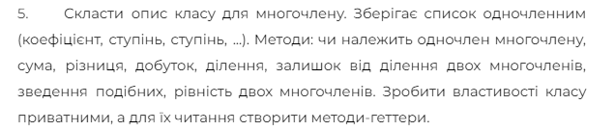
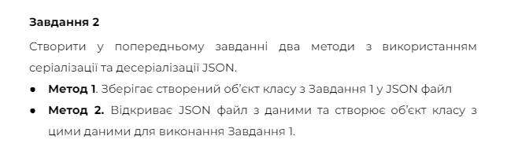
using System;
using System.Collections.Generic;
using System.Linq;
using System.Text;
using System.Threading.Tasks;
using System.Text.Json;
using System.Text.Json.Serialization;
using System.IO;

namespace Lab1_OOP
{
class Program
{
static void Main(string[] args)
{
Console.WriteLine("Input polynom 1 fileName:");
string fileName1 = Console.ReadLine();
string jsonString1 = File.ReadAllText(fileName1);
Polynom polynom1 = JsonSerializer.Deserialize<Polynom>(jsonString1);

Console.WriteLine("Input polynom 2 fileName:");
string fileName2 = Console.ReadLine();
string jsonString2 = File.ReadAllText(fileName2);
Polynom polynom2 = JsonSerializer.Deserialize<Polynom>(jsonString2);

Console.WriteLine("Polynom 1 initial:");
Console.WriteLine(polynom1.ConvertToString());
Console.WriteLine("Polynom 1 simpified:");
Polynom polynom1Simplified = polynom1.Simplified();
Console.WriteLine(polynom1Simplified.ConvertToString());

Console.WriteLine(" ");

Console.WriteLine("Polynom 2 initial:");
Console.WriteLine(polynom2.ConvertToString());
Console.WriteLine("Polynom 2 simpified:");
Polynom polynom2Simplified = polynom2.Simplified();
Console.WriteLine(polynom2Simplified.ConvertToString());

Console.WriteLine("Polynoms Sum (saved to polynomsSum):");
Polynom polynomSum = polynom1 + polynom2;
Console.WriteLine(polynomSum.ConvertToString());
string sumJson = JsonSerializer.Serialize(polynomSum);
File.WriteAllText("polynomsSum.json", sumJson);

Console.WriteLine("Polynoms Difference (saved to pylynomsDif):");
Polynom polynomDif = polynom1 - polynom2;
Console.WriteLine(polynomDif.ConvertToString());
string DifJson = JsonSerializer.Serialize(polynomDif);
File.WriteAllText("polynomsDif.json", DifJson);

Console.WriteLine("Polynoms Multiplication (saved to pylynomsMultipl):");
Polynom polynomMultipl = polynom1 * polynom2;
Console.WriteLine(polynomMultipl.ConvertToString());
string MultiplJson = JsonSerializer.Serialize(polynomMultipl);
File.WriteAllText("polynomsMultipl.json", MultiplJson);

Console.WriteLine("Polynoms Division(saved to polynomsDiv):");
Polynom polynomDiv = polynom1 / polynom2;
Console.WriteLine(polynomDiv.ConvertToString());
string DivJson = JsonSerializer.Serialize(polynomDiv);
File.WriteAllText("polynomsDiv.json", DivJson);

Console.WriteLine("Polynoms Remainder (saved to polynomsRem):");
Polynom polynomRem = polynom1 % polynom2;
Console.WriteLine(polynomRem.ConvertToString());
string RemJson = JsonSerializer.Serialize(polynomRem);
File.WriteAllText("polynomsRem.json", RemJson);

Console.ReadLine();
}
}

class Single
{
private double _koef;
private int _power;
public double Koef
{
get { return _koef; }
}
public int Power
{
get { return _power; }
}

public Single (double koef, int power)
{
_koef = koef;
_power = power;
}
}

class Polynom
{
private List<Single> _singles;

public List<Single> Singles
{
get { return _singles; }
}

public Polynom (List<Single> singles)
{
_singles = singles;
}

public string ConvertToString()
{
string result = "";

for (int i = 0; i < _singles.Count; i++)
{
Single s = _singles[i];

if (s.Koef >= 0)
{
result += "+";
}

if (s.Power == 0)
{
result += String.Format(" {0} ", s.Koef);
}
else
{
result += String.Format(" {0}x^{1} ", s.Koef, s.Power);
}
}

return result;
}

public void AddSingle(Single single)
{
for (int i = 0; i < _singles.Count; i++)
{
Single s = _singles[i];

if (s.Power == single.Power)
{
double newKoef = s.Koef + single.Koef;

if (newKoef != 0)
{
_singles[i] = new Single(newKoef, s.Power);
} else
{
_singles.RemoveAt(i);
}
return;
}
}
_singles.Add(single);
}
public void MultiplySingle(Single single)
{
for (int i = 0; i < _singles.Count; i++)
{
Single s = _singles[i];

double newKoef = s.Koef * single.Koef;
int newPower = s.Power + single.Power;
_singles[i] = new Single(newKoef, newPower);
}
}

public void SubtractSingle(Single single)
{
Single s = new Single(-single.Koef, single.Power);
AddSingle(s);
}

public Polynom Simplified()
{
Polynom p = new Polynom(new List<Single>());

for (int i = 0; i < _singles.Count; i++)
{
Single s = _singles[i];
p.AddSingle(s);
}

return p;
}

public void SortSingles()
{
_singles = _singles.OrderByDescending(s => s.Power).ToList();
}

public static Polynom operator +(Polynom a, Polynom b)
{
Polynom p = new Polynom(new List<Single>());

for (int i = 0; i < a.Singles.Count; i++)
{
Single s = a.Singles[i];
p.AddSingle(s);
}

for (int i = 0; i < b.Singles.Count; i++)
{
Single s = b.Singles[i];
p.AddSingle(s);
}

return p;
}

public static Polynom operator -(Polynom a, Polynom b)
{
Polynom p = new Polynom(new List<Single>());

for (int i = 0; i < a.Singles.Count; i++)
{
p.AddSingle(a.Singles[i]);
}
for (int i = 0; i < b.Singles.Count; i++)
{
p.SubtractSingle(b.Singles[i]);
}
p.SortSingles();
return p;
}
public static Polynom operator *(Polynom a, Polynom b)
{
Polynom p = new Polynom(new List<Single>());
for (int i = 0; i < a.Singles.Count; i++)
{
Single aSingle = a.Singles[i];
for (int j = 0; j < b.Singles.Count; j++)
{
Single bSingle = b.Singles[j];

double newKoef = aSingle.Koef * bSingle.Koef;
int newPower = aSingle.Power + bSingle.Power;
Single s = new Single(newKoef, newPower);

p.AddSingle(s);
}
}
return p;
}

public static Polynom operator /(Polynom a, Polynom b)
{
Polynom aSimplified = a.Simplified();
Polynom bSimplified = b.Simplified();

aSimplified.SortSingles();
bSimplified.SortSingles();

if (aSimplified.Singles[0].Power < bSimplified.Singles[0].Power)
{
return new Polynom(new List<Single>());
}

Polynom result = new Polynom(new List<Single>());
Polynom remainder = new Polynom(aSimplified.Singles);

while (remainder.Singles.Count > 0 && remainder.Singles[0].Power >= bSimplified.Singles[0].Power)
{
Single multiplier = new Single(remainder.Singles[0].Koef / bSimplified.Singles[0].Koef, remainder.Singles[0].Power - bSimplified.Singles[0].Power);
Polynom temp = new Polynom(new List<Single>());
for (int i = 0; i < bSimplified.Singles.Count; i++)
{
Single s = new Single(bSimplified.Singles[i].Koef * multiplier.Koef, bSimplified.Singles[i].Power + multiplier.Power);
temp.AddSingle(s);
}
remainder = remainder - temp;
remainder.SortSingles();
result.AddSingle(multiplier);
}

return result;
}

public static Polynom operator %(Polynom a, Polynom b)
{
Polynom aSimplified = a.Simplified();
Polynom bSimplified = b.Simplified();

aSimplified.SortSingles();
bSimplified.SortSingles();

if (aSimplified.Singles[0].Power < bSimplified.Singles[0].Power)
{
return new Polynom(new List<Single>());
}

Polynom remainder = new Polynom(aSimplified.Singles);

while (remainder.Singles.Count > 0 && remainder.Singles[0].Power >= bSimplified.Singles[0].Power)
{
Single multiplier = new Single(remainder.Singles[0].Koef / bSimplified.Singles[0].Koef, remainder.Singles[0].Power - bSimplified.Singles[0].Power);
Polynom temp = new Polynom(new List<Single>());
for (int i = 0; i < bSimplified.Singles.Count; i++)
{
Single s = new Single(bSimplified.Singles[i].Koef * multiplier.Koef, bSimplified.Singles[i].Power + multiplier.Power);
temp.AddSingle(s);
}
remainder = remainder - temp;
remainder.SortSingles();
}

return remainder;
}

public bool hasSingle(Single single)
{
Polynom p = this.Simplified();

for (int i = 0; i < p.Singles.Count; i++)
{
Single q = p.Singles[i];
if (q.Koef == single.Koef && q.Power == single.Power)
{
return true;
}
}
return false;
}
public static bool operator ==(Polynom a, Polynom b)
{
Polynom aSimplified = a.Simplified();
Polynom bSimplified = b.Simplified();
aSimplified.SortSingles();
bSimplified.SortSingles();

if (aSimplified.Singles.Count != bSimplified.Singles.Count)
{
return false;
}

for (int i = 0; i < aSimplified.Singles.Count; i++)
{
Single singleA = aSimplified.Singles[i];
Single singleB = bSimplified.Singles[i];
if(singleA.Koef != singleB.Koef || singleA.Power != singleB.Power)
{
return false;
}
}
return true;
}

public static bool operator !=(Polynom a, Polynom b)
{
bool isEqual = a == b;
return !isEqual;
}
}
}
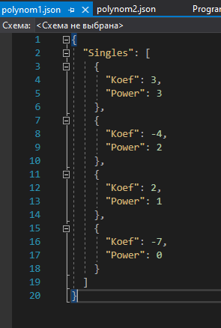
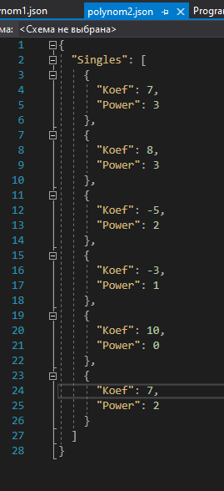
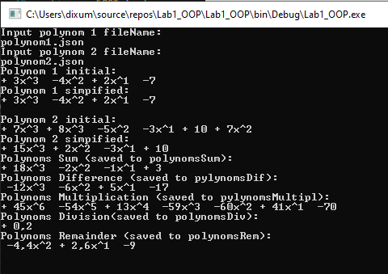
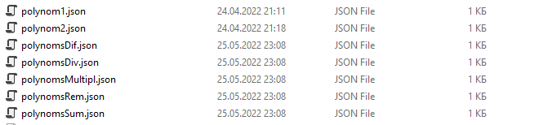

Висновок: виконавши дану лр я навчився працювати з класами і об’єктами. Використовувати конструктори, деструктори та модифікатори.

