**Gerardo Fuentes Tabla**

**Dudas: 5613592187**

**gerfuetab@gmail.com**

**Manual de instalación**

Manual basado en el IDE **Spring Tool Suite**

**1.-Descargar proyecto**

https://github.com/gerfuetab/audicion-bimbo.git

**2.-Importar proyecto**

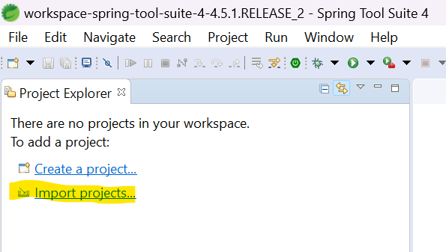

**Run configuration**

**3.-Modulo** **audicion-bimbo-provedor-plan**

**Levantar modulo**

* Explorar a la clase main org.gerfuetab.audicionbimbo.proveedorplan.ProveedorPlanApplication
* Click derecho, Run as, Spring Boot App.

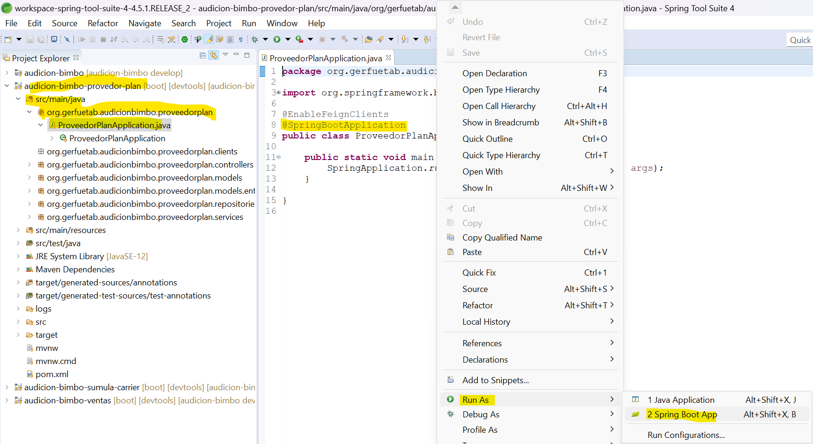

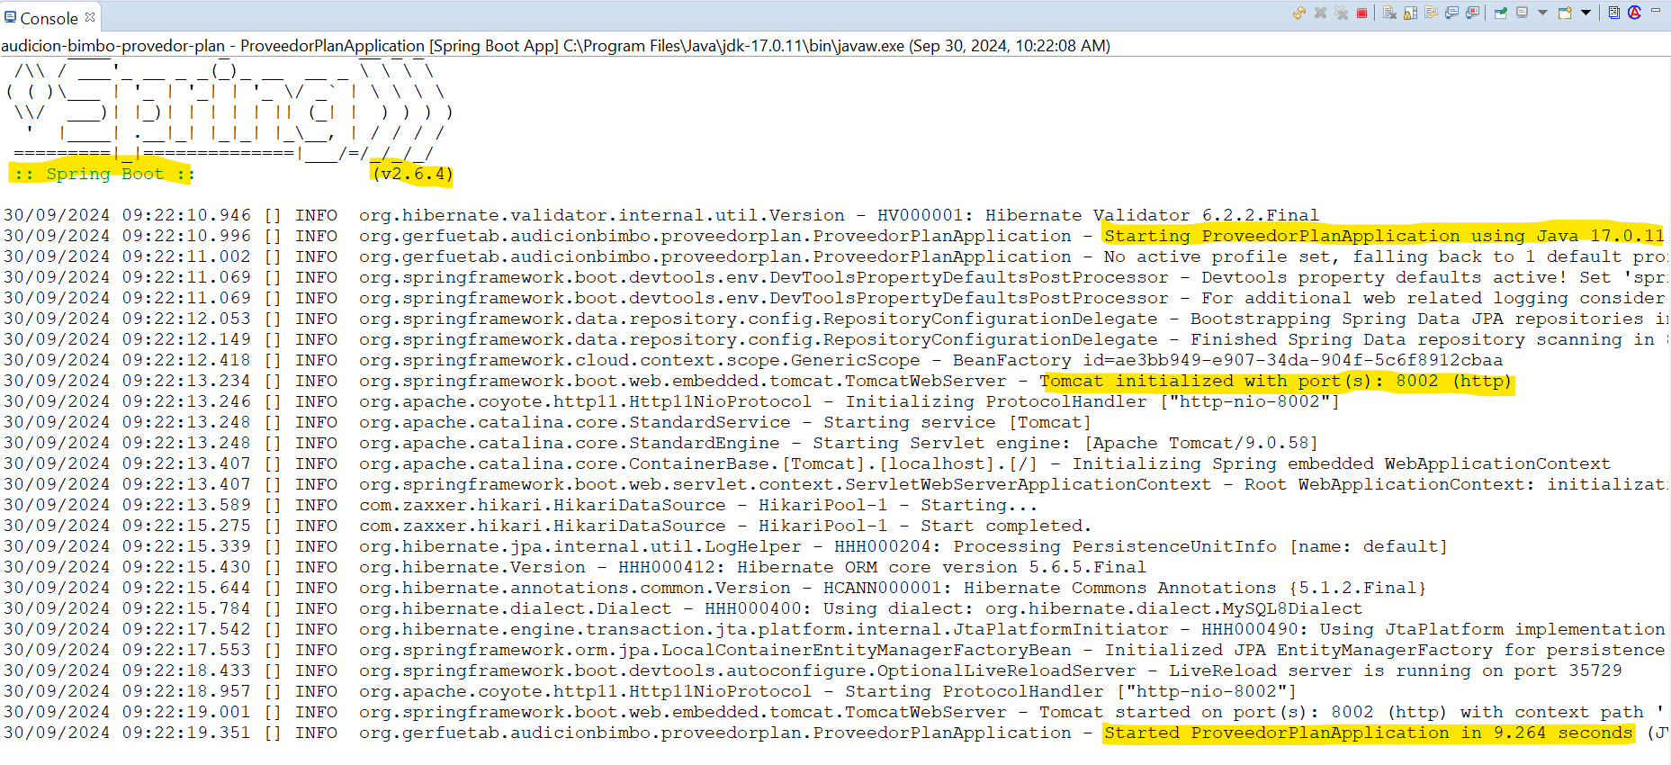

**4.-Modulo** **audicion-bimbo-sumula-carrier**

**Levantar modulo**

* Explorar a la clase main org.gerfuetab.audicionbimbo.carrier.CarrierApplication
* Click derecho, Run as, Spring Boot App.

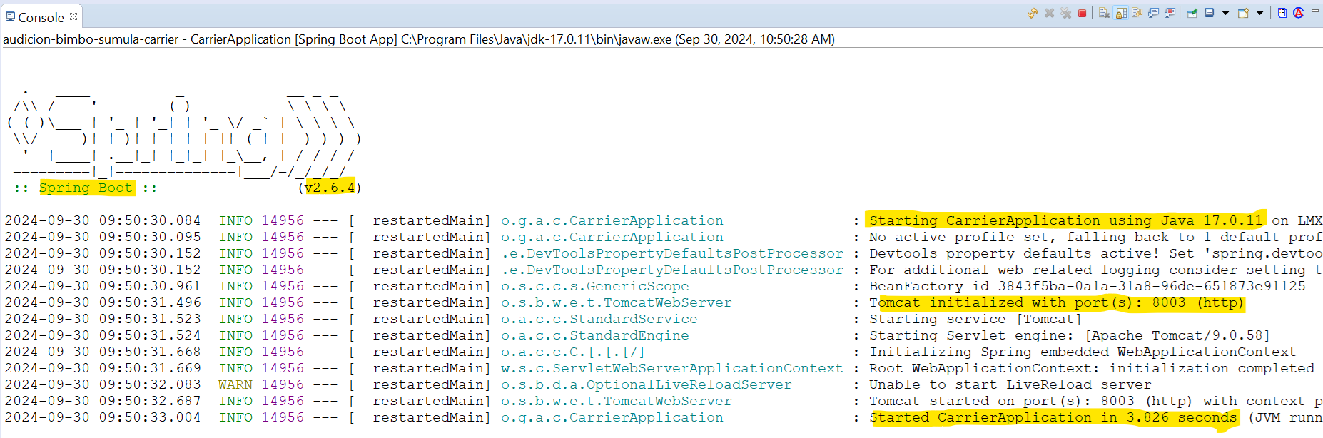

**5.-Modulo** **audicion-bimbo-ventas**

**Levantar modulo**

* Explorar a la clase org.gerfuetab.audicionbimbo.ventas.VentasApplication
* Click derecho, Run as, Spring Boot App.

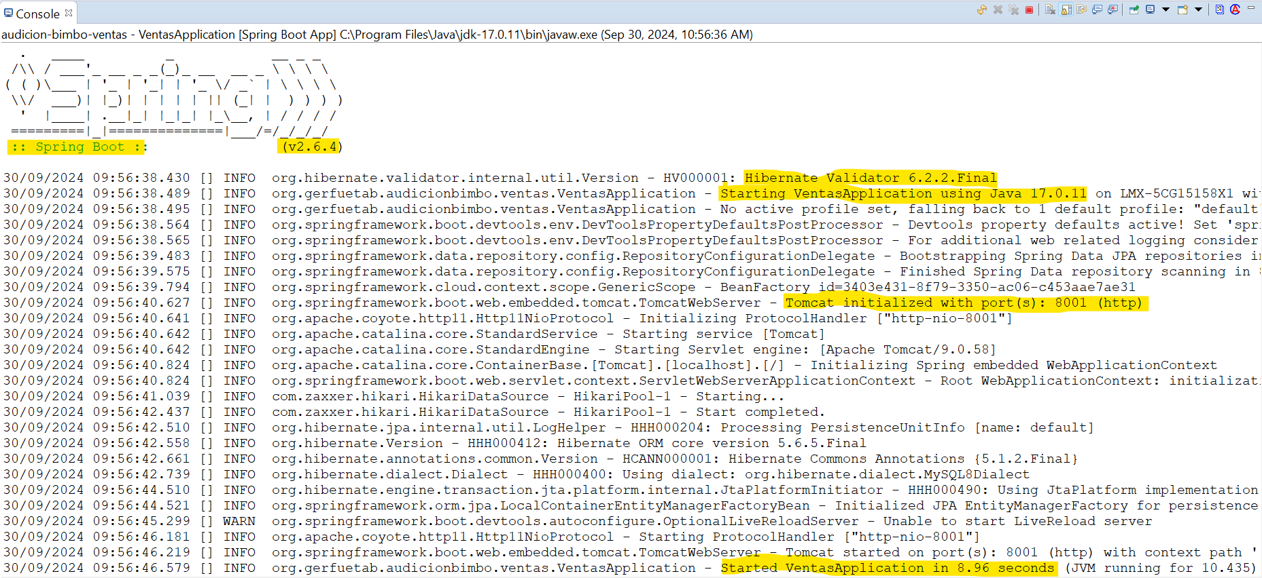

**6.-Ahora ya se tienen los 3 módulos corriendo**

**7.- Probar servicios**

**audicion-bimbo-provedor-plan**

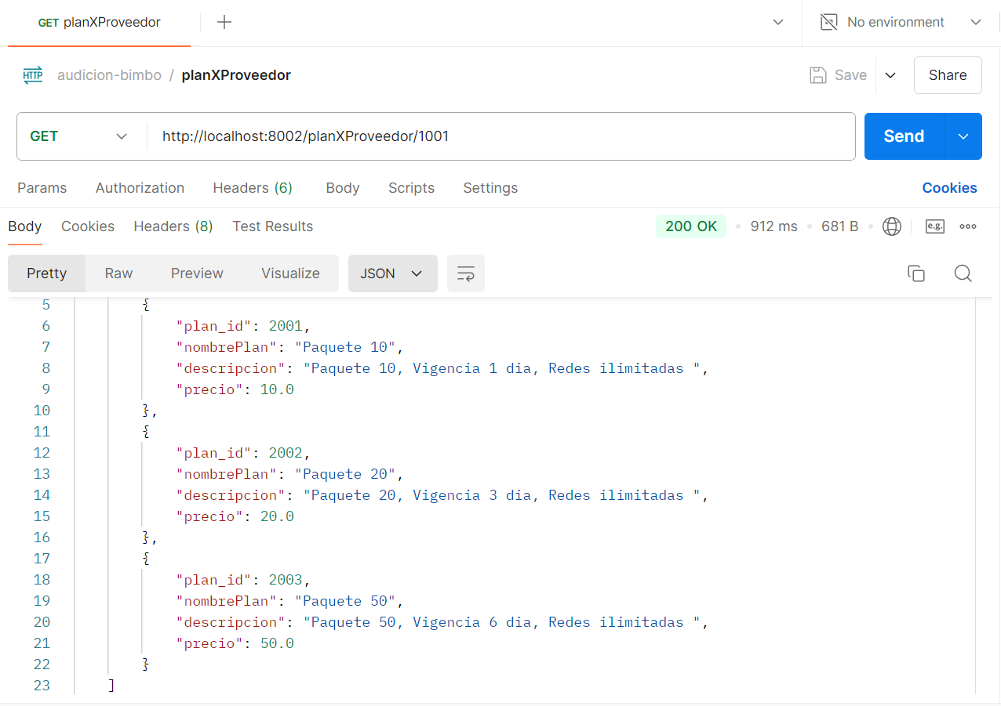

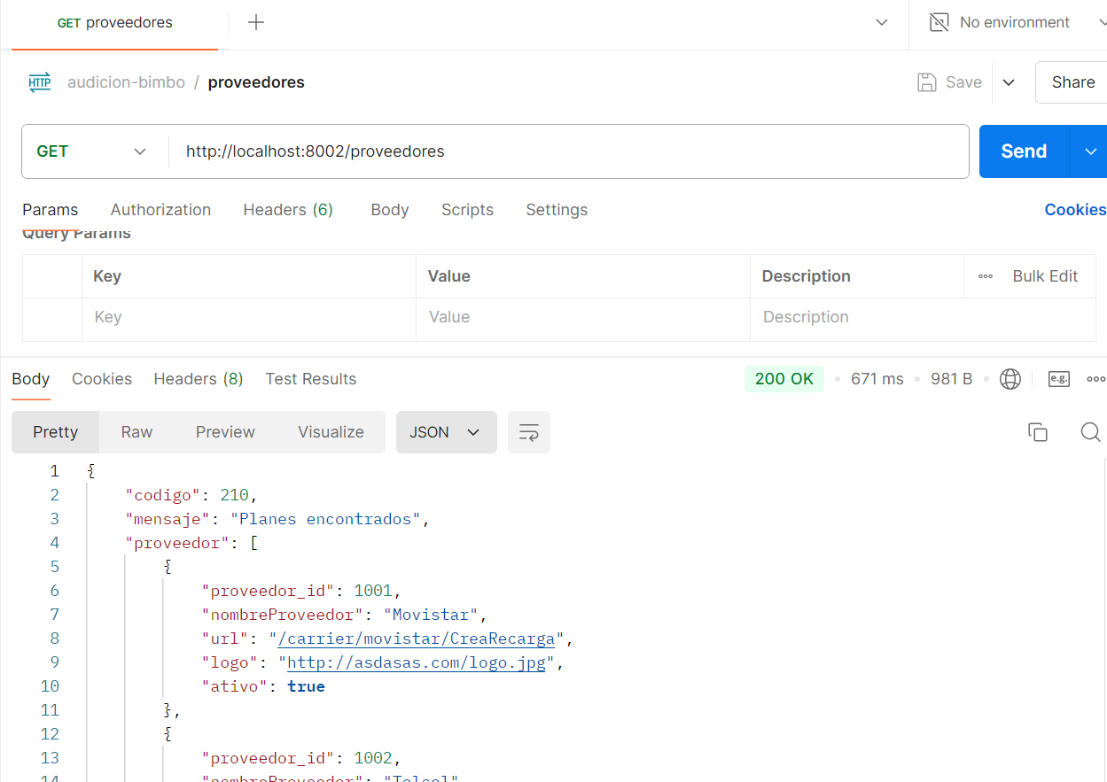

**audicion-bimbo-sumula-carrier**

**audicion-bimbo-ventas**

