**Software Requirement Specification**

*for*

ProjectName : “Blog Functionality”

*created from:*

*With members :*

*Jordan Petkov – Junior QA*

*Gergana Suvandzhieva – Junior QA*

[*Dimitar*](https://www.facebook.com/zahariq.pehlivanova?fref=pb_other) *Dimitrov – Junior QA*

*Jordan Mihailov – Junior QA*

*Tsvetelina Gogova – Junior QA*

*Ilian Panchev– Junior QA*

*Valeria Savova– Junior QA*

CONTENTS……………………………………………………….............page

1. Introduction……………………………………………………………………...3
   1. Purpose……………………………………………………………….......3
   2. Scope of project…………………………………………………………..3
   3. Constrains…………………………………………………………………3
2. Overall description
   1. Vocabulary…………………………………………………………………3
   2. Game View and Description…………………………………………........4
   3. “How it Work” Block Scheme……………………………………………..5
   4. Non-functional Requirements……………………………………………..6
   5. Functional Requirements………………………………………………7÷10
3. **Introduction**
   1. ***Purpose***

The main purpose of this document is to describe in details what is the exact functionality, how the system will work properly, what needs to be done for improving the system. This document is prepared to help developers and stakeholders to understand in depth the project.

* 1. ***Scope of Project***

Team “PassionFruit” will develop and present a blog named “SoftUni Blog – Web App”. It is discussion or information website, consisting of structured, informal diary-style text arias named “posts”. It will be used from SoftUni students for posting topics of any kind related with the university life.

Every student must have registration for posting in the blog. After login he/she will have the option to post, edit and delete his/her own blog posts. Guest users can only read the posts.  
  
***1.3*** ***Constrains***

* The project must be started at any Windows, OSX, Linux PC as well as Android, iOS and Windows Phone with a modern web browser.
* You need a Internet connection to get into the blog.

1. **Overall Description**
   1. ***Vocabulary***
      1. **Main Page** – This is the place where all the blog post will be displayed. There will be links for registration and login in the blog. Not registered users will not allowed to write posts.
      2. **User –** anyone, who enter the Home page of the Blog
      3. **Registered User –** anyone, who has registration in the Blog. Registered user can write, edit and delete his own posts.
      4. **Login Page** – Page for login existing users.
      5. **Registration page –** Page for new user registration.
      6. **Details page –** Page for reading full post
      7. **Edit page –** Page for editing the blog post
      8. **Blog topic page –** Full content of the blog topic.
   2. ***Blog View and Description***

In the Home page of the blog you will see header with logo and two buttons – Register and Login. On the main div will be loaded the posts in blog. Every post will have Title, blog post and author. In the footer will be copyright info.

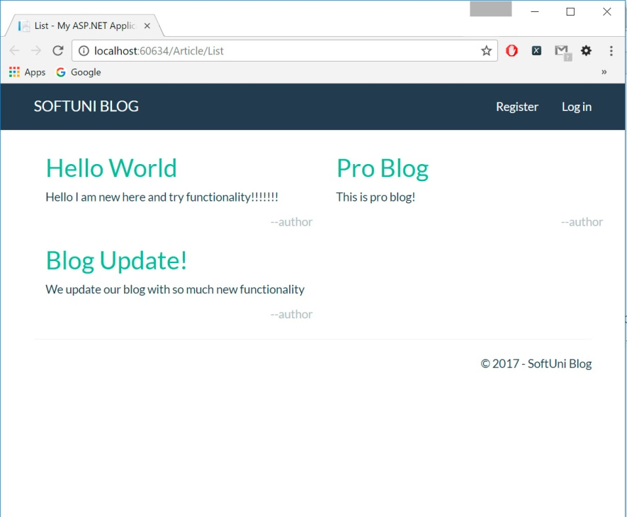

Register page will have form for registration with this fields – Email, Full Name, Password, Confirm Password. Will be not allowed two users with the same username. The form will check for valid email and password before registration.

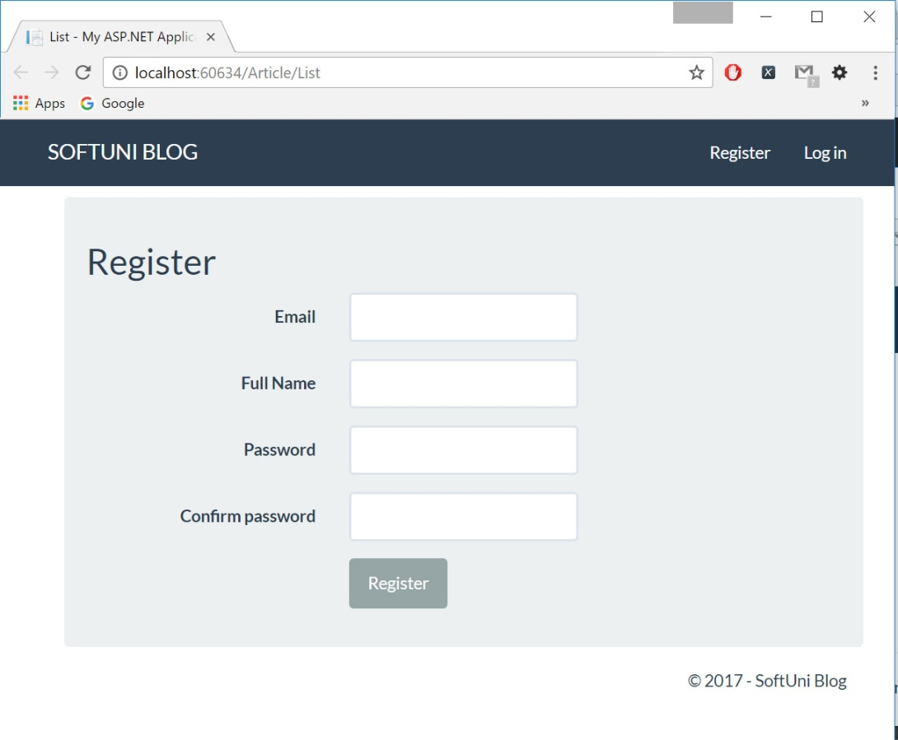

Login page will have form for login with two fields: Email and password. When registered user input correct email and password will be allowed to write blog posts.

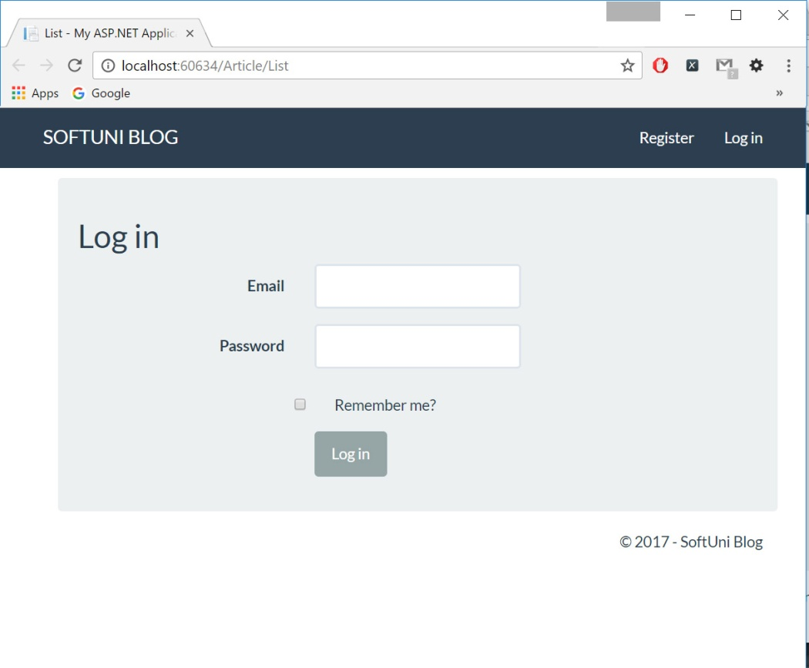

Details page will contain full blog post from the Home Page. Under the blog post there are two buttons – Edit and Delete. If user is logged in and is the author of the post it will have the rights to edit or delete the post.

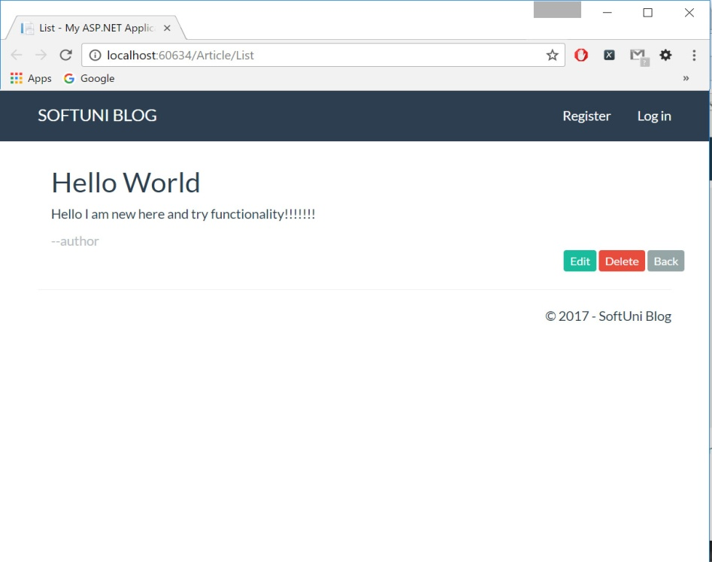

Edit page will contain the blog post that will be edited. Under the blog post there are two buttons – Cancel and Edit. If user is logged in and is the author of the post it will have the rights to edit the post.

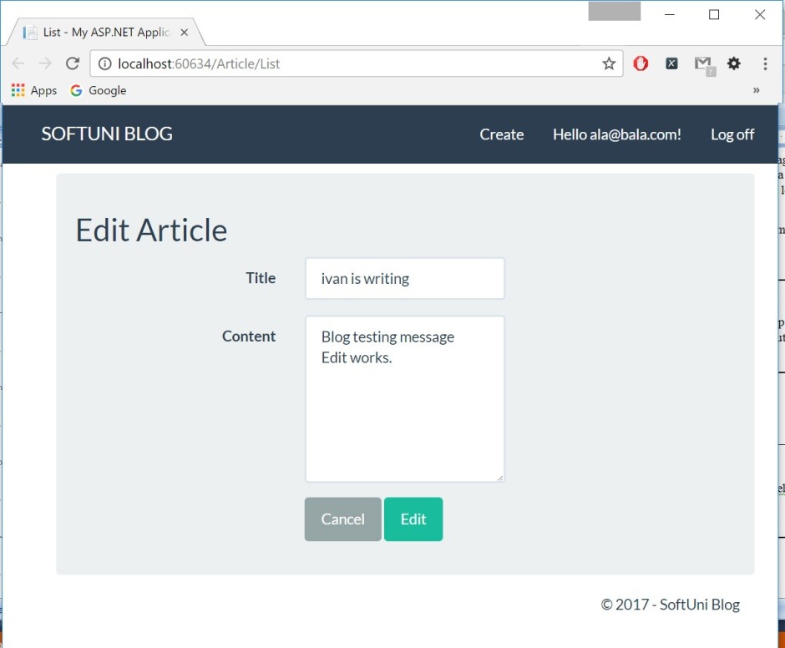

Delete page will contain full blog post from the Home Page. Under the blog post there are two buttons – Cancel and Delete. If user is logged in and is the author of the post it will have the rights to delete the post.

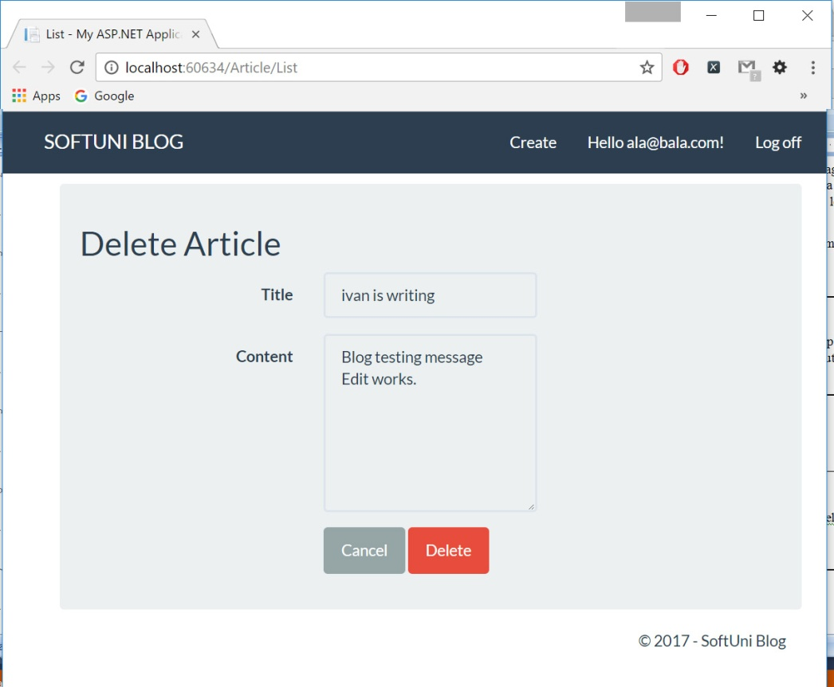

* 1. ***Block Scheme of functionality***

**Enter into the Blog**

Write web address of the Blog Home page

**IF**

User has registration

User hasn’t registration

Guest user

Register user

Everyone can read all blog posts

User hasn’t registration

User has registration

**IF**

User can edit and delete his own posts

User can only read posts

**Exit**

**the Blog**

* 1. ***Non - functional Requirements***

*Loading of the Blog*

1. Loading/response time for Home Page and all other pages must **be in 1 sec.** according to connection speed.
2. When Home Page is loaded user must **see all blog posts** without delay.
3. When User enters the specific blog post he may see the **full post** version in new window.

*Registration into the Blog*

1. Everyone who wants to write in the Blog **must make a registration**.
2. After registration User may write, edit and delete **only his own posts**.
3. All information for registrations must be **stored and protected** for unauthorized change/usage.
4. All information of registered users must **stay consistent** for the lifetime of the Blog.

*Every logged user*

1. Can write, edit and delete **only his own posts**.
2. Can edit **his own** user information.

*The Blog system*

1. Can handles from 10000 to 20000 simultaneously reading users.
2. The number of registered users must be unlimited.
3. Every registration must be unique.
4. Every registration in the Blog should happen quickly and without delay.
5. Must be hosted on reliable hardware/software configuration.

* 1. **Functional Requirements**

**For detailed information please check the document “ScenariosPassionFruit.xlsx”**

1. *Use Case – loading Blog Entry page*

When entering the URL of Blog in browser the Home page with latest posts must be load.

1. *Use Case – User Register*

From the Home page when new user pushed Register button the Register page must be load. When User fill the form with requested information for the given fields, a New Registration must be activated. User will be redirect to Home page where is displayed that user is registered and logged in – in the right side of the Header will be displayed “Create” post button, registered email and “Log off” button.

If there are problems with some of the form fields an appropriate error message must be displayed.

1. *Use Case – User Login*

From the Home page when Registered user pushed Login button the Login page must be load. When User fills the form with requested information for the given fields, a Login must be activated. User will be redirect to Home page where is displayed that a user is logged in the right side of the Header will be displayed “Create” post button, registered email and “Log off” button.

If there are problems with some of the form fields an appropriate error message must be displayed.

1. *Use Case – Guest user tries to edit post*

From the Home page when Guest User clicks on the Title of the blog post Blog will be redirected to the Details page. In the Details page when User clicks on buttons Edit Blog will be redirected to Log in page.

If User hasn’t registration he will not allowed to edit the post.

1. *Use Case – Guest user tries to delete post*

From the Home page when Guest User clicks on the Title of the blog post Blog will be redirected to the Details page. In the Details page when User clicks on buttons Delete Blog will be redirected to Log in page.

If User hasn’t registration he will not allowed to delete the post.

1. *Use Case – Logged user tries to edit his own post*

From the Home page when User is logged and click on the Title of his own blog post Blog will be redirected to the Details page. In the Details page when Logged User clicks on buttons Edit Blog will be redirected to Edit page, where Logged User can edit Title and body of the message. When User click Edit button Blog redirects to Home page where user see messages and his edited message.

1. *Use Case – Logged user tries to delete his own post*

From the Home page when User is logged and click on the Title of his own blog post Blog will be redirected to the Details page. In the Details page when Logged User click on Delete button Blog will be redirected to Delete page, where Logged User must confirm delete operation with click on Delete button or cancel the deletion with click on Cancel button. After that Blog redirects to Home page. The deleted blog message disappears.

1. *Use Case – Logged user tries to edit post of another user*

From the Home page when User is logged and click on the Title post Blog will be redirected to the Details page. In the Details page when Logged User clicks on button Edit, Blog must appropriate report that this post belongs to another user and edition is prohibited.

1. *Use Case – Logged user tries to delete post of another user*

From the Home page when User is logged and click on the Title post Blog will be redirected to the Details page. In the Details page when Logged User clicks on button Delete, Blog must appropriate report that this post belongs to another user and deletion is prohibited.

1. *Use Case – User exit the Blog*

When the User closed the blog window or browser application.

1. *Use case – User re-entry into the Blog*

When the User load Home page of blog.

If user has account he can automatically logged in. His browser must store cookie or some other information for restoring the login.