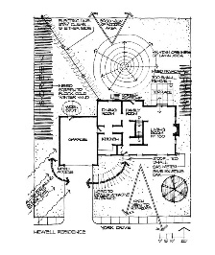

Student Learning Outcomes:
After this lab session you will be able to
- Apply fundamental principles of landscape design in designing a residential yard.

Landscape design is a creative environmental problem-solving process to organize external space and attain an optimum balance of natural factors and human needs, i.e. the functional and attractive composition of plants and constructed elements in small-scale situations, including residential and commercial sites (from Residential Landscapes by G.M. Pierceall). The landscape designer, landscape architect, interior designer, or architect all follow a similar design process.

- Research and preparation, which can include interviewing the client, preparing a base map, conducting a site inventory and analysis, and developing a design program outline.
- Preparing the actual design solution based on the research and preparation step.
- Preparing the construction documentation, which would include the layout plan, the grading plan, the planting plan, and other construction details.
- Implementation of the plan, i.e. construction and installation.
- Maintenance
- Evaluation

The landscape around a home or business creates the functional environment of the area. Ideally, this landscape serves to provide design solutions enhancing the usage of the area to meet specific wants or needs while preserving natural features and resources. Unfortunately, it is possible to create more design problems while attempting to provide solutions. To this end several considerations need to be made:

- Desired use of area by client
- Funding available
- Appropriate plant selection (See “Tips on Plant Selection/Placement” below)
- Soil, rainfall, climate, and other environmental features
- Existing wildlife
- Municipal ordinances, laws, permits, or operating procedures that must be followed

In this laboratory exercise you will be given a residential design case to prepare a design for and will then present your design plan to the class.

Tips on Plant Selection/Placement

- Choose the right tree for the right location, consider height and diameter at maturity.
- A small house dwarfed by large trees, makes them look smaller; large trees add distinction to large houses.
- Placement: 15 – 20 feet from house side, 12 to 15 feet from corner, large trees no less than 25 feet from septic tank, sewer, or utilities.

Trees
- provide visual dividers
- leafy roof for sitting area
- cut down on direct rays of sun, cooling the spot they shade
- landscape screens – mask unsightly area
- evergreens provide year-round screening, cuts down on noise
- can frame a view-plant 2 trees to balance
- strong wooded
- disease and insect resistant
- lawn trees have fine textures to allow light penetration
- for winter sun, summer shade, place trees in SW

Wind Protection
- Wind breaks obstruct and redirect flow of wind
- Kansas winter winds from N or NW
- Summer winds from S or SW
- Effective zones – maximum protection 5-7 times height of planting

Shrubs
- practical for small subdivisions
- close enough together for solid wall and far enough from house to create dead air space (dead air cools less than moving air)
- rows of shrubs on NW side to protect from cold winter winds as well as direct summer heat

Espaliers and Vines – trained to grow flat against wall
- cools house during summer by shading walls and windows
- warms house during cold windy winter
- deciduous – allows sun to penetrate in winter
- vines as ground cover or trained to grape arbor; wisteria, Carolina jasmine
- overhead structures – arbors, slatted wooden structures

DESIGN EXERCISE
Recent clients you have been given are the Scott family. They have recently bought a new home on a totally cleared site. You have been provided with a base plan and have acquired the following information about the family.

Husband: 40 years of age; enjoys gardening; likes fruit trees (apple); enjoys playing with children in the yard; likes to entertain with outdoor cookouts

Wife: 40 years of age; enjoys vegetable and flower gardening; loves to cook and entertain small groups for dinners

Children: Twin boys, 15; one daughter, 13; active in sports; want open lawn area; love nature, especially bird-watching

Family’s wants and needs:
- Sidewalk to front door
- Recreation area
- Outdoor sitting and entertaining area with partial shade
- Privacy on patio area and from busy street on west side
- Flower gardens front and back
- Small vegetable garden

Other:
- House is a 2-story traditional with light grey siding, the trim is white
- Busy street on west side of house
- Family places high value on neighbor relationships
- Cold winds blow from north, hot winds blow from the south
- Wood stockpile area needed

ASSIGNMENT: Complete a general design for this property. Your design should reflect the information presented on the family and the site. You do not need to name specific plants, rather indicate if it is deciduous, evergreen, broadleaf evergreen, herbaceous perennial, or annual. You will be evaluated on how well you have addressed the needs of the family and the site.

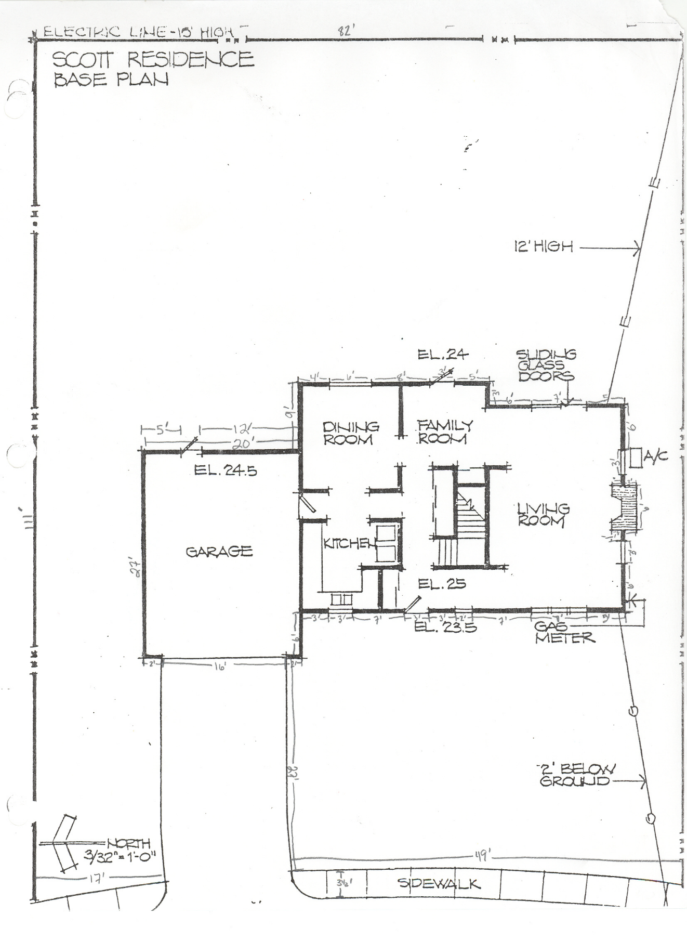
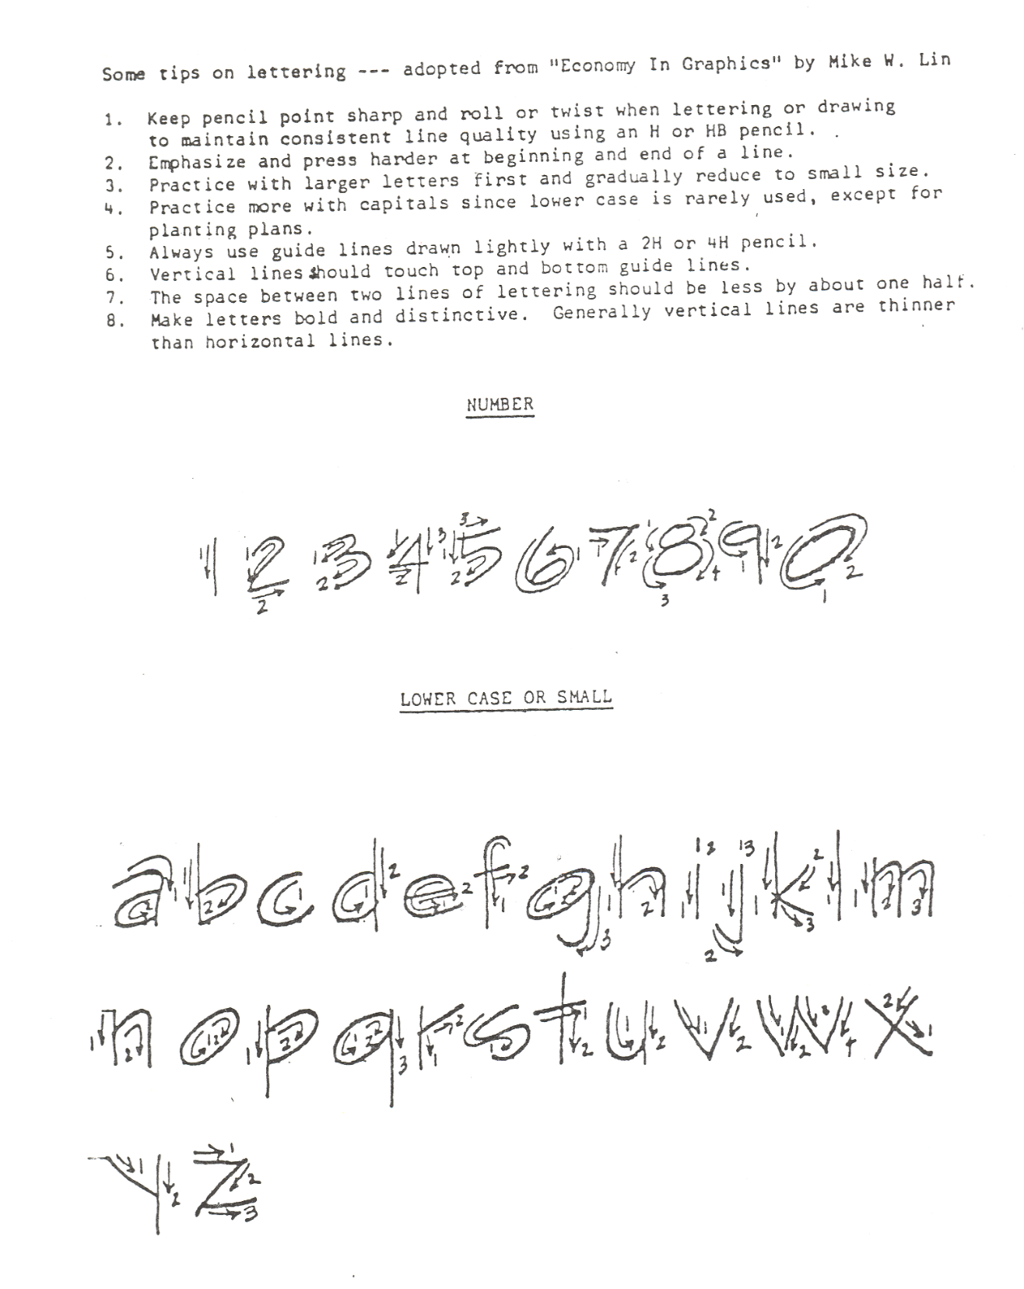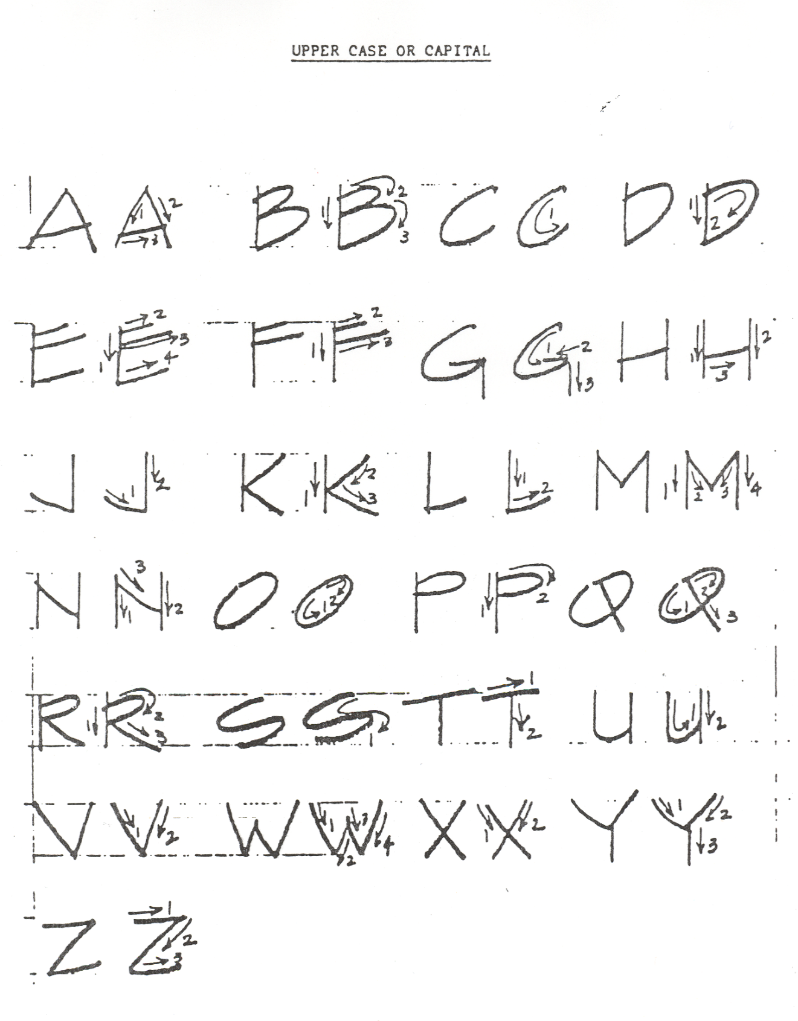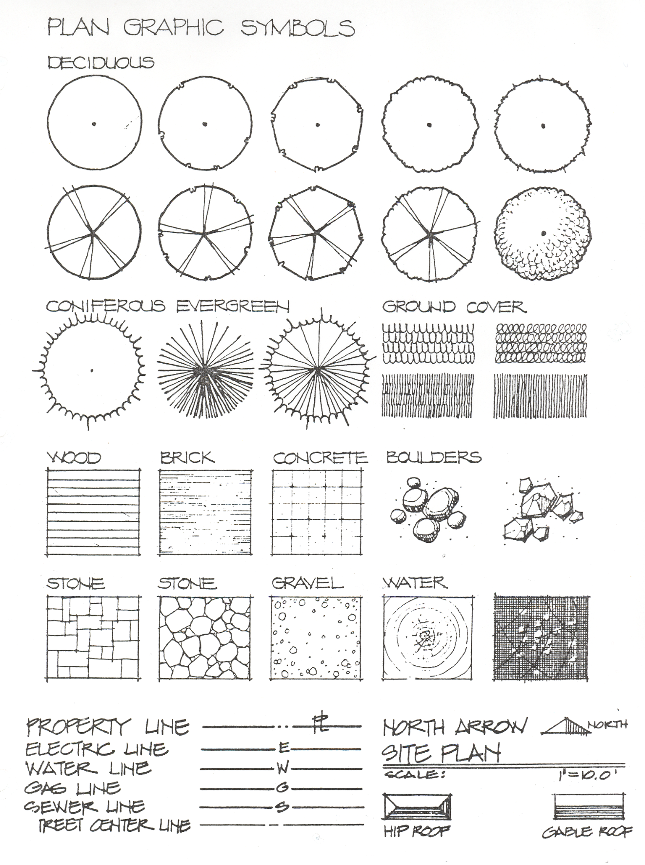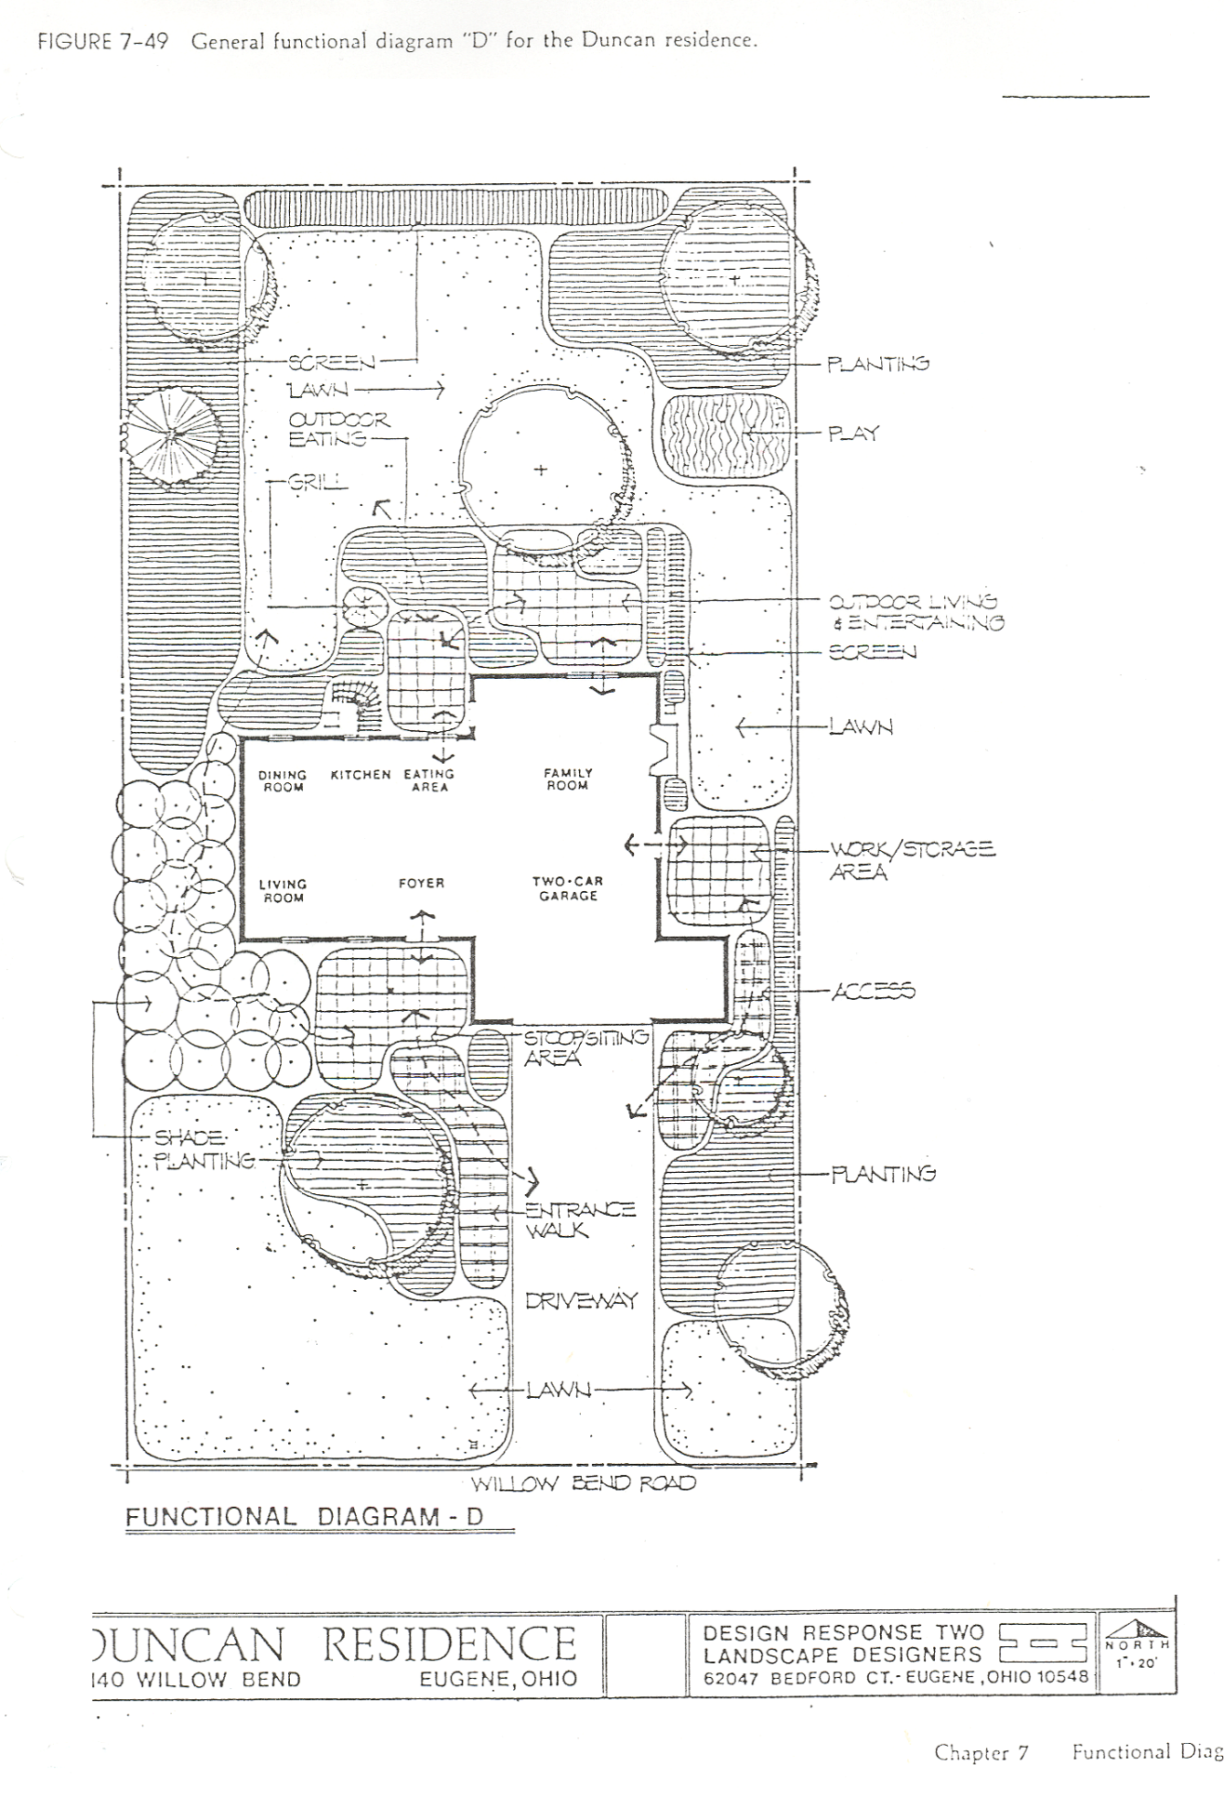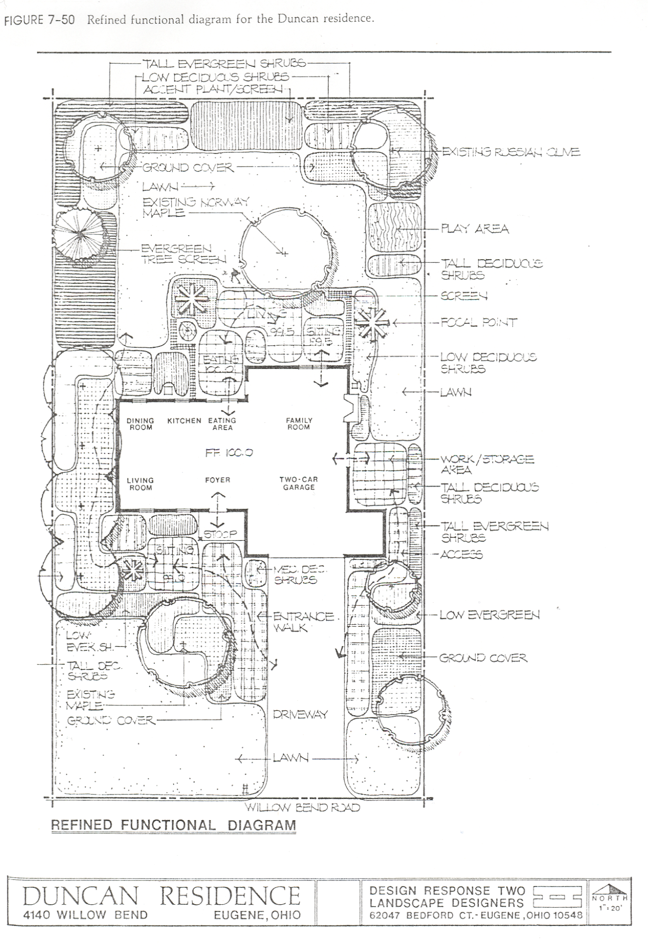
NOT DRAWN TO SCALE. The site plan for you to use will be distributed in lab.

