**POLITICAL CAMPAIGN**

**1. BUSINESS DESCRIPTION**

**1.1 BUSINESS BACKGROUND**

The electoral process is complex and involves several stakeholders such as voters, campaign contributors, volunteers, event coordinators, and survey analysts. To ensure transparency and efficiency, our independent company collects and manages data related to campaigns. This includes voters, donations, campaign expenses, volunteers’ assignments, and surveys. Proper management of this information is crucial for running campaigns smoothly and maintaining trust among the public.

**1.2 PROBLEMS. CURRENT SITUATION**

Currently, the data for campaigns is often fragmented or stored in non-relational formats, leading to inefficiencies and data duplication. Issues such as tracking donors’ contributions, managing volunteer schedules, and evaluating public opinion about candidates or opponents are time-consuming tasks that could be automated. Without a proper database system, it is difficult to analyze election trends, monitor finances, or gauge public sentiment efficiently.

**1.3 THE BENEFITS OF IMPLEMENTING A DATABASE. PROJECT VISION**

The implementation of a database system will bring numerous benefits:

* **Centralized Data***:* All campaign-related information, including donations, volunteers, finances, and survey results, can be accessed and managed from one location.
* **Improved Transparency:** Financial contributions and expenses will be recorded clearly, enhancing accountability.
* **Efficient Data Handling**: The ability to link volunteers to events, track campaign contributions, and assess public opinion will streamline the management of campaign logistics.
* **Better Decision-Making:** The data collected can be analyzed to assess campaign performance, voter satisfaction, and opposition strength, allowing for informed decisions.

**2. MODEL DESCRIPTION**

**2.1 DEFINITIONS & ACRONYMS**

Voter: A person registered to vote in an election.

Contribution: A financial donation given to support a campaign.

Campaign: An organized effort to win an election, including activities such as rallies and town halls.

Finance: Records of campaign-related expenses, such as event costs or marketing.

Volunteer: A person who helps a campaign by participating in events and other activities without pay.

Survey: A method of gauging voter opinion on the candidate and the opposition.

Opponent Measure: Data collected on the performance and public opinion of opposing candidates.

**2.2 LOGICAL SCHEME & OBJECTS**

In this section, we describe how the data flows and interacts within the database system, outlining the logical relationships between different entities and explaining why certain tables are linked together.

1. voter Table:

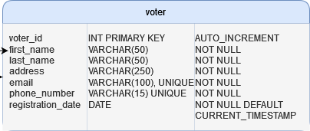

This table stores details about individual voters, including their contact information and registration date. It is referred to the Survey Responses table, because many voters participate in surveys. The voter_id serves as the primary key and ensures that each voter's responses can be individually identified and analyzed.

1. campaign Table:

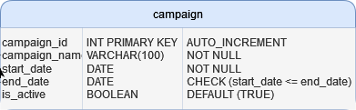

The Campaign Table records all relevant information about each campaign, including start and end dates. It is important to the system since almost every other table is related to a specific campaign (e.g., contributions, events, surveys, and finances). The campaign_id is used as a foreign key in several tables, ensuring that each piece of data (contributions, expenses, events) can be linked to the appropriate campaign.

1. contribution Table:

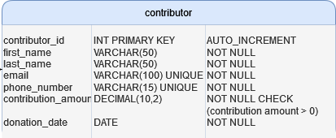

This table logs all financial contributions made to campaigns, tracking the amount, date, and associated campaign. Each contribution is linked to a specific Campaign through campaign_id. This table forms a many-to-many relationship with the Finances table (contribution_finance), because multiple contributions may support specific expenses or activities within a campaign.

1. volunteer Table:

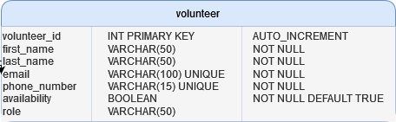

Volunteers are key participants in campaigns, helping organize events and execute campaign-related tasks. The Volunteer Table tracks individual volunteer details, such as contact information and their availability to work. Volunteers are linked to Events through the volunteer_assignment table, which maps which volunteers are assigned to which events. This allows campaign managers to track who is doing what during specific campaign events. Also linked to event_participants, if they are assigned for duties on events.

1. event Table:

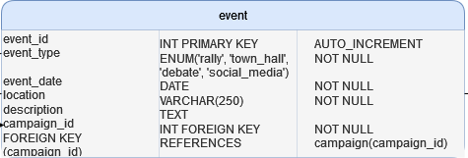

Events such as rallies, town halls, and debates are recorded in the Event Table. Events are closely tied to Campaigns via the campaign_id foreign key. Volunteers are linked to events through the volunteer_assignment table. The purpose of this structure is to manage campaign logistics, such as assigning specific volunteers to different campaign events and tasks. Events may also be part of the measure_event, when collecting public feedback or polling during or after events.

1. finance Table:

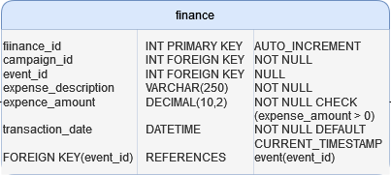

The Finance Table captures the details of campaign-related expenses, such as marketing costs, event expenses, and other financial obligations. It is linked to the campaign Table through campaign_id, indicating which campaign the expense is related to. Additionally, it is linked to contribution_finance, which connects specific financial records to the contributions that fund them. This ensures that the origin of funds for each expense is traceable, providing transparency in campaign spending.

1. contribution_finance Table:

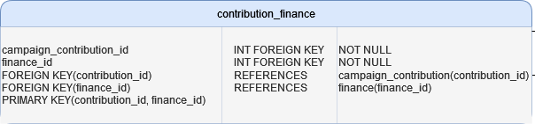

The Contribution_Finance Table serves as a bridge between the contribution and finance tables. This table allows for multiple contributions to be associated with specific expenses or events. For instance, two different donors may contribute to the cost of a particular marketing campaign. The presence of this bridge table facilitates a many-to-many relationship, ensuring that contributions can be linked to more than one expense or activity.

1. survey Table:

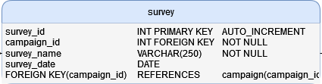

Campaigns often use surveys to check public opinion on their candidate or their opponent. The Survey Table stores information about each survey, linking the survey to the appropriate campaign using campaign_id. Surveys are conducted to collect responses from voters and track how voters view the campaign’s performance or the opponents’ strength.

1. survey_question Table:

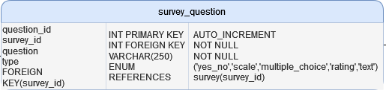

Each survey consists of multiple questions, which are stored in the survey_question Table. Each question has a question_type (such as yes/no or a rating scale) to categorize the nature of the responses. These questions are linked to specific surveys through survey_id.

1. survey response Table:

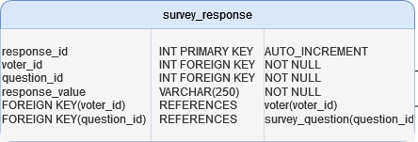

This table stores the actual responses provided by voters to survey questions. Each response links a specific voter (voter_id) to a specific question (question_id) from the survey. This connection allows campaign managers to analyze individual voter feedback and the overall sentiment towards the campaign or its opposition.

1. measure_event Table:

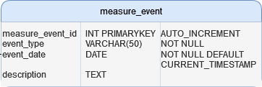

The measure_event Table records specific events aimed at gathering data, such as polls or public opinion analyses related to the campaign or its opposition. These events can either be stand-alone surveys or events like rallies where feedback is gathered afterward. Each event has a type (e.g., a poll or feedback session) and is associated with a particular campaign via campaign_id.

1. opponent_measure Table:

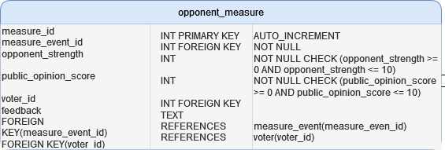

This table stores the results of measurements taken on opposing candidates during or after events (e.g., public sentiment towards the opposition). It is linked to the Measure_Event Table and records the strength of the opposition’s performance (opponent_strength), public opinion scores (public_opinion), and additional feedback from voters. This table helps campaign managers assess how well the opposition is doing and adjust their strategy accordingly.

**Why the Tables Are Linked:**

Campaigns are the central entity connecting donations (Contribution Table), expenses (Finance Table), events (Event Table), and public sentiment (Survey Table). Every action, whether it’s an event, donation, or survey, is tied to a particular campaign.

Volunteers are assigned to specific Events to manage campaign logistics, and these events are part of the overall campaign strategy. The Volunteer Assignment table serves to connect volunteers to their tasks for particular events.

Contributions fund specific campaign expenses, so the Contribution_Finance table serves as a bridge between the contributions and where the money is spent in the Finance table.

Surveys collect voter feedback on both the campaign and the opposition, while Survey Responses store individual voter answers. Opposition Measures track the strength and public perception of opposing candidates, giving campaigns insights into how the opposition is performing.

By linking all these elements together, this model ensures a comprehensive view of the campaign from every angle, from voter engagement to financial transparency, allowing for better decision-making and more efficient campaign management.