* First, we will write the regular expression for the digit, reserved words, and symbols and then draw the NFA for each one of them.
  + Convert from regular expression to NFA by using Thompson construction.
* Second draw the DFA and then combine them in final DFA.
  + Convert from NFA to DFA.
  + Combine all the DFA in one DFA.

**###################################**

* The regular expression for the digit:
  + [0-9].
* The NFA:

* The DFA:

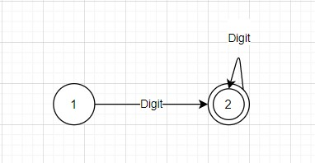

* The transition table:

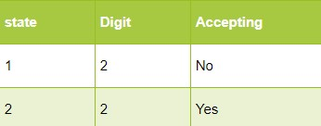

**###################################**

* The regular expression for the reserved words:
* (Pattern|DerivedFrom|TrueFor|Else|Ity|Sity|Cwq|CwqSequence|Ifity|Sifity|Valueless|Logical|BreakFromThis|Whatever|Respondwith|Srap|Scan|Conditionof|Require).
* The NFA:

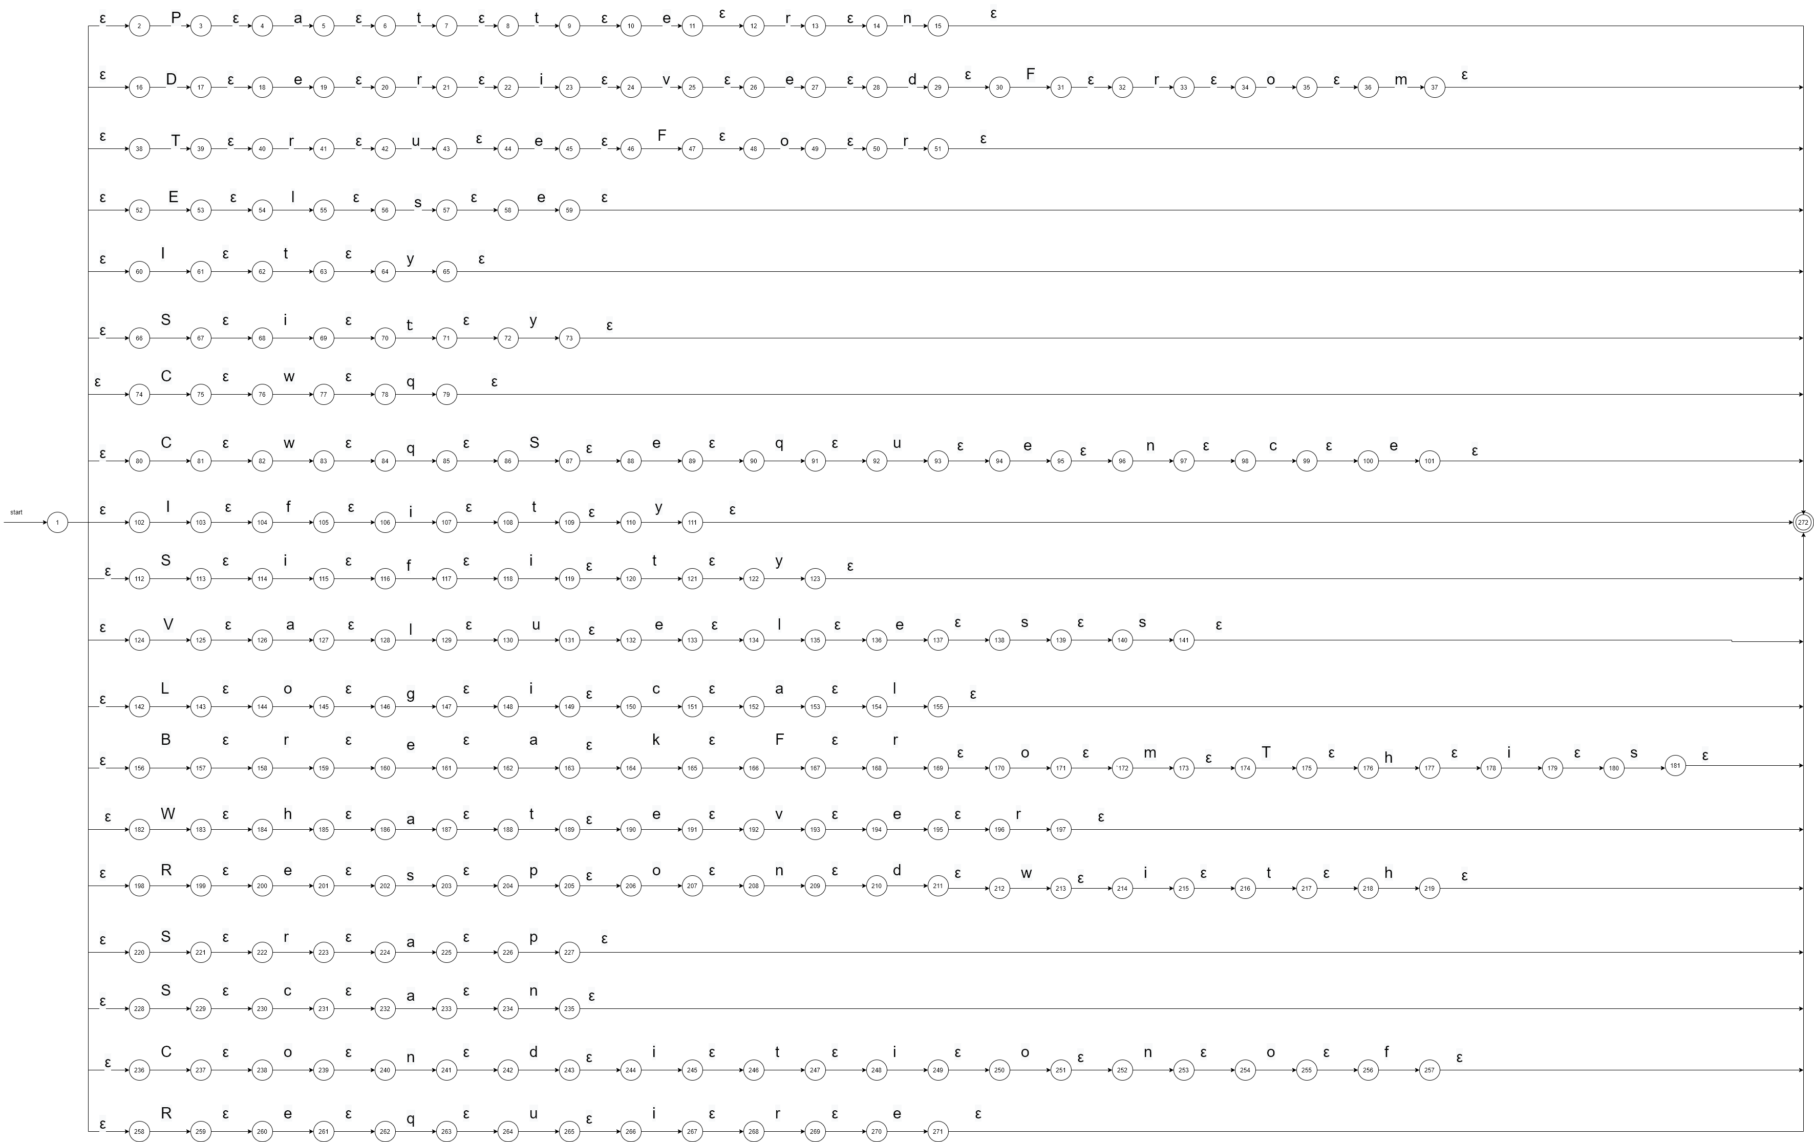

* The DFA:

* The transition table:



**###################################**

* The regular expression for the symbols:
  + (@|$|+|-|*| /|&&| || | ~| ==| <| >| !=| <=| >=| =| ->| {| }| [| ]| '| "| /-| -/ |--| #| ^).
* The NFA:

* The DFA:

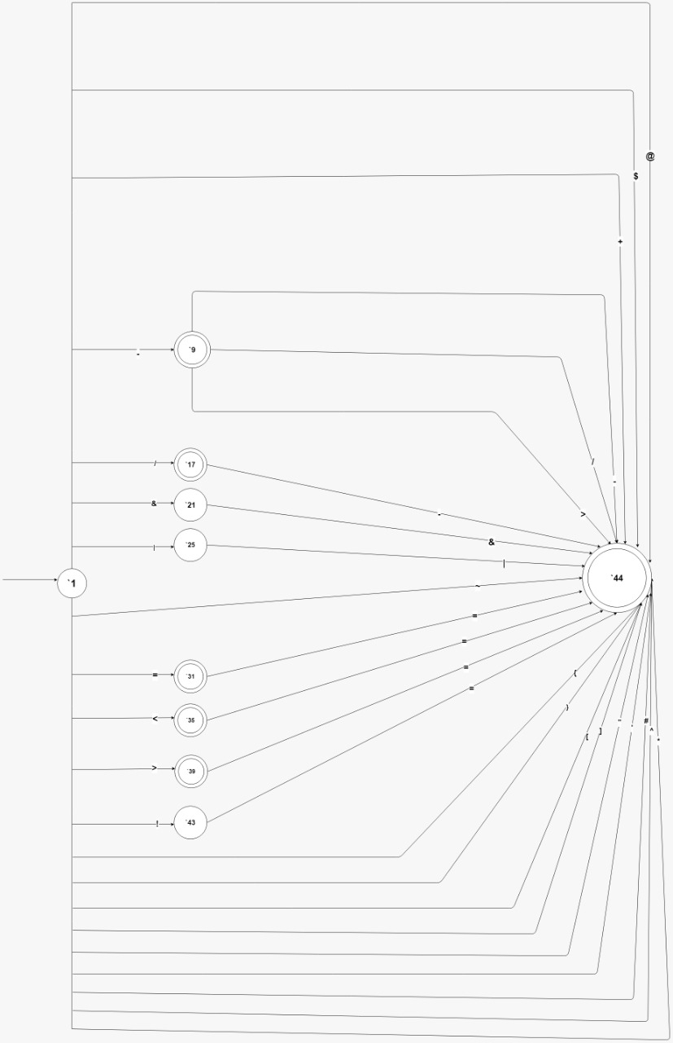

* The transition table:

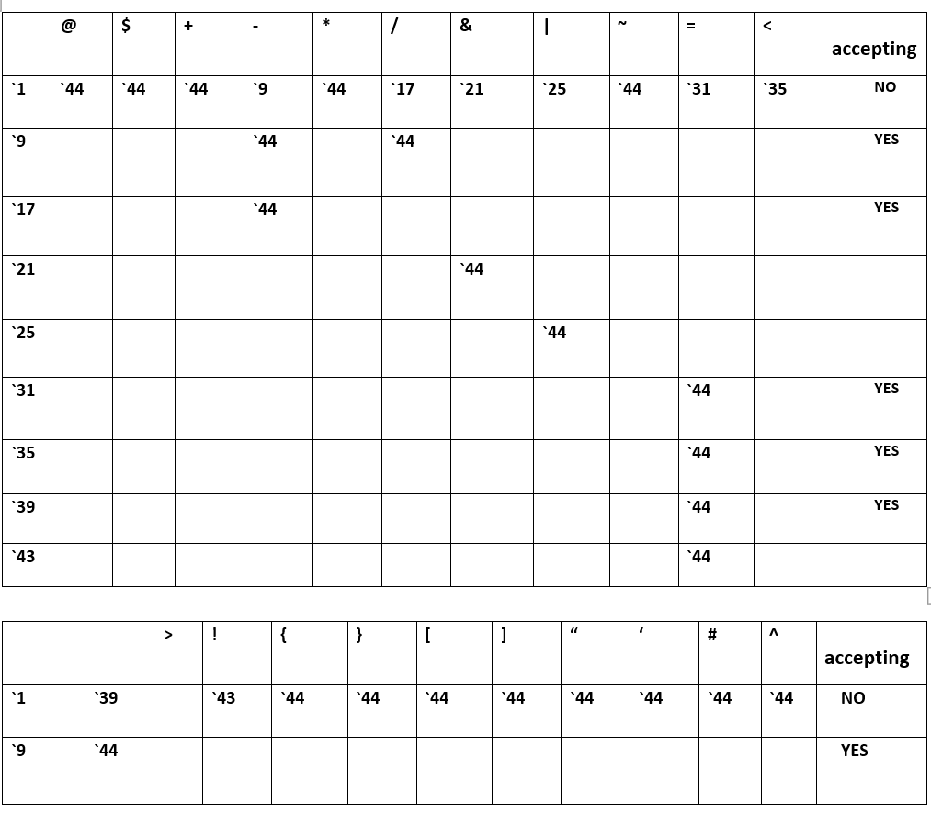

**###################################**

* The final DFA:

* The final transition table:

|  |  |  |  |  |  |  |  |  |  |
| --- | --- | --- | --- | --- | --- | --- | --- | --- | --- |
| State | Whitespace | / | - | Other | Symbol | Letter | Operator | Digit | Accepting |
| 1 | 1 | 2 |  | 9 | 5 | 6 | 7 | 8 | NO |
| 2 |  |  | 3 |  |  |  |  |  | NO |
| 3 |  | 4 |  | 3 |  |  |  |  | NO |
| 4 |  |  | 1 |  |  |  |  |  | NO |
| 5 |  |  |  | 9 |  |  |  |  | NO |
| 6 |  |  |  | 9 |  | 6 |  |  | NO |
| 7 |  |  |  | 9 |  |  | 7 |  | NO |
| 8 |  |  |  | 9 |  |  |  | 8 | NO |
| 9 |  |  |  |  |  |  |  |  | yes |