Documentation

<Dictionary>

Homework number: 5

Due date: week 13

# Purpose

The purpose of this project is to efficiently design a program which manages a dictionary for storing synonyms in the English language.

# Problem analysis

<Modelling, scenarios, usage>

A dictionary contains a large amount of words and links between them, so one requirement is to be able to store a bug amount of data. This data also has to be saved to the hard disk for later use.

The user has to be able to add new words and link synonyms to them (and also to remove words or synonyms). Another important operation on the data itself is saving the dictionary and completely removing it. These operations are required to manage to dictionary but they are useless without the ability to search for words and their synonyms. As a conclusion we have to implement search operations.

The following list sums up the needed operations:

When adding a new word, the following cases can occur:

The addition of a new synonym to a word follows the same procedure – we have to make sure a word does not contain the same synonym twice.

To make the application user-friendly, we have to implement the following search operations:

# Design

<UML diagrams, data structures, class design, interfaces, relationships, packages, algorithms, user interface>

Most of the classes are part of the gui package, which, off course manages the user interface of the application. When starting the app,

The UML class diagram is presented below:

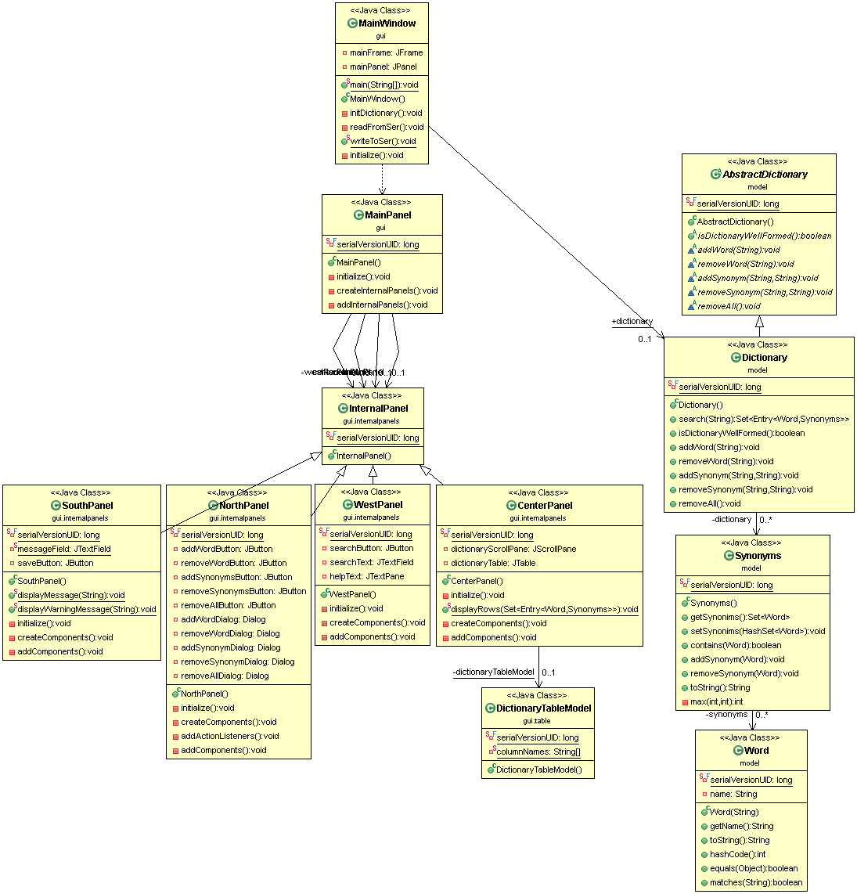

# Implementation and testing

# Results

# Conclusions

<What have I learned, further improvements & development>

# Bibliography