Documentation:

First run the MFA script which relies on the data folder with csv files - these can be adjusted depending on what coefficient to input for the substances.

The MFA files creates an output files with the amount of the various flows. This file will be used in the BW script later on.

The BW script is designed around the following graph, the first part is simply about creating a project, loading the ecoinvent database that serves as background data for electricity and methane (biosphere)

The second part of the codes then is about modelling all the various nodes and edges as represented on the graph below

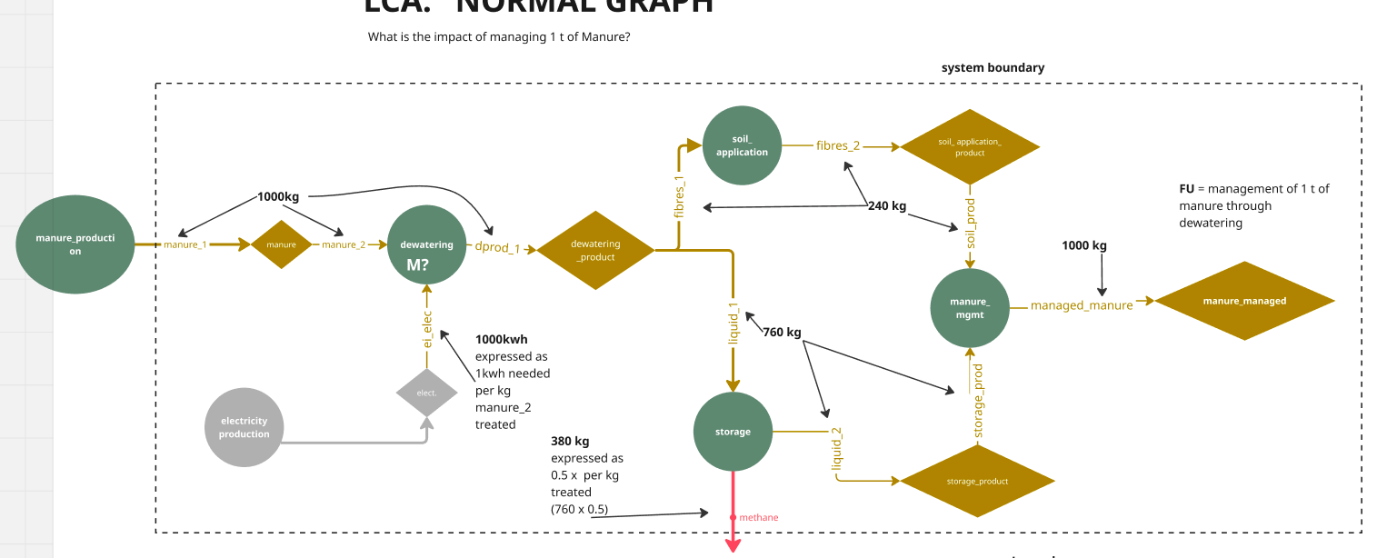

The novelty of the script is that it models a graph, based on the nodes and edges defined earlier in the script, which allows to check easily whether everything was modelled correctly. The structure of the mermaid graph should be the same as the modeled graph above.

The BW script then computes the impact of the defined functional unit which is 1000kg of managed manure.

