Habit Tracking Application

Table of contents

Introduction 2

Overview 2

Definitions 2

Project Overview 2

User Interaction 2

**Command line interface (CLI)** 2

**Swagger UI** 3

Project Structure 6

Technology choices 7

Bibliography 8

# Introduction

Everybody wants to stop unhealthy habits and create good habits in its place. They are turning to technology for assistance to achieving this. We want to create a habit tracking application to assist them to achieve their goals.

## Overview

We used Python version 3.10.3 with FastAPI to create our backend for our Habit tracking application.

## Definitions

1. ***Habit:*** Regular activity or practice that you want to create or stop e.g. *Go running every day*
2. ***Completed Habit:*** A activity or practice that you completed at a specific time e.g., Running at 1pm today.
3. ***Tracked Habit:*** A habit that was completed at least once is considered a tracked habit.

# Project Overview

We created a backend with a command line interface and a Swagger UI to simplify user interaction. We have limited data input and some other features to the Swagger UI for simplicity. You could also use tools like Postman to interact with the REST API.

For testing we included functions to seed (loading data) and delete (purge all data excluding frequencies) testing data.

## User Interaction

All the commands listed below should be run from the command line in the ***habits_backend*** folder of the cloned project.

### **Command line interface (CLI)**

#### Help Menu

To load a list of all available commands, run the following command

python main.py –help

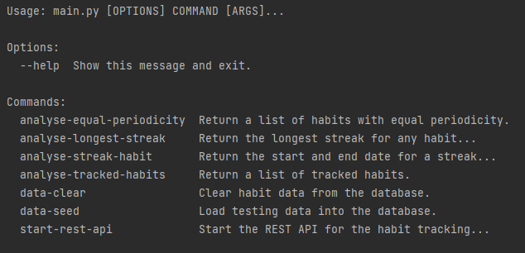

#### Load Data

To load testing data into the database run the following command

python main.py data-seed

#### Clear Data

To clear the database of all habits and completed habits run the following command

python main.py data-clear

#### Get all tracked habits

This will return a list of all tracked habits.

python main.py analyse-tracked-habits

#### Get habits with the same period (equal periodicity)

python analyse-equal-periodicity --frequency daily

Equal Periodicity:

[{'id': 1, 'name': 'Running', 'repeated': 'Daily', 'count': 15}, {'id': 2, 'name': 'Meditation', 'repeated': 'Daily', 'count': 8}]

#### Habit with the longest run streak

python main.py analyse-longest-streak

Longest Streak any habit:

{'start': datetime.datetime(2022, 4, 27, 14, 17, 45), 'end': datetime.datetime(2022, 5, 3, 15, 57, 21), 'cnt': 8, 'habit_id': 2}

#### Longest streak for a habit

python main.py analyse-streak-habit --habit_id 1

Streak Details:

{'start': datetime.datetime(2022, 4, 27, 14, 17, 45), 'end': datetime.datetime(2022, 5, 2, 15, 57, 21), 'cnt': 6}

### **Swagger UI**

To start the Swagger UI for a visual and interactive interface run the following command.

python main.py start-rest-api

If you browse to the <http://localhost:8000/> URL in your browser, you should see the following Swagger UI interface. This will allow you to interact with the API’s resources, inspect the paths, see a color-coded representation of the HTTP verbs.

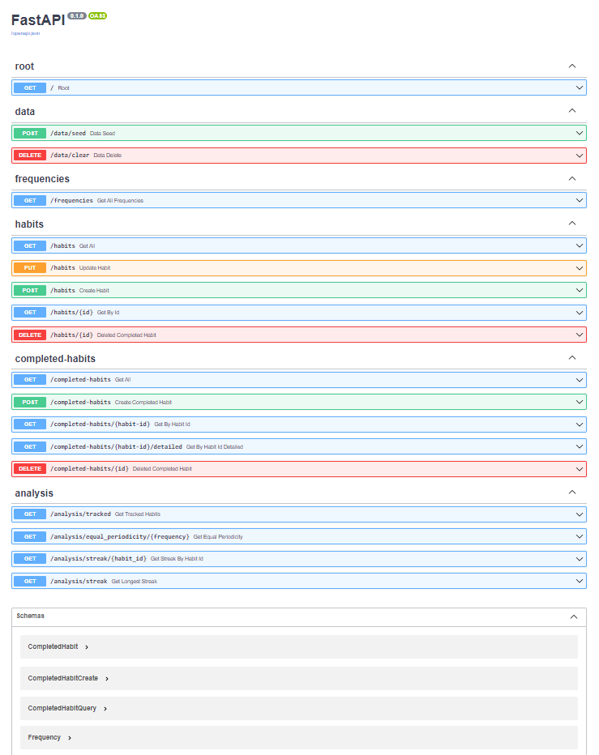

#### Data (Assist with testing)

We have URLs for loading and clearing the data. Normally this would not be part of the REST API but have been added to assist wit testing. This allows for loading test data or clearing the database. It will not delete the default frequencies.

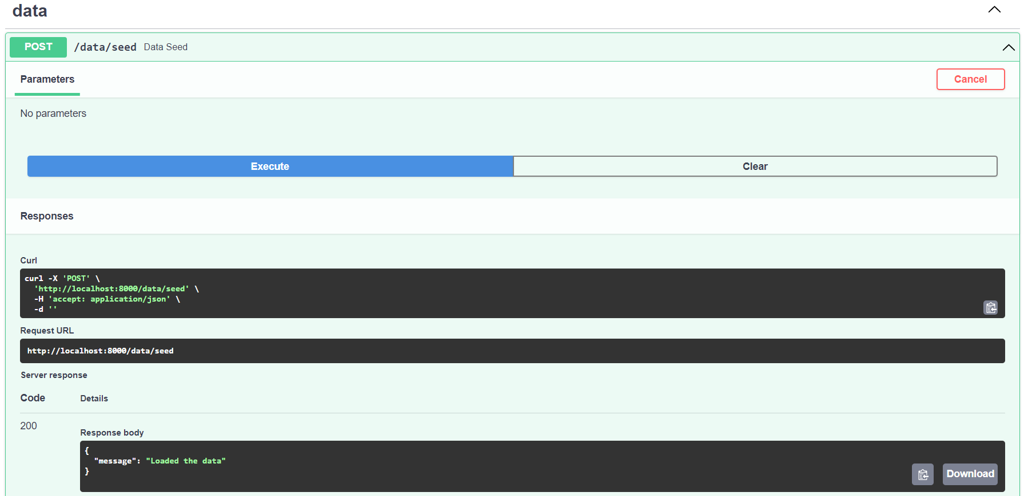

#### Frequencies

We have pre-loaded three default frequencies to indicate how often a habit is repeated. For example, a habit must be repeated daily.

#### Habits

The habit URLs are used to query, create, and delete habits.

#### Completed Habits

The completed habit URLs are used to query and track when a habit has been completed. The completed habits are used for the analysis and to calculate the streaks.

#### Analysis

The analysis URLs are used to query information like which habits are tracked, the longest running streak.

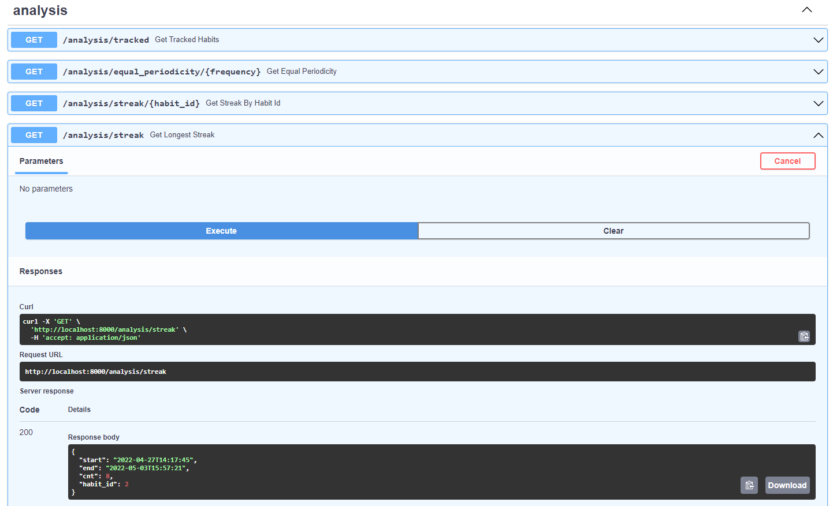

## Project Structure

The main entry point for the application is through main.py. This module uses the [click](https://click.palletsprojects.com/en/8.1.x/) package to create a command line interface.

The user will interact with the cli or the REST API. The interface will call the relevant service which in turn would call the crud functions. This is based on an [Clean Architecture approach](https://blog.cleancoder.com/uncle-bob/2012/08/13/the-clean-architecture.html).

The ***pydantic*** schemas is used for data parsing and validation. In turn the ***SQLAlchemy*** models are used for parsing the data for the database. I have added the functional programming module to the modules folder.

I used docstrings and inline comments to document my code.

I used ***pytest*** to test the functionality of my backend

## Technology choices

* ***Python version 3.10.3*** – Project requirement to use 3.7 or later.
* ***PyCharm 2022.1.1*** - Popular IDE / source-code editor that runs on Windows, Linux and macOS. We found that it works better than Visual Studio Code for python development.
* ***sqlite3*** – It is a library that provides lightweight disk-based database to persist the data.
* ***pytest*** – Framework for writing tests.
* ***FastAPI*** – Framework for building APIs with python. This will provide an alternative for the CLI.
* ***click*** – Python library for creating command line interfaces.
* ***Pylint*** – Linting tool that checks for coding errors and enforce coding standards.
* ***Swagger UI*** – Interactive exploration to call and test your API from the browser.
* ***SQLAlchemy –*** Accessing data stored in the database.
* ***pydantic -*** Data parsing and validation.

## Bibliography

1. n.a. (n.d). Google Python Style Guide – Naming <https://google.github.io/styleguide/pyguide.html#316-naming>
2. Lutz, M (2013). OOP: The Big Picture, Learning Python 5th Edition. O’Reilly
3. Marcus, S (2021, July 16). Test Driven Development with pytest <https://stackabuse.com/test-driven-development-with-pytest/>
4. n.a. (n.d). [Zalando RESTful API and Event Guidelines](https://opensource.zalando.com/restful-api-guidelines/#_zalando_restful_api_and_event_guidelines)

<https://opensource.zalando.com/restful-api-guidelines/>

1. n.a. (n.d). [FastAPI](https://opensource.zalando.com/restful-api-guidelines/#_zalando_restful_api_and_event_guidelines) - SQL (Relational) Databases

<https://fastapi.tiangolo.com/tutorial/sql-databases/>

1. n.a. (n.d). click

<https://click.palletsprojects.com/en/8.1.x/>

1. Martin, Robert C (2012, August 13) – The Clean Architecture

<https://blog.cleancoder.com/uncle-bob/2012/08/13/the-clean-architecture.html>