# Overview

## Introduction

The AO16BC aims to:

* Manage the process of issuance of certificate or clearance for airborne and space borne imaginaries performed in the Photogrammetry Division.
* Include barcode on the certification and clearance report.
* Provide a facility that would locate a specific certificate or clearance.
* Provide a facility that will capture the scanned documents.
* Generate official reports, such as clearance certification, evaluation report, statistics reports such as but not limited to inventory of issuance, inventory of pending certificate and list of clients.

## System Requirements

Window XP or higher

Microsoft SQL Server 2005

.Net Framework 2.0

20MB of Disk Space

Pentium 133 MHz Processor

128 MB RAM

## Installation and Uninstallation

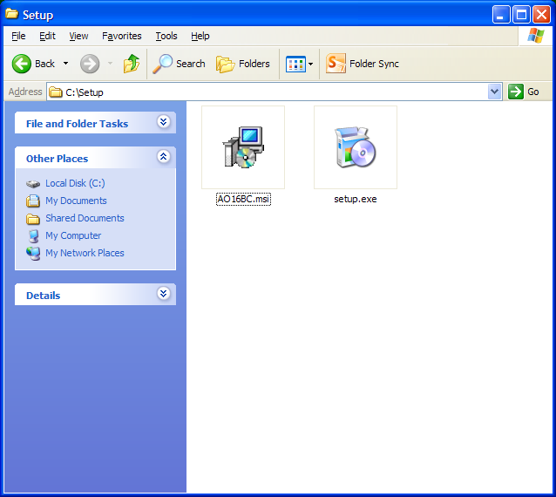 Double click **AO16BC.msi**

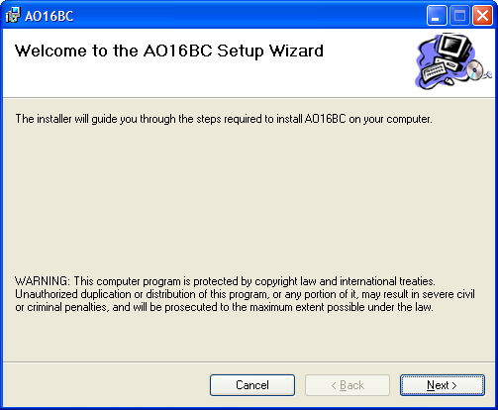Click **Next**

Choose where you want to install the application. It is recommended to accept the default by just clicking **Next**.

### 

Click next to confirm installation.

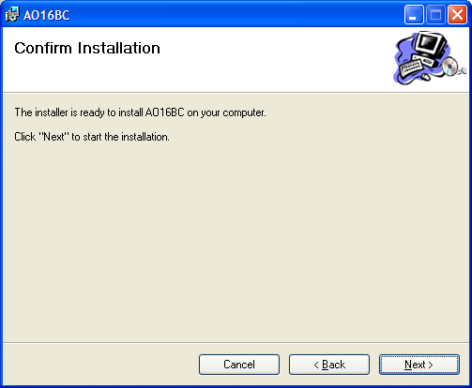

Click **Close** when the installation is complete.

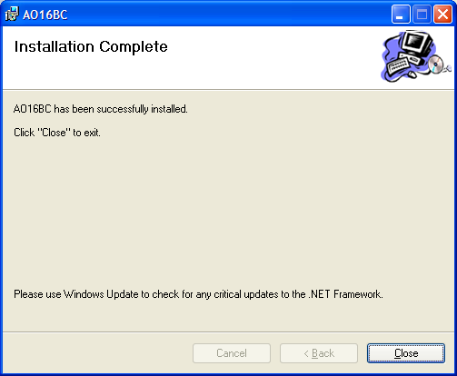

# Quick Start Tutorials

## Getting Started

Enter your content...

# How to use

## Step-by-Step Procedures

Enter your content...

## Reference

Enter your content...

# Hints and Tips

## Frequently Asked Questions

Enter your content...

# Miscellaneous

## Technical Support

Enter your content...

## Ordering Information

Enter your content...

## Other information

Enter your content...

## Contacting Me

Enter your content...

## End User License

Enter your content...

## License Agreement

Enter your content...

## Credits

Enter your content...