1-1 Connecting to the Database

At first, the program will try to connect to the GCPDS database. You must supply the IP address or computer name of the Microsoft SQL Server machine. e.g. 192.168.0.1 then click Connect button.

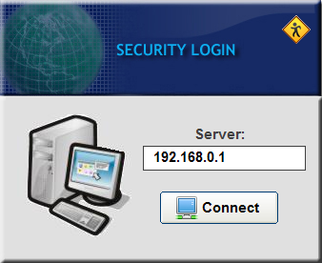

1-2 Logging to the Database

If you’re able to connect to the database - a log-in dialog box will appear prompting you to enter your login ID and password. Supply the following information then click the Login button. note: default login ID is admin and the default password is also admin.

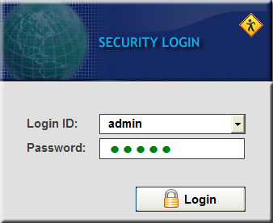

2-1 The Main Tabs

- GCPs – data maintenance module for geodetic control points.
- Benchmarks – data maintenance module for benchmarks information.
- Query – facility for retrieving information from the database by specifying certain criteria.
- Map – facility for displaying the geographic information of benchmarks and geodetic control points.
- Libraries – facility for the maintenance of libraries.
- Utilities – collection of tools.

3.1 GCPs Toolbar

- Search – quick search facility.
- Add – add a new record of geodetic control points.
- Edit – modify current record.
- Delete – delete current record.
- Back – move to the previous record.
- Next – move to the next record.
- Print – print information regarding the gcp.
- Map – display the location of the gcp on the map.
- Info – add gcp description.
- Images- add image to gcp.

3.2 GCPs Screen

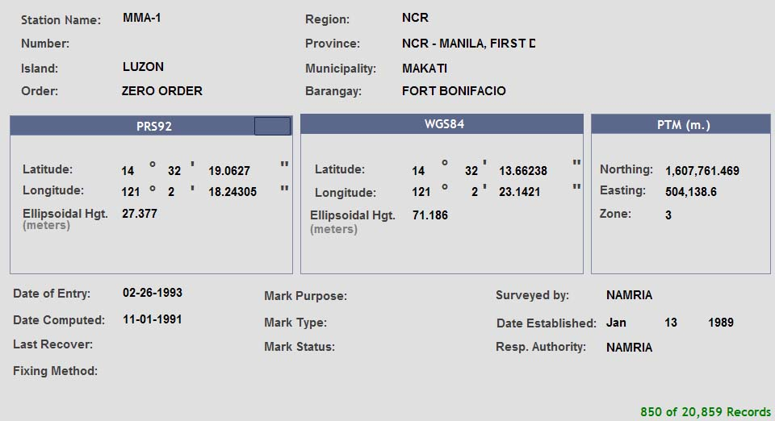

- Station Name – name of the geodetic control point. It allows maximum of 50 characters. This is a required field.
- Island –
- Region – name of the region where the gcp is located. This is a required field.
- Province – name of the province where the gcp is located. This is a required field.
- Municipality – name of the municipality where the gcp is located.
- Barangay –name of the barangay where the gcp is located.
- Order – order of accuracy of the gcp.
- PRS92 Coordinates – Philippine Reference System
  - Latitude – northing , y-coordinate
  - Longitude – northing , y-coordinate
  - Ellipsoidal Hgt. – ellipsoidal height in meters
- WGS84 Coordinates – World Geographic System
  - Latitude – northing , y-coordinate
  - Longitude – northing , y-coordinate
  - Ellipsoidal Hgt. – ellipsoidal height in meters

- PTM Coordinates – Philippine Transverse Mercator
  - Northing – Y grid coordinate in meters
  - Easting – X grid coordinate in meters
  - Zone – PTM Zone 1-5
- Date of Entry – date when the record is created.
- Date Computed – date when the coordinates is process for validation.
- Last Recovered – date when the gcp is last recovered.
- Fixing Method – method in acquiring the coordinates. For example GPS
- Mark Purpose – purpose for establishing the gcp.
- Mark Type – marker use for the gcp monument.
- Mark Status – status of the gcp monument.
- Surveyed By – party who establish the gcp monument.
- Date Established – date when the gcp monument is established.
- Responsible Authority – party who are accountable for the gcp.

3.3 Adding a new record
- Click the 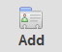 button from the toolbar.

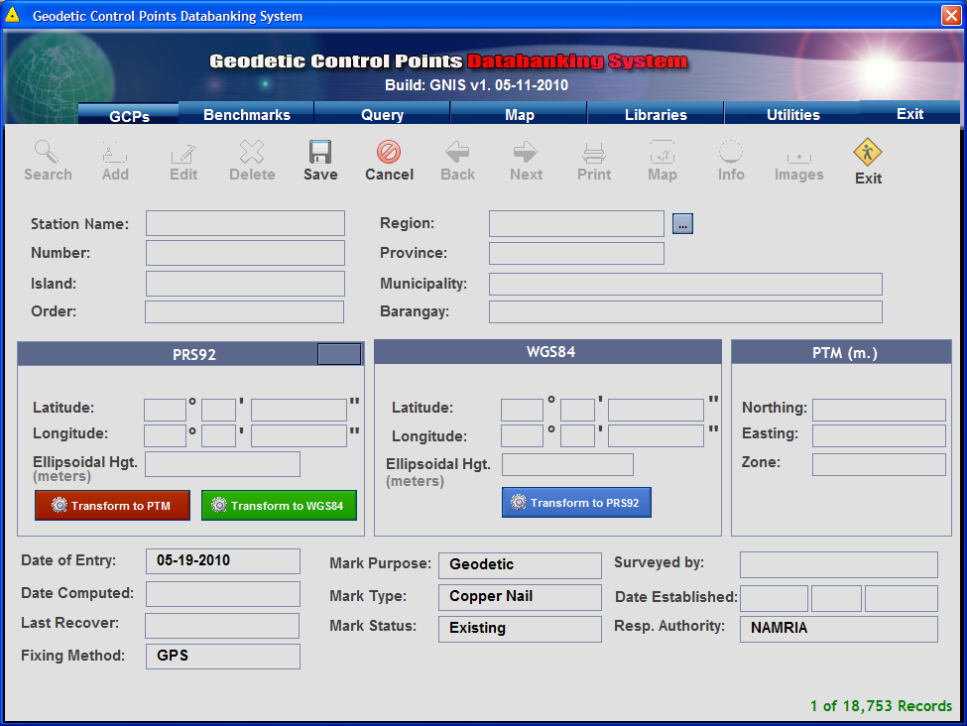

- Start the encoding.
- Click 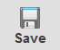 button when is done.

3.4 Editing a record

- Click the 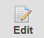 button from the toolbar.

- Modify the value of the field you wish to edit.

- Click the button when done.

3.5. Deleting a record
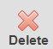
- Click the button from the toolbar.

- A confirmation dialogue box will appear.
- Click yes to continue. Click No to cancel deletion.
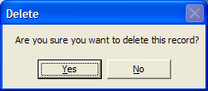

- A notification screen will appear confirming that the selected record is deleted.

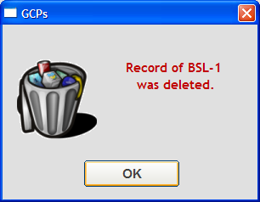

Note: Deleted records were moved to a table so that it can be restored in case of accidental deletion.

3.6. Printing of certificate

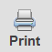
- Click the button from the toolbar.

- The preview of the certificate will be displayed.
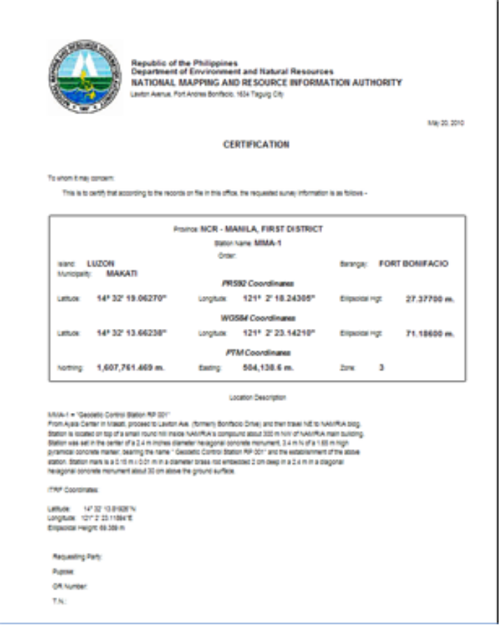

- Click the printer button to print the certificate.

3.7 View the geodetic control point on the map.

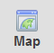
- Click the button from the toolbar.

- The control point will be centered on the Map screen.

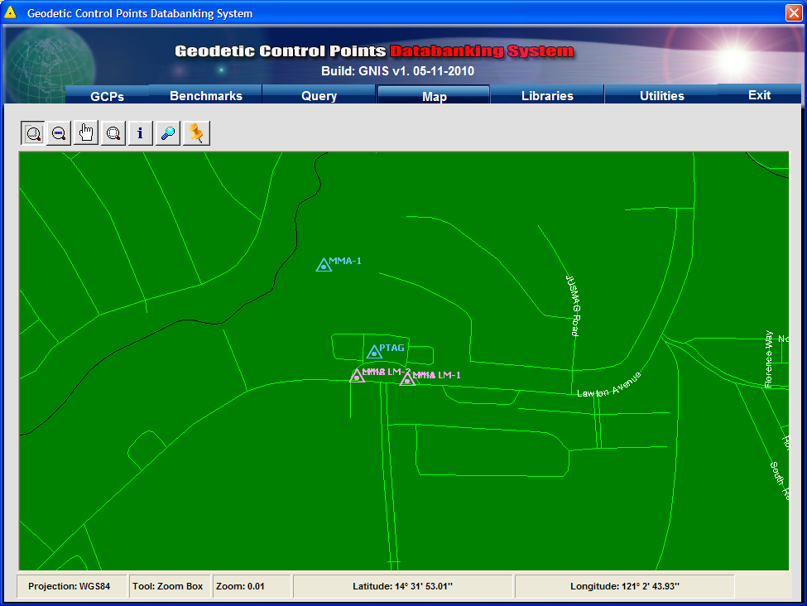

- To zoom in, click the 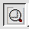 zoom box. Click on the map then drag to make a box. The map will zoom in to the box that you created.

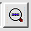
- To zoom out, just click the zoom out button.
- To pan or move the map to the left or right, click on the pan button. Drag the map to which ever direction.

  - Viewing/Adding the geodetic control point description.

- Click the 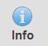 button from the toolbar.

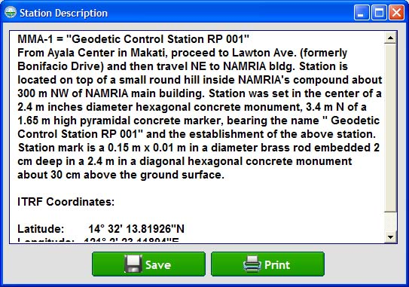

- Type in the description
- Then click Save button.

Benchmarks

  - Benchmarks Toolbar

- Search – quick search facility.
- Add – add a new record of benchmark.
- Edit – modify current record.
- Delete – delete current record.
- Back – move to the previous record.
- Next – move to the next record.
- Print – print information regarding the benchmark.
- Map – display the location of the benchmark on the map.

  - Benchmark Screen

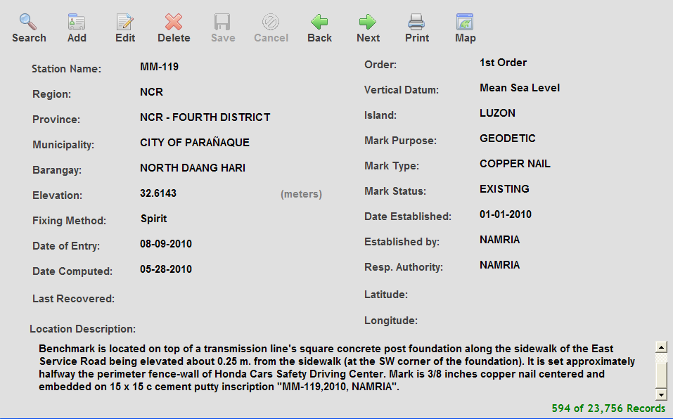

- Station Name – name of the benchmark. It allows maximum of 50 characters. This is a required field.
- Region – name of the region where the benchmark is located. This is a required field.
- Province – name of the province where the benchmark is located. This is a required field.
- Municipality – name of the municipality where the benchmark is located.
- Barangay –name of the barangay where the benchmark is located.
- Order – order of accuracy of the benchmark.
- Elevation – elevation of the benchmark in meters.
- Date of Entry – date when the record is created.
- Date Computed – date when the coordinates is process for validation.
- Last Recovered – date when the benchmark is last recovered.
- Fixing Method – method in acquiring the coordinates. For example GPS
- Mark Purpose – purpose for establishing the benchmark.
- Mark Type – marker use for the benchmark monument
- Mark Status – status condition of the benchmark monument.
- Established By – party who establish the benchmark monument.
- Date Established – date when the benchmark monument is established.
- Responsible Authority – party who are accountable for the benchmark.
- Vertical Datum – vertical datum of the benchmark.
- Longitude – estimated x-coordinate of the benchmark.
- Latitude – estimated y-coordinate of the benchmark.

4.3 Adding a new record
- Click the button from the toolbar.

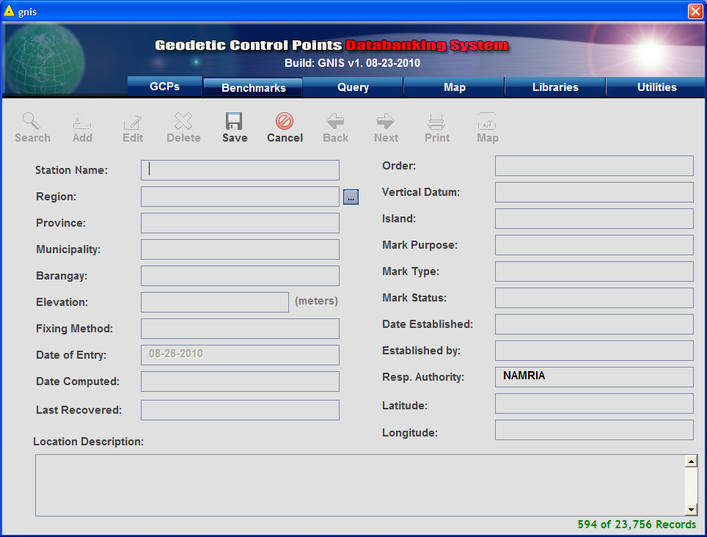

- Start the encoding.
- Click button when is done.

4.4 Editing a record

- Click the button from the toolbar.

- Modify the value of the field you wish to edit.

- Click the button when done.

4.5. Deleting a record
- Click the button from the toolbar.

- A confirmation dialogue box will appear.
- Click yes to continue. Click No to cancel deletion.

- A notification screen will appear confirming that the selected record is deleted.

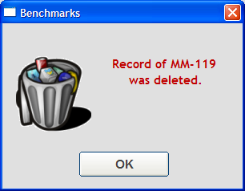

Note: Deleted records were moved to a table so that it can be restored in case of accidental deletion.

4.6. Printing of certificate

- Click the button from the toolbar.

- The preview of the certificate will be displayed.
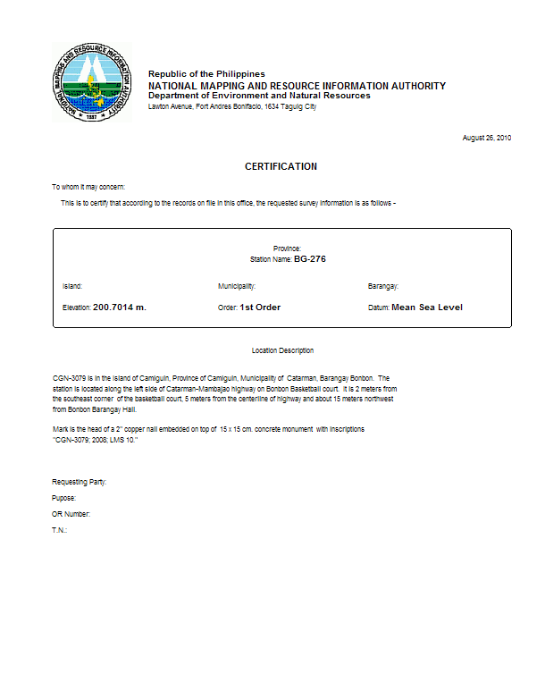

- Click the printer button to print the certificate.

4.7 View the geodetic control point on the map.

- Click the button from the toolbar.

- The benchmark will be centered on the Map screen.

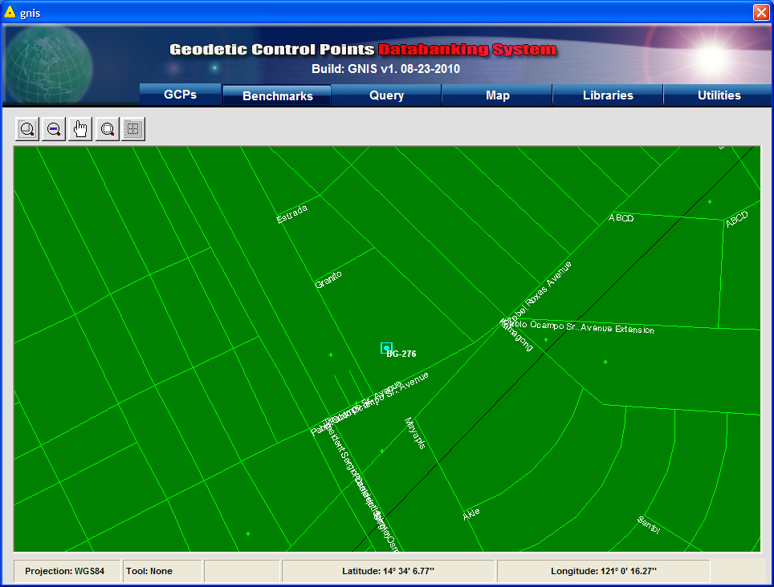

- To zoom in, click the zoom box. Click on the map then drag to make a box. The map will zoom in to the box that you created.

- To zoom out, just click the zoom out button.
- To pan or move the map to the left or right, click on the pan button. Drag the map to which ever direction.

