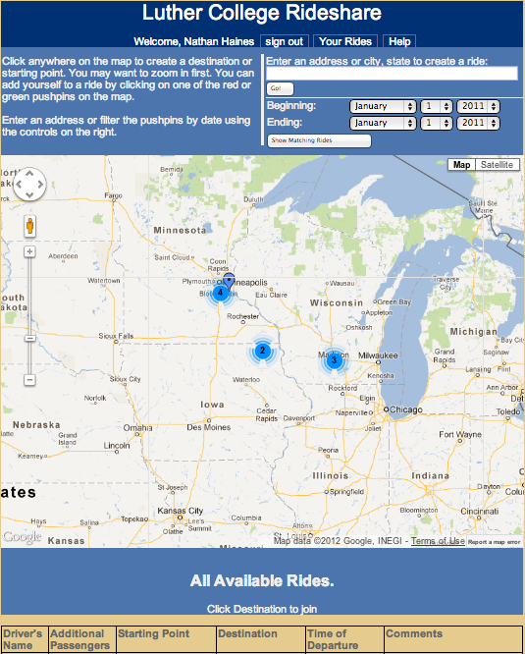

Sign up to offer a ride on the Luther College Rideshare website for Christmas Break, and you will entered for a chance to win one of two Kwik Trip gas Cards!

To get started, visit http://rideshare.luther.edu

Driving home for Christmas Break?

Don’t miss out on your chance to win a

**$50**

**gas card!**

[Date]

## Aenean a magna vel pede vestibulum rhoncus. Nulla cursus orci quis tortor.