Conv-LSTM Development
Baseline:
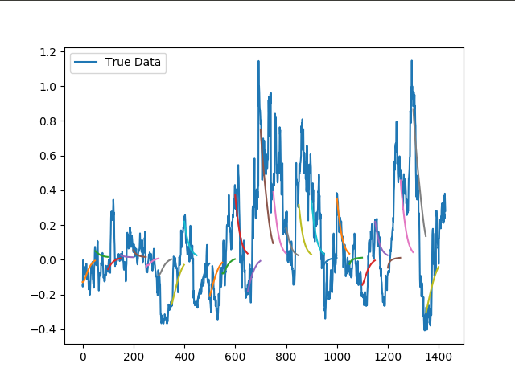
- AMD test predictions with Conv-LSTM: 30 epochs

