 | University of Eastern Africa, Baraton  A Chartered Seventh-day Adventist Institution of Higher Learning

SCHOOL OF BUSINESS
DEPARTMENT OF INFORMATION SYSTEMS AND COMPUTING

COURSE: INSY 492 - SENIOR PROJECT

VEHICLE HIRE AND SESSION TRACKING SYSTEM
Project Proposal

STUDENT NAME: | GERISON KIMATHI MURIUNGI
STUDENT ID: | SMURGE2311
INSTRUCTOR: | OMARI DICKSON MOGAKA
SUPERVISOR: | OMARI DICKSON MOGAKA

Background Information

The vehicle hire industry is a rapidly growing sector across East Africa, driven by increasing urbanization, business travel demand, and tourism. Despite this growth, most car hire operations — particularly small and medium-scale agents — continue to rely on phone calls, paper logs, and manual agreements to manage bookings, track vehicle usage, and compute charges. These approaches are error-prone, difficult to audit, and provide no real-time visibility into vehicle status or hire duration.
For hire agents managing multiple vehicles, keeping track of which car is with which client, for how long, and at what accumulated charge is a significant operational challenge. Clients, on the other hand, have no transparent way to monitor the charges accruing during their hire session, nor can they easily communicate session status to the agent in real time.
Advances in web technologies and real-time databases now make it feasible to build affordable, cloud-based platforms that can serve both agents and clients simultaneously — automating session management, providing live cost tracking, and capturing approximate vehicle location data from the client's mobile device. The Vehicle Hire and Session Tracking System is designed to meet exactly this need.

Problem Statement

Car hire agents and their clients lack a centralized digital platform to manage the full hire lifecycle — from vehicle listing and booking, through active session tracking, to billing and completion. Agents have no real-time view of which vehicles are in use, by whom, or how long a session has been running. Clients have no transparent access to live charge accumulation during their hire. This information gap results in billing disputes, unaccounted vehicle usage, poor fleet visibility, and a generally low-trust experience for all parties involved.

Proposed Solution

The proposed Vehicle Hire and Session Tracking System is a web-based platform that digitizes the entire car hire workflow through three distinct user roles: Admin, Agent, and Client. Authentication is handled by Better Auth with Google OAuth 2.0, allowing users to register and sign in securely using their Google accounts.
Agents register on the platform and, upon administrator approval, can list their vehicles with defined hire rates and session charge parameters. Clients browse available vehicles, place hire orders, and wait for session initiation. When a client physically picks up the vehicle, the agent or system converts the booking from Pending to In Progress, at which point a live session timer begins. The system continuously tracks elapsed duration and calculates the running charge based on the agent-defined rate. The client's mobile device provides approximate location data throughout the session, giving the agent fleet-wide visibility into where each vehicle is at any time. Both the client and agent can monitor the live session — the client sees their own session details, while the agent sees a dashboard covering all active vehicles. On return, the session is marked Complete, and a final charge summary is generated.

Objectives

- To develop a web-based platform enabling car hire agents to register, list vehicles, and manage hire operations following administrator approval.
- To provide real-time session tracking including elapsed duration and live charge accumulation based on agent-defined rates, visible to both client and agent.
- To capture and display approximate vehicle location from the client's mobile device during an active hire session, giving agents fleet-wide location awareness.
- To integrate Paystack payment processing — supporting M-Pesa, Airtel Money, and card payments — and Nodemailer email notifications to streamline billing and communication between all parties.
- To enable clients to submit reviews and ratings for completed hire sessions, improving agent accountability and service quality.

System Modules

Module | Description
Agent Module | Agent self-registration with business details. Profile review pending admin approval. Vehicle listing management including photos, descriptions, hire rate (charge per time unit), and availability. Dashboard showing all owned vehicles with live session status, duration, charges, and approximate client location.
Client Module | Account registration and login. Browse and search approved vehicle listings. Place hire orders (Pending status). View real-time session screen during active hire — live elapsed timer and running charge. Access hire history and completed session invoices. Submit star ratings and written reviews.
Admin Module | Review and approve or reject agent registration requests. Manage all users (agents, clients) and vehicle listings system-wide. Monitor all active sessions across the platform. Access platform-wide analytics and generate reports.
Session Tracking Module | Manages the full Pending → In Progress → Completed lifecycle. On session start, initializes a real-time timer and charge counter using the agent-defined rate. Continuously receives and stores the client's approximate GPS coordinates (obtained from browser geolocation API) and makes them available to the agent dashboard.
Billing & Payment Module | Computes total hire charge from session duration and agent-defined rate. Generates itemized session invoice on completion. Initiates payment via Paystack, supporting M-Pesa, Airtel Money, and card payments. Records and displays payment status on both client and agent dashboards.
Notifications Module | Sends transactional email notifications via Nodemailer at key session events: booking confirmation (Pending), session start (In Progress), session completion, and payment receipt. Notifies agents of new bookings and session state changes in real time.
Reviews & Ratings Module | On session completion, prompts the client to submit a star rating and optional review for the agent and vehicle. Ratings are displayed publicly on vehicle listings to help future clients make informed decisions.
Reporting Module | Provides agents with session history, revenue summaries, and per-vehicle utilization reports. Provides administrators with platform-wide session and revenue analytics. All reports are filterable by date range.

Conceptual Diagram

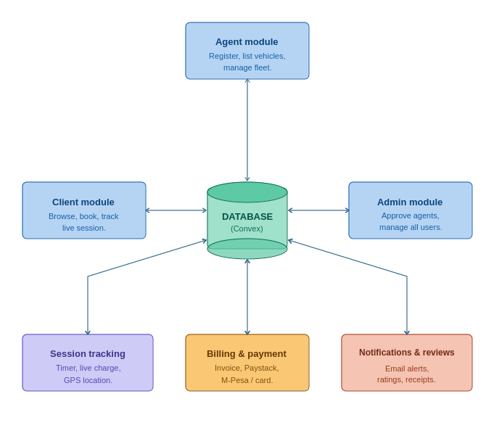

Tools and Technologies

Layer | Technology
Frontend Framework | React with TypeScript
Routing | TanStack Router
Styling | Tailwind CSS
Backend & Database | Convex (real-time backend-as-a-service with built-in reactive database, server functions, and live queries)
Authentication | Better Auth with Google OAuth 2.0 (social sign-in via Google Cloud Console credentials; supports email/password and Google provider)
Location Tracking | Browser Geolocation API (client-side GPS coordinates sent to Convex in real time during active sessions)
Payments | Paystack (supports M-Pesa, Airtel Money, and card payments; PCI-DSS Level 1 certified)
Email Notifications | Nodemailer (transactional emails for booking confirmations, session updates, and payment receipts)
UI Design & Prototyping | Figma
Version Control | Git / GitHub

System Functionality Overview

1. Agent Registration & Admin Approval
A prospective hire agent registers by providing business and personal details. The registration is submitted with a Pending Approval status and is visible to the system administrator. The admin reviews the submission and either approves or rejects the account. Only upon approval can the agent log in, list vehicles, and begin operating on the platform. Agents receive an email or SMS notification of the decision.

2. Vehicle Listing
An approved agent can add vehicles to their profile, providing details such as vehicle make, model, year, capacity, photos, and description. Crucially, the agent defines the hire rate — specifying the charge amount per unit of time (e.g., KES 500 per hour). This rate is used by the system to compute charges automatically throughout every active session. Agents can update availability or deactivate a listing at any time.

3. Client Browsing & Booking
Registered clients browse all available approved vehicle listings. They can filter by type, rate, or availability. When a client selects a vehicle and places a hire order, the booking is created with a Pending status. The vehicle is marked unavailable to other clients, and the agent is notified of the new booking. The client sees the booking in their dashboard with a Pending label until pickup.

4. Session Initiation — Pending to In Progress
When the client physically arrives to pick up the vehicle, the session is activated — transitioning the hire status from Pending to In Progress. At this point, the system records the exact session start timestamp and begins the live duration counter. The charge meter starts accumulating in real time based on the agent's defined rate. Simultaneously, the client's browser requests geolocation permission, and once granted, begins periodically reporting the device's approximate GPS coordinates to the system.

5. Live Session Monitoring
Throughout an active session, both the client and agent have access to a live session view. The client's screen displays the elapsed hire duration (updating every second) and the current accrued charge (computed as duration multiplied by the agent's rate). The agent's dashboard displays the same information for all active vehicles simultaneously — elapsed time, live charge, and the approximate current location of each vehicle derived from the respective client's device. This gives the agent complete real-time fleet visibility.

6. Session Completion & Billing
When the vehicle is returned, the session is marked Completed. The timer stops, and the system computes the final hire charge from the total elapsed duration and the agent's rate. An itemized invoice is generated and made accessible to both the client and agent. Payment is processed through Paystack, which supports M-Pesa, Airtel Money, and card payments. Upon payment confirmation via Paystack's webhook, the invoice is marked as Paid, a receipt email is dispatched via Nodemailer, and the vehicle listing becomes available again for new bookings.

7. Reviews & Ratings
After a session is completed and payment is confirmed, the client is invited to leave a star rating and written review for the agent and vehicle. Reviews are displayed on the vehicle's public listing page and contribute to the agent's overall platform rating, creating accountability and helping future clients make informed hire decisions.

