Fed Dual Mandate Dashboard
Data Engineering Pipeline Project Proposal
German Collado Blanco | MSBA 692
Background
The Federal Reserve has two official goals set by Congress: keep inflation around 2% and keep unemployment as low as possible. Together these are called the dual mandate, and they drive most of the Fed's major decisions.
The catch is that the two goals pull in opposite directions. Raising rates slows inflation but also slows hiring. Cutting rates supports employment but can let prices run too hot. The Fed has been managing that tension for decades, with mixed results.
This project builds an automated pipeline that extracts historical data on interest rates, inflation, and unemployment from the FRED API, loads it into a PostgreSQL database, and displays it in a Power BI dashboard, a working tool that shows how the Fed has handled that trade-off from the 1970s through today.
Problem statement
Anyone who wants to analyze Fed policy history usually ends up downloading data manually from multiple sources, stitching it together in Excel, and rebuilding charts whenever new figures come out. There is no single automated view of the dual mandate trade-off that stays current on its own.
This project addresses that gap. The pipeline handles data extraction automatically, stores it in a structured database, and keeps the dashboard ready without any additional work after the initial setup.
Objectives
- Extract historical data on interest rates, inflation, and unemployment from the FRED API using Python.
- Clean and load that data into a PostgreSQL database using SQLAlchemy.
- Run validation checks to confirm the data is complete and consistent before storing it.
- Build a Power BI dashboard with interactive charts showing how the three indicators moved together from 1970 to today.
- Present the findings clearly to a finance audience, not just a technical one.
Methodology / Technical approach
Data source
The project uses the FRED API from the Federal Reserve Bank of St. Louis. It is free, the API key takes a couple of minutes to register, and the data comes back as clean JSON. The four series tracked are:

- FEDFUNDS — Federal Funds Rate. The rate the Fed controls directly, its main lever for responding to inflation or recession.
- CPIAUCSL — Inflation (CPI). How fast consumer prices are rising. The Fed's stated target is 2% annual inflation.
- UNRATE — Unemployment rate. The share of the labor force without work. The Fed aims to keep this as low as inflation allows.
- USREC — Recession indicator. A 0/1 flag from the NBER marking official recession periods, used to shade charts automatically.

Pipeline architecture
Data moves through four stages, each with a clear input and output:
- Extract — Python calls the FRED API and retrieves JSON data for each series.
- Transform — pandas clean the data, standardizes date formats, and flags any missing values.
- Validate — checks run before loading to confirm data is complete and within expected ranges.
- Load — SQLAlchemy writes the cleaned data to PostgreSQL using an incremental strategy, so new observations are appended without re-downloading everything.
Technology stack
- Python — requests for API calls, pandas for data cleaning, SQLAlchemy for database writes.
- PostgreSQL — relational database storing all four-time series.
- Power BI — connects to PostgreSQL and renders the interactive dashboard.
- GitHub — version control, documentation, and reproducibility.
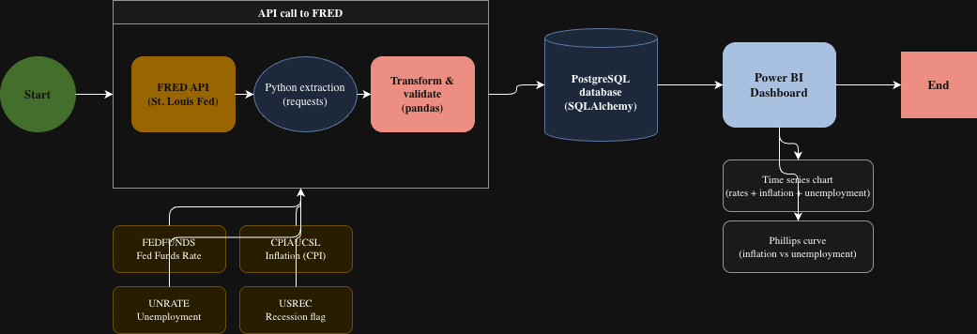

Dashboard
Two charts will form the core of the dashboard:
- Time series view — Fed Funds Rate, inflation, and unemployment plotted on the same timeline from 1970 to today, with recession periods shaded using the USREC series.
- Scatter view (Phillips curve) — inflation on one axis, unemployment on the other, each point colored by the interest rate level at that moment. This makes the dual mandate tension visible across fifty years of data in a single chart.
Both views will include a date range filter to zoom into specific periods, such as the Volcker rate hikes of the early 1980s, the post-2008 near-zero rate era, or the 2022-2023 tightening cycle.
Timeline
Week 1:
- Select the four FRED data series and register for a free API key at fred.stlouisfed.org.
- Draft this proposal and sketch the pipeline architecture diagram.
- Run a first test API call in Python to confirm data returns correctly.
Week 2:
- Design the PostgreSQL database schema and create the ER diagram.
- Write the initial Python script to pull data from FRED and load it into the database.
Week 3:
- Build the full ETL pipeline with data validation checks, error logging, and incremental loading.
- Develop the data quality framework to ensure clean, consistent data before each load.
Week 4:
- Connect Power BI to the PostgreSQL database.
- Build the time series chart and the Phillips curve scatter chart with date range filters and recession shading.
Week 5:
- Polish all documentation and finalize the GitHub repository.
- Run reproducibility tests to confirm the pipeline works end to end.
- Prepare and rehearse the executive presentation.
Expected outcomes
- A Python pipeline that pulls data from the FRED API and loads it into PostgreSQL automatically.
- A documented database schema with validation and error logging built in.
- A Power BI dashboard with two interactive charts covering 1970 to the present.
- A GitHub repository with all code and setup instructions so the project can be reproduced from scratch.
- A 10–12-minute executive presentation covering the pipeline architecture and the macro insights the data reveals.
Risks and contingencies
- FRED API unavailable or slow — save data locally after the first successful pull so the pipeline does not depend on the API being live every run.
- Pipeline scope grows too large — start with three series only and add USREC once the core is stable.
- PostgreSQL connection issues — fall back to CSV file storage if the database setup runs into problems.
- Scope creep on the dashboard — the project is scoped to two charts, no new features until both are working.
Resources
- FRED API — free, registration at fred.stlouisfed.org.
- Python libraries — requests, pandas, SQLAlchemy (all open source)
- PostgreSQL.
- Power BI Desktop.
- GitHub — free public repository.
Conclusion
This is a focused project with a realistic scope for five weeks. The data is free and well-structured, the tools match what the course covers, and the question it addresses, whether the Fed can manage inflation without damaging employment, is one that finance professionals think about regularly.
The pipeline replaces a process most analysts currently do by hand. The dashboard makes the trade-off readable to anyone who looks at it, with no economics background required.
Next steps
- Register for a FRED API key at fred.stlouisfed.org.
- Run a test call in Python to confirm data returns for at least one series.
- Verify the PostgreSQL connection works from Python.
- Set up the GitHub repository with a basic folder structure and README.
- Begin Week 2: design the database schema and write the initial load script.

