Database Schema Documentation
Fed Dual Mandate Dashboard
German Collado Blanco
Project Overview
This database stores Federal Reserve economic data from the FRED API (Federal Reserve Bank of St. Louis). Four monthly time series loads into PostgreSQL and feed a flat view that Power BI reads directly to show how the Fed has balanced inflation and unemployment over time.
The schema follows approximately Third Normal Form (3NF) by:
- storing series metadata separately from observation records
- not repeating series names, units, and descriptions across rows
- enforcing referential integrity through primary and foreign key constraints
ER Diagram
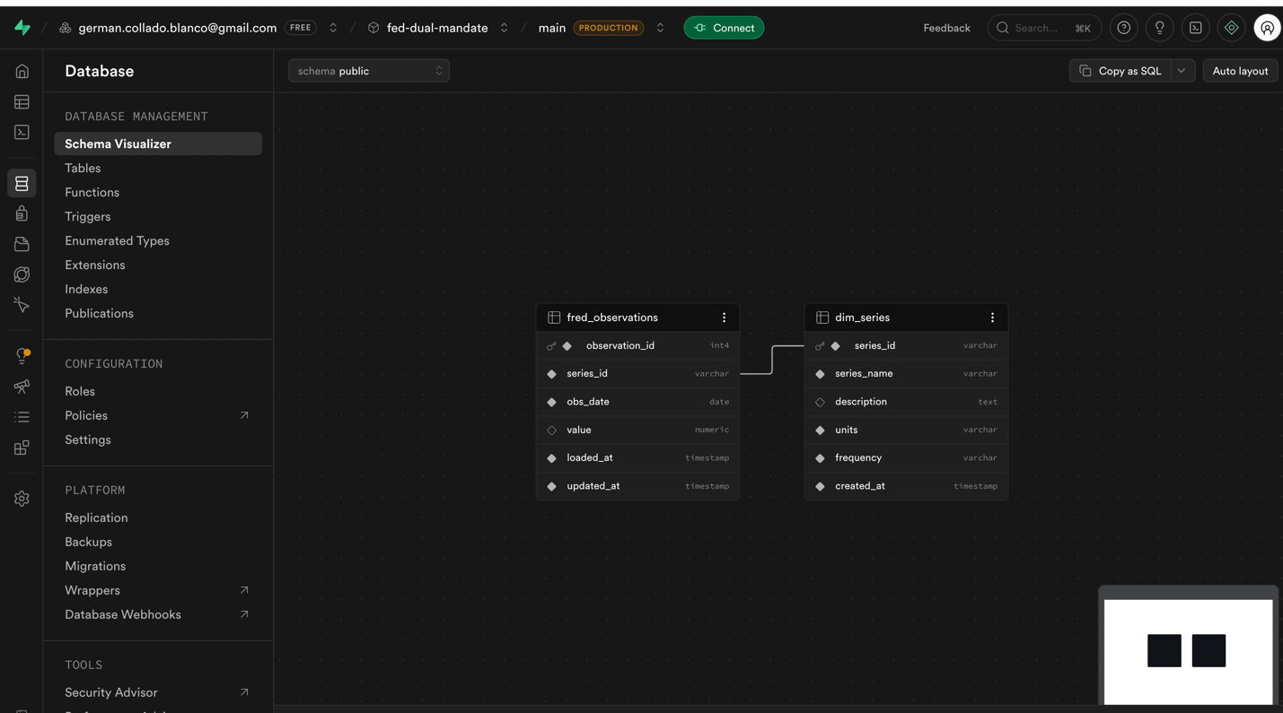
Database Overview
The database contains two physical tables and one derived view:
- dim_series
- fred_observations
- macro_dashboard (VIEW)

Entity Relationship Summary
Table | Purpose
dim_series | Stores metadata for each FRED series tracked by the pipeline (name, units, frequency)
fred_observations | Stores every historical observation retrieved from the FRED API — one row per series per month
macro_dashboard | Derived view that pivots observations into one row per month with all four indicators as columns — used by Power BI

Table Documentation
1. dim_series
Purpose
Metadata table for the four FRED series. Series names, units, and descriptions live here rather than being copied into every observation row. The fact table references this table by series_id.
Primary Key
series_id
Relationships
- One dim_series record can relate to many fred_observations records.
- Referenced by fred_observations.series_id.
Table Structure
Column Name | Data Type | Key | Description
series_id | VARCHAR(20) | Primary Key | Official FRED series code. Uniquely identifies each indicator. E.g. FEDFUNDS
series_name | VARCHAR(100) |  | Full human-readable name of the series. E.g. Federal Funds Rate
description | TEXT |  | Explanation of what the indicator measures and its relevance to the Fed's dual mandate
units | VARCHAR(50) |  | Unit of measurement used to label chart axes in Power BI. E.g. Percent
frequency | VARCHAR(20) |  | Publication frequency. All four series in this project are monthly
created_at | TIMESTAMP |  | Timestamp when the row was inserted, auto-generated when the load script runs

2. fred_observations
Purpose
The main data table. Each row is one monthly reading for one series, going back to 1954 for most indicators. Dashboard visuals and analytical queries both read from this table.

Primary Key
observation_id
Foreign Keys
- series_id -> dim_series.series_id
Relationships
- Many observations can reference one series.
- Each combination of series_id and obs_date is unique.
Table Structure
Column Name | Data Type | Key | Description
observation_id | SERIAL | Primary Key | Auto-incrementing surrogate key. No business meaning — used only to uniquely identify rows
series_id | VARCHAR(20) | Foreign Key | References dim_series.series_id. Links each observation to its indicator
obs_date | DATE | Unique | Observation date. FRED uses the first day of the month for monthly data. E.g. 1982-01-01
value | NUMERIC(12,4) |  | Observed value. Can be NULL if FRED has no data for that date. E.g. 10.8000
loaded_at | TIMESTAMP |  | Timestamp of the first load. Used for pipeline auditing
updated_at | TIMESTAMP |  | Last update timestamp. Changes if FRED retroactively revises a historical value

Note: unique constraint on (series_id, obs_date) prevents duplicate records if the script runs more than once.
3. macro_dashboard (VIEW)
Purpose
A SQL view, not a physical table. It pivots fred_observations into one row per month with each indicator in its own column. The CPI column uses LAG to compute year-over-year change, so Power BI gets a clean flat table and runs no joins at query time.
Relationships
- Derived from fred_observations — no physical foreign key.
- One row per month from July 1954 to present.

Table Structure
Column Name | Data Type | Key | Description
obs_date | DATE |  | Time axis. One row per month from 1954 to present. X-axis for all dashboard charts
fed_funds_rate | NUMERIC | FEDFUNDS | Fed interest rate. Main line on time series chart and color encoding for Phillips curve points
cpi_yoy | NUMERIC | CPIAUCSL | Year-over-year inflation: ((CPI / CPI 12 months prior) - 1) x 100. Y-axis of the Phillips curve
unemployment | NUMERIC | UNRATE | Unemployment rate. X-axis of the Phillips curve. Visualizes the dual mandate tension alongside cpi_yoy
is_recession | SMALLINT | USREC | NBER binary flag. 1 = recession month, 0 = expansion. Used to shade bands on the time series chart
Cardinality Relationships
Parent Table | Child Table | Relationship Type
dim_series | fred_observations | One-to-Many
fred_observations | macro_dashboard | One-to-Many (via VIEW pivot)
Normalization Notes (3NF)
The schema follows approximately Third Normal Form:
- Series metadata (name, description, units, frequency) is stored in dim_series rather than copied into each observation row.
- Non-key columns in each table depend only on that table's primary key.
- macro_dashboard is a view rather than a physical table, so no derived data is stored twice.
- The unique constraint on (series_id, obs_date) prevents duplicate records at the database level.
Data Sources
FRED API (Federal Reserve Economic Data)
All data comes from the FRED API (Federal Reserve Bank of St. Louis, fred.stlouisfed.org). It returns monthly time series going back to the 1950s as clean JSON and requires only a free API key.
The four series loaded in this project:
The four series loaded in this project:
- FEDFUNDS — Federal Funds Rate (Percent, Monthly)
- CPIAUCSL — Consumer Price Index, All Urban Consumers (Index 1982-84=100, Monthly)
- UNRATE — Unemployment Rate (Percent, Monthly)
- USREC — NBER Recession Indicator (Binary 0/1, Monthly)

