**CODE SETUP:**

**Prerequisites:**

1.Eclipse IDE

2.Apache tomcat

3.ARC (Advanced rest client)

4. JDK installed(>1.8)

5.JAVA_HOME env variable set

**Setup:**

Open eclipse> File > Import > Existing projects into workspace

Select root directory of egt_talent project

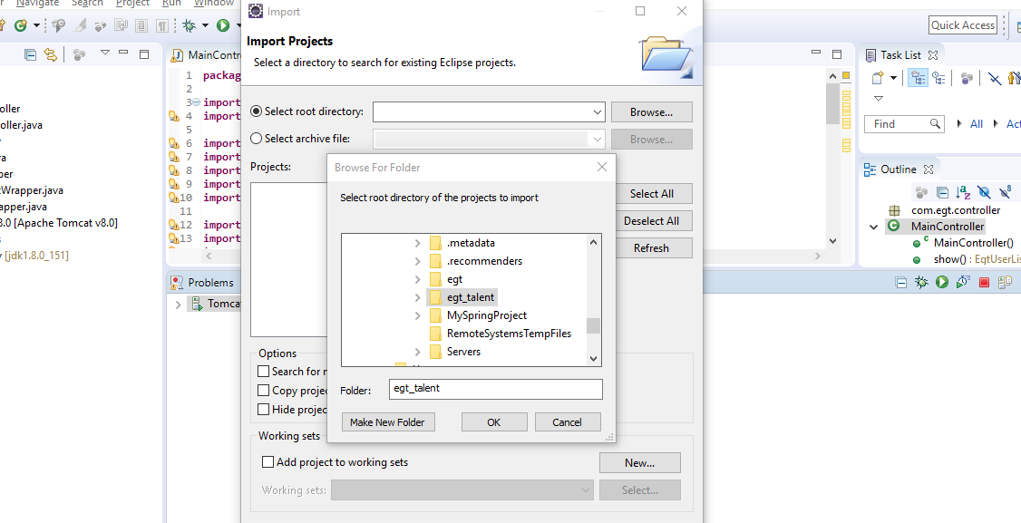

**When the project is imported, see if there are any issue “cross sign” or ! sign on project name.**

**If yes, contact me .**

**Setup of Tomcat:**

**Click on servers tab**

**If tab not present, click on Window tabe> show view> servers**

**In the servers tab , click on add server>**

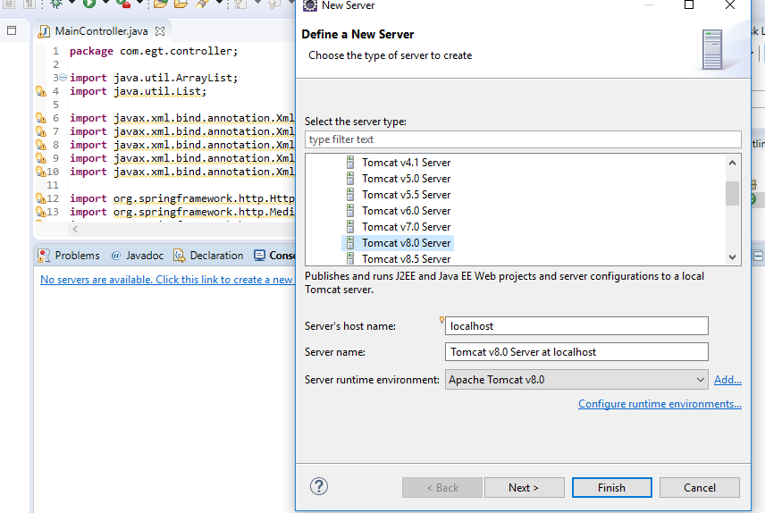

**Select the version, try to use 8.0 (copied it in softwares tab, Windows users can use that )**

**Others will have to download from tomcat website**

**Then select the directory where you have kept it**

**Then servers tab should show Tomcat added !**

**Now , double click on the Tomcat**

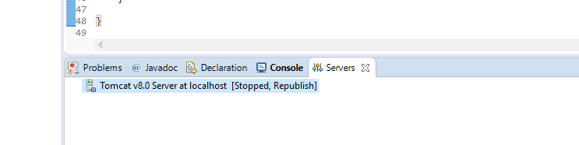

**Set timeout to 100 like this: (shown as 45 in the picture … make it to 100 )**

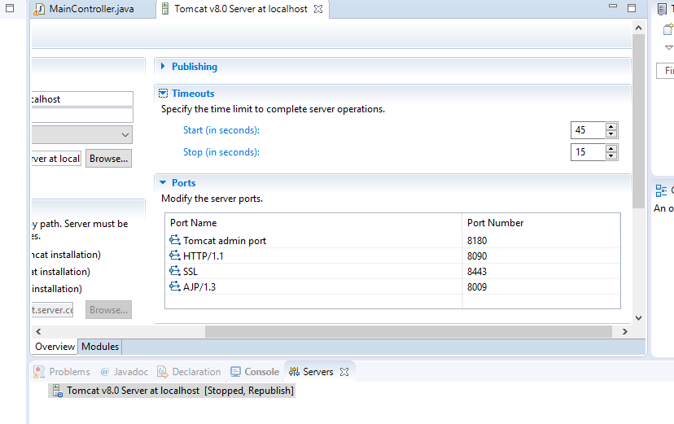

**And also make sure HTTP port is same as in picture**

**After this click on cross at Tomcat tab > ask for save > click on save**

**Tomcat is configured.**

**Now, right click on the project name “egt_talent” > run as> run on server > finish**

**Server will start.**

**If no issue occurs**

**Open this URL in your browser (sanity check)**

**Localhost:8090/egt_talent/egtUsers**

**If you are able to see some data in XML format**

**Then move forward to ARC setup**

**Install ARC on your pc(.exe is copied in softwares folder )Windows users can use that**

**Install it**

**Open it and put the same URL as mentioned above**

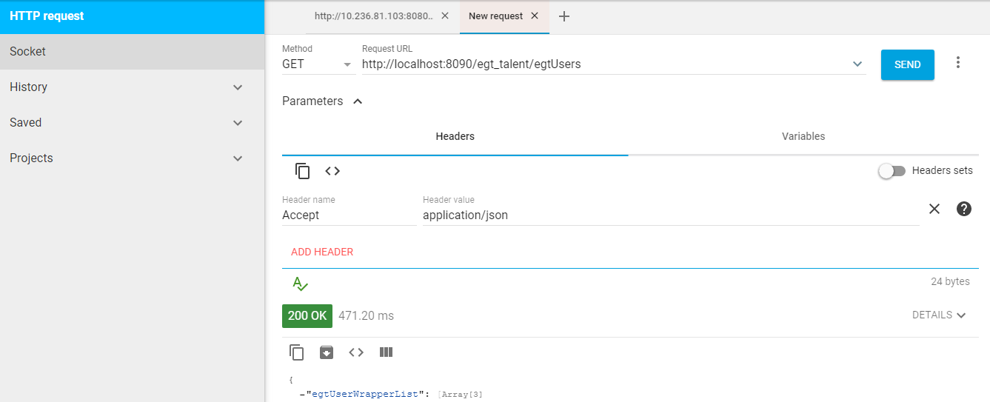

**In the header section , put as given in picture**

**Click on SEND, you should be able to see some data.**

**Setup of postgresql:**

**postgresql-10.5-2-windows-x64**

**Download postgres from postgres website and install it on pc. I have installed the version specified above.**

**Note down the username and password that you will set and put the port as 5432 (by default)**

**After installation, go to the c drive(or where it gets installed in your pc)**

**The location on my pc is:**

**C:\Program Files\PostgreSQL\10\pgAdmin 4\bin**

**And double click on**

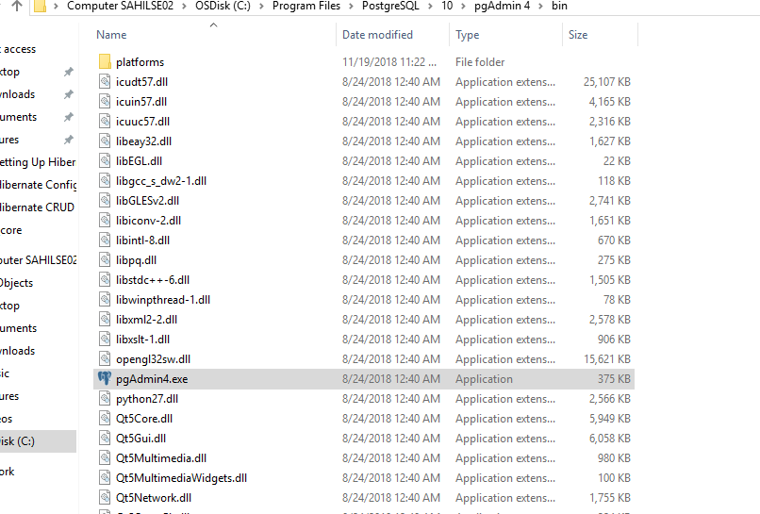

**Pgadmin4.exe**

**A page will open in your browser similar to this:**

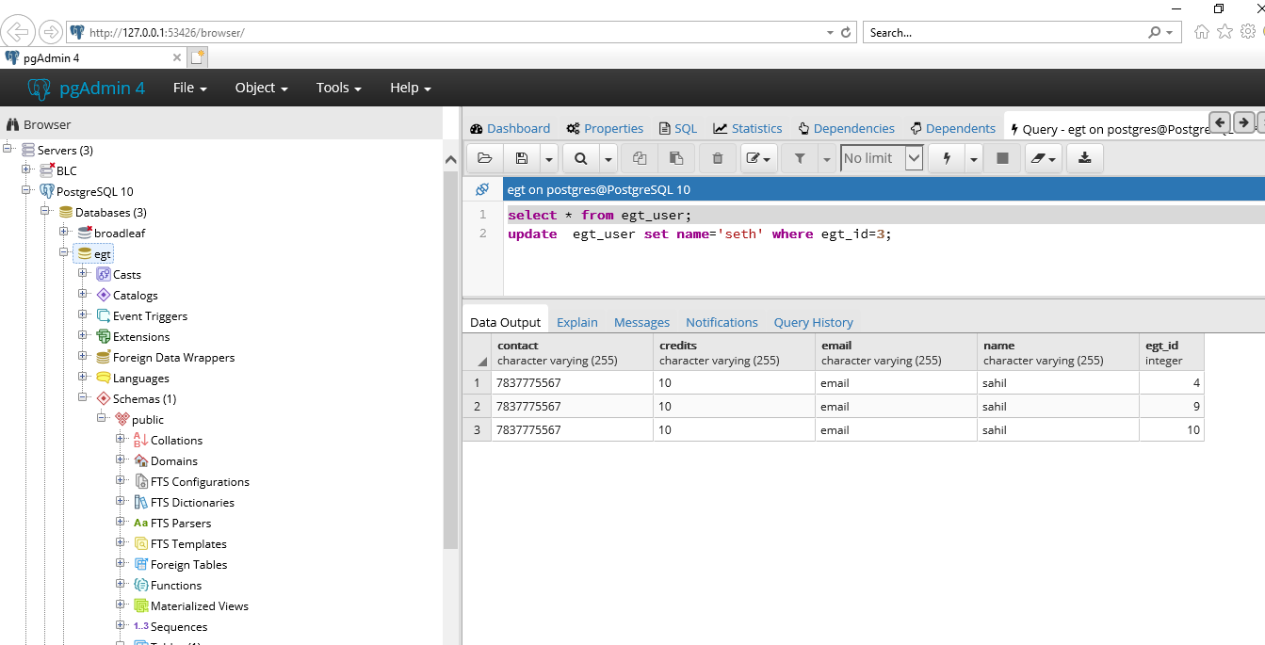

**If you get here, you are good to go.**

**After this update your code after pulling from repository.**

**Import this as a new project following the same instructions as previously followed.**

**After that, contact me**

**New APIs(for reference):**

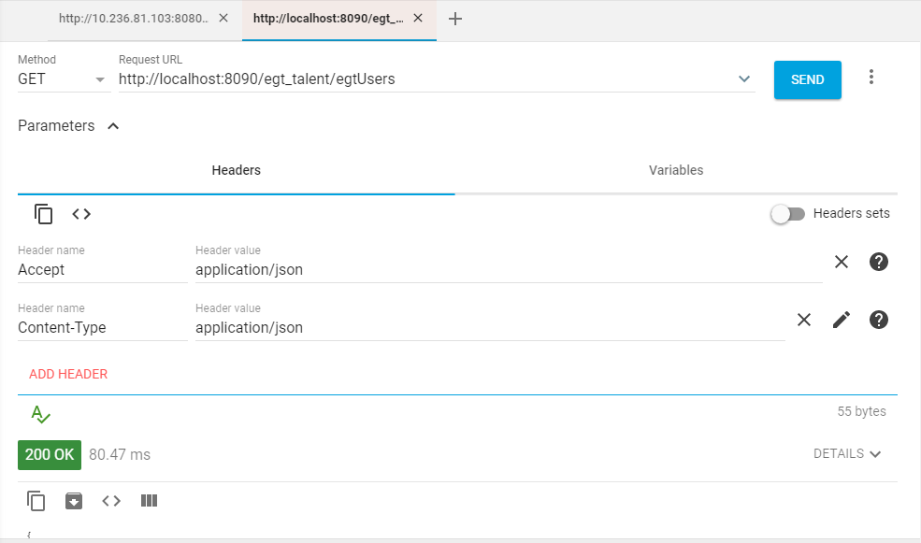

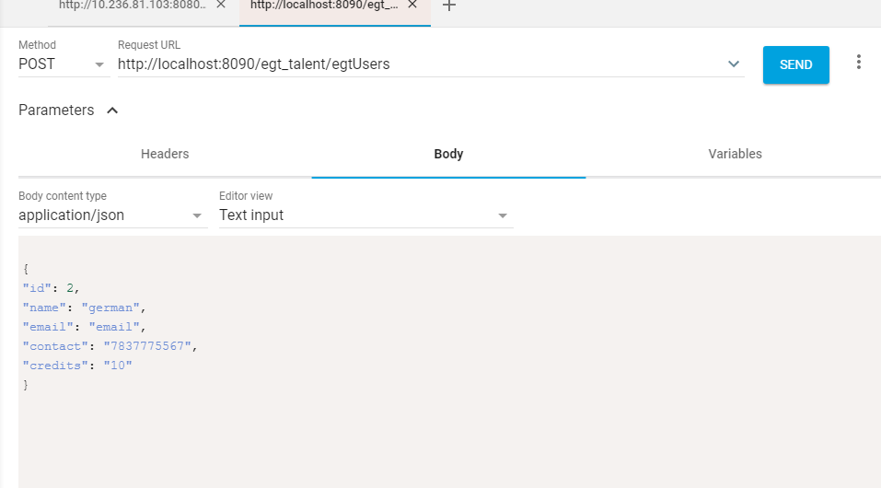

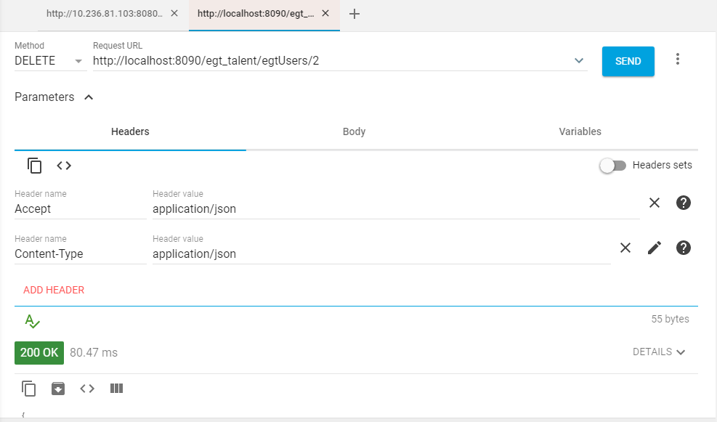

**Setup for Android Developers:**

Android developers don’t need to setup CORE code in eclipse.

Following are the things needed to be done:

1. **Setup postgres Database** (Steps given above) For now, when you set password for postgres , set it as sahilpostgres (because currently war file has this password) .
2. Copy tomcat in your pc from the repository ( apache-tomcat-8.5.34 🡪 this version )
3. Copy egt_talent.war (from repository) into C:\Users\sahilse\**apache-tomcat-8.5.34\webapps(Already done …. Just visit the folder and check once)**
4. Now go to C:\Users\sahilse\**apache-tomcat-8.5.34\bin** and run **startup.bat**
5. The server should come up like this:

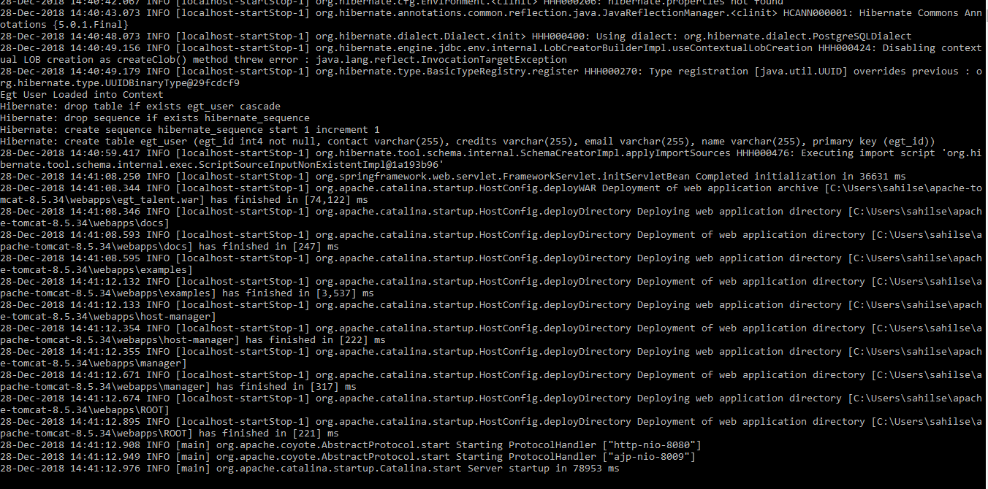

1. See if there is any error. If not , then server is up successfully and tables **should** be created automatically in your DB.
2. Now , hit this url in your browser

<http://localhost:8080/egt_talent/egtUsers>

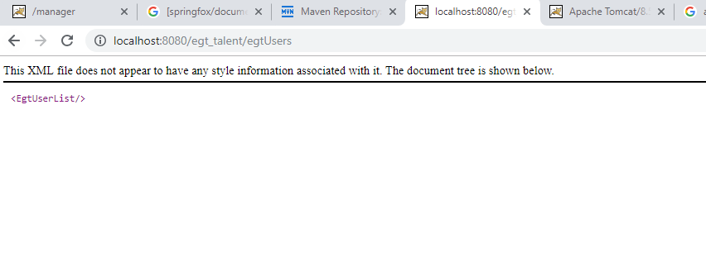

1. If you see this, you are good to test your android API calls.

UPDATE:

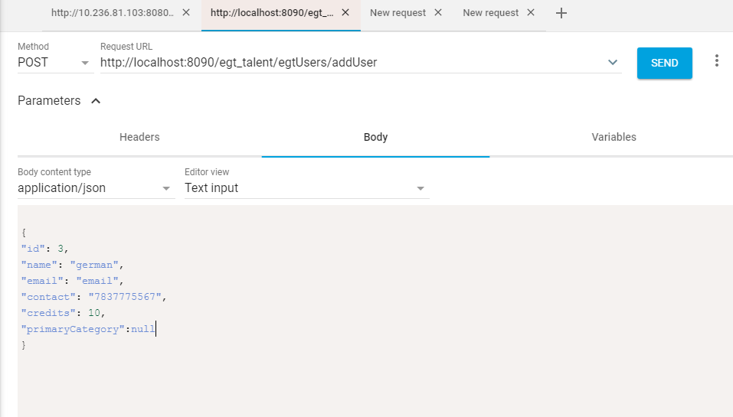

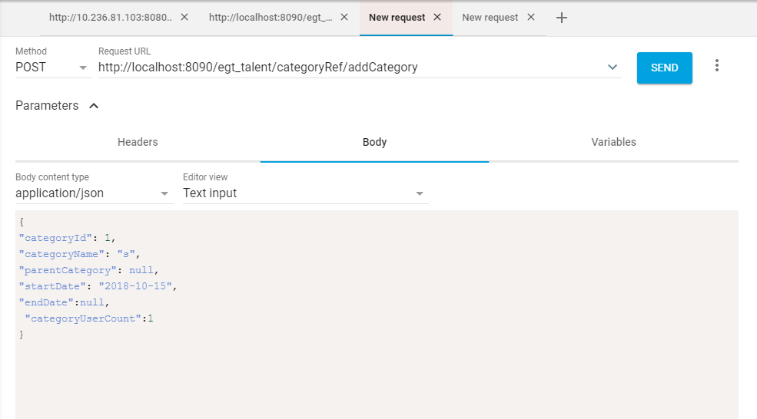

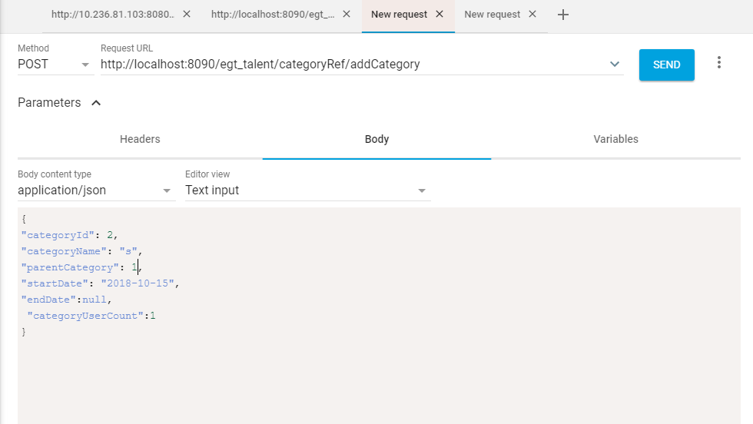

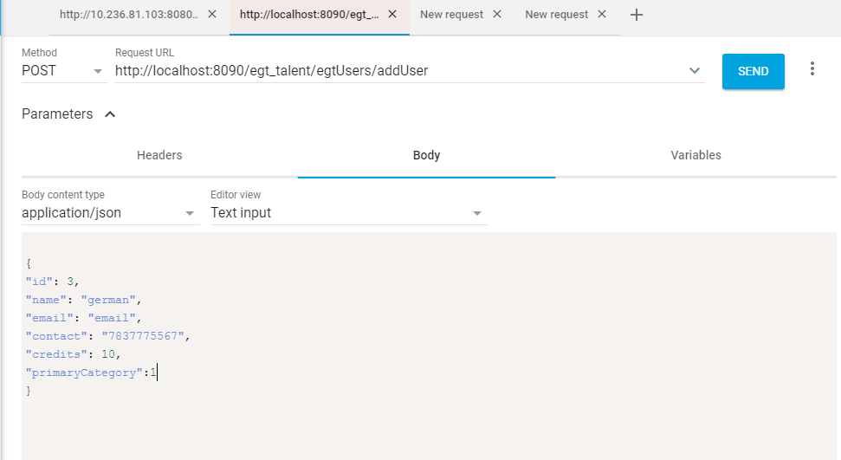

Exception handling:

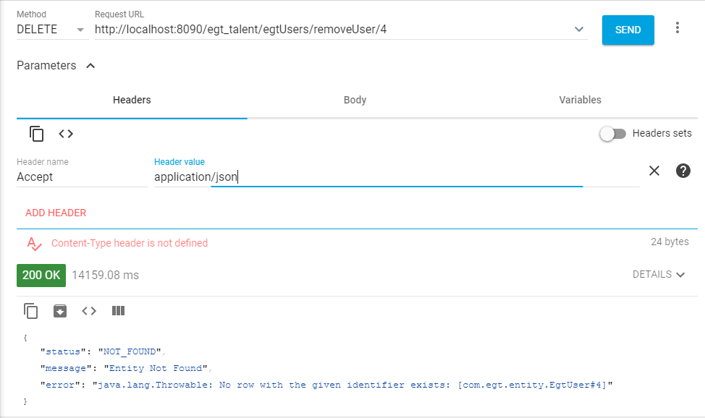

Not Nullable Columns and Length:

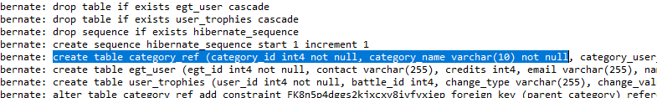

Find API:

We have to keep note of name and datatype of parameters. These will be same as wrapper object has.,

One parameter passed as query parameter. (Integer type parameter)

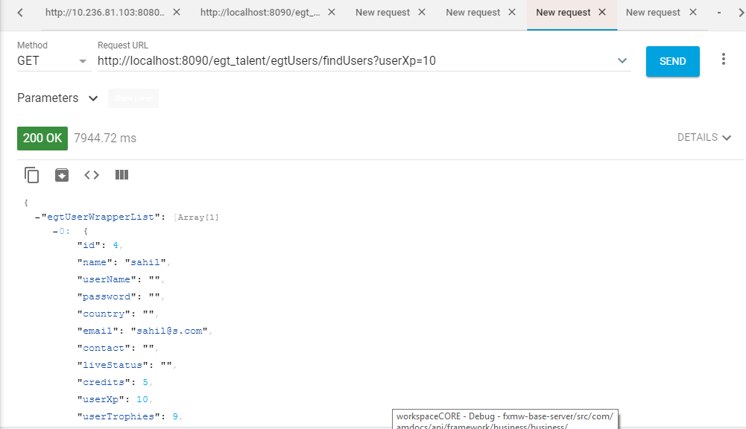

Similar Call(for string parameter)

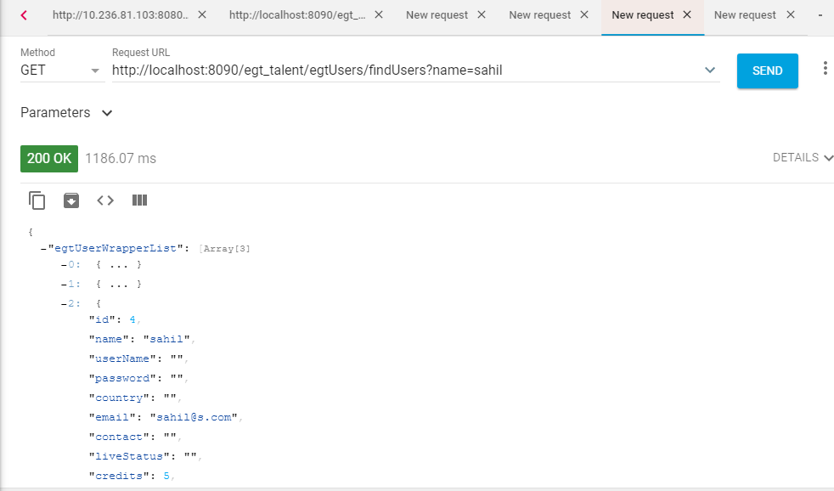

Multiple parameters:

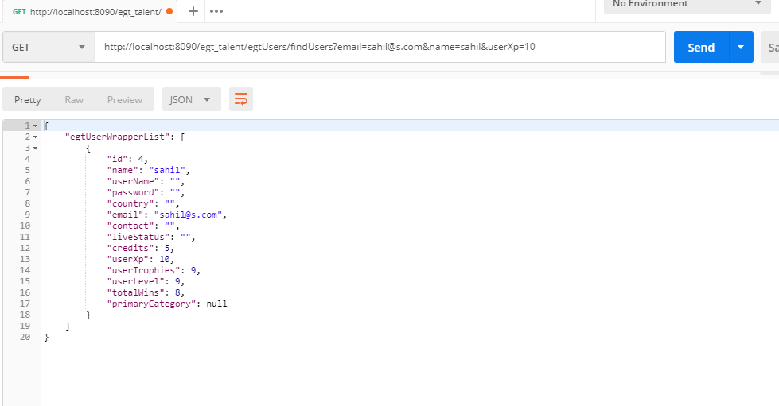

NOTE: A very complex filter will be done on client side.

UPDATE API:

Pass whatever columns needed to be updated and response will have final object

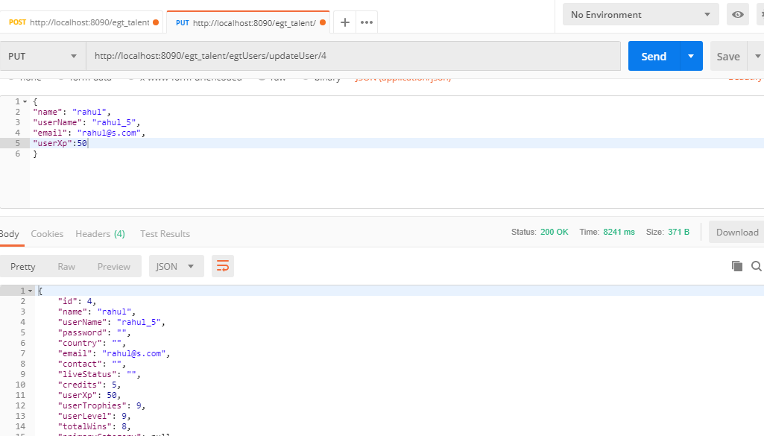

Revised Add category(with New date format)

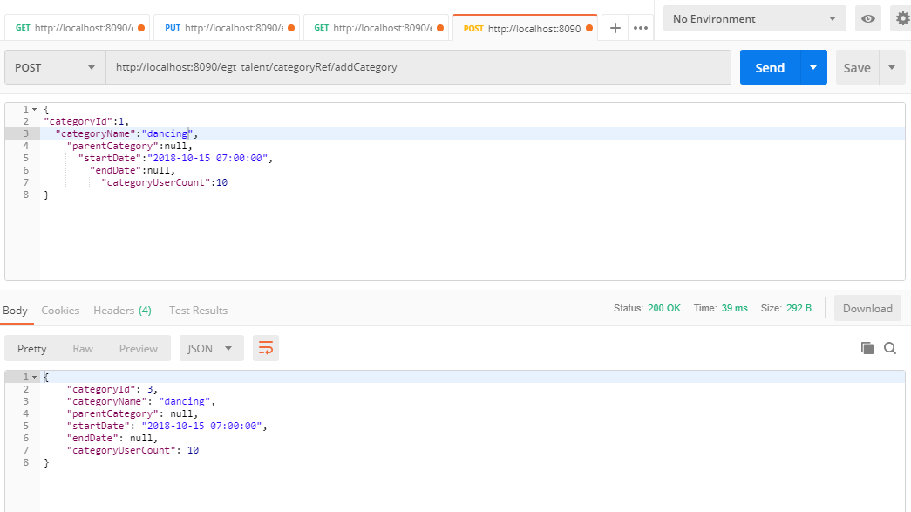

yyyy-MM-dd hh:mm:ss

This should be the format of date everywhere

Find Category:

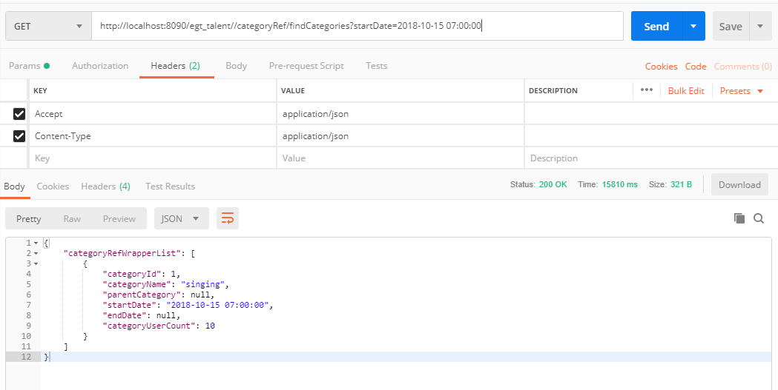

Multiple paramters:

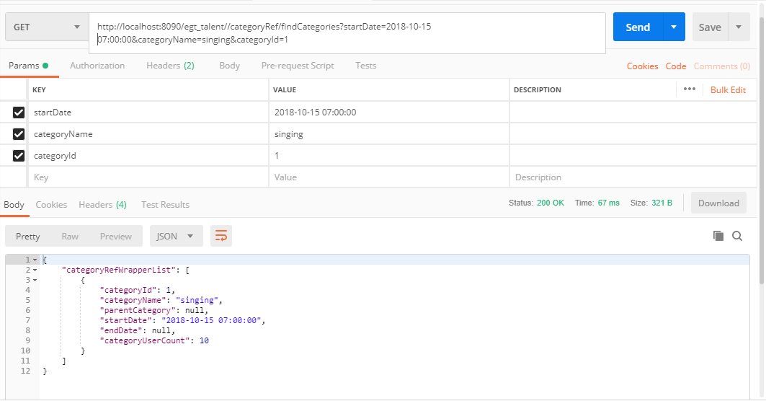

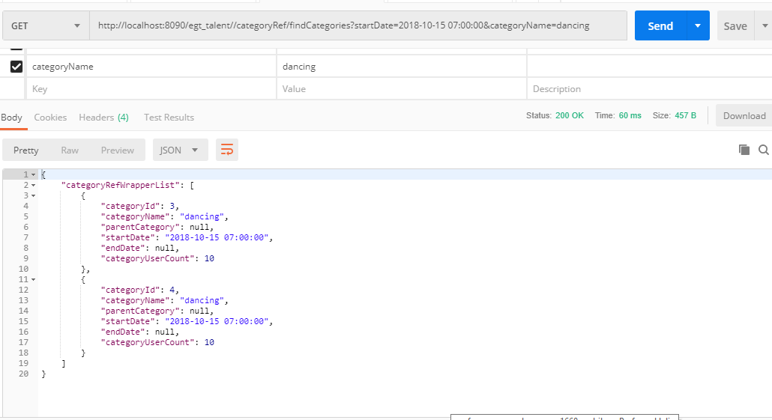

Swagger Implementation:

Swagger dependency JARS have been added and checked in.

After running the current server, (if it comes up fine)

Try this URL:

<http://localhost:8090/egt_talent/swagger-ui.html>

You should be able to see something like this:

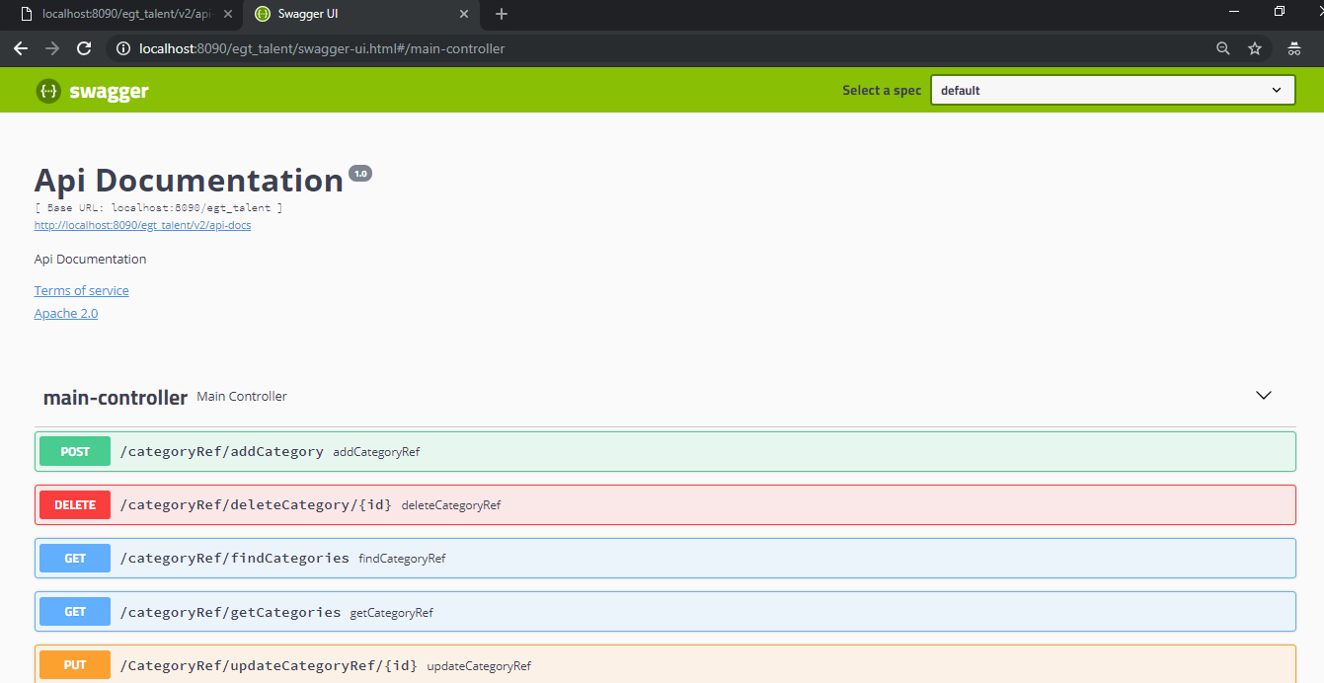

**Swagger Implementation on client side:**

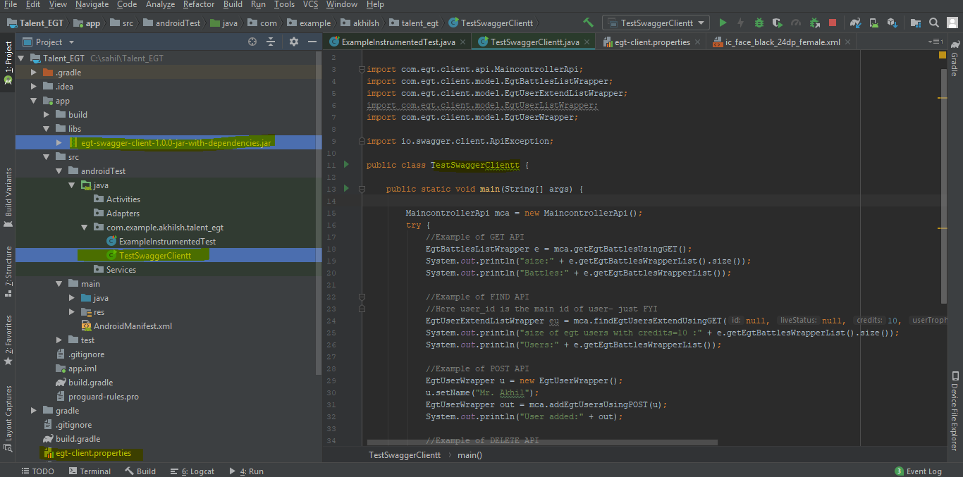

Steps to add dependency JAR:

Under app/lib

Copy the JAR **egt-swagger-client-1.0.0-jar-with-dependencies.jar**

**Right click- add as library**

**Done !**

1. **This JAR needs a properties file. Right click on your project>New file> egt-client.properties(this file is already checked in) You can specify the IP of the server in this file.**

**We can use all the classes in our code**

**Created one java class as example for 4 type of APIs**

Output of test class I created:

