

STOCK LIST

988 E. Saratoga . Ferndale, MI 48220
Phone (800) 247-5966 . Phone (248) 548-3150 . Fax (248) 548-0265
Email: bondplywood@bondply.com
www.bondply.com

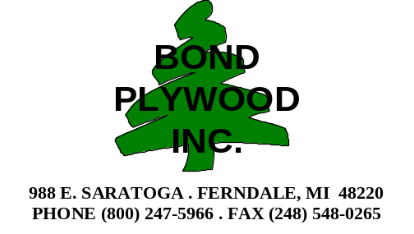



Standard
General Purpose Grade (G48) | Call for Pricing
Solids, Patterns, Stones & Woodgrains - Standard Finish
Special Finish Upcharge
Gloss Finish Upcharge
Granite Finish
StoneX Finish
Peel coat Upcharge
Vertical Grade (F28) | Call for Pricing
Solids, Patterns, Stones & Woodgrains - Standard Finish
Gloss Finish Upcharge
Special Finish Upcharge
Peel coat Upcharge
Postforming Grade (F39) * Stocked at Auburn, ME | Call for Pricing
Solids, Patterns, Stones & Woodgrains - Standard Finish
Special Finish Upcharge
Gloss Finish Upcharge
Granite Finish
StoneX Finish
Peel coat Upcharge
Edging - Postformable | Call for Pricing
2” x 144”
6” x 144”

Finish Options
Standard Finishes: N - Suede,
Special Finishes: C - Soft Leather, H - Hi-Brite J - Crystal, L - Leather, W - Slate, Z -Ashwood
Gloss Finish: G- Gloss
Granite Finish: R – Granite
StoneX Finish: V – StoneX

All pricing and information is subject to change without notice.

Commodity
General Purpose Grade (G48) 4 x 8 & 5 x 12 |  | Call for Pricing
SW806 Carnation White  SW826 Angel White  SW836 Winter White | SE101 Black  ST655 Almond  SG241 Folkstone Gray
Vertical Grade (F28) 4 x 8 Only |  | Call for Pricing
SW806 Carnation White  SW826 Angel White  SW836 Winter White | SE101 Black  ST655 Almond  SG241 Folkstone Gray
Vertical Grade (F28) – Gloss 4 x 10 w/ peelcoat |  | Call for Pricing
SW806 Carnation White  SW826 Angel White  SW836 Winter White | SE101 Black  ST655 Almond

Pearlescent Collection
Pearlescent Collection (F26) 4 x 10 w/ peelcoat |  | Call for Pricing
AB061 Blue Arctic  AG221 Silver Patina  AT891 Gold Patina  AV644 Verdigris Patina  AW811 White Arctic  PFA38 - Christmas in NYC | WM811 Red Parisian Maple  WM831 Green Parisian Maple  WM871 White Parisian Maple  WM881 Scarlet Parisian Maple  WM891 Black Parisian Maple  WS601 White Pearlwood

Stocked Special Finish Colors
Ashwood Finish (Z) – Vertical Grade
SE101 Black | 4 x 8 & 4 x 10
Crystal Finish (J) – General Purpose & Vertical Grade
SE101 Black & SW826 Angel White | Full sheet sizes only

All pricing and information is subject to change without notice.

Specialty Products
Melcor II Solid Core Laminate (M55/M56) | Call for Pricing
All Colors

Leatherlam (R48) – 4 x 8 |  |  | Call for Pricing
Caviar (NL010)  Chocolate (NL020) | Bordeaux (NL030)  Oasis (NL040) | Cashmere (NL050)

Hi-Wear (I48) - General Purpose | Call for Pricing
All Solids, Patterns & Woodgrains

Fire Rated Laminates - All Colors | Call for Pricing
K32 (Vertical Grade)
K51 (General Purpose Grade)

Fire Rated Backer - Brown | Call for Pricing
KB0 (Vertical Grade )
KB8 (General Purpose Grade)

Micastat (Electrostatic Dissipative Laminate) |  | Call for Pricing
SB020 ESD Blue  SG248 ESD Grey | ST681 ESD Beige  SW837 ESD White

ChemGuard (H48) - General Purpose | Call for Pricing
All Solid Colors

Chemical-Resistant Thick Phenolic (ChemGuard) | Call for Pricing
1/4” Black Core (HD2) – All Solid Colors
1/2” Black Core (HD5) – All Solid Colors
3/4” Black Core (HD8) – All Solid Colors
1” Black Core (HDI) – All Solid Colors

All pricing and information is subject to change without notice.

Specialty Products
Thick Phenolic (Double-Faced) | Call for Pricing
1/8” Brown Core (D20) / Black Core (D21)
1/4” Brown Core (D44) / Black Core (D45)
3/8” Brown Core (D50) / Black Core (D51)
1/2” Brown Core (D56) / Black Core (D57)
5/8” Brown Core (D62) / Black Core (D61)
3/4” Brown Core (D68) / Black Core (D69)
1” Brown Core (D74) / Black Core (D75)

Resobak | Call for Pricing
Brown (QYACR184)
Black (QYBCR184)

Backer Sheets | Call for Pricing
B20 (.020”)
B48 (.048”)

Cabinet Liner |  | Call for Pricing
SW812 Tawny White | SW814 White

Marker Board - Gloss Finish W/ Peelcoat |  | Call for Pricing
Frosty White  Snow Flake White | Black  Gray

Metallics - Phenolic Backed (M33) 4 x 8 w/peelcoat |  | Call for Pricing
Brushed Aluminum (ZA002)  Polished Aluminum (ZA001) | Brushed Gold (ZY006)  Polished Gold (ZY001)

Metallics - All Metal (M25) 4 x 8 w/peelcoat |  | Call for Pricing
Brushed Aluminum (FA006)  Polished Aluminum (FA005) | Brushed Gold (FS003)  Polished Gold (FS002)

All pricing and information is subject to change without notice.



FRP – Class C | Call for Pricing
White Textured FRP .090 x 4 x 8 (FRPEW48)
White Textured FRP .090 x 4 x 10 (FRPEW410)
Almond Textured FRP .090 x 4 x 10 (FRPEA410)

Moldings | Call for Pricing
White Division Bar FRP 8’ (VMDBWT96)
White End Cap FRP 8’ (VMECWT96)
White Inside Corner FRP 8’ (VMICWT96)
White Outside Corner FRP 8’ (VMOCWT96)
White Division Bar FRP 10’ (VMDBWT120)
White End Cap FRP 10’ (VMECWT120)
White Inside Corner FRP 10’ (VMICWT120)
White Outside Corner FRP 10’ (VMOCWT120)
Almond Division Bar FRP 10’ (VMDBAL120)
Almond End Cap FRP 10’ (VMECAL120)
Almond Inside Corner FRP 10’ (VMICAL120)
Almond Outside Corner FRP 10’ (VMOCAL120)

FRP – Adhesive, Trowels & Rivets | Call for Pricing
FRP Solvent-Free Adhesive Titebond 4 Gal.
Trowel – ¼” V-Notch 3/16”W x 1/4"D x 1/2”C.C.
Rivets – ¾” Plastic Pin White & Almond (100/box)
Rivets – 1 ½” Plastic Pin White & Almond (100/box)

Other Colors Are Available With Quick Lead Times!

Call For Pricing And Availability!

All pricing and information is subject to change without notice.



- Class A fire rated for flame spread and smoke development
- Solid, monolithic construction
- High-impact strength
- Durable, easy to clean surface

FRL is an excellent application in the following areas:
- Hospitals and Health Care Facilities
- Schools and Universities
- Restaurants and Food Service Areas
- Trains and Buses
- Airports
- Hotels
- Department Stores
- Supermarkets and Grocery Stores

- Available in over 320 Pionite and Panolam colors and patterns
- Available in 3’, 4’ and 5’ sizes, in lengths of 8’ and 10’
- 5 sheet minimum per size and color
- Textures available: Suede, Soft Leather, Ashwood and Crystal

Call for Pricing!

All pricing and information is subject to change without notice.



Standard Solids
S411 Oxford White | Pionite Match - HP411* | Call for Pricing
1/2 x 49 x 97
5/8 x 49 x 97
3/4 x 49 x 97
1 x 49 x 97
1/2 x 61 x 109
5/8 x 61 x 109
3/4 x 61 x 109
S411 Oxford White – Western Core |  | Call for Pricing
1/2 x 49 x 97
5/8 x 49 x 97
3/4 x 49 x 97
1/2 x 61 x 109
5/8 x 61 x 109
3/4 x 61 x 109
S411 Oxford White – ZCore (No Added Urea-Formaldehyde) |  | Call for Pricing
1/2 x 49 x 97
3/4 x 49 x 97
S557 International White | Pionite Match – SW806 | Call for Pricing
1/2 x 49 x 97
5/8 x 49 x 97
3/4 x 49 x 97
1/2 x 61 x 109
5/8 x 61 x 109
3/4 x 61 x 109
* Special Order Laminate

All pricing and information is subject to change without notice.

Standard Solids
S402 Cabinet Almond | Pionite Match – ST655 | Call for Pricing
1/2 x 49 x 97
5/8 x 49 x 97
3/4 x 49 x 97
S556 Almondine | Pionite Match – ST655 | Call for Pricing
1/2 x 49 x 97
5/8 x 49 x 97
3/4 x 49 x 97
1/2 x 61 x 109
5/8 x 61 x 109
3/4 x 61 x 109
S405 Black | Pionite Match – SE101 | Call for Pricing
1/2 x 49 x 97
5/8 x 49 x 97
3/4 x 49 x 97
1 x 49 x 97
1/2 x 61 x 109
5/8 x 61 x 109
3/4 x 61 x 109
S548 Custom Grey | Pionite Match – SG241 | Call for Pricing
1/2 x 49 x 97
5/8 x 49 x 97
3/4 x 49 x 97
3/4 x 61 x 109
S409 Smoke Grey | Pionite Match – SG246 | Call for Pricing
3/4 x 49 x 97
S431 Willow Grey | Pionite Match – SG208 | Call for Pricing
3/4 x 49 x 97
S551 Fog Grey | Pionite Match – SG213 | Call for Pricing
3/4 x 49 x 97

All pricing and information is subject to change without notice.

FAB 5
W140 Riviera Maple | Pionite Match – HP140* | Call for Pricing
1/4 x 49 x 97 (MDF)
1/2 x 49 x 97
5/8 x 49 x 97
5/8 x 61 x 109
3/4 x 49 x 97
W290 Hardrock Maple | Pionite Match – WM791 | Call for Pricing
1/2 x 49 x 97
5/8 x 49 x 97
3/4 x 49 x 97
W272 Nutmeg Cherry | Pionite Match – HP272 | Call for Pricing
1/2 x 49 x 97
3/4 x 49 x 97
W336 Sunset | Pionite Match – HP336 | Call for Pricing
1/2 x 49 x 97
3/4 x 49 x 97
W684 Field Cherry | Pionite Match – HP684 | Call for Pricing
1/2 x 49 x 97
3/4 x 49 x 97
PN44 Oiled Cherry | Pionite Match – WC421 | Call for Pricing
3/4 x 49 x 97

Select Solids
S451 Pepperdust | Pionite Match – HP451* | Call for Pricing
3/4 x 49 x 97
S463 Antique White | Pionite Match – SW803 | Call for Pricing
1/2 x 49 x 97
5/8 x 49 x 97
3/4 x 49 x 97
S491 Pumice | Pionite Match – HP491* | Call for Pricing
3/4 x 49 x 97
S495 New Oyster Grey | Pionite Match – HP495* | Call for Pricing
3/4 x 49 x 97
S569 Birch | Pionite Match – HP569* | Call for Pricing
3/4 x 49 x 97
*Special Order Laminate
All pricing and information is subject to change without notice.

Woodgrains
Item (3/4 x 49 x 97) | Pionite Match | Call for Pricing
W144 Wild Cherry | HP144
W155 Trytoo Savatre | WC105*
W156 Grand Cherry | HP156*
W176 Opto Printatre | WX230
W190 Gunstock Walnut | WW971
W196 Appears Likatre | WP115
W200 Aimtoo Savatre | WC115*
W221 Leave Likatre | WP120
W234 Iwantoo Savatre | WC125*
W273 Mahogany Clove | HP273*
W292 Nightfall | WX421
W333 Electo Printatre | WX240*
W338 Sunrise | HP338
W340 Brown Pearwood | HP340
W365 Mahogany Impression | HP365*
W372 Mahogany | WY031
W373 Castle Oak | HP373*
W381 Chusto Printatre | WX250*
W391 Natural Oak | HP391*
W687 Grove Myrtle | HP687
W688 Arbor Myrtle | HP688
* Special Order Laminate

All Other Colors Are Available In Small Quantities With Quick Lead Times!

All pricing and information is subject to change without notice.


Hardwood Plywood
Red Oak – Plain Sliced | Call for Pricing
1/4 x 4 x 8 A-3 V.C. (Import)
1/4 x 4 x 8 A-4 V.C.
1/4 x 4 x 8 A-2 V.C.
1/2 x 4 x 8 A-2 V.C.
1/2 x 4 x 8 A-2 MDF Core
3/4 x 4 x 8 A-1 V.C.
3/4 x 4 x 8 A-1 MDF Core
Red Oak – Rotary WPF | Call for Pricing
1/4 x 4 x 8 B-4 V.C.
1/2 x 4 x 8 B-2 V.C.
1/2 x 4 x 8 A-2 PBC
3/4 x 4 x 8 B-2 MDF Core
3/4 x 4 x 8 B-2 V.C.
3/4 x 4 x 8 B-2 MDF Core
Red Oak - Rift | Call for Pricing
1/4 x 4 x 8 A-4 V.C.
1/2 x 4 x 8 A-2 V.C.
3/4 x 4 x 8 A-1 V.C.
3/4 x 4 x 8 A-1 MDF Core
Natural Birch - Rotary | Call for Pricing
1/4 x 48 x 96 A-3 V.C. (Import)
1/4 x 48 x 96 A-4 V.C. - WPF
1/2 x 48 x 96 B-2 V.C. - WPF
1/2 x 48 x 96 C-3 ( Paint Grade) -V.C.
3/4 x 48 x 96 B-2 V.C.- WPF
3/4 x 48 x 96 B-2 MDF Core
3/4 x 48 x 96 B-2 PB Core
3/4 x 48 x 96 Fall Down V.C.
3/4 x 48 x 96 C-3 (Paint Grade) - V.C.
3/4 x 48 x 96 A-1 V.C. – WPF
3/4 x 48 x 120 A-2 V.C.
1 x 48 x 96 A-2 V.C.
White Maple Pre-finished - Rotary WPF | Call for Pricing
1/4 x 4 x 8 C-4 V.C. UV-Filled 1-Side
1/2 x 4 x 8 C-2 V.C. UV-Filled 1-Side
1/2 x 4 x 8 C-2 V.C. UV-Filled 2-Sides
3/4 x 4 x 8 C-2 V.C. UV-Filled 1-Side
3/4 x 4 x 8 C-2 V.C. UV-Filled 2-Sides
All pricing and information is subject to change without notice.

Hardwood Plywood
White Maple (Uniform) - Rotary WPF | Call for Pricing
1/4 x 4 x 8 B-4 V.C.
1/2 x 4 x 8 B-2 V.C.
1/2 x 4 x 8 B-2 PB Core
3/4 x 4 x 8 B-2 V.C.
3/4 x 4 x 8 B-2 MDF Core
White Maple – Plain Sliced | Call for Pricing
1/4 x 4 x 8 A-4 V.C.
1/2 x 4 x 8 A-2 MDF Core
3/4 x 4 x 8 A-1 V.C.
3/4 x 4 x 8 A-1 MDF Core
Cherry – Plain Sliced | Call for Pricing
1/4 x 4 x 8 A-4 V.C.
1/2 x 4 x 8 A-2 V.C.
1/2 x 4 x 8 A-2 PB Core
1/2 x 4 x 8 A-2 MDF Core
3/4 x 4 x 8 A-1 V.C.
3/4 x 4 x 8 A-1 MDF Core
African Mahogany – Plain Sliced | Call for Pricing
1/4 x 4 x 8 A-4 V.C.
1/2 x 4 x 8 A-2 V.C.
1/2 x 4 x 8 A-2 MDF Core
3/4 x 4 x 8 A-1 V.C.
3/4 x 4 x 8 A-1 MDF Core
Hickory – Plain Sliced | Call for Pricing
1/4 x 4 x 8 A-4 V.C.
1/2 x 4 x 8 A-2 V.C.
3/4 x 4 x 8 A-1 V.C.
Knotty Pine – Plain Sliced | Call for Pricing
1/4 x 4 x 8 A-4 V.C.
1/2 x 4 x 8 A-2 V.C.
3/4 x 4 x 8 A-1 V.C.
Walnut – Plain Sliced | Call for Pricing
1/4 x 4 x 8 A-4 V.C.
1/2 x 4 x 8 A-2 V.C.
3/4 x 4 x 8 A-1 V.C.
3/4 x 4 x 8 A-1 MDF Core
All pricing and information is subject to change without notice.

Bending Plywood
Bending Lauan – Columbia Forest Products | Call for Pricing
3/8 x 96 x 48 “Drum”
3/8 x 48 x 96 “Post”

Import Plywood
Natural Birch – Rotary Import | Call for Pricing
1/2 x 48 x 96 - WPF
3/4 x 48 x 96 - WPF
All-Ply – Exterior | Call for Pricing
25mm x 4 x 8 BB/CC
Baltic Birch – Import | Call for Pricing
12mm x 5 x 5 BB/BB
18mm x 5 x 5 BB/BB

Homasote
Homasote | Call for Pricing
1/2 x 48 x 96 2-Sides

Veneer
Veneer (4 x 8) | Call for Pricing
Red Oak - Flat Cut - 10 mil
Red Oak - Flat Cut - 20 mil (Bubble-Free)
White Birch – Rotary Cut - 10 mil
White Maple – Flat Cut - 10 mil
White Maple – Flat Cut - 20 mil (Bubble-Free)
Cherry - Flat Cut -10 mil
Cherry - Flat Cut - 20 mil (Bubble-Free)
African Mahogany – Flat Cut -10 mil
White Oak – Flat Cut – 10 mil
Hickory – Flat Cut – 10 mil
Knotty Pine – Flat Cut – 10 mil
Walnut – Flat Cut – 10 mil

Over 200 species are available in a few days.
Larger sheet sizes, bubble-free, phenolic-back & wood on wood are available.
Call for Pricing!
All pricing and information is subject to change without notice.



Particleboard

Boise Cascade – Western Industrial Pine | Call for Pricing
3/8 x 49 x 97
1/2 x 49 x 97
5/8 x 49 x 97
3/4 x 25-1/2 x 97
3/4 x 25-1/2 x 121
3/4 x 25-1/2 x 145
3/4 x 30 x 97
3/4 x 30 x 121
3/4 x 30 x 145
3/4 x 36 x 97
3/4 x 36 x 121
3/4 x 36 x 145
3/4 x 49 x 97
3/4 x 49 x 121
3/4 x 49 x 145
3/4 x 61 x 97
3/4 x 61 x 109
3/4 x 61 x 121
1 x 49 x 97
1-1/8 x 49 x 97

Boise Cascade – Evergreen (NAUF & FSC) | Call for Pricing
1/2 x 49 x 97
3/4 x 49 x 97

All pricing and information is subject to change without notice.

Particleboard

Forpan – Canadian | Call for Pricing
1/2 x 49 x 97
5/8 x 49 x 97
3/4 x 49 x 97
3/4 x 49 x 121
3/4 x 61 x 97
1 x 49 x 97
1-1/8 x 49 x 97
1-1/8 x 61 x 97

Flakeboard – Southern Pine | Call for Pricing
3/4 x 61 x 145
1 x 49 x 97
1-1/8 x 30 x 97
1-1/8 x 30 x 121
1-1/8 x 30 x 145
1-1/8 x 36 x 121
1-1/8 x 36 x 145
1-1/8 x 49 x 97
1-1/8 x 61 x 97
1-1/8 x 61 x 121
1-1/8 x 61 x 145

All pricing and information is subject to change without notice.

Medium Density Fiberboard (MDF)
Flakeboard – Premium | Call for Pricing
1/2 x 49 x 97
5/8 x 49 x 97
3/4 x 49 x 97
3/4 x 49 x 121
3/4 x 61 x 97
3/4 x 61 x 121

Temple – Standard | Call for Pricing
1/8 x 48 x 96
7/32 x 49 x 97
1/2 x 49 x 97
5/8 x 49 x 97
3/4 x 49 x 97
3/4 x 49 x 97 - Lite
3/4 x 61 x 145
1 x 49 x 97
1-1/8 x 49 x 97

Temple – Moisture-Resistant | Call for Pricing
15/16 x 49 x 97

Temple – No Added Formaldehyde | Call for Pricing
3/4 x 49 x 97

All pricing and information is subject to change without notice.

BENCHMARK COLLECTION
Thermofoil Doors, Drawer Fronts and Accessories
Excellent Quality with Quick Lead-times
Made in Michigan

- Over 40 colors available with possible matching backs
- A variety of profiles and styles
- Glazing
- Specialty doors and panels
- Moldings
- Valances
- Flutes and rosettes
- Five year guarantee
Please Call For A Price Quote!

Valley Custom Door
Custom Wood Doors, Drawer Fronts and Accessories
Quality Craftsmanship Since 1960

- Over 30 standard wood species
- Over 250 door styles
- Over 131 standard finishes
- Available in finished or unfinished
- Custom stain matching available
- Specialty doors and panels
- Dovetail drawer boxes
- Moldings
- One year guarantee

Please Call For A Price Quote!

All pricing and information is subject to change without notice.


White & Almond | Call for Pricing
1/4 x 49 x 97 1-Side (MDF Core) White, Almond & Black
1/2 x 49 x 97 1-Side
5/8 x 49 x 97 1-Side
3/4 x 49 x 97 1-Side

Bennet Birch | Call for Pricing
1/4 x 49 x 97 1-Side (MDF Core)
1/2 x 49 x 97 1-Side
1/2 x 49 x 97 2-Sides
3/4 x 49 x 97 2-Sides

Bennet Birch – Trifecta ½ x 4 x 8 PBC | Call Special Pricing
Red Oak – Rot. WPF
White Maple – Rot. WPF
Cherry – P/S


Contact Adhesive & Solvent
Northstar Chemicals - Adhesives | Call for Pricing
Flammable – Spray Grade PB938 Red / Clear (5 Gallons)
Flammable – Brush Grade PB935 Clear (1 Gallon)
Flammable – Spray Canisters PB925 Red / Clear (38 lbs)
Flammable – Aerosol Can PB925 Clear (17 oz)
Northstar Chemicals - Solvent | Call for Pricing
Flammable – Solvent PB922 (5 Gallons)


Edgebanding Adhesive
Raubond Adhesive | Call for Pricing
Granulate – 288 White / Natural (55 lbs/bag)
Cartridge – 286 White / Natural (34 lbs/box)
Laminate Lubricant
The Lubricator | Call for Pricing
Non-silicone Lubricant Aerosol Can (10 oz)

All pricing and information is subject to change without notice.

Edgebanding
Standard Solids – Automatic PVC - 15/16” x 600’ |  |  |  | Call for Pricing
White
Almond |  | Black
S409 Smoke Grey  S431 Willow Grey |  | S548 Custom Grey  S551 Fog Grey
Select Solids – Automatic PVC – 15/16” x 600’ |  |  |  | Call for Pricing
S451 Pepperdust  S463 Antique White  S491 Pumice |  | S495 New Oyster Grey  S569 Birch
Woodgrains – Automatic PVC – 15/16” x 600’ |  |  |  | Call for Pricing
W140 Riviera Maple  W144 Wild Cherry  W155 Trytoo Savatre  W156 Grand Cherry  W176 Opto Printatre  W190 Gunstock Walnut  W196 Appears Likatre  W200 Aimtoo Savatre  W221 Leave Likatre  W234 Iwantoo Savatre  W272 Nutmeg Cherry  W273 Mahogany Clove  W290 Hardrock Maple |  | W292 Nightfall  W333 Electo Printatre  W336 Sunset  W338 Sunrise  W340 Brown Pearwood  W365 Mahogany Impression  W372 Mahogany  W373 Castle Oak  W381 Chusto Printatre  W391 Natural Oak  W684 Field Cherry  W687 Grove Myrtle  W688 Arbor Myrtle
Standard Solids – Pre-Glued PVC – 15/16” x 200’ |  |  |  | Call for Pricing
White | Almond |  | Black

Edgebanding
Real Wood Veneer – Automatic – 7/8” x 600’ |  | Call for Pricing
Red Oak  White Birch  White Maple | Cherry  Mahogany  Walnut
Maple – Pre-finished

Real Wood Veneer – Pre-Glued – 7/8” x 250’ |  | Call for Pricing
Red Oak  White Birch  White Maple | Cherry  Mahogany  Walnut
Maple – Pre-finished
All pricing and information is subject to change without notice.

Pan American Screw
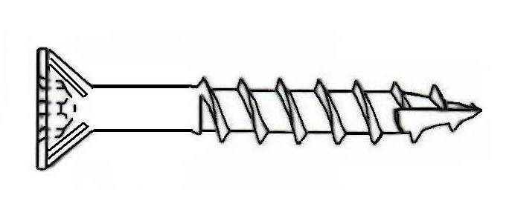


Flat Phillips™ - Lo Root® Thread Type 17 with Nibs
Type 17 w/ Nibs – Black | Quantity |  | Call for Pricing
#8 x 1” | 11M
#8 x 1-1/4” | 9M
#8 x 1-1/2” | 7M
#8 x 1-5/8” | 5.5M
#8 x 1-3/4” | 4.8M
#8 x 2” | 4M
#8 x 2-1/4” | 3.5M
#8 x 2-1/2” | 2.5M
#8 x 3” | 2M
Type 17 w/ Nibs – Zinc | Quantity |  | Call for Pricing
#8 x 1” | 11M | 1M
#8 x 1-1/4” | 9M | 1M
#8 x 1-1/2” | 7M | 1M
#8 x 1-5/8” | 5.5M | 1M
#8 x 1-3/4” | 4.8M | 1M
#8 x 2” | 4M | 1M
#8 x 2-1/4” | 3.5M | 1M
#8 x 2-1/2” | 2.5M | 1M
#8 x 3” | 2M | 1M
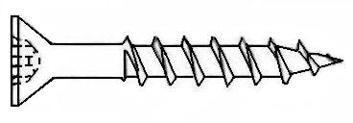

PHILLIPS™ LO ROOT®
Flat Phillips™ Drive Lo Root® Thread | Quantity | Call for Pricing
#6 x 5/8” (Nickel) | 15M
#6 x 5/8” (Zinc) | 15M
#6 x 3/4” (Zinc) | 15M

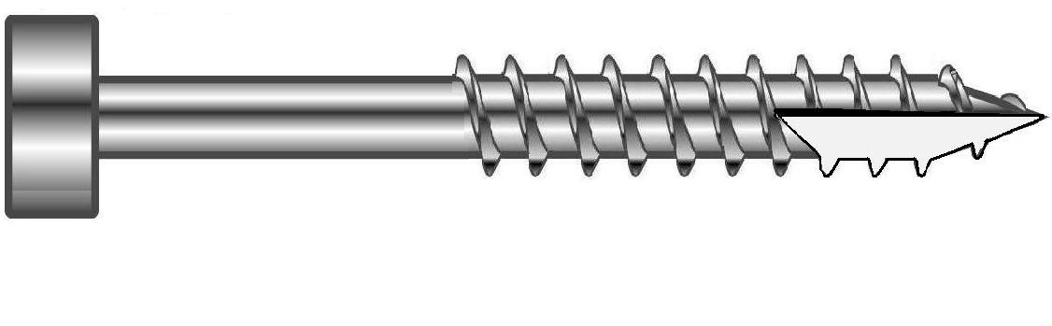

Flat Top Pan Robertson® drive - Type 17 Point Fine Thread
Face Frame Screw - Lubricized | Quantity | Call for Pricing
#6 x 1-1/4” | 15M
#6 x 1-1/2” | 15M
All pricing and information is subject to change without notice.

Pan American Screw
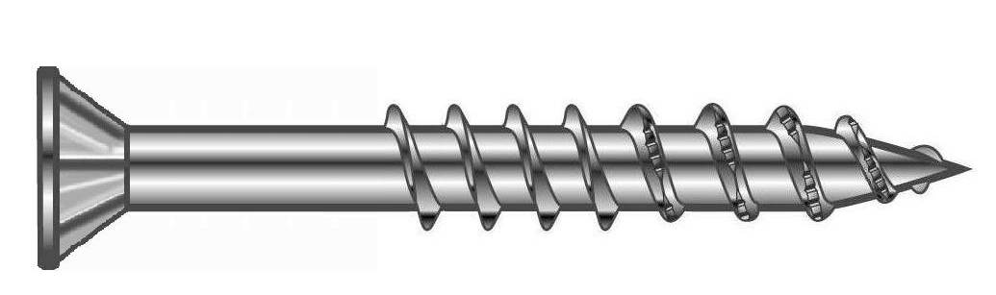


WOODMASTER® - RECEX® Drive - Serrated Tooth Threads
Flat w/ Nibs – Lubricized | Quantity |  | Call for Pricing
#8 x 1” | 10M | 500
#8 x 1-1/4” | 7.5M | 500
#8 x 1-1/2” | 5M | 500
#8 x 1-3/4” | 4M | 500
#8 x 2” | 3.5M | 250
#8 x 2-1/2” | 2.5M | 250
#8 x 3” | 1.5M | 250
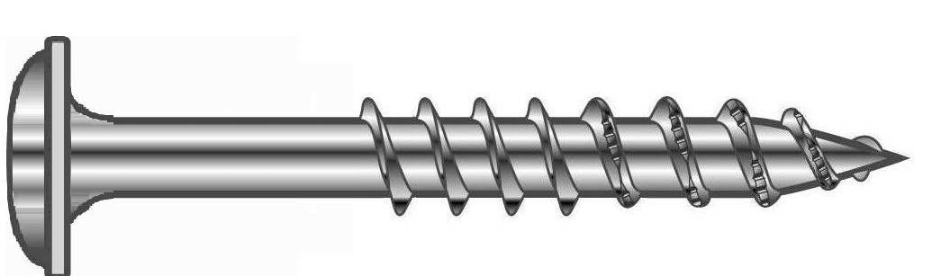

WOODMASTER® - RECEX® Drive - Serrated Tooth Threads
Round Washer – Lubricized | Quantity | Call for Pricing
#8 x 1” | 500
#8 x 1-1/4” | 500
#8 x 1-1/2” | 500
#8 x 1-3/4” | 500
#8 x 2” | 250
#8 x 2-1/2” | 250
#8 x 3” | 250
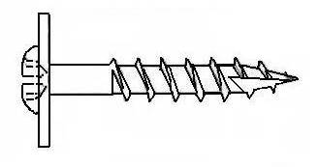


Round Washer Recex® Drive - Lo Root® Type-17
Extra Large Washer Head - 1/2 inch Washer Diameter
Drawer Front Adjustment Fasteners | Quantity | Call for Pricing
#8 x 1-1/4” – Zinc | 5M
#8 x 1-1/2” – Zinc | 4M

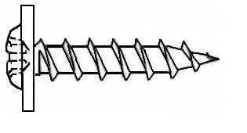

Modified Truss Phillips™ Drive – Lo Root® Thread
Ball Bearing Slide Installation | Quantity | Call for Pricing
#8 x 7/16” – Zinc | 15M
All pricing and information is subject to change without notice.

Pan American Screw
DRIVER BITS
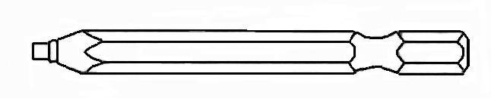

Robertson® / Recex® Driver Bits | Call for Pricing
#2 X 1"
#2 X 2"
#2 X 3"
#2 X 4"
#2 X 6"
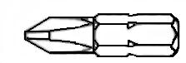

Phillips Bits | Call for Pricing
#2 X 1"
#2 X 2"
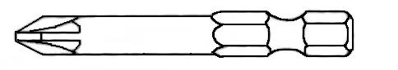

POZIDRIV® Bits | Call for Pricing
#2 X 1"
#2 X 2"

Slides
Full Extension Drawer Slide – Zinc (100 lb Load Rating) | Call for Pricing
14” ZP 46MM F/E B/B Slide (15 pair/box)
16” ZP 46MM F/E B/B Slide (15 pair/box)
18” ZP 46MM F/E B/B Slide (10 pair/box)
20” ZP 46MM F/E B/B Slide (10 pair/box)
22” ZP 46MM F/E B/B Slide (10 pair/box)
24” ZP 46MM F/E B/B Slide (10 pair/box)



FORMFILL COLOR CAULK - 5.5 FL. OZ. TUBE | Call for Pricing
All Pionite Colors (Verify Availability)

All pricing and information is subject to change without notice.

