# Week 1 Requirement

In this assignment, you will build a web design skeleton using HTML/CSS. Your completed work should look just like the image below:

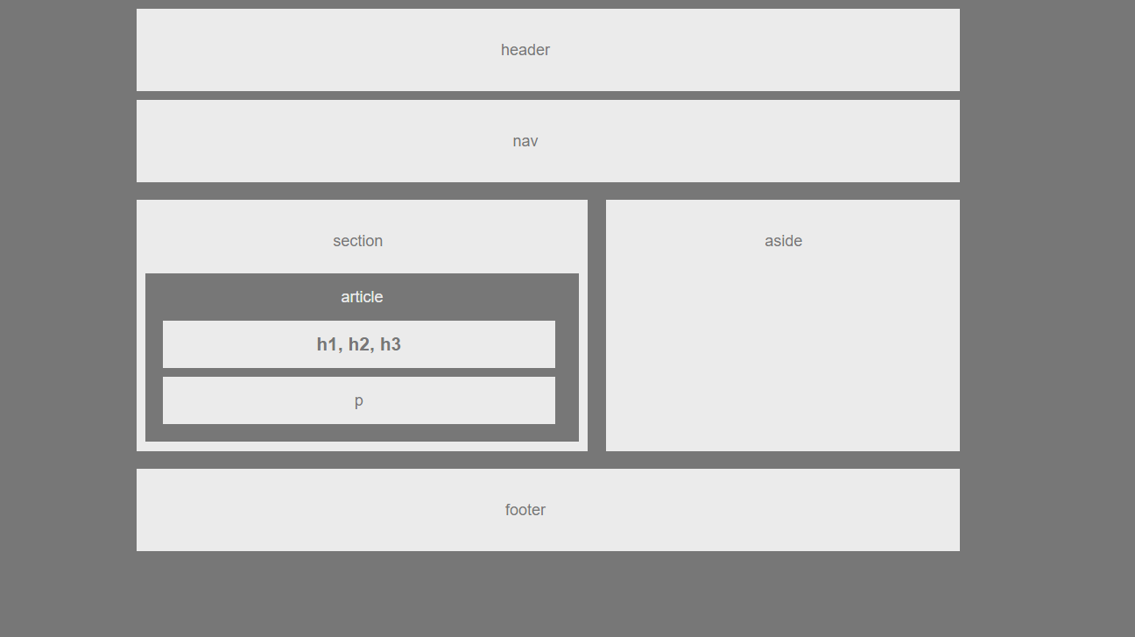

## Design Strategy

Although the Week1 assignment was already submitted, it has to be changed so it can work better with the requirements of Week2.

1. Rebuild the site with frames and boxes
2. Style.css file to include floats to define boxes better
3. Changes on dimensions from original instructions that do not create a friendly user experience, specially the 960px fixed lenght in the margin.
4. Include hover functionality on the navigation buttons

The design of the above framework will be based the following sections:

1. Section Header
2. Section Navigation Panel
3. Section Main Panel
4. Section Article
5. Section Aside
6. Section Footer

### 1. Section Body

Functional Specification 1.0

Body should contain the padding to the sides so all the content of the page stays in the middle

### 2. Section Header

Functional Specification 2.0

Contains the title of the page. It has to call the attention of the user. An animation is ok

### 3. Section Navigation Page

Functional Specification 3.0

Section right defines four buttons. Each button shall trigger the corresponding section page in the same window.

The possibilities are:

- Contact

- About

- Portfolio

- Home

Functional Specification 3.1

Include functionality in the buttons to indicate the user he/she can interact with the page through them.

### 4. Section Main Panel

Main Panel section contains the contect of the main page/index

Functional Specification 4.0

Article sub-section should describe the main purpose of the page. Text only

Functional Specification 4.1

Aside sub-section shall contain a picture of any kind. This is just to indicate we can include a picture later one. Leave the space for the picture if nothing is found by the time of submission.

### 5. Section Footer

Functional Specification 5.0

Footer section shall contain a copyright indicator in all the pages and an email address in the home page. Email address shall not be explicit.