Hypothesis Testing - Video Study Guide
English transcript + Spanish translation + explanation + examples
Source material: user-provided video transcript and screenshots. The guide groups the video into conceptual blocks, keeps key original sentences, translates them into Spanish, and explains the statistics step by step.

User-provided screenshot / pantallazo aportado
This is the accessible screenshot supplied with the message. Additional clean figures below recreate the rest of the video concepts for study purposes.
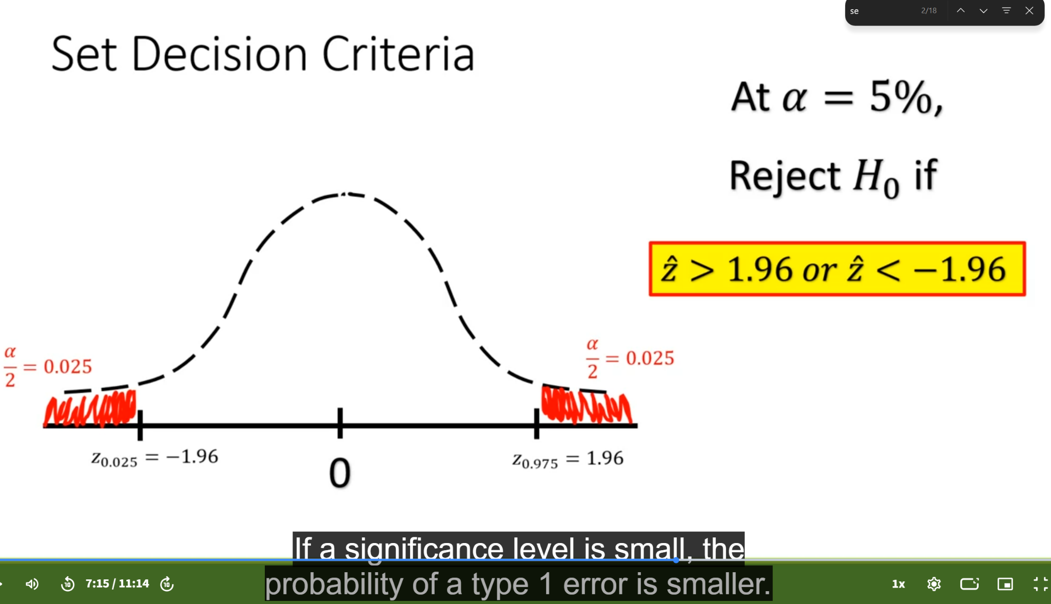

Quick cheat sheet
Concept | Meaning | Spanish memory hook
Null hypothesis H0 | The default claim we test against. | Lo que intentamos rechazar.
Alternative hypothesis Ha | The claim we accept if evidence is strong enough. | Lo que queremos demostrar si rechazamos H0.
Significance level alpha | Maximum tolerated Type I error probability. | Riesgo de falso positivo.
Rejection region | Extreme values where H0 is rejected. | Zona roja de la distribución.
p-value | Probability of observing an equally or more extreme result if H0 is true. | Si p < alpha, rechazo H0.
z-hat / t-hat | Standardized distance between sample mean and hypothesized mean. | Diferencia medida en errores estándar.

1. Why hypothesis testing is needed
Original English | In many situations, we need to demonstrate validity of assertions. Suppose you will invest if average monthly profit is over 20,000. This question is not to ask you to estimate some parameters. Instead, you need to make a judgement whether the condition is satisfied. We need a new statistic tool, hypothesis testing.
Spanish translation | En muchas situaciones necesitamos demostrar la validez de ciertas afirmaciones. Supón que invertirás si el beneficio mensual medio supera 20.000. La pregunta no consiste en estimar parámetros, sino en decidir si se cumple una condición. Necesitamos una herramienta estadística nueva: el contraste de hipótesis.
Explanation | Hypothesis testing is used when the decision is yes/no: should I believe this condition is true? It is different from estimation. Estimation asks “what is the value?” Hypothesis testing asks “is there enough evidence to reject a claim?”
Examples | Investment example: invest only if average monthly profit > 20,000.  Software example: release only if average response time < 200 ms.  Medical example: approve a treatment only if average recovery improvement > 0.
Useful vocabulary | assertion = afirmación; validity = validez; judgement = decisión/juicio; condition is satisfied = se cumple la condición.

2. Visual inspection is not enough: Apple price and returns
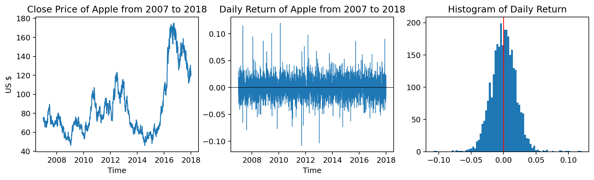
Original English | This is a daily close price of Apple from 2007 to 2018. It looks like the price is in an upward trend and we may guess the average of daily return is positive. However, if we plot the daily return directly, the daily return goes positive, negative. In the histogram daily return, it is approximately symmetric above 0.
Spanish translation | Este es el precio de cierre diario de Apple de 2007 a 2018. Parece que el precio tiene una tendencia alcista y podríamos pensar que la rentabilidad diaria media es positiva. Sin embargo, si representamos directamente la rentabilidad diaria, esta alterna entre valores positivos y negativos. En el histograma, la rentabilidad diaria es aproximadamente simétrica alrededor de 0.
Explanation | A rising price chart can be misleading. The price level accumulates many daily changes. Daily returns are noisy: many positive and negative movements. The histogram helps show the distribution, but even then it may not be obvious whether the true mean is different from zero.
Examples | Bad inference: “the price went up, therefore the average daily return is definitely positive.”  Better inference: “the chart suggests a positive mean, but we need a statistical test.”  Practical rule: visualization suggests; hypothesis testing decides under a controlled error probability.
Useful vocabulary | upward trend = tendencia alcista; daily return = rentabilidad diaria; histogram = histograma; symmetric = simétrico.

3. The core question: positive, zero, or negative?
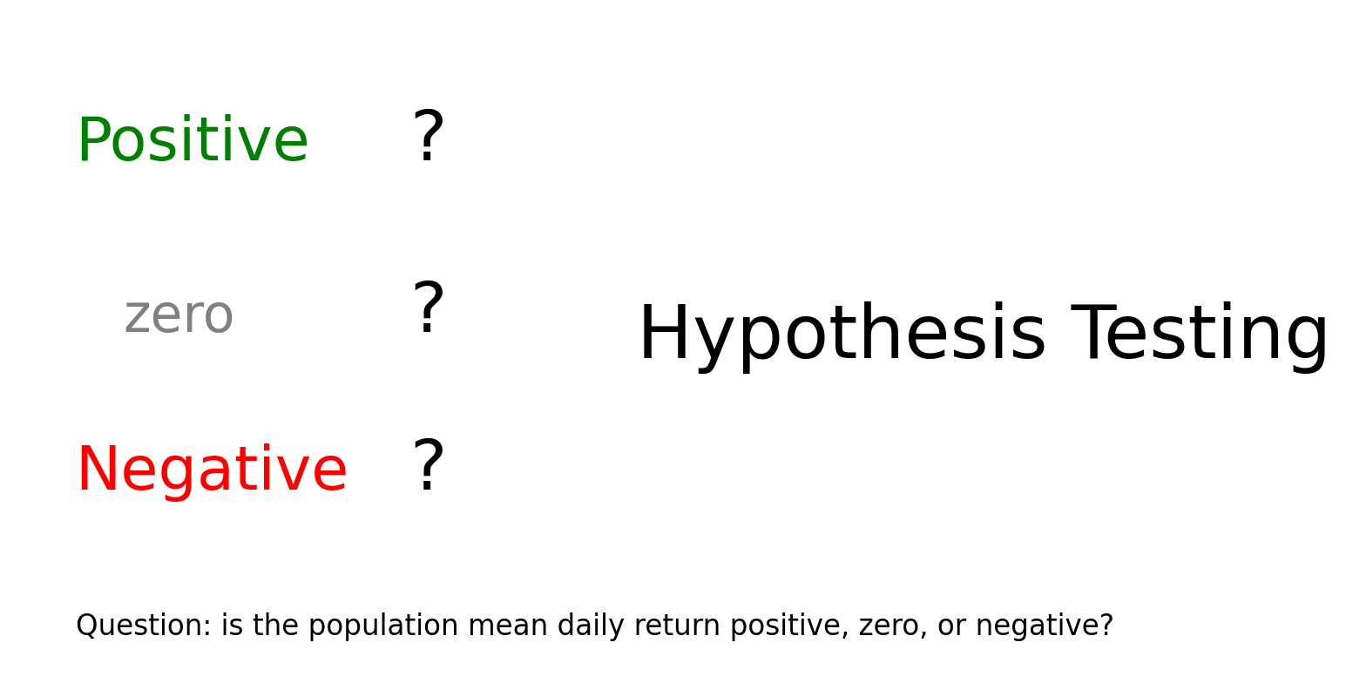
Original English | Our assertion that the average of daily return is positive is not obvious. It is also not obvious whether the average of daily return is 0 or not. We want to use a quantitative statistical tool to make judgement about the assertion that the average daily return is not 0.
Spanish translation | Nuestra afirmación de que la rentabilidad diaria media es positiva no es evidente. Tampoco es evidente si la rentabilidad diaria media es 0 o no. Queremos usar una herramienta estadística cuantitativa para decidir sobre la afirmación de que la rentabilidad diaria media no es 0.
Explanation | The video first tests whether the mean is different from zero. That is a two-tailed problem: the mean could be positive or negative. Later it tests whether the mean is specifically positive. That is a one-tailed problem.
Examples | Two-tailed: “Is the average daily return different from 0?”  Right-tailed: “Is the average daily return greater than 0?”  Left-tailed: “Is the average daily return less than 0?”
Useful vocabulary | quantitative = cuantitativo; conjecture = conjetura; not obvious = no evidente.

4. Null and alternative hypothesis
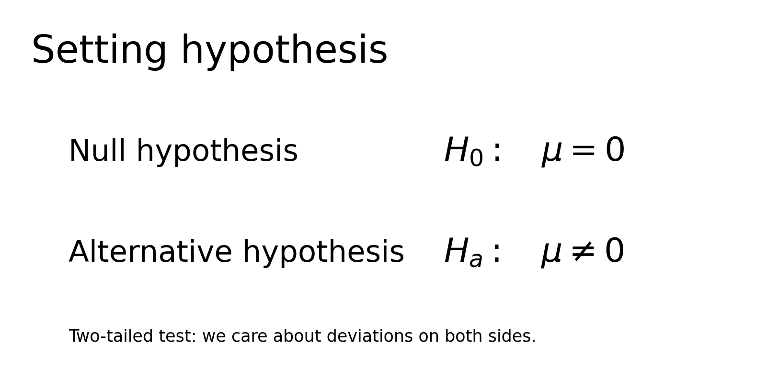
Original English | The first step is to set hypothesis. We have null hypothesis and alternative hypothesis. Usually, the null hypothesis is assertion we are against. Alternative hypothesis is a conclusion we accept whenever we reject the null.
Spanish translation | El primer paso es formular las hipótesis. Tenemos hipótesis nula e hipótesis alternativa. Normalmente, la hipótesis nula es la afirmación contra la que vamos. La hipótesis alternativa es la conclusión que aceptamos cuando rechazamos la nula.
Explanation | The null hypothesis is the default position. In many finance examples, H0 says “nothing special is happening”. The alternative hypothesis expresses the effect you want to detect. Rejecting H0 does not prove Ha with absolute certainty; it means the data are sufficiently incompatible with H0.
Examples | Finance: H0: average return = 0; Ha: average return != 0.  Quality control: H0: defect rate <= 1%; Ha: defect rate > 1%.  A/B testing: H0: conversion rate A = conversion rate B; Ha: they differ.
Useful vocabulary | null hypothesis = hipótesis nula; alternative hypothesis = hipótesis alternativa; reject = rechazar; accept = aceptar.

5. Sample-based decision and standardization
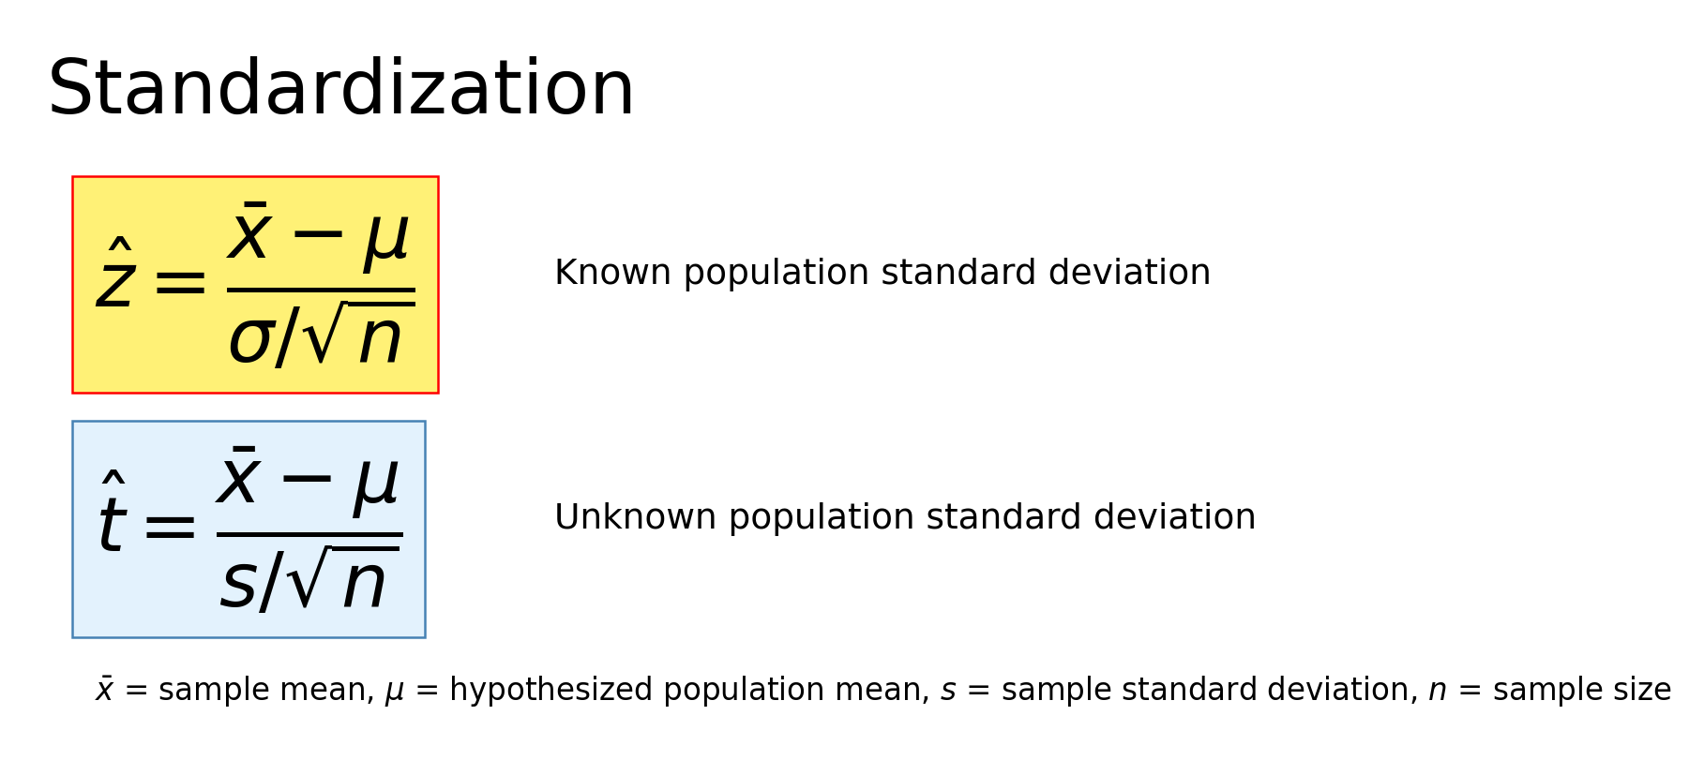
Original English | Whether to reject or not reject null hypothesis is a sample based decision. Given that the null is correct, the difference between sample statistic, x-bar, and the population parameter mu cannot be very large. To measure the magnitude of difference, we also need to consider the standard deviation of the sample, hence we need to do standardization.
Spanish translation | Decidir si rechazamos o no la hipótesis nula es una decisión basada en la muestra. Si la nula es correcta, la diferencia entre el estadístico muestral, x-barra, y el parámetro poblacional mu no debería ser muy grande. Para medir la magnitud de esa diferencia también debemos considerar la desviación estándar de la muestra; por eso necesitamos estandarizar.
Explanation | A difference of 0.01 may be huge or tiny depending on volatility. Standardization divides the difference by the standard error. The result tells us how many standard errors away the sample mean is from the hypothesized mean.
Examples | If average return is 0.1% with very low volatility, it may be significant.  If average return is 0.1% with very high volatility, it may be random noise.  Same difference, different conclusion because the denominator changes.
Useful vocabulary | sample-based = basado en la muestra; sample statistic = estadístico muestral; standard deviation = desviación estándar; standardization = estandarización.

6. z-hat and t-hat: known vs unknown sigma
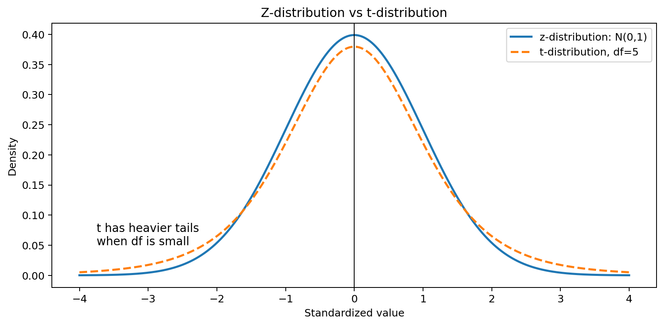
Original English | If we know population standard deviation, the standardized sample mean we denote as z-hat. But in most situations, population standard deviation is not known. Then we can replace population standard deviation with the sample standard deviation. Then this new term denoted as t-hat, has a new distribution, t-distribution.
Spanish translation | Si conocemos la desviación estándar poblacional, al promedio muestral estandarizado lo denotamos como z-hat. Pero en la mayoría de situaciones no conocemos la desviación estándar poblacional. Entonces podemos sustituirla por la desviación estándar muestral. Ese nuevo término se denota como t-hat y sigue una nueva distribución: la t de Student.
Explanation | When population sigma is known, use z. When sigma is unknown and estimated with sample s, use t. In large samples, t becomes very close to z, so the video treats the statistic approximately as z.
Examples | Known sigma: factory process with long-established population variability.  Unknown sigma: stock returns, startup profits, user conversion rates.  Large sample: t and z are almost identical for practical purposes.
Useful vocabulary | population standard deviation = desviación estándar poblacional; sample standard deviation = desviación estándar muestral; bell-shaped = con forma de campana; tails = colas.

7. Degrees of freedom and heavier tails

Original English | The difference lies in the tail. T-distribution had flat tails which implies t has a higher chance to take the values in the two tails. The t-distribution is dependent on the degree of freedom. In our example, the degree of freedom is n-1. As the sample size increases, t is more and more like z-distribution.
Spanish translation | La diferencia está en las colas. La distribución t tiene colas más planas, lo que implica mayor probabilidad de tomar valores en las dos colas. La distribución t depende de los grados de libertad. En nuestro ejemplo, los grados de libertad son n-1. A medida que aumenta el tamaño muestral, la t se parece cada vez más a la z.
Explanation | The t distribution is more cautious for small samples because estimating s adds uncertainty. Heavier tails mean extreme values are less surprising than under a normal z distribution. As n grows, the uncertainty in s decreases.
Examples | Small sample, n=10: use t and be conservative.  Large sample, n=3000 daily returns: z approximation is usually fine.  Degrees of freedom for a one-sample mean test: df = n - 1.
Useful vocabulary | degree of freedom = grado de libertad; flat/heavy tails = colas pesadas; sample size = tamaño muestral.

8. Computing z-hat in Python
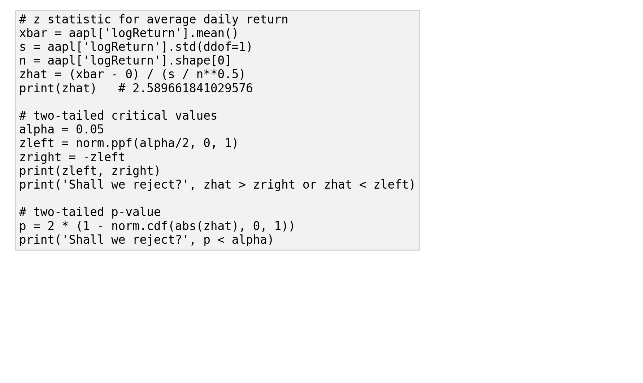
Original English | We can compute z-hat using Python. X-bar is sample mean, average daily return. S is sample standard deviation, n is a sample size. Z-hat equal to 2.5897. It is a standardized statistics. We use mu equal to 0 because we assume the null is correct at the beginning.
Spanish translation | Podemos calcular z-hat usando Python. X-barra es la media muestral, la rentabilidad diaria media. S es la desviación estándar muestral y n es el tamaño de la muestra. Z-hat es igual a 2.5897. Es un estadístico estandarizado. Usamos mu igual a 0 porque al principio asumimos que la hipótesis nula es correcta.
Explanation | The statistic 2.5897 means the observed sample mean is about 2.59 standard errors above zero. Under H0, values this far from zero are uncommon. That is why the test may reject H0.
Examples | If zhat = 0.3, the sample mean is close to 0: probably not significant.  If zhat = 2.59, the sample mean is far from 0: likely significant at 5% in a two-tailed test.  If zhat = -2.59, evidence points to a negative mean.
Useful vocabulary | standardized statistic = estadístico estandarizado; standard error = error estándar; assume = asumir/suponer.

9. Two-tailed test and rejection regions
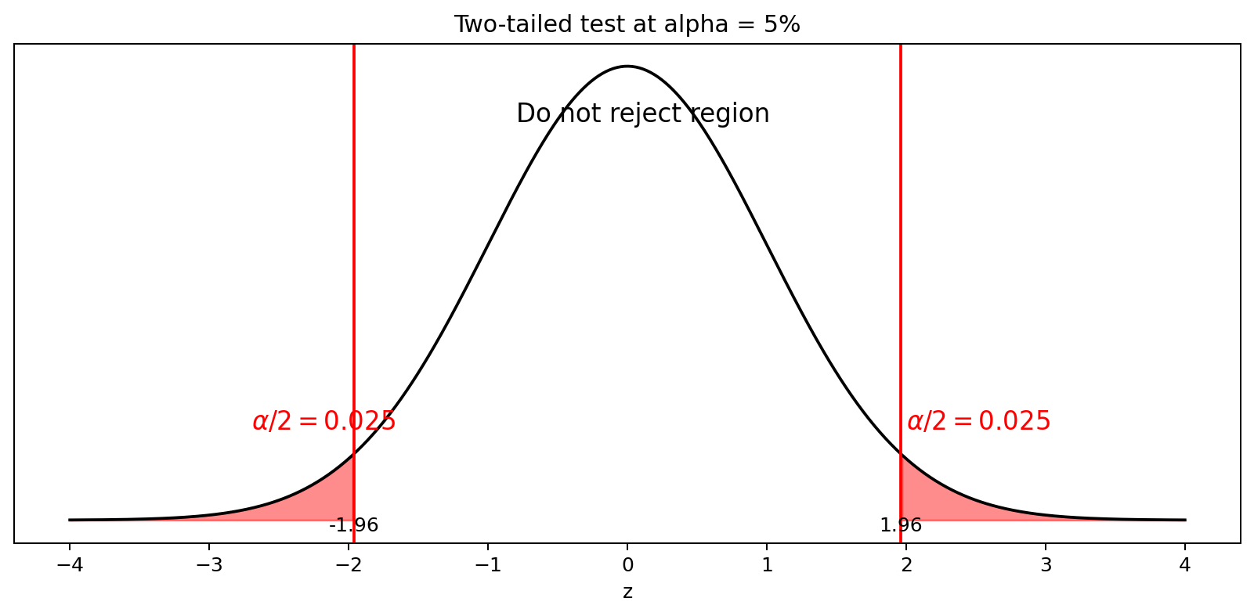
Original English | We fixed the significance level, for example, alpha equal to 5%. We can see that these two domains are z less than -1.96 and z bigger than 1.96. These two domains are called rejection regions and this kind of test is called two-tailed test.
Spanish translation | Fijamos el nivel de significación, por ejemplo alpha igual al 5%. Vemos que las dos zonas son z menor que -1.96 y z mayor que 1.96. Estas dos zonas se llaman regiones de rechazo y este tipo de test se llama test de dos colas.
Explanation | In a two-tailed test, alpha is split into two tails: 2.5% on the left and 2.5% on the right. If zhat is below -1.96 or above 1.96, the result is extreme enough to reject H0 at alpha = 5%.
Examples | H0: mu = 0, Ha: mu != 0.  zhat = 2.59: reject, because 2.59 > 1.96.  zhat = 1.20: do not reject, because it is inside the central region.
Useful vocabulary | significance level = nivel de significación; critical values = valores críticos; rejection region = región de rechazo; two-tailed = dos colas.

10. Type I error: rejecting a true null
Original English | Z-hat is also possible to take values in rejection region even if the null is correct. This chance is equal to alpha 5%. In other words, we have a 5% chance to reject null wrongly. This is called a type 1 error.
Spanish translation | Z-hat también puede tomar valores en la región de rechazo aunque la nula sea correcta. Esa probabilidad es alpha, 5%. En otras palabras, tenemos un 5% de probabilidad de rechazar incorrectamente la nula. Esto se llama error de tipo I.
Explanation | A Type I error is a false positive. You conclude there is evidence of an effect, but in reality the null is true. Alpha controls how often you are willing to make that mistake in the long run.
Examples | Finance: you conclude a strategy has positive returns, but its true average return is zero.  Medical: you conclude a treatment works, but it does not.  Software A/B test: you conclude version B is better, but the difference was random.
Useful vocabulary | Type I error = error de tipo I / falso positivo; wrongly = incorrectamente; long run = a largo plazo.

11. Critical values with Python

Original English | Here, we demonstrate how to get the quantiles which is also called critical values. Alpha equal to 5% is a given. Hence, norm.ppf can be applied to get the quantiles.
Spanish translation | Aquí demostramos cómo obtener los cuantiles, también llamados valores críticos. Alpha igual al 5% es un dato. Por tanto, norm.ppf puede aplicarse para obtener los cuantiles.
Explanation | norm.ppf(q) returns the z value whose cumulative probability is q. For a two-tailed test with alpha=0.05, the left critical value is norm.ppf(0.025) = -1.96. The right one is +1.96.
Examples | Python: norm.ppf(0.025) -> -1.96.  Python: norm.ppf(0.975) -> 1.96.  Decision: reject if zhat < -1.96 or zhat > 1.96.
Useful vocabulary | quantile = cuantil; cumulative probability = probabilidad acumulada; ppf = percent point function.

12. Two-tailed conclusion
Original English | Hence, our final conclusion, we will reject null hypothesis and the average daily return is not equal to 0. Our conclusion may be wrong but it happens only with 5% probability.
Spanish translation | Por tanto, nuestra conclusión final es que rechazamos la hipótesis nula y que la rentabilidad diaria media no es igual a 0. Nuestra conclusión puede ser errónea, pero eso ocurre solo con una probabilidad del 5%.
Explanation | This conclusion is about the specific test at alpha=5%. It does not mean there is zero risk of error. It means the result is statistically significant under the chosen risk threshold.
Examples | Correct wording: “We reject H0 at the 5% significance level.”  Avoid: “We have proven with 100% certainty that the mean is not zero.”  Better: “The data provide statistically significant evidence that the mean differs from zero.”
Useful vocabulary | statistically significant = estadísticamente significativo; threshold = umbral.

13. One-tailed test: proving positivity
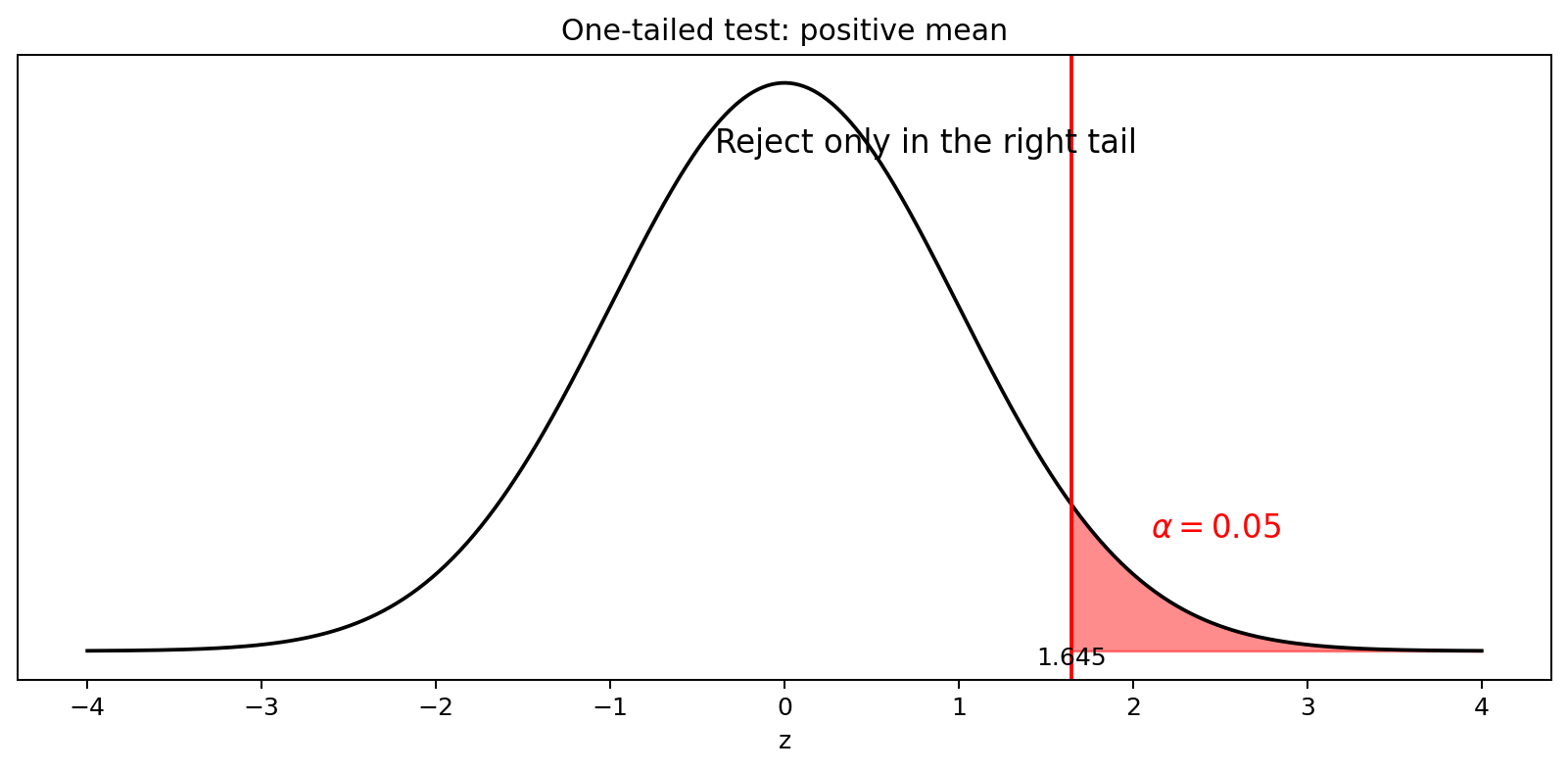
Original English | We may want to further demonstrate that the average return is in fact positive. We need another kind of test, one-tail test. In one tail test, the null is the average daily return is less than or equal to 0. The alternative hypothesis, the average daily return is positive.
Spanish translation | Podemos querer demostrar además que la rentabilidad media es de hecho positiva. Necesitamos otro tipo de test: test de una cola. En un test de una cola, la nula es que la rentabilidad diaria media es menor o igual que 0. La hipótesis alternativa es que la rentabilidad diaria media es positiva.
Explanation | A one-tailed test is directional. You only reject in the direction of interest. Here the direction is positive, so the rejection region is only on the right tail.
Examples | H0: mu <= 0; Ha: mu > 0.  Use this when only a positive effect matters.  Do not use a one-tailed test after seeing the data just to make rejection easier; choose it before testing.
Useful vocabulary | one-tailed = una cola; directional = direccional; positive return = rentabilidad positiva.

14. One-tailed decision rule

Original English | Similarly, we fix significance level alpha, and identify rejection region using z-distribution, which is z-hat is larger than z-alpha. Using Python, we can show that the null is rejected under 5%. It means that the average daily return of a population is indeed positive.
Spanish translation | De forma similar, fijamos el nivel de significación alpha e identificamos la región de rechazo usando la distribución z: z-hat debe ser mayor que z-alpha. Con Python podemos mostrar que la nula se rechaza al 5%. Esto significa que la rentabilidad diaria media de la población es efectivamente positiva.
Explanation | For a right-tailed test at alpha=5%, the critical value is about 1.645. Since zhat=2.5897 is greater than 1.645, H0 is rejected. The data support a positive population mean.
Examples | Right-tailed alpha=5%: reject if zhat > 1.645.  zhat = 2.59 -> reject.  zhat = 1.20 -> do not reject.
Useful vocabulary | right tail = cola derecha; indeed = efectivamente; population mean = media poblacional.

15. Decision criteria summary
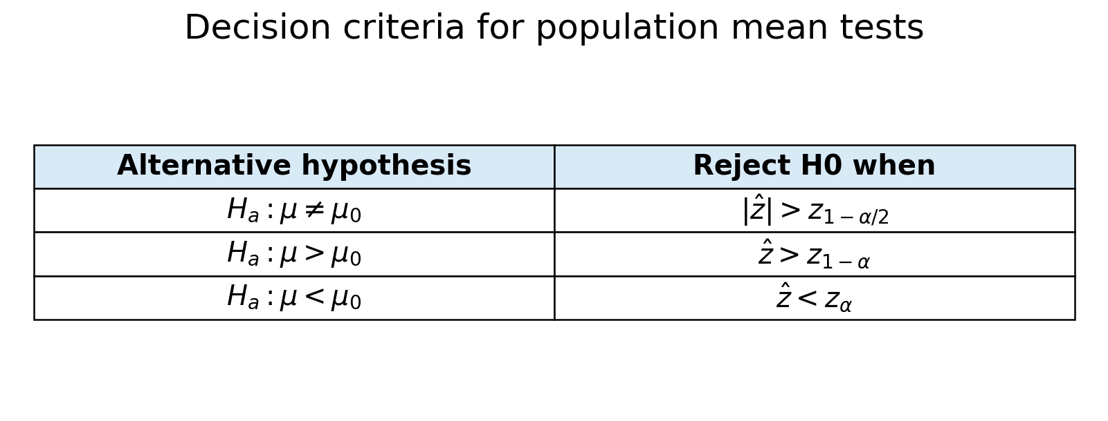
Original English | For population mean, we have these three kinds of hypothesis in the rejection criteria. For different kinds of hypothesis, the criterion is different.
Spanish translation | Para la media poblacional tenemos estos tres tipos de hipótesis en los criterios de rechazo. Para distintos tipos de hipótesis, el criterio es diferente.
Explanation | The alternative hypothesis determines where the rejection region goes. If Ha says “different”, use both tails. If Ha says “greater”, use the right tail. If Ha says “less”, use the left tail.
Examples | Different: H_a: mu != 0 -> two-tailed.  Greater: H_a: mu > 0 -> right-tailed.  Less: H_a: mu < 0 -> left-tailed.
Useful vocabulary | criterion = criterio; rejection criterion = criterio de rechazo.

16. p-value approach
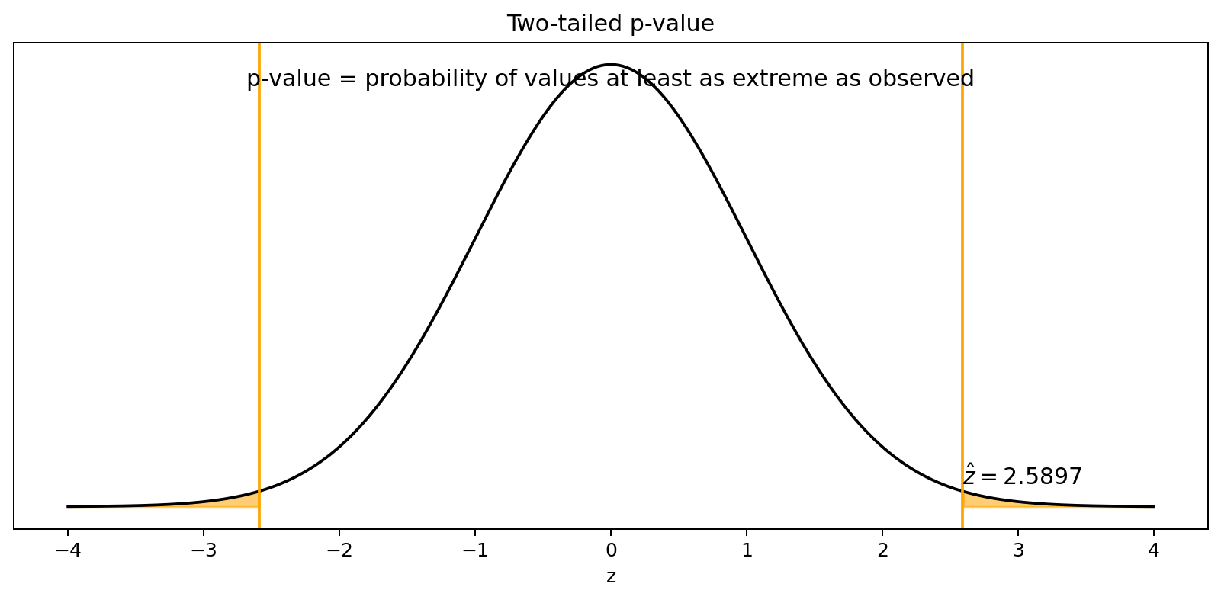
Original English | A more popular way of testing is to compute p-value. What is the probability for this distribution to take a more extreme value than our observation in given sample? This is a p-value. If p is less than alpha, it means that the null is unlikely to be true.
Spanish translation | Una forma más popular de hacer el test es calcular el p-value. ¿Cuál es la probabilidad de que esta distribución tome un valor más extremo que nuestra observación en la muestra? Eso es el p-value. Si p es menor que alpha, significa que la nula es poco probable.
Explanation | The p-value measures extremeness under H0. Small p-value means: if H0 were true, seeing data this extreme would be rare. Then we reject H0. The p-value is not the probability that H0 is true.
Examples | p = 0.0096, alpha = 0.05 -> reject.  p = 0.12, alpha = 0.05 -> do not reject.  Wrong interpretation: “p=0.01 means H0 has 1% probability of being true.”
Useful vocabulary | p-value = valor p; extreme value = valor extremo; unlikely = poco probable.

17. p-value in Python and final wrap-up

Original English | Here is a demonstration of p-value approach. In two-tailed test, abs is to compute the absolute value. We use norm.cdf to compute cumulative probability. In this video, we discussed another quantitative tool which is applied to validate assertion about population.
Spanish translation | Aquí hay una demostración del enfoque basado en p-value. En el test de dos colas, abs se usa para calcular el valor absoluto. Usamos norm.cdf para calcular la probabilidad acumulada. En este video hemos tratado otra herramienta cuantitativa que se aplica para validar afirmaciones sobre la población.
Explanation | For a two-tailed test, both positive and negative extremes matter. That is why abs(zhat) is used. norm.cdf(abs(zhat)) gives the probability to the left of the positive observed value. The right-tail probability is 1 - that value, then multiplied by 2 for both tails.
Examples | Two-tailed p-value: p = 2 * (1 - norm.cdf(abs(zhat))).  Right-tailed p-value: p = 1 - norm.cdf(zhat).  Left-tailed p-value: p = norm.cdf(zhat).
Useful vocabulary | absolute value = valor absoluto; cumulative distribution function = función de distribución acumulada; validate = validar.

Practice exercises
Exercise 1: A startup reports 36 months of profit. You want to test whether the average monthly profit is greater than 20,000. Write H0 and Ha.
Answer: H0: mu <= 20,000. Ha: mu > 20,000. This is a right-tailed test.
Exercise 2: A trading strategy has zhat = 2.10 in a two-tailed test at alpha=5%. Reject or not?
Answer: Reject H0, because 2.10 > 1.96.
Exercise 3: A strategy has zhat = 1.70 in a right-tailed test at alpha=5%. Reject or not?
Answer: Reject H0, because 1.70 > 1.645.
Exercise 4: A p-value is 0.08 and alpha is 0.05. Reject or not?
Answer: Do not reject H0, because p > alpha.
Exercise 5: Explain Type I error in one sentence.
Answer: It is rejecting H0 when H0 is actually true.

Common mistakes to avoid
- Do not say “p-value is the probability that the null hypothesis is true.” It is not.
- Do not choose one-tailed vs two-tailed after seeing the result. Choose it from the research question.
- Do not confuse standard deviation with standard error. Standard error is s / sqrt(n).
- Do not say “accept H0” too strongly. Usually say “do not reject H0”.
- Do not rely only on a price chart. Always test returns when the question is about average return.

