My Trips App

# Overview

The web page template consists of a menu with 2 sections: Trips and Profile. (LogIn and LogOut are nice to have functionalities that can be added as future steps).

## Trips page

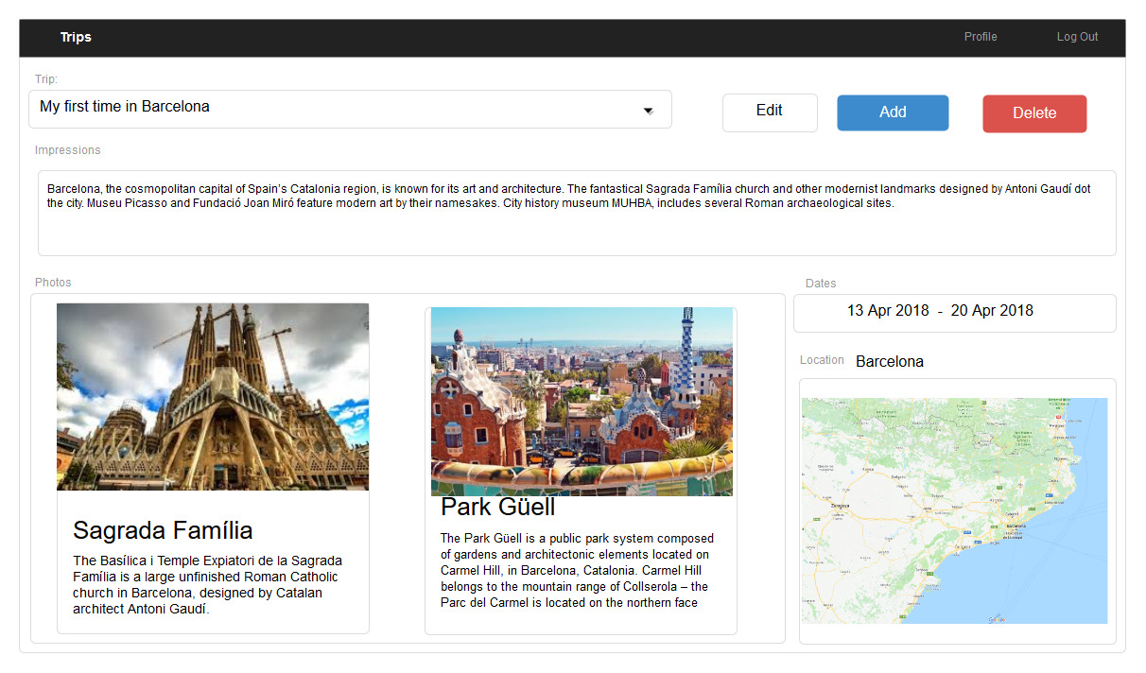

This is the main page of the application. It consists of the following components:

* **Trip**: A drop down with all the registered trips. When a new trip is selected from the dropdown the page will be refreshed to display the details of the selected trip.
* **Edit** button (optional): a window (similar with the Add Trip window) is displayed and all the fields of the active trip are populated and editable.
* **Add** button: The Add Trip Window described bellow will be displayed when Add button is selected.
* **Delete** button: Deletes the active Trip
* **Impressions**: A text area containing the description that the user inserted for the trip.
* **Photos**: Contains two photos with a title and a short description for each one.
* **Dates**: The travel period
* **Location**: A photo of the map location

## Add trip window

## D:\SCI\proiect\add_window.jpg

Details of a new trip have to be specified in this window.

**Trip Name** is a short text unique per user (a user cannot have same Trip Name for multiple trips, but different users can have the same trip name).

**Date From** and **Date To** are the limits of the travel period. (Optional: when clicking on the calendar icon in the right, a pop-up with a calendar will appear).

**Impressions** is a free text, it should have a limit of characters.

In **Photo 1** and **Photo 2** fields the user must specify the path to local disk where the photos are available. The window should also let the user insert details about the photos (not displayed in the mock image).

**Location -** path to local disk where the photos are available. (Nice to have: location can be inserted ether by selecting a location in a map or by simply inserting the gps coordinates in a text field -using google.maps API).

## Profile page

Example:

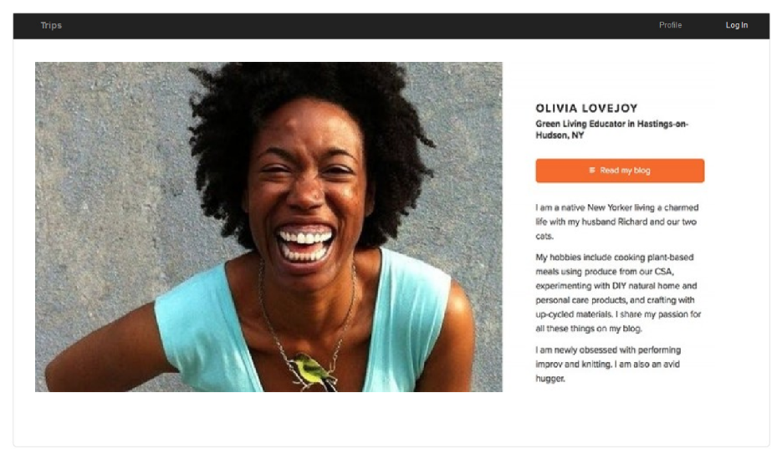

Create a personal profile page with details about you. Same examples to inspire you creating the profile page content:

<https://eusuntv.ro/despre-mine/>

<http://mirceamester.ro/about-2/>

The style used for the user interface is just a proposal. Feel free to change the style, colors, layout, width of the interface as long as you have the components described in the text.

<div class="col-lg-3" th:object="${trips}">  
 <label for="testOrder" text="TRip:">Trip:</label><br>  
 <select class="form-control" id="testOrder" name="testOrder">  
 <option value="">Select Trip</option>  
 <option th:each="trip : ${trips}"  
 th:value="${trip.name}"  
 th:text="${trip.name}">  
 </option>  
 </select>  
</div>

<select th:field="\*{trips}">  
 <option value="">Select Trip</option>  
 <option th:each="trip : ${trips}"  
 th:value="${trip.title}"  
 th:text="${trip.title}">  
 </option>  
</select>