Grab Safety Data Cleaning

1. Remove Duplicate labels
   1. 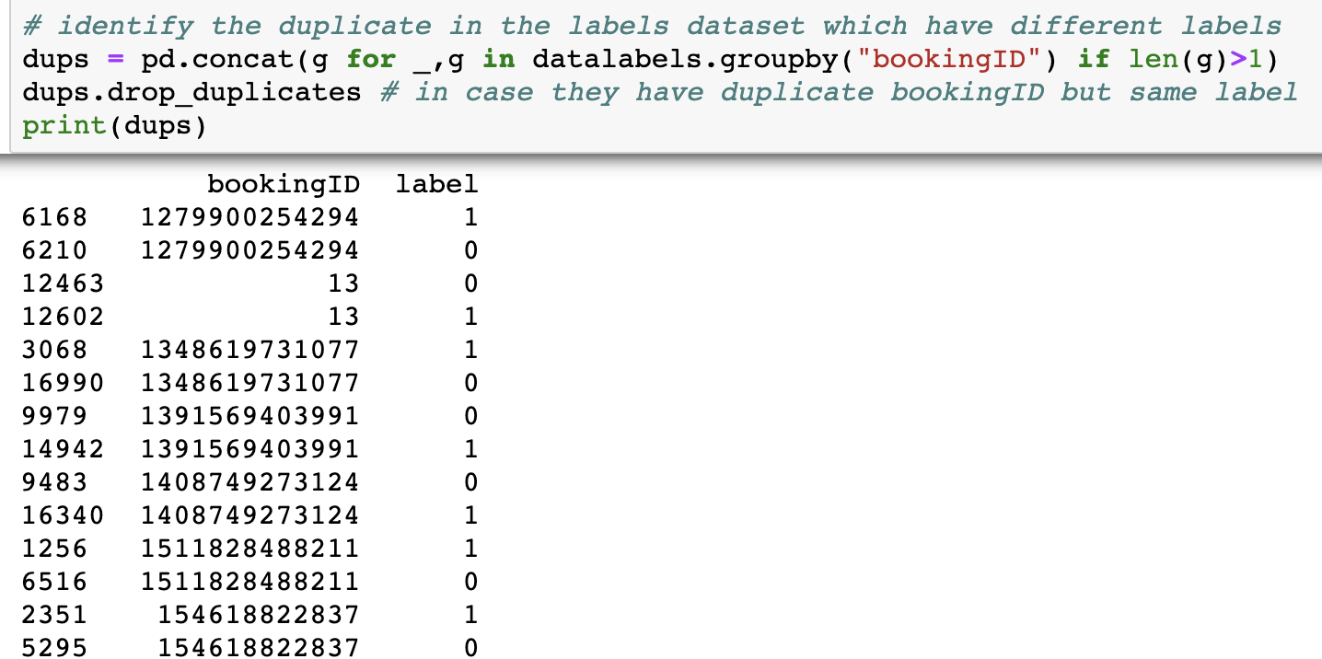
2. Remove raw records where second >= 10000 (more than 2 hours long trip)
   1.  Only some records at the end of the trip which are negative – the rest are correct. (Number of records = Max(second))
   2. Records removed by this rule: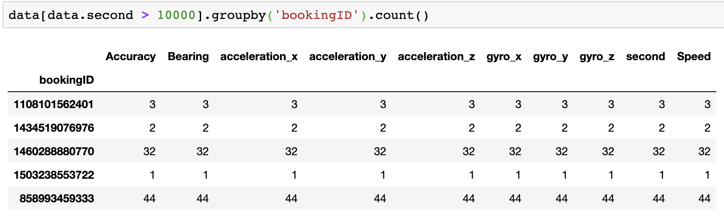
3. If speed suddenly dips to -1 and the x records before/after it are normal (high), use moving average to impute.
   1. Some bookingIDs have majority of records with Speed < 0