To Do Application –

Assumptions -:

* User has one todo list.
* He would add, delete, read, search from that list only.
* Updating an item in the list means that it has been completed ie its state has been changed.
* We have 3 levels of priority. 0 means lowest,1 means middle,2 means highest.
* Date filed is the date by which the task is to be completed i.e. deadline of the task.

My Approach -:

* I have created the application with the assumption that only one list would be there and all the operations would be carried on that list only.
* I have created a database table in PostgreSQL.
* Database has one table todo. It contains fields like Id, title, priority, date and state.
* The Database is connected with our application and all the operations like reading, creating, updating, deleting and searching would then be carried on using API.

Database Schema -:

Database contains one table names as todo. It has fields like Id, title, priority, date and state.

* Id – Id contains unique id of the item that is added in the todo list.
* Title – Title contains the title of the task that is to be done.
* Priority – Priority contains priority of that task. Range of values in priority are (0,1,2) where 0 being the lowest and 2 being the highest.
* Date – Date field contains date of the task it is to be completed before.
* State – State contains whether the task is completed or not. 0 means not completed and 1 means completed.

Steps to run the application -:

* You can use postman or any simple browser to test the application.
* Download the project files.
* Run “NPM INSTALL” to automatically install the dependencies.
* Run “NPM START” to run project.
* Download the Database and import the database in your system with postgres.

Proof -:

Create a Item using “<http://localhost:3000/create>“ route and add the body in the request body. Eg in the screenshot.

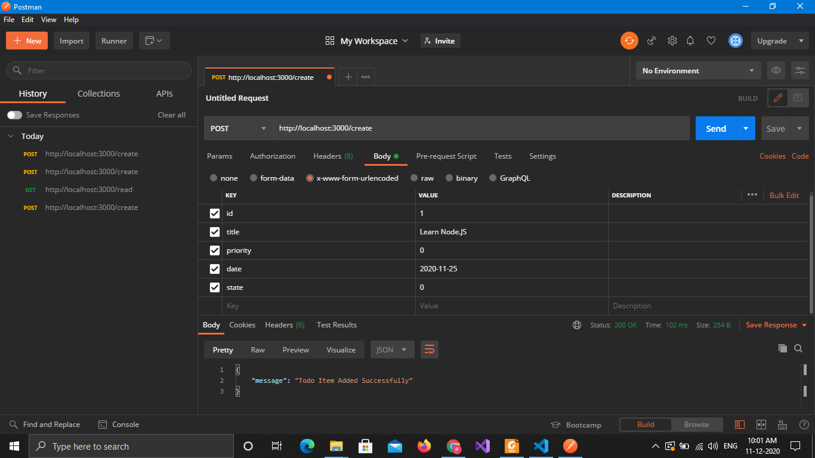

Read the contents of list using <http://localhost:3000/read>.

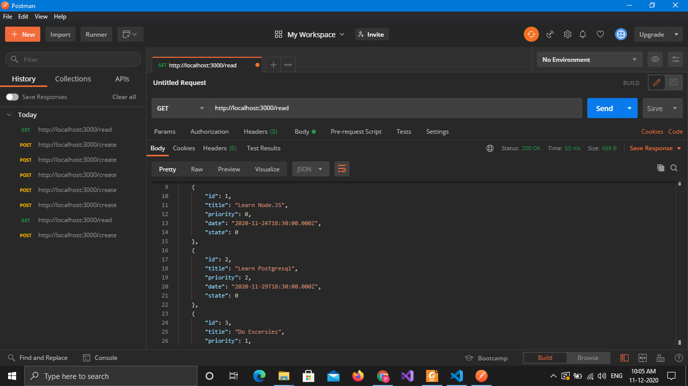

Update the state of any task by providing the id of the task along the api. Eg. <http://localhost:3000/update/2>. This would update the state of task 2 to completed.

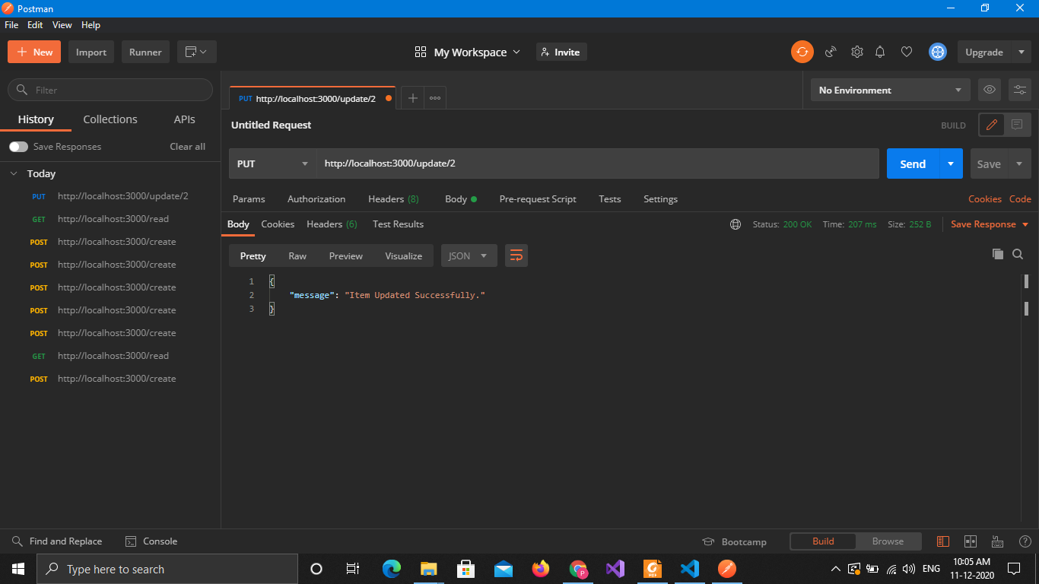

As you have completed task 4, you then need to delete it. You can do that using delete route.

<http://localhost:3000/delete/4>. This would delete task 4 from the list.

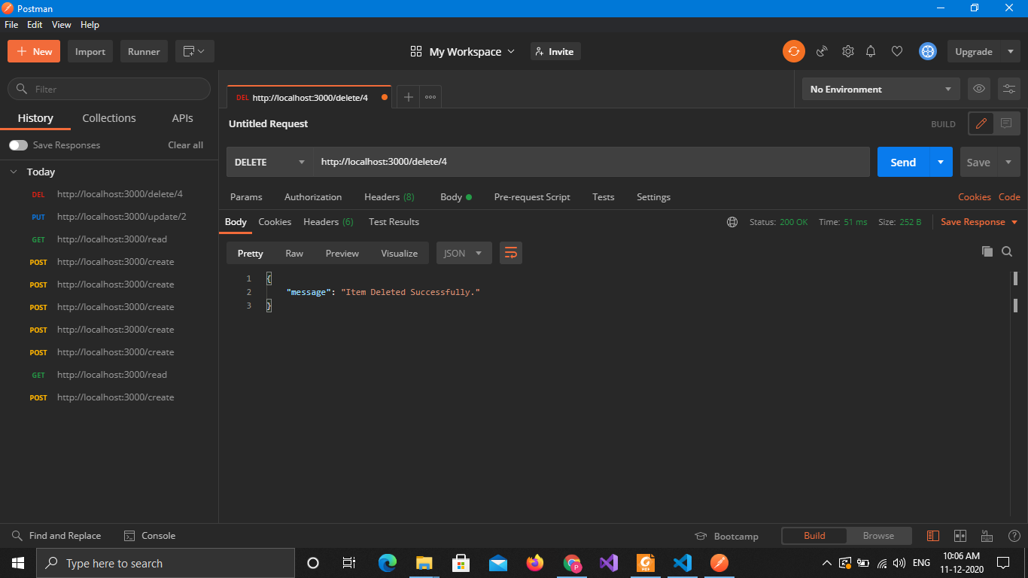

If you wish to search for a particular task using any parameters, you can do that using search route.

“http://localhost:3000/search?priority=2”. This would give result for all the task that had priority of 2. In the same way you can search of any specific title, date, priority and state.

