
UNIVERSITY OF PISA

Large Scale and Multi-Structured Databases

Year 2019/20

OrgaBET
An aggregator website for sport bets, powered by MongoDB

GERARDO ALVARO
SILVIA NOIRJEAN
RICCARDO POLINI
GIULIO SILVESTRI
INDEX

1. INTRODUCTION...…………………………………………………………. |  | 1
2. REQUIREMENTS ANALYSIS…...………………………………………… |  | 2
 | 2.1. Application Actors.....…………………………………………… | 2
 | 2.2. Functional and Non-Functional Requirements……………….. | 2
3. UML DIAGRAMS……...….....……………………………………………… |  | 3
 | 3.1. Use-Case Diagram…..…………………………………………… | 3
 | 3.2. Class Diagram…………………...……………………………….. | 4
4. ENTITIES AND DATABASE ORGANIZATION…................................... |  | 5
 | 4.1. Main Entities.…………………………………………………….. | 5
 | 4.2. E-R Diagram of the DB….……...……………………………….. | 5
5. SOFTWARE ARCHITECTURE……………………………………………. |  | 6
 | 5.1. Repository Structure…………………………………………….. | 6
6. INSTRUCTION MANUAL.………………………………………………... |  | 7
8. CONCLUSIONS...…………………………………………………...............

- INTRODUCTION

OrgaBet, acronym of Organize your Bets, is a web-application that acts as an aggregator for sports betting odds, suggesting to the user which bookmakers offer the best odds for the desired events.
When a visitor lands on the homepage, he is prompted to log-in (signin up first if he is not registered) in order to use the functionalities of the application.
Once logged in, the user is presented with a homepage containing a default match list of the day. The application will have a side panel in which the sport and competition may be selected by the user in order to display all the playable matches for the current date, with the respective average odds. If the user wishes to bet on a certain result, he/she will select the desired odd and the event will be added to “My Coupon”.
“My Coupon” is a recap of all selected events and will be displayed in a side panel. The list will show the total odds for each available bookmaker (sorted by convenience) so that the user may choose the one to bet on. The coupon may be saved by the user: if this happens, the list is saved in an archive accessible through the personal profile.
Some sports statistics are also available in a specific panel, accessible to users. Here one can browse various analytics about Teams and Players of different sports and divisions.

- REQUIREMENTS ANALYSIS

2.1. Application Actors
The actors of the application are the User and the Admin.
The first one is the main user of the application.
The second, has the same functionalities as the regular user but also has additional responsibilities available only to an administrator of the website.

2.2. Functional and Non-Functional Requirements
The functional requirements of this application, divided with respect to the two actors, are as follows:
- The application is available only to registered users.
- The application acts as an aggregator for sports betting odds.
- For each sport, the application presents all the events of the day for the available competitions in the available nations.
- For each event, the application displays the average odds of the available bookmakers.
- For each sport and division, the application presents statistics and analytics relative to the previous years.

- A User selects a result to bet on and this is added to “My Coupon”.
- A User may remove a selected result from “My Coupon”.
- A User may clear “My Coupon”.
- For each element added to “My Coupon”, the application shows the most convenient bookmakers for betting on the selected events, if any.
- A User may save the “My Coupon” in the personal profile.
- A User can browse the saved coupons in his profile
- A User may delete his/her profile.
- A User may edit his/her personal profile.
- A User may remove a previously saved coupon from the personal archive.

- An Admin can view the profiles of registered users, including their coupon archive.
- An Admin can ban users who violate the Terms & Agreements.
- An Admin can add matches to the collection.

The non-functional requirements of the application are:
- The application’s interface must be user-friendly.
- The application must have a low response time.
- The application will store information in a non-relational Database (MongoDB).
- The application must guarantee data availability.
- The application must ensure prevention against server crashes thanks to replicas.
- The application, thanks to sharding, allows the possibility to store more data and handle more load without requiring more powerful machines.
- The application must be easily scalable.
- The application must be reliable: no system crashes, exceptions are handled etc.
- Admins of the application periodically monitor the behaviour of Users in order to guarantee that they comply to the Terms & Agreements.

- UML DIAGRAMS

3.1. Use-Case Diagram
See the linked PDF file for an high-resolution version of the diagram.

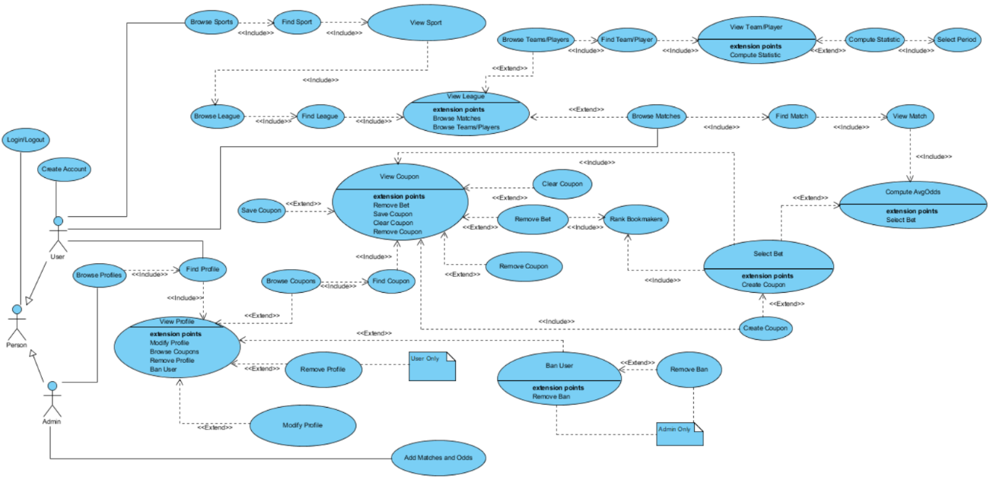
Figure 1: Use-Case Diagram

In the above figure is reported the Use-Case diagram in which we can see: the actors of the application, Admin and Use; their respective action lists and some notes to specify when an action is available only to the admin or only to the user (if it is not already obvious from the diagram).
3.2. Class Analysis Diagram
In Figure 2 are reported the main entities of the application and the relationships among them. User and Admin are generalized into Person.

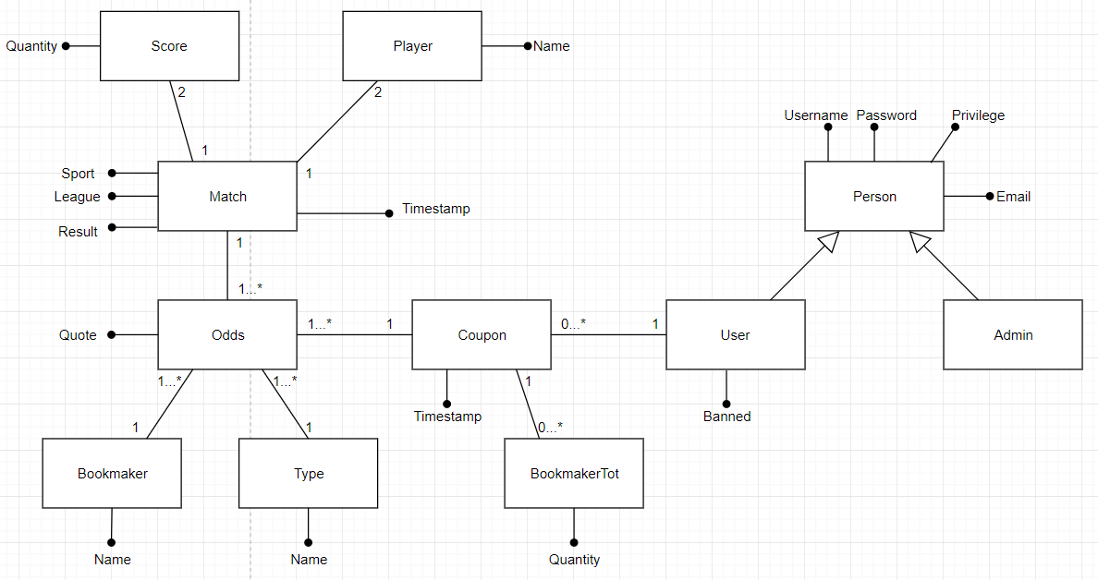
Figure 2: Class Diagram

Each user can create one or more coupons, each of which will be composed of one or more odds and will generate a list of BookmakerTot which represent the multiplier for each bookmaker. Odds are characterized by a bookmaker, a type of bet and a unique quote. All matches are made of two players with the relative score and other fields such as the sport, the league, the timestamp and the outcome of the game.

- ENTITIES AND DATABASE ORGANIZATION
4.1. Data Model
<User>
{
username:
password:
email:
name:
surname:
roles:[]
banned:
coupons: [{
id
date:
bookmakerTot: [{
bookmaker:
quoteTot:
}]
bets: [{
matchId:
homeTeam:
awayTeam:
result:
avgOdd:
quotes: [{
bookmaker:
odd:
}]
}]
}]
}
The roles are provided by a collection used by Spring Security to authenticate users and restrict access to some functionalities (admin only ones).

<Match>
{
sport:
division:
date:
time:
homeTeam:
awayTeam:
fullTimeHomeScore:
fullTimeAwayScore:
fullTimeResult:
odds: [{
type:
quotes: [{
bookmaker:
odd:
}]
}]

//other sport-dependant data in our dataset
}

- SOFTWARE ARCHITECTURE
OrgaBet is a web application programmed with the use of the Spring Framework, an application framework for the Java platform.
Spring uses a Model-View-Controller (MVC) paradigm where the view layer is handled by Thymeleaf, a template engine fully integrated with Spring. Thymeleaf allows the programmer to extend the functionalities of HTML5 tags by adding new types of tags and options fully accessible by the associated java-written controller class.
The back-end is composed of a MongoDB document database which is used by Spring Data, a native MongoDB driver for the Spring Framework.
Altri discorsi su come funziona Spring cazzoh…

schema architettura spring
Figure 4: Software architecture of BibliOS

5.1. Repository Structure
OrgaBet is a Maven project. The project repository is organized as follows:
- ./ : contains the makefile and the POM file used to generate the maven dependencies and build the project.
- src/main/java/com/example/Orgabet: contains all the source files of the application.
  - /controller: contains the controller classes.
  - /repository: contains the MongoDB repository classes, used to store/retrieve data from the database.
  - /dto: contains the Data Transfer Object classes.
  - /models: contains the Java classes that reflect the entities of the application.
  - /config: contains configuration classes used to implement functionalities of the Spring Security extension framework like password encoding and customized Authentication handler.
  - /services: contains functions used to build authorities on registration and authenticate users.
- src/main/resources: contains the subdirectories static and templates which hold all the HTML, CSS and image files used in the application.

- INSTRUCTION MANUAL

Installation
After downloading BibliOS on a UNIX-like system, import the Database schema bibliosDB.sql in a MySQL Server application. After this operation, open the terminal inside the project folder.
If you do not already have maven installed, make sure you have a working internet connection and run the following command:
- sudo apt install maven
BibliOS requires java (version 11 or higher) and javafx (version 11 or higher) to run, install these if you do not already have them.
After installing all the necessary packages, you can run BibliOS by executing the following command:
- make

- CONCLUSIONS
The proposed application is only provided with the main features requested for this task however, it would be possible to implement other functionalities that a realistic context would otherwise require such as: …

