Task 3 proposal document

Task 3 will be a variation of BibliOS, our application for Task 1.
This new version will be modified accordingly to accomodate an implementation of a graph database. More specifically, the new application will not handle the loans of books but rather will be a sort of social portal for book reviews.

Requirements

The requirements have been modified accordingly. Registration of Users was managed by JPA in the previous Task and will stay the same with the difference that it will be performed directly by the User.

Functional requirements:
- A User can browse the catalogue of books in the library.
- A User can rate a book.
- A User can view a book suggestions page, based on user ratings & wish list.
- A User can add a tag to a book. A tag is metadata that identifies in some way the books.
- A User can search books by tag.
- A User can add books to a personal wish-list, used by the application to suggest new books.

- The Admin can add/remove new books to the catalogue.

Non-Functional requirements:
- The application’s interface must be user-friendly.
- The application must have a low response time.
- The application will store information in a Graph Database (Neo4j).
- The application must guarantee data consistency.
- The application must be reliable: no system crashes, exceptions are handled etc.

Use Case Diagram
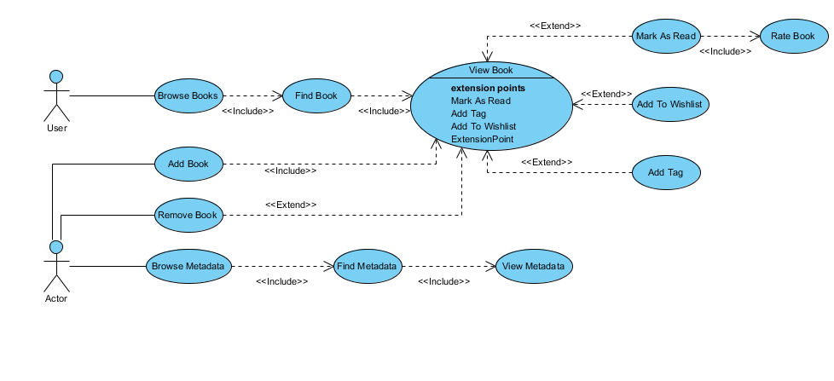
Class Analysis Diagram

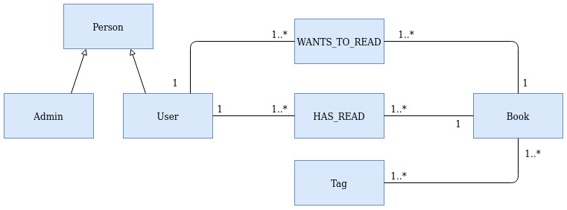
A User can read one or more Books, for which he can provide a Rating.
A User can add one or more metadata tags to a book.
A User can add one or more Books to his Wish-List.

Graph Model

