Import Dataset from Tensorflow:

1. **import** tensorflow as tf
2. **from** tensorflow.examples.tutorials.mnist **import** input_data
3. mnist = input_data.read_data_sets("MNIST_data/", one_hot=True)
4. train_x = mnist.train.images
5. train_y = mnist.train.labels
6. test_x = mnist.test.images
7. test_y = mnist.test.labels
8. **MNIST Fashion Dataset**

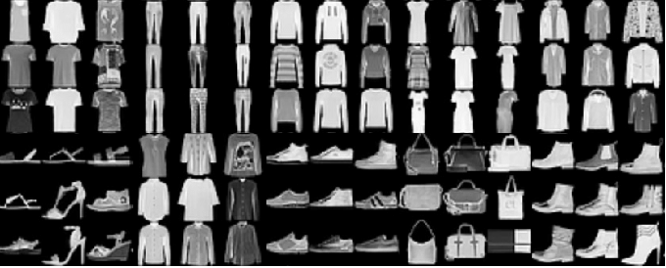

Figure 2: Examples of the images in the Fashion MNIST dataset

**Intro:** Fashion-MNIST contains 70,000 grayscale images of 10 categories’ fashion products like sneakers, trousers and coats. There are 7,000 images in each category. This dataset is more challenging than MNIST dataset therefore it is considered to be a replacement for the original MNIST dataset for benchmarking machine learning algorithms. It shares the same image size(28*28) , data format and the structure of training and testing splits.

**Link to Dataset:** <https://arxiv.org/abs/1708.07747>

**Applications:** Shallow/Deep Neural Networks; CNN; RNN

Import from Keras:

1. **from** keras.datasets **import** fashion_mnist
2. # Setup train and test splits
3. (x_train, y_train), (x_test, y_test) = fashion_mnist.load_data()

Import Dataset from Tensorflow:

1. **import** tensorflow as tf
2. **from** tensorflow.examples.tutorials.mnist **import** input_data
3. mnist = input_data.read_data_sets("MNIST_data/", one_hot=True)
4. train_x = mnist.train.images
5. train_y = mnist.train.labels
6. test_x = mnist.test.images
7. test_y = mnist.test.labels
8. **MNIST Fashion Dataset**



Figure 2: Examples of the images in the Fashion MNIST dataset

**Intro:** Fashion-MNIST contains 70,000 grayscale images of 10 categories’ fashion products like sneakers, trousers and coats. There are 7,000 images in each category. This dataset is more challenging than MNIST dataset therefore it is considered to be a replacement for the original MNIST dataset for benchmarking machine learning algorithms. It shares the same image size(28*28) , data format and the structure of training and testing splits.

**Link to Dataset:** <https://arxiv.org/abs/1708.07747>

**Applications:** Shallow/Deep Neural Networks; CNN; RNN

Import from Keras:

1. **from** keras.datasets **import** fashion_mnist
2. # Setup train and test splits
3. (x_train, y_train), (x_test, y_test) = fashion_mnist.load_data()

**Instructions: Datasets for DL course (2019 Fall):**

**Preparations:**

* **Download the Platform Software: Python 3.7.4 (the latest version)**

Official Download Website: <https://www.python.org/downloads/>

* **Install TensorFlow:** A widely used and open-source library developed by Google for implementing Machine Learning topics. A quick guide to install TensorFlow is available here: <https://www.geeksforgeeks.org/introduction-to-tensorflow/>
* **Install Keras API (Optional but Recommended):** A highly developed Deep Learning API based on Python. There are several guides to build this with TensorFlow Backend:

1. If you are not using Anaconda

<https://www.pyimagesearch.com/2016/07/18/installing-keras-for-deep-learning/>

1. If you are using Anaconda:

<https://towardsdatascience.com/installing-keras-tensorflow-using-anaconda-for-machine-learning-44ab28ff39cb>

**Datasets:**

1. **MNIST Dataset**

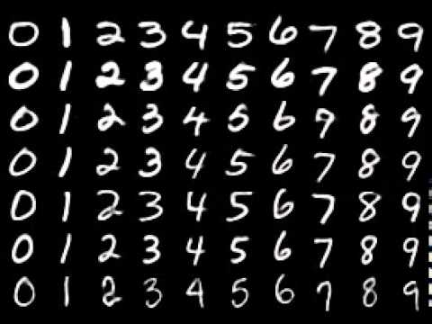

Figure 1: Examples of the images in the MNIST dataset

**Intro:** The MNIST database of handwritten digits, available from this page, has a training set of 60,000 examples, and a test set of 10,000 examples. It is a subset of a larger set available from NIST. The digits have been size-normalized and centered in a fixed-size image.

**Applications: Shallow/Deep Neural Networks; CNN; RNN**

**Link to Dataset:** <http://yann.lecun.com/exdb/mnist/>

Import from Keras:

1. **from** keras.datasets **import** mnist
2. # Setup train and test splits
3. (x_train, y_train), (x_test, y_test) = mnist.load_data()

Import Dataset from Tensorflow:

1. **import** tensorflow as tf
2. **from** tensorflow.examples.tutorials.mnist **import** input_data
3. mnist = input_data.read_data_sets("MNIST_data/", one_hot=True)
4. train_x = mnist.train.images
5. train_y = mnist.train.labels
6. test_x = mnist.test.images
7. test_y = mnist.test.labels
8. **MNIST Fashion Dataset**



Figure 2: Examples of the images in the Fashion MNIST dataset

**Intro:** Fashion-MNIST contains 70,000 grayscale images of 10 categories’ fashion products like sneakers, trousers and coats. There are 7,000 images in each category. This dataset is more challenging than MNIST dataset therefore it is considered to be a replacement for the original MNIST dataset for benchmarking machine learning algorithms. It shares the same image size(28*28) , data format and the structure of training and testing splits.

**Link to Dataset:** <https://arxiv.org/abs/1708.07747>

**Applications:** Shallow/Deep Neural Networks; CNN; RNN

Import from Keras:

1. **from** keras.datasets **import** fashion_mnist
2. # Setup train and test splits
3. (x_train, y_train), (x_test, y_test) = fashion_mnist.load_data()