Palaeogeographic

Chris Southby, Stephen Johnston, Megan E. Lech, Diane C. Jorgensen, Irina Borissova, Liuqi Wang

Introduction

In 2011 as part of the National CO2 Infrastructure Plan, Geoscience Australia started a three year project to provide new pre-competitive data and a more detailed assessment of the Vlaming Sub-basin prospectivity for the geological storage of CO2. An initial assessment of this basin by Causebrook et al. (2006) identified the Gage Sandstone and South Perth Shale (SPS) formations as the main reservoir-seal pair suitable for long-term storage of CO2. The SPS is a thick (up to 900 m) deltaic succession with highly variable lithologies. It was estimated that SPS is capable of holding a column height of CO2 of 663 m at Gage Roads 1 and 308 m at Warnbro 1 based on mercury injection capillary pressure (MICP) tests (Causebrook et al., 2006). Applying a sequence stratigraphic approach, this study defined the South Perth (SP) Supersequence as a second order supersequence and the distribution of pro-delta mudstone facies within the supersequence was mapped across the basin. These facies could provide an effective sub-regional seal in the area and are the focus of this study. Analysis of the spatial distribution and thickness of the effective seal is used for characterisation of the containment potential in the Vlaming Sub-basin CO2 storage assessment.

Methods and datasets

The analysis of the Early Cretaceous SP Supersequence is based on the integration of 2D seismic interpretation, well log analysis and the new biostratigraphic data (Macphail, 2012). Palaeogeographic maps are based on mapping higher-order sequences within the SP Supersequence. The pro-delta facies was mapped as being distal to the slope break and used to characterise mudstone facies in sequences not intersected by wells.

Results

The SP Supersequence is interpreted to comprise two 3rd order sequences (Figures 1a and 1b): Sequence 1 (G. mutabilis) and Sequence 2 (K. scrutillinium to B. jaegeri). Sequence 1 is sub-divided into the Gage low stand systems tract (LST) and a high stand systems tract (HST). Sequence 2 comprises the falling stage systems tract (FSST), a LST, a transgressive systems tract (TST) and a HST.

Figure 1a shows prograding complex of the South Perth Shale, subdivided according to sequence-stratigraphic interpretation into lower shaly and upper sandy units.The Gage LST is located at the right hand side of the line near the Challenger-1 well. To the left of it, the base of sequence 1 is HST. This unit is overlain by a sequence boundary and a FSST unit, an LST unit, a TST unit and an HST unit, followed by another sequence boundary. The top of the pro-delta facies of the prograding inits is shown as a sub horizontal line extending across the deeper portions of the deposits.
 Figure 1b shows a shorter seismic section. In this section, a thicker portion of the Gage LST is present consisting of two sub-units. Above this Gage sequence a series of systems tracts are shown, similar to those in 1a - LST, TST and HST. Again, the systems  tracts are cut by the top of the pro-delta facies that forms a sub-horizontal line across the seismic line.

Figure 1 a) Seismic line Wa227_93_3572 from the southern part of the Vlaming Sub-basin showing prograding complex within the South Perth Supersequence with interpreted systems tracts stages. See figure 3 for location. B) Seismic line HV85A-12 from the northern part of the Vlaming Sub-basin showing prograding complex within the South Perth Supersequence with interpreted systems tracts stages. See figure 3 for location.

**The initial prograding units of the FSST and LST were formed as a result of a forced regression. The TST following the FSST / LST shows an initial rising of the shelf break with minor basinward progradation. There is a backstepping of the deltaic shallow marine shoreline by approximately 20 km from the end of the LST to the top of the TST both in the southern and northern parts of the sub-basin.**

**During Sequence** 1 HST (Figure 2a) sediments from the south were transported down the two canyons located to the east and west of the Sugarloaf Arch. During the FSST (Figure 2b) and LST (Figure 2c), sediments coming from the south east began to fill the depression to the north of the Harvey Ridge, while another deltaic system continues build from around the Sugarloaf Arch. During the TST deltas continue to build in the south, south-west and adjacent to the south eastern margin of the basin. The southern shore line regresses approximately 20 km northwards during Sequence 2 FSST and LST (Figure 2d) and transgresses back southwards approximately the same distance during the TST.

**The sediment supply to the northern depocentre** probably came from the trough located to the east of the Edwards Island Block. The prograding units of Sequence 2 FSST and LST in the northern part of the sub-basin build southwards following the underlying palaeotopography with the shoreline regressing by approximately 18 km (Figures 2b and 2c). During Sequence 2 TST (Figure 2d) the shoreline transgresses back to almost the same position as at the end of Sequence 1 HST.

The pro-delta mudstone facies, mapped as the effective seal, builds out into the Vlaming Sub-basin during all phases of deposition and eventually cover almost the entire Gage LST reservoir by the end of the Sequence 2 HST.

A series of four figures showing the palaeogeography for different systems tracts starting from the end of Sequence 1  and continuing through the end of Sequence 2. Figure 2a (HST; left) and 2b (FSST; right) show the progressive build-up of the delta into the restricted marine area from the north and the south. By the end  of the FSST, the delta had only extended a short distance over the Gage sands. Figures 2c and 2d show progressive filling up of the basin during LST and TST with the front of the delta moving from the south to the central part of the basin, while the nothern delta remained restricted roughly to the same extent confined to the Rottnest Though.
 Figure 2 also shows the location of seismic lines presented  Figure 1a and b. Both lines extend N-S, 1a is located in the SW portion of the SPS and 1b in the NE portion of the SPS.

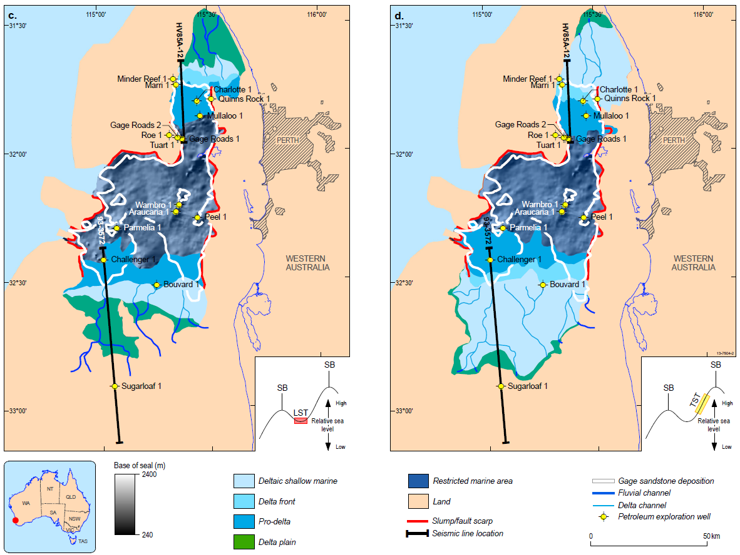

Figure 2 a) Palaeogeographic map for the end of Sequence 1, highstand systems tract. b) Palaeogeographic map for the end of Sequence 2, falling stage systems tract. c) Palaeogeographic map for the end of Sequence 2, lowstand systems tract. d) Palaeogeographic map for the end of Sequence 2, transgressive systems tract.

Summary

* Sequence stratigraphic analysis of the SPS resulted in defining two 3rd order sequences
* Each of these sequences has been split up into several system tracts stages reflecting relative changes in the sea level and sediment supply
* Palaeogeographic maps for these stages reveal a series of regressions and transgressions leading to filling in the palaeotopographic depression by the deltaic succession
* The pro-delta facies at the base of this succession cover most of the Gage LST reservoir and with the known MICP results (Causebrook et al., 2006) is likely to provide an adequate seal for the CO2 storage in the Vlaming Sub-basin.

References

CAUSEBROOK, R., Dance, T., and Bale, K., 2006, Southern Perth Basin site investigation and geological model for storage of Carbon dioxide.: CO2CRC, RP06-0162.

MACPHAIL, M., 2012, Palynostratigraphic analyses of samples encompassing the Valanginian unconformity in Challenger 1, Mullaloo 1, Parmelia 1, Peel 1, Quinns Rock 1 & Warnbro 1: Warnbro & Parmelia groups, Vlaming Sub-basin, Perth Basin.