Test Report Template
Student | Gerardo Galván Olvera | Date | 10/2/18
Program | Program 5 | Program # | 5
Instructor | Adriana B. | Language | Python

Objective of all tests: Revise if program gives correct results.
Description of all tests: values are supplied to the program as described in the picture below.

Conditions of all tests: The program is executed once, exclusively per test with no preconditions.

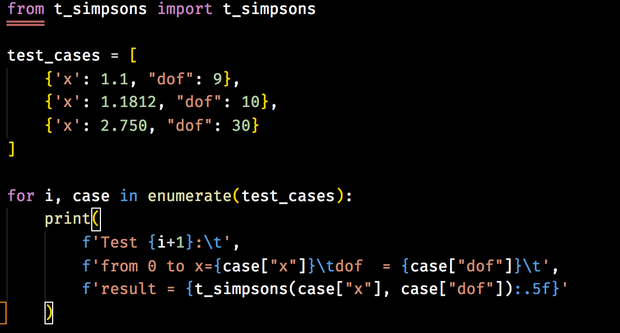

Furtherly explained, the input data was:
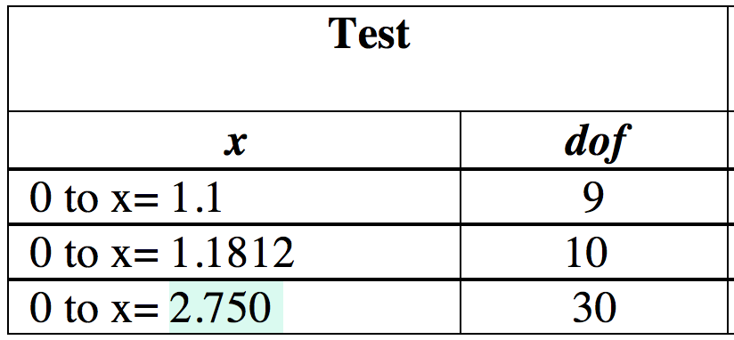
for each test, respectively
Expected results:
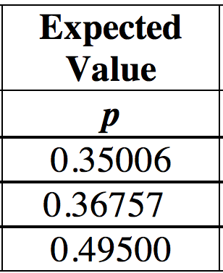
for each test, respectively

Actual results
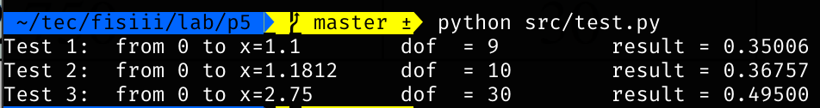
Test Report Template Instructions
Purpose | - To maintain a record of the tests run and the results obtained  - To be sufficiently complete so that you can later re-run the same tests and get the same results  - To facilitate regression testing of modified or reused programs
General | - Expand this table or use multiple copies as needed.  - Report all the tests that were successfully run.  - Be as brief and concise as possible.
Header | - Enter your name and the date.  - Enter the program name and number.  - Enter the instructor’s name and the programming language you are using.
Test Name/Number | Uniquely identify each test for each program.  - the same tests with different data  - the same data with different tests
Test Objective | Briefly describe the objective of the test.
Test Description | Describe each test’s data and procedures in sufficient detail to facilitate its later use as a regression test.
Test Conditions | - List any special configuration, timing, fix, or other conditions of the test.  - When multiple tests are run with different parameters or under varying conditions, separately list each.
Expected Results | List the results that the test should produce if it runs properly.
Actual Results | List the results that were actually produced.

