# 1. Problem Identification

Traditional measurement methods for monitoring a person’s breathing are often manual, these approaches are inefficient, prone to error, and not continuously tracked, yet irregular breathing or temporary cessation of breathing can be life-threatening if not noticed.

Thus, this design includes a wearable breathing sensor, in which it alerts the caregiver to any abnormal respiration, thereby enabling prompt intervention.

# 2. Research/Theory

## 2.1 Mathematical Foundation of Resistance and Strain

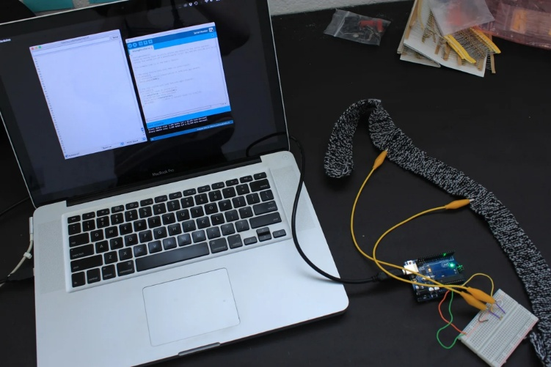The essence of the breathing sensor used in this design is a knitted conductive stretch sensor around the chest. It is made from interwoven conductive thread whose electrical resistance changes with its geometric shape ($R=ρ\frac{L}{A}$) (Lumen Learning, 2025). As the sensor stretches during user’s inhalation, its effective length ***L*** increases and its cross-sectional area ***A*** decreases due to the material deforms under tension. This makes electrons more difficult to path through the thread and therefore increases ***R***. The geometric effect of this sort is the primary case for resistance change in many conductors under strain (Wikipedia, 2025). In this application, the act of breathing from users changes the ratio of ***L/A*** and thus the resistance of the sensor, as the user breaths in, the sensor is under tension (high ***L***, low ***A***) which increases its resistance. Exhalation is the opposite. After conversion of the resistance to output voltage, the Arduino’s analogue input captures the output voltage change as a waveform in order to model chest motion (i.e. breathing motion).

Figure 1: Example of testing the stretch sensor

## 2.2 Conductive Material Selection

Here it is necessary to distinguish between conductive threads and conductive rubbers. As the conductive rubber stretches, the conductive particles of the band spread apart, and therefore electrons take a less direct pass (Adafruit, 2025). This increases the sensor’s resistance. By contrast, a metal based conductive thread

## 2.3 Circuit Selection

Arduino cannot measure resistance directly; it can only measure voltage. So, there are two ways to covert resistance into output voltage:

* First, using the Ohm’s Law ($V=I∙R$), and let ($I=constant$), then $V∝R$. This approach is very accurate, but it is not easy to achieve, especially for a simple microcontroller-based design – it requires additional power regulation components to achieve a stable current source.
* Second, using a voltage divider, it is a simple circuit on which the breathing sensor is connected in series with a fixed resistor, the output volage (i.e. the voltage measured by the Arduino) is such that: $V_{out}=V_{in}×\frac{R_{sensor}}{R_{ref}+R_{sensor}}$ (Hamel, 2025), as the user inhales, $R_{sensor}$ increases, so does $V_{out}$. When the user exhales, $R_{sensor}$ decreases, reducing $V_{out}$. This creates a continuous breathing waveform and can be analysed to determine breathing rate (a.k.a. BPM, breaths per minute).

This design adopts the second approach, namely, the voltage divider, since it is easy to achieve, cheaper, no extra power regulation needed (unlike the first approach) and allows direct integration with microcontrollers that read analog voltage data.

# 3. Circuit Design

Alligator clips attach the sensor to a simple circuit on a breadboard to form part of a voltage divider as shown below.

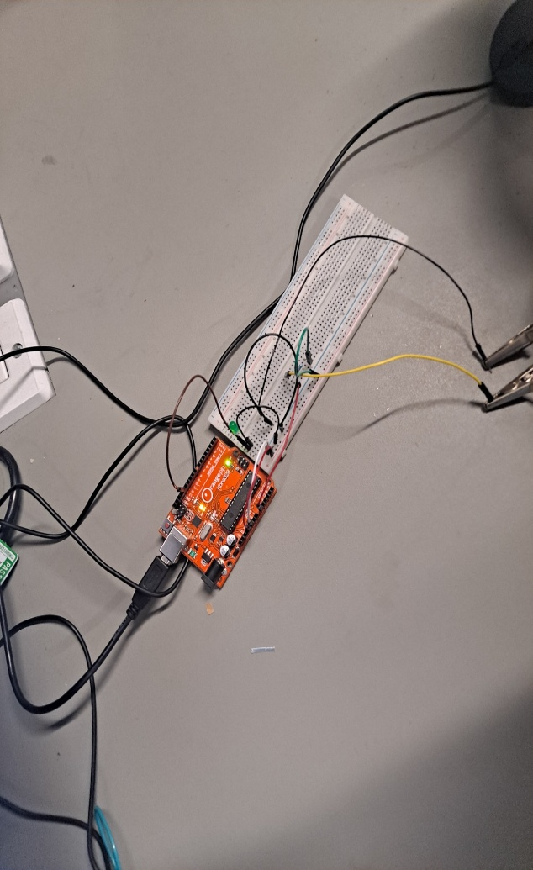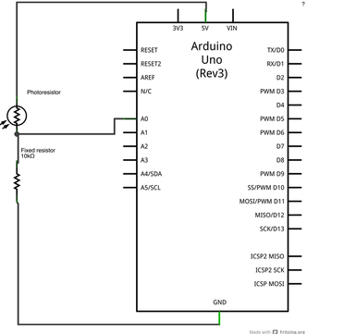

Figure 2: circuit diagram of breathing sensor

In a voltage divider, the sensor (with resistance R_sensor) is placed in series with a fixed reference resistor (R_ref) (108 ohms). One end of this series pair is connected to a known supply voltage (+5V from the Arduino), and the other end to ground. The junction between the two resistors generates an output voltage V_out that depends on the ratio of the two resistances. The voltage divider equation shows: $V_{out}=V_{in}×\frac{R_{sensor}}{R_{ref}+R_{sensor}}$. In our circuit, we choose the configuration such that when R_sensor increases (inhalation), the V_out also increases, and the Arduino’s analogue input pin reads V_out, thereby creating an analogue waveform to model the chest motion. This approach eliminates the need for additional power regulation components and uses Ohm’s law to produce a measurable voltage. Moreover, the response of which is continuous, this means that every small change in band resistance generates a corresponding analogue voltage change, which facilitates the analysis of relative breathing depth and rate further (after appropriate calibration).

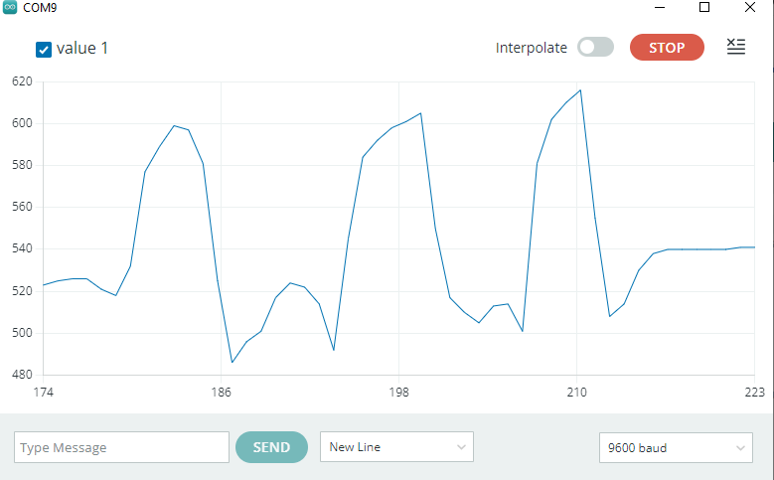

# 4. Calibration and Stability Considerations

# References

[1] **Lumen Learning**, *20.3 Resistance and Resistivity*. Available at: <https://courses.lumenlearning.com/suny-physics/chapter/20-3-resistance-and-resistivity/> (Accessed: 9 March 2025).

[2] **Adafruit**, *Conductive Yarn - Stainless Steel - 524ft/160m on Spool*. Available at: <https://www.adafruit.com/product/519> (Accessed: 9 March 2025).

[3] **Wikipedia**, *Piezoresistive effect*. Available at: <https://en.wikipedia.org/wiki/Piezoresistive_effect> (Accessed: 9 March 2025).

[4] **Hamel, L.,** *Sensors and Voltage Dividers*. Available at: <https://homepage.cs.uri.edu/faculty/hamel/workshops/as220-sept-09/sensors-voltage-dividers.html> (Accessed: 9 March 2025).

[5] **Skach, S. and Stewart, R.,** *Initial Investigations: E-Textiles*, available at: <https://www.sophieskach.com/media/research/2_SkachStewart_InitialInvestigationsETextiles.pdf> (Accessed: 9 March 2025).

[6] **Instructables**, *DIY Breath Sensor with Arduino (Conductive Knitted Stretch Sensor)*. Available at: <https://www.instructables.com/DIY-Breath-Sensor-with-Arduino-Conductive-Knitted-/> (Accessed: 9 March 2025).