# Expert Report Template for *Court Case*

Expert’s Name

## Introduction

Scope of Project: *Specify here who is retaining you and what you are trying to determine. For example:* “to determine if there is racially polarized voting in ____ ”*.*

Summary: *give a quick overview of the findings, and state conclusions as to the extent of polarized voting. Give brief details about why you find this to be true.*

*For example:* “I find that in ___ there is indeed racially polarized voting. This is evident from my analysis showing that when there is a black candidate, the black voters cohesively support this candidate, while white voters vote to oppose her.”

## Qualifications

*Give brief discussion about your qualifications as a witness if necessary.*

## Methodology

*Boilerplate text here about racially polarized voting and methods of homogeneous area, Goodman’s ecological regression, and King’s ecological inference. Give overview of what these analyses are and how they work.*

*For example:*

”In order to establish racially polarized voting, one must show that the specific minority group votes as a bloc for their preferred candidate and the majority votes as a bloc against the minority. These are the criteria known as Gingles Two and Three, established in the *Thornburg v. Gingles (1986)* Supreme Court case. This test, appearing in many subsequent cases, is well accepted as the basis upon which to demonstrate a violation of Section 2 of the Voting Rights Act.

In order to demonstrate these criteria, it is necessary to pull election results as well as demographic data and do statistical analysis to determine the voting behavior by race or ethnicity. Experts frequently use King’s ecological inference as a method to demonstrate racially polarized voting, corroborated by other ecological inference methods. In this report I have used the Homogeneous Area method, Goodman’s Ecological Regression, and Ecological Inference (EI) in order to verify my results across multiple accepted methods.”

*Text about where the data comes from. This is critical to show validity of results.*

*For example:* “The demographic data is pulled from the U.S. 2010 census data available online, and was then matched with precincts by matching data with shapefiles through GIS. The election results for (list elections here) were obtained through the office of the Secretary of State.”

## Findings

*Report findings by election. For each contest, make sure to include a discussion of input data and results. Points to discuss include:*

* *Why you chose that contest. For example, if your case is dealing with school districts and school board elections, analyze past school board elections. If you use supplementary election results that are not school board elections to show racial polarization, make sure to explain how this shows the breadth of polarization in the area.*
* *Whether the elections have a minority candidate or not. Would be useful to include some that do (likely easier to show polarization), and some that do not as a control. Discuss the makeup of the candidates in each race and why it matters.*
* *Outcomes of races. If minority candidates never win, it is useful to point this out as evidence in support of a minority vote dilution claim.*
* *The meanings of tables and figures included, and your report on patterns observed (more details to follow).*

*INSERT TABLES AND FIGURES FROM PDF OUTPUT of SHINY APP BY CANDIDATE*

*Insert table showing vote share given by each of the three methods and give discussion of numbers. Insert Goodman’s regression figure with discussion. Insert Ecological Inference figure with discussion*

*For example:*

“For Candidate 1: Hardy

*Table 1: Hardy’s results in (Insert which election)*

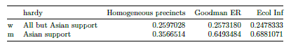

The above table shows that under both Goodman’s ecological regression model and King’s ecological inference model, the minority Asian population support Hardy at a high percentage than the non-Asian population. Goodman’s ER shows that 64.93%of Asian voters support Hardy, while Ecological Inference shows 68.8% Asian support. Meanwhile the rest of the population supports Hardy at a significantly lower percentage. Goodman’s ER shows 25.73%, and Ecological Inference shows 24.78% of non-Asians support Hardy. The homogeneous precinct analysis shows a less polarizing account. However, it should be noted that this method is inaccurate when considering a large number of districts where none has a population close to 100% of a specific racial group, which is the case with this data. For further discussion of the homogeneous precinct analysis, see the discussion accompanying Figure 1.

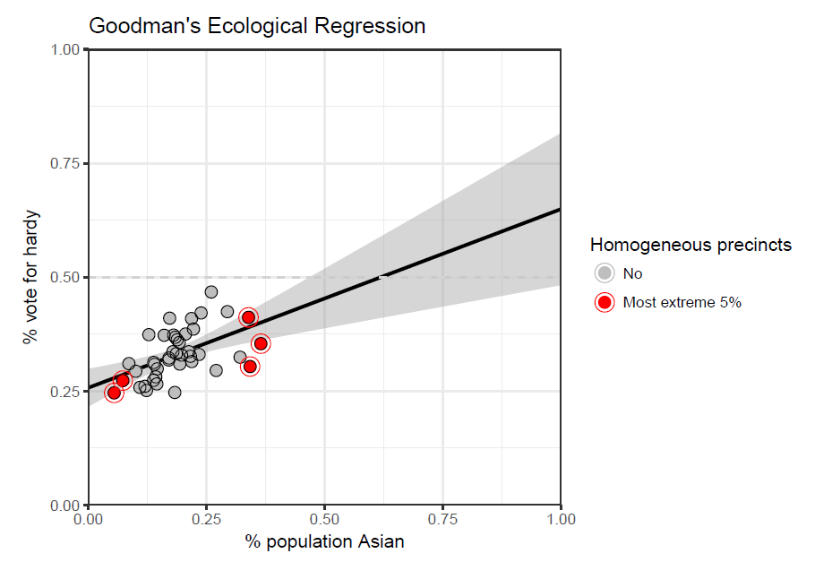

*Figure 1: Ecological Regression model for Hardy in (insert election here)*

The above figure shows a plot containing each precinct. The horizontal axis shows where they fall by Asian population percentage and the vertical axis shows their level of electoral support for a specific candidate. The red points represent the most extreme precincts—

that is, those that have the top 5% Asian population makeup and bottom 5% Asian population makeup. The black line shows the regression line for how votes for a candidate change with percent minority population. A positive slope on the regression line signifies a favorable view of the candidate by the minority. The grey area shows the confidence interval.

Only the red points are used in the homogeneous method, which does a similar regression restricted to the most extreme values. That method only considers precincts with the least diverse make-up (mostly Asian or mostly non-Asian). This method works well when the upper end of this extrema is 85% or more Asian population, and in this figure we can see that the highest Asian population in any precinct is only about 35%. Therefore in this case, the homogeneous area method does not give as strong results.

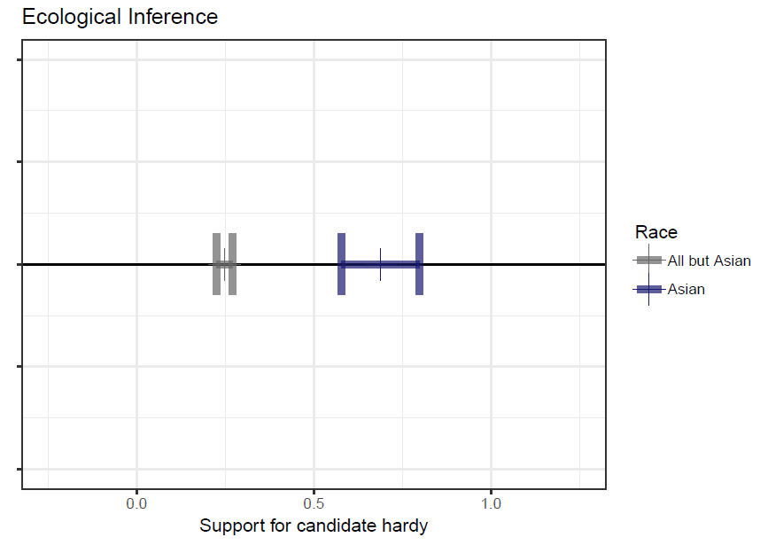

*Figure 2: Ecological Inference model for Hardy in (insert election here)*

The above figure shows a confidence interval for EI inference. If the confidence intervals do not overlap, there may be racial polarization, because the figure indicates that the two different groups have strong support for different candidates.”

F*or each section analyzing an election, insert here a short two to three sentence “takeaway” of the interpretation of that data: how does this data support your conclusions?*

*For example:*

*“*Takeaway:*In 7 out of 9 of the recent gubernatorial elections including minority candidates in ___ voting was clearly polarized, with black voters supporting African-American candidates and whites casting very few votes for the minority candidates. Black-preferred candidates were always defeated.”*

*For example:*

*“*Takeaway:*The results of the recent three school board elections in ___ all show racially polarized voting, even in cases where there were no minority candidates running.”*

## Conclusion

*Give a statement about the minority voters: if they exhibit racially polarized voting, discuss how it relates to showing Gingles Two and Three.*

*For example:* “The results of my analysis show there is racially polarized voting in ___. The minority group of black voters vote cohesively as a bloc, and the majority group of white voters generally vote as a bloc against the minority, therefore satisfying the *Gingles* Two and Three criteria for determining racially polarized voting. ”

*Summarize your results and patterns you have observed in your findings. Try to write this section in as easily accessible a manner as possible. Ideally, somebody with no background on your methods could read this conclusion and understand what the results mean for the case, even if not the exact numbers in the results themselves.*