|  |
| --- |
| **The VERY MEAN approach for trading extreme tops at leveraged zero-sum markets** |
|  |
| **Graduate Thesis of Psychology of Trading** |
|  |
|  |
| **Author: Gerry Zhou** |
|  |
| **Advisor: Jason Alan Jankovsky** |
|  |
| **6/30/2012** |
|  |

Table of Contents

Abstract 5

Overview 5

Topping Market Structure and Work Flow 6

The Typical Topping Schema 8

V-shape 10

Technical Measurements 12

Trend 13

Correction 13

Breakout 13

Range 13

Timing 14

Wave sequence 14

Rate of Change (ROC) 15

Execution 15

Intraday execution 15

Rally 16

Grinding slow up 16

Decline 16

Grinding slow down 16

Correction 16

Pausing 16

Very mean entry order 16

Adaptive exit order 17

Pyramid stop loss 17

Warm-up 17

Think of Randomness 18

Inter-day execution 18

48 hours and end of day entry verification period 18

Use stop order to get in entry 18

How to avoid being stopped out ? 18

How to make the market stop loss meaningful ? 19

Breakout or false breakout ? 20

Money Management 20

The logic behind the scenes 20

Where is the source of profits for trading 20

Execution time frame for small money and big money 20

Does big oops really value that much ? 21

Think about "blow-out" 21

Chart Pattern Case studies 21

Inter-day patterns 22

Range narrow down pattern for time compression (PTER-RNTC) 22

Quick reversal pattern for the extreme topping (PTER-QRXT) 22

False breakout major resistance/support (PTER-FBMRS) 23

Two feet or Two horns pattern (PTER-TFTH) 23

Intraday patterns 23

Round bottom after the last day rally (PTRA-RBALR) 24

First wave setback pattern (PTRA-FWSB) 25

OOPS pattern (PTRA-OOPS) 25

Five days exhaustion pattern (PTRA-FDX) 26

Doji entry and exit pattern (PTRA-DJNX) 28

Trade cycle 31

Computer-Aided Execution 31

Remarks 31

Trading on 2012 Robbins World Cup Trading Championships 32

Calendar 32

Markets Research 35

Markets to focus on 35

Soybean Meal Characters 35

Dollar Index Characters 40

Natural Gas Characters 47

Daily Routine (CST) 51

Trading Strategies and Patterns 51

Inter-day patterns 51

Intraday strategies 52

Homework 52

Trading 52

Checklist 52

Time 53

Pattern and waves 54

Trend 55

Range 55

VML 55

Stop loss 55

Target 55

Records 55

Weekly/Monthly summary and market analysis 55

Entry 55

Exit 56

Money management 56

Records 57

Performance 57

Analysis 58

Future Work 58

# Abstract

**In the leveraged zero-sum market, selling short an extreme top and following the downtrend trading is the most profitable approach as I know so far. How to identify when the top is forming; how to dip in the early stage of the topping formation; how to stay in the process and trade with small profits before the market will slump down; and how to catch the last breath of the late buyers. Those issues are interesting and challenging. In this project, I purposed a "VERY MEAN" trading model to trade on the extreme tops at US futures market. It includes the work flow for this kind of market, the "VERY MEAN" entry strategy, the pyramid stop loss strategy, the adaptive exit strategy, and the pattern triggered inter-day entry strategy.**

**Very Mean Approach focus on risk manage to get entry into the market,**

**1) Never attempt to buy an opportunity other than paying commissions. Even if it has the risk to lose opportunities, it's better than that risk to lose money, especially consistently losing money because of attachment of catching opportunities**

**2) Play small intraday trading and play big inter-day trading; intraday trading is working for accumulation small gains to pyramid stop loss level that will use to bid for big moves in inter-day trading with wide stop loss; inter-day moves is the source that major profits comes. Intraday trading is the way to accumulate knowledge and keep good control of the trade for the specific market before risk wide to catch big moves.**

**It's not realistic for a trader only trade on big moves without observation of the intraday moves, especially for the beginners with small size account. It's a winning trader's responsibility to know when to play small and when to play big. It's not necessary to play small intraday to help to catch big swings, but it's better for growth and experience gaining, it will make the development of skills faster than doing less on trading**

**3) Use Very Mean order for intraday trading. The Very Mean order will put on the edge of in range stop loss or slightly out of range stop loss which has higher probability to gain than to lose. The stop loss is tight, and the gain could be small; But the point is, the loss is small, the gain is small, so a) if it makes a break even gain/loss, it's OK. That's a good preparation of inter-day trading, the warm up could give more hints when and where the big moves will happen; b) if it makes a profitable accumulation, it could use for wide stop loss when biding for inter-day moves; c) if it loses in intraday trading consistently, it means I have no clue how this market works, it's better to avoid risk more on inter-day trading because something is WRONG, BE CAREFUL !**

# Overview

In the bottoming or topping market, you can choose going flat (stay off the market) or staying in the market. I prefer to stay. The reason is that I need more practice and learning the real feelings of competing in this kind of situation; or later if it proves to be wrong choice trading in those situations by my real experience, I will stay off from then on without any doubts and will be well disciplined without any problems. So, let me try and learn......

In this market, never overestimate anybody. In the topping market, never overestimate late buyers, in certain cases, they can generate pretty much powers. Play smart with those guys is the key point to be able to stay in the topping market because they are the major opponents in this situation.

# Topping Market Structure and Work Flow

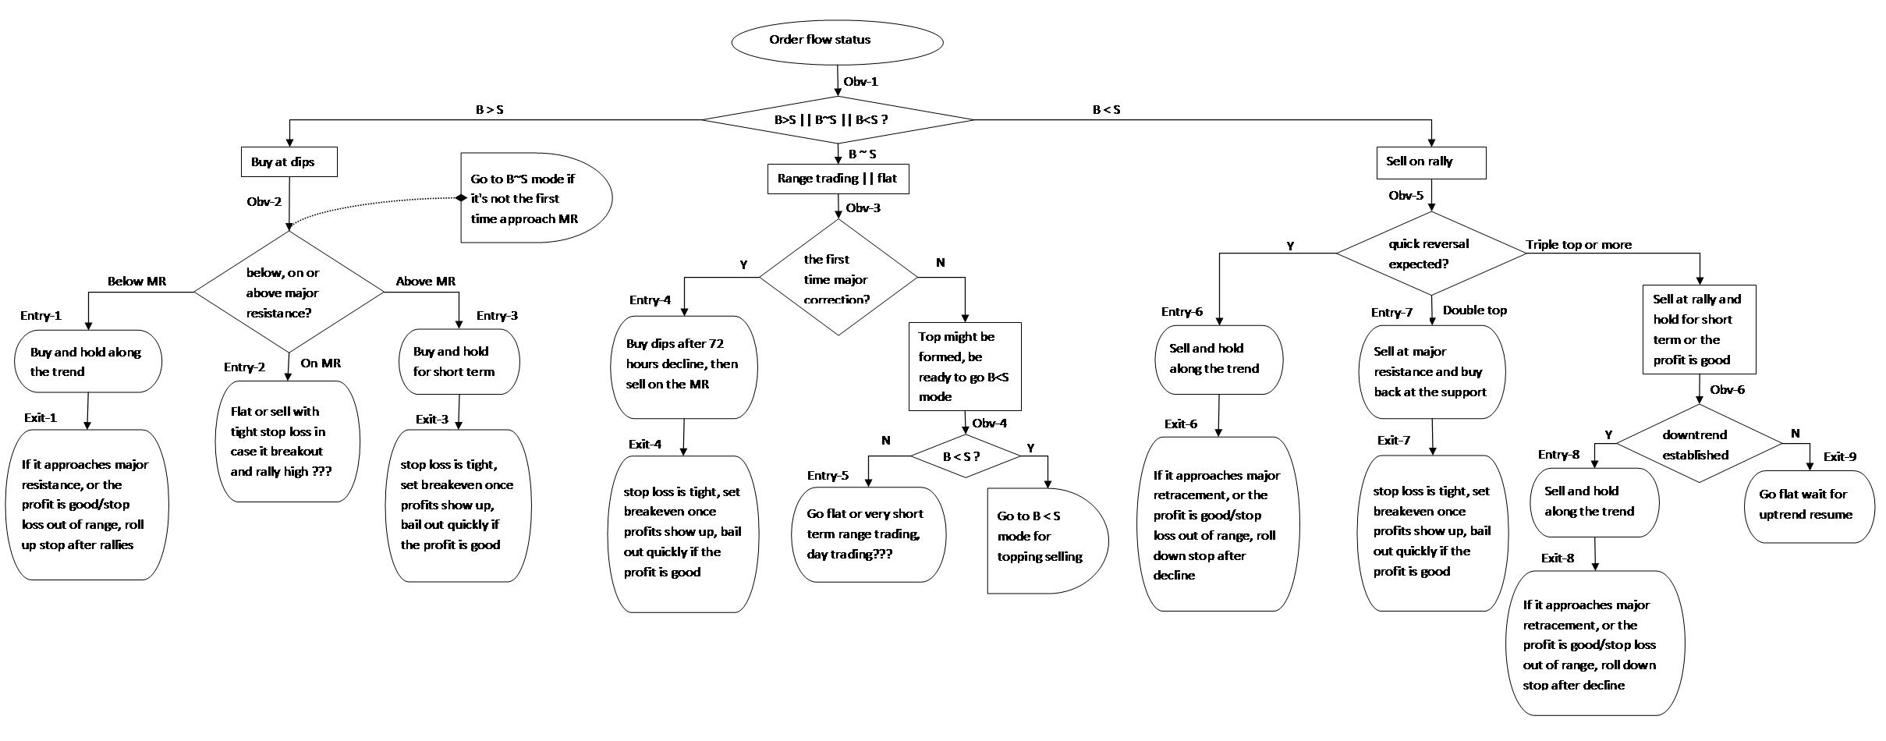

**Obv-1**: does it approach B ~ S mode (potential reversal point)? i.e., from yearly, monthly, and weekly charts, does it approach yearly or multiple years, or historic high ? In topping market, the price should be above at least 12 months moving average, or be above 200 weeks moving average, i.e., the uptrend had been formed and lasting for a period of time, it's no doubt an uptrend market at least for the yearly time frame (looking back 1-5 years).

**Obv-2**: the major resistance refers to yearly, multiple years or historic resistance in price;

or seasonal tendency, yearly cycles, or other time sensitive factors in timing;

or some abnormal volumes, big wicks in price;

or psychology price level like gold to $2000, silver to $50, Natural gas to $3, $2, $1, those cases can be considered as major resistance. Every major resistance will cause more liquidation pressure or buying desires. In physic, the boundary or edge is a chaos mode, it will generate more risk as well as more opportunities, it is the decision point that needs more attentions. Below, on or above the resistance line need different strategies. If it's the first time the price reaches or approaches the major resistance for the working uptrend, I think it's still in B > S mode, otherwise, I think it's B ~ S mode.

**Obv-3**: the first time major correction refers to at least 3 days decline following 3-10 days rally before, the rally starts from below or at the major resistance and forms an acceleration uptrend, it's reaching a hysteria mode, the end of the bull market; the correction is not too deep and the volume is not too high to form a quick reversal. The bull needs to take a breath, or the late buyers need a chance to get in.

**Obv-4**: this is the observation of topping formation, if the major correction causes one time failure of recovery back previous high, the order flow has switch to B < S mode, i.e., it needs more time to recover and could either form the second top or triple top; or it will fall directly forming the reversal without looking back.

**Obv-5**: this quick reversal needs a hysteria rally and is a kind of character of some products like silver, gold, no double or triple tops, reversal quickly from one failure recovery to previous high. Often times there is big wick, huge volume at the top. Big oops decline can be expected.

**Obv-6**: after double tops/triple tops, it should be easy to identify the downtrend, for example, breakout support, 50 MA, or 100 MA, otherwise, if it goes grinding, it might have re-bounce back previous high, stay off to wait if that happens.

**Entry-1**: the first major correction will cause buying dips orders to lift it back the resistance zone, but it may fail below or slightly above the resistance line, that might generate multiple tops and eventually reverse; or if the correction does not violate the trend, the trend will continue after it breaks out the resistance. In both cases, the buying dips action is secure.

**Exit-1**: this is actually a trend follow trade, hold the position as long as the trend develops, add to the winner and get out once the target is achieved or the signal of topping is detected.

**Entry-2**: this entry is not high probability selling so going flat might be better trade.

**Entry-3**: the breakout for major resistance line might be causing reversal, or accelerating, so buy and keep short term is good strategy, if it starts to accelerate, that could buy back a hold for longer time.

**Exit-3**: set tight stop loss in case it re-test the major resistance or even reversal, after that if it resumes the uptrend and accelerates, hold it firm.

**Entry-4**: the first time major correction will attract late buyers get in, but the volatility will be high, so it's hard to hold the position too long, and be cautious the quick reversal could happen after the recovery goes a little bit.

**Exit-4**: tight stop loss a little bit below the correction bottom, no profits for 24-48 hours, go flat; if there is profit or the rally gives a good profit, bail out and exit to wait. Just be quick and smart, otherwise, stay off.

**Entry-5**: very high volatility expected, tough trading opportunities, go flat might be better.

**Entry-6**: this is most profitable entry can be seen for a topping market, the conditions of Obv-5 should be investigated to make it easy to catch.

**Exit-6**: until it reaches the profits target, or the resistance, hold it and adding to the winners, move stop loss dips by dips.

**Entry-7**: double tops, no quick reversal expected, do range trading, sell at previous high resistance line, and buy back at the support formed by the previous correction.

**Exit-7**: tight stop loss a little bit over the previous high, set breakeven stops once profits show up. bail out quickly 24-72 hours or the profit is good.

**Entry-8**: downtrend established, keep selling and adding to the winners.

**Exit-8**: hold it until it reaches major support or the target is achieved. Move stop loss as downtrend develops.

**Exit-9**: it might have head fake back to previous high, stay off without saying.

# The Typical Topping Schema

RS4

RS2

RS3

RS1

W4

W3

C1

W2

W1

C2

SP1

SP2

SP3

SP4

BP1

C3

W1: Uptrend established, the rising speed is moderate, it takes months or even a year to move along this wave

RS1: the first resistance after a long time uptrend, after that, it might take a deep correction or even reversal. It reversal happens, the story will end at this point

W2: the major acceleration uptrend move, the slope is big, and the lasting time can be several months but normally not more than 6 months, the market was catching the public attention, until it reaches a significant resistance level

RS2: this is a significant resistance, like historic high, multi-year high, an important time point or event, a psychology high price level. Often times, the volume is huge and open interest is very high before the sell off happens

SP1: the first selling point, it is hard to catch the exact price for selling, a wide stop loss may use if want to be early seller at SP1. The selling price may be a little bit lower than RS2 or a little bit higher than RS2, most of the time, the breakout of RS2 then stalled with tight daily range would be a good sigh of selling off.

C1: this is the first major correction for W2, which is the hysteria mode. C1 could lead to a quick reversal as V-shape top, or lead to a range topping mode with multiple heads and support involved. C1 should happens at the significant resistance level, with high volume sell off, deep decline at least 3 days, the drop could eat 3-5 daily up bars before. This is the sign that big sellers start to take actions. If the correction does not happen as described above, it might be a normally correction without violating the uptrend.

RS3: this is the support line for the first major correction C1, if RS3 is broken out with slight recovery from C1, the V-shape reversal could be formed. Otherwise, the RS3 and RS2 could form a secure range for a period time

BP1: C1 could attract late buyers, the late buyers can generate a recovery, and even can push the price to a new high after the major correction. So if the buy of BP1 will not break out down side for RS3, the long position can be hold till the price approach

SP2: the first head formed after the first major correction, the high of the head or the resistance of RS2 could be good selling point, and the RS2 and RS4 become the firm resistance of later moves, every time the price reaches the RS2 and RS4 zone, it could form a good selling point

C2: C2 and later recoveries/corrections above the RS3 level are similar, the market has entered Sell>Buy mode, every recovery could be selling point, the range become more and more narrow is a good clue that the buyer have quit the long side, once the breakout downside under RS3, the selling off will accelerate

SP3: SP3 and later recoveries above the RS3 level are good selling points

W3: this is the first breakout below the RS3 which is a significant move to form the downside trend

SP4: this is the point to identify the breakout, could set a stop sell order there and wait

C3: any recovery after the W3 formed will be a good point to add to the winners for short

W4: downtrend established, trend following selling short

In summary, to identify an extreme topping market, three phases should be formed:

1) the first phase is rising uptrend with smooth slope;

2) the second phase is rising uptrend with sharp slope after a period of correction, the market rally until it reaches some significant points like price level, timing points, or events;

3) the third phase is the appearance of left shoulder and head, left shoulder is the first major correction after the failure of making new high, (in V-shape topping market, the left shoulder might not exist, regarding V-shape topping, it needs some strategy to handle it, I'll talk about it later), the first head is the recovery from the left shoulder and failed to make new high. After the left should and the first head are formed, the rest of the later shoulders and heads are running within the ranges formed by the left shoulder and the first head, or slightly out of the support/resistance level. After the first head, it considered the market come into S>B mode, seeking selling points instead of trading two ways

4) the trading strategy is trading ranges until the S>B mode was detected, the first head could be the sign. or weak recovery from left shoulder without forming a head. The breakout of the support level of left shoulder is the stop selling point

## V-shape

Let's take Sliver market at May 2011 as example, see the picture below,

a) The first slump is really attractive, but what is the possibility of that kind of slump happened every month, every year or every 5 years ? What's the cost of catching that kind of slump ? what's the profits leftover after the cost was subtracted ?

b) If the first slump was missed, what will happen? what the loss of missing this opportunity? See the Silver market the first slump moves, the high of 49.5 before the slump down to as low as 42.5, then the first slump was closed at 46.4 level, the seller still has chance to enter. After that, it declined for the rest of 4 days until below 34 level. It has a 49.5-46.4=3.1 loss of opportunity, and 46.4-34=13.4 potential thereafter. So missing the first slump never be a big loss as I can see so far

c) Big oops is not so profitable as it appears, let's do some calculation as below:

Average daily move range is 10 pips, big oops is 50 pips, stop loss for daily trade is 2, stop loss for big oops is 5,

if 3 stop loss happened before catching a big oops, the cost is 15, assume it can take 45-48 pips profits out of 50 pips for the big oops, and the winning probability is 80%, so the profits for the big oops is,

48*0.8 -15 = 23.4

for average daily profits, assume the probability of win and loss is 50%, the stop loss is 2, the gain is 5-8 pips out of 10 pips, so the daily profits is,

8*0.8 - 2 = 4.4

it takes up to 23.4/4.4= 5 small daily gains to get an equally big oops

But,

the probability of big oops happened every year might be 10/250, the probability of small daily gains could be every week, say 50/250,

so the 23.4*(10/250) VS 4.4*(50/250) ~ 0.936 VS 0.88, they are similar value trades

d) The first slump means the bulls lost control and the bears seriously come into the market, the bears might get control immediately or the two sides come into a balanced mode, keep this point in mind and seeking selling opportunities is the key to win in the extreme topping market. No emotional attachment to the big oops of the first slump and trade the high probability moves will be helpful

e) Two hints for the V-Top prediction, first is the historic research for the specific market to see how the market behave most of the time at topping, second hint is that if the situation of topping is extremely different than before or other topping market, include the price level it reaches, the time period it lasted, the event that will trigger the topping, all of the clues could be useful for expectation of the V-Top

Silver market May 2011

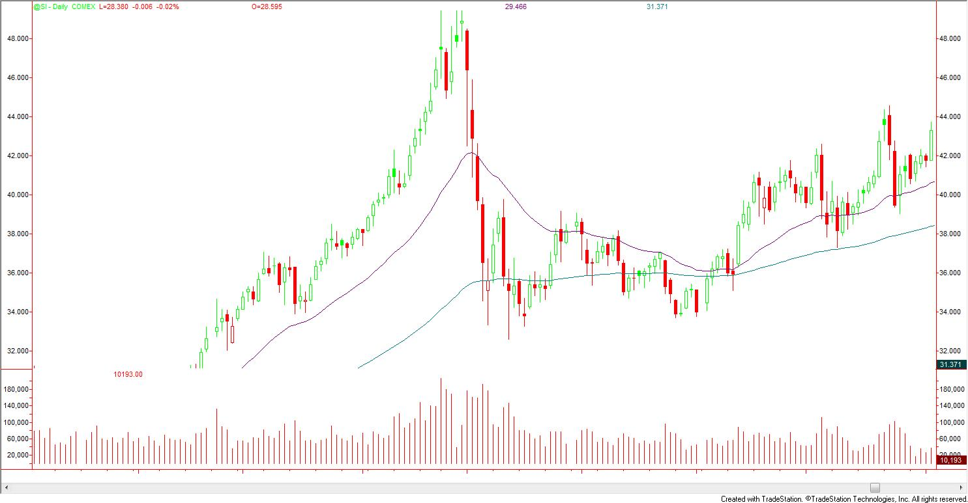

# Technical Measurements

Skill set a trader should have, whatever the trading style he/she has:

* Trend identification
* Breakout identification
* Reversal identification
* Correction identification
* Support/resistance identification
* Range identification
* Time identification

Lack of the abilities could lead higher potential risk to make biased conclusions and decisions about market moves, which will lead to higher risk trading

A good set of technical measurement could help to develop those skills and abilities:

slope = ($ amount per tick)*(total ticks since acceleration)/(initial margin) or day margin or (initial margin-maintenance margin)

value of the entry = (potential profit)*(possibility of winning)

value of the stop loss = (amount of stop loss pre-defined)*(possibility of losing)

Average daily range: 3 day, 5 day, 10 day, 30 day, 90 day

Maximum daily range: past 12, 24, 36, 48, 60, 120 months

Minimum intraday stop loss size

Minimum inter-day stop loss size

Maximum intraday stop loss size

Maximum inter-day stop loss size

## Trend

Trend follow means only long and liquidate in bull market, only sell short and liquidate in bear market, no counter trend entry. The resistance and support will be significant for trend, correction and breakout.

## Correction

Correction for trend;

Correction for intraday moves: pause in intraday move, it should be defined product by product,

## Breakout

Most of the breakouts are false, that's the normally status of the market, so identifying the price level and timing for a breakout is essential. It will decide the stop loss strategy. At the edge of the range, assume the breakout will fail most of the time and counter the breakout most of the time, although it will lose some real opportunities, the winning rate could be high. And use stop order to get in the breakout is better than a limit order.

Inter-day breakout

Intraday breakout

## Range

Range related topics:

1) Daily, weekly, monthly, yearly, and multiple-day, multiple-year ranges (high VS low, open VS close)

2) Range extension and Range shrinkage: range extends to a higher/lower level or narrow down to previous bars ranges; For example, Range Extension from previous bars could be 1/3, 1/2/, 2/3 of the previous bar, it could extend to weekly high, low, support/resistance, previous three days high/low/support/resistance, etc.

3) Open range and closed range: range extends to a direction with high potential means it's open to that side, otherwise, if the resistance/support is obvious at a certain level that means the range is closed at that level

4) Range overlap: current bar range may have overlap with previous bars range

5) Range alternation: wide range and narrow range days happen alternatively and the daily sequence of those two types of ranges

Example: (397, 400 -- 406, 415, 420], "(" or ")" means open range, "[" or "]" means closed range, prices on the left to "--" means downside range, normally it has 1-3 levels; prices on the right to "--" means upside ranges, normally it has 1-3 levels also; To figure out the ranges for next day trading is my daily homework.

## Timing

Tracking daily time points for peak and valley, day high and day low, include price and volume. The time span last for each wave, for example, soybean meal normally starts to rally or decline when the pit session opens at 10:30 AM CDT, and it can last 30-120 mins, often times 60-90 mins. This is the daily homework I should do.

Watch on daily/weekly/monthly/yearly time frame, trade on intraday time frame, from 1min-60min, use technical indicator decide entry price/exit price. because the account size is small, it's suitable for smaller time-frame (small account use small time frame, large account use large time frame).

Some special days for trade: end of month, end of season, have more liquidations; week day specials (Friday has more side way moves, Wednesday and Thursday have more reversals, Tuesday to Thursday have more bigger swings, Monday is the day to give out hinds about the direction for the rest of the week)

## Wave sequence

For a intraday moves, there is usually 1-3 waves for one direction and 2-4 waves for side way direction, if the move go beyond that much waves, it goes beyond my control, stay off without saying. The first move gives no hint for the direction of next move under the same time frame, it can see the hints from large time frame, the second move would give a better hint if it is a one direction move intraday or side way move intraday.

The sequence of the moves has four folds:

1) The price level and time points the turns will happen for the swings

2) The range of each swing

3) The rate of change for each swing

4) The direction of the swings and the sequence of the directions (Up and down sequence). For example, a rising day often times opens at a low swing and then rally sharply at an active time point. The sequence of the directions depends on the previous day and the trend the current day is working under. It should find some patterns to identify some specific cases for profits. For topping market, the up and down sequence for first major correction often times will follow a pattern.

## Rate of Change (ROC)

For the intraday move, if it goes smooth and slow, the slope is moderate, the volume is moderate, that means probably small buys/seller are working, the big buyers/sellers normally will generate a big volume and price change in a sharp slope. Count trend trade small buyers/sellers is good strategy.

For inter-day move, at early stage of the uptrend market, the ROC is smooth; after several months moves with corrections, it will start to speed up ROC, which will attract public to get in, the rally will breakout some important resistance or approaching them, then the top will be formed. So the high ROC is essential for an extreme topping market, the higher ROC the better topping will be formed.

# Execution

Before I put an order, I asked myself two questions:

Question #1: what's the potential risk for this trade?

Question #2: Is this the high probability winning trade?

For question #1: I answer it for intraday execution and inter-day execution respectively below.

For question #2: I only trade the patterns that I have researched and documented.

## Intraday execution

For intraday moves, there are usually 1-3 waves for one direction and 2-4 waves for two way direction, if the moves go beyond that much waves, it goes beyond my control, stay off without saying.

The first move gives no hint for the direction of next move under the same time frame, it can see the hints from larger time frame, the second move would give a better hint to know if it is one direction move intraday or two way move intraday. Two much two way moves means high volatility.

First rally followed by pausing, it means it's in the buying mode, probably it will have the second rally.

Execution time sensitive entry/exit/stop loss

Use time points/span for entry/exit instead of price, Critical Time of Day (CTOD)

Home work before a trade day starts:

1) Trend and volatility expected

2) Range

3) Time points/spans for entry and exit

4) Waves

4) Profits and Stop loss

### Rally

Research each individual product to define the rally for intraday move

### Grinding slow up

Small sellers are working

### Decline

Research each individual product to define the decline for intraday move.

### Grinding slow down

Small sellers are working

### Correction

Counter trend wave at between 1/4 and 1/2 of last major wave, normally 1/3 or 1/2. There are two types of corrections: quick correction and slow correction. The first counter trend wave is correction, after that, it will either breakout previous high or grinding side way, use larger time frame to decide the action for next step;

### Pausing

Tight range move, going flat and last for a while with no direction

### Very mean entry order

The level of Very Mean Entry order are defined by the range of the day. Normally it has three levels for each side of up/down, VMEL1, VMEL2, VMEL3.

VMEL depends on the volatility of the day (higher volatility day use higher VMEL), stop loss deposit (less deposit use higher VMEL). VME means it's ready to give up some opportunities because high VMEL will not be easily hit by the market.

Use for non-time-compression period trading, or intraday trading, facing the 2nd or 3rd wave or one-way move, and the stop loss point beyond the range;

In large time frame(yearly, monthly, weekly), trading on extreme overbought market; in intraday time frame, trading on extreme daily range edge or a little bit out of range (avoid the active trading hours, or slightly behind the active trading hours like 1 or 2 hour before the end of the day session, think about where the loser's stop loss at? entry after the loser's stop loss are triggered).

Range, Wave, Time (space , direction, time) need to be considered for an entry/exit.

Use time points/span for entry/exit instead of price will be better for me because I have limited time and resources to watch and analysis the market during the day time.

### Adaptive exit order

Exit by time sensitive point

Exit by price resistance/support level

Exit by candlestick pattern

### Pyramid stop loss

At warm-up phase, trade on intraday basis, use as mean as possible entry and as tight as possible stop to accumulating small gains and increase stop loss size with the profits, which is the deposit for risk more at time-compression period trading. i.e., warm-up for time-compression, no deposit, no bigger risk, no bigger profits.

Any intraday session get two consecutive stop out, quit the day for trading.

### Warm-up

Warm-up before get into deep trade. If I do not have an accumulative profits for a cost of large out of range stop loss, I am not qualified for putting an out of range stop loss. Have difficulties gain the first buck of gold to risk larger ? Then I am not warm-up yet, I did not understand this product well enough yet, so the attempt I risk more money as stop loss means a HP losing trade, I am not qualified for the formal trade yet. Do more research or practice somewhere else to better warm-up and avoid injury. Normally, I need two weeks warm-up trading when I get into a new product or at least one week warm-up before I can really get into a top forming trading.

Every month allow only once without stop loss deposit, it depends on the market, normally under 10% of account balance;

Friday and Monday only do intraday trading, liquidate at the end of Friday.

### Think of Randomness

What is random or what is deterministic in the market ?

## Inter-day execution

### 48 hours and end of day entry verification period

After 48 hour no profits show, it means the timing or entry price is not good, get it out. No inter-day positions left by the end of Friday unless it is really a sure thing to hold the winning position over weekend.

### Use stop order to get in entry

Pick the reversal time point to setup, if the breakout is close range, take small profit as quick as possible, if it's the open range breakout, wait for a while to see if it's false breakout or not.

## How to avoid being stopped out ?

First assumption before putting the stop loss is: I will be stopped out anyway, how to deal with that ??

Which time frame: intraday, inter-day ? it depends on is it on a time-compression mode ? if it is, go inter-day with wide stop loss. otherwise, go intraday with tight stop loss and trade on the stop loss edge

Range and range extension, 2 and 8 are good numbers for price entry/exit

Identify wide range days and narrow range days

Trend follow, never expect too much at first rising from bottom, often times it needs setback; if the first rally from bottom is a big rocket, it will set back 50% retracement

There is no trend, only ranges, open range and closed range, entry at the edge of closed range, stop loss set out of the closed range and then wait for the open range developed or closed. 48 hours verification or bail out.

Intraday up/down sequence, the slope of each wave and volume of each wave, the slope is high normally the volume is high also, vise versa;

The intraday wave sequence: if it's in buy mode, normally the first wave is down, then up; if it's in sell mode, the first intraday move might be rally, then sell off. The major troop normally wait for the chance before it takes actions;

Intraday active trading intervals, pit session is more active, the open of pit could be the time point big moves start; Figure out the active trading time points for each market, the time for low, high, start to rally, start to decline, end of rally, end of decline.

Inter-day: week days for each market, Tuesday, Wednesday, Thursday

Account size is small which is good for short-term, the larger size account is good for longer term trading, also if the range is closed and it's not in time-compression mode, it's good for short-term dip in/bail out, if the range is opened to one side and it's setting up the time-compression mode, it's good for longer term entry with wide stop loss.

Put the order where the public stop loss is, the right sequence, the right time interval, the right direction(breakout the range or set back into the range)

Trade on edge !!!

Where the stop loss is ? VML2+..... !!!

Daily wick/hammer pattern...., BE CAREFUL!!!

No opportunity losing in this business !!!

Trade in flat day for inter-day, don't follow the rocket or slump, it's too late.... !!!

Stop market ? stop limit ? Event/price trigger stop ?

## How to make the market stop loss meaningful ?

Don't be panic when the stop loss is hit, especially for the inter-day trading. It means I should get out this trade, but it may have better chance to get a better price. The point is, get out, but get out in a better way.

In some cases, I have chance to decide if the market changes when I can get out. For intraday trading with the closed range side, the stop loss could be hit but it does not mean the market changes, so get out with a better price is possible. For closed range, it will be the cases that a false breakout will trigger the stop loss, so don't be panic.

Another point is, don't be too early to put the entry order in case someone will test the market at inactive hours that could generate big wick/hammer.

## Breakout or false breakout ?

Range for topping, when to breakout ? before that, just trade on edge, the midway move will lead to touch of the support/resistance, most of the breakout is false? Suppose breakout is false, even if it breaks through the support/resistance, use reversal order, trading on active hours instead of before opening or after closing which could have a gap open the next session or someone test the market leading a big wick/hammer to trigger the stop loss order.

(TODO) Analysis the buyer/seller status for the patterns; Why false breakout happens?

When is good time for testing ? Big wick/hammer is hard to get entry because all of the entry orders are waiting there at the good price.

Add pattern records for weekly performance report;

Name pattern: PTER-FE, PTRA-RBAR

# Money Management

## The logic behind the scenes

### Where is the source of profits for trading

Moves generate difference, difference generates profits and losses. Range overlaps and range extension are the key points to identify the opportunities for making profits and avoiding losses. For small money account, intraday range is more important than inter-day range. For large money account, inter-day range is more important than intraday range unless the trade is working on intraday basis. Range and wave sequence identifications can help with entry and exit, or they are the actual execution road map. Trend or breakout are kinds of range extension. Unfolding the ranges with proper wave sequence identification is the best way to realize profits from the market potential, as well as the best way of avoiding losses. This is the basic skill that needs practice every day while the trading activity is going on.

Trading financial market to make profits is all about the pyramid game, if you do not use it or do not use it properly, the profits is always limited, and the market will provide more risk than profits for those people who don't understand this rule.

### Execution time frame for small money and big money

Big money should execute on a larger time frame, i.e., daily, weekly or monthly time frame, because it takes effort to get in big lots and the stop loss could be wide for big money. Small money, as I have in my account, MUST execute on the intraday basis, the stop loss could not be too wide.

### Does big oops really value that much ?

Big oops is not so profitable as it appears,

Average daily move 10 pips, big oops is 50 pips, stop loss for daily is 2, stop loss for big oops is 5,

3 stop loss for big oops is 15, assume it can take 45-48 pips profits for big oops, and the winning probability is 80%

48*0.8 -15 = 23.4

average daily profits, assume the probability of win and loss is 50%, the stop loss is 2, the gain is 5-8,

8*0.8 - 2 = 4.4

it takes up to 23.4/4.4= 5 small daily gains to get an equally big oops

the probability of big oops happened every year might be 10/250, the probability of small daily gains could be every week, say 50/250,

so the 23.4*(10/250) ~ 4.4*(50/250), they are similar value trades

### Think about "blow-out"

Active blow-out instead of passive blow-out.

For small account like 1K-3K, blow-out is easy, to be ready blow it out to gain more experience, that is called active blow-out. Never risk big money to do experiment or trade it in un-experienced years.

For large account or formal investment/speculation money, a blow-out should not happen. If that happened, it is called passive blow-out, which is a disaster.

Do active blow-out to gain the experience to avoid passive blow-out.

# Chart Pattern Case studies

Only work on significant signals, indicators or patterns;

Identify which pattern match which market better to use it more efficiently;

Know when to play big and when to play small;

Know when to use the specific pattern and when NOT to use it;

## Inter-day patterns

Topping pattern: V top, Double top, Triple top, Rounding top, Saucer top, Head and Shoulder top,

Complex tops (complex head and shoulder, wedge, triangle, diamond, rectangle, multiple heads, island gap higher then gap lower)

### Range narrow down pattern for time compression (PTER-RNTC)

The moves went one direction for several days (3-10 days) with more and more narrow range, volume decreased obviously, it's setting up a time-compression bounce back. Or if it's in a recovery status but grinding slow for several days with more and more narrow range and failed to break out the resistance, the time-compression is setting up.

Example Live Cattle 2012, narrow range extension pattern: the previous ranges are wide, then three to five days narrow ranges, be ready to get a big bar, use stop order to get in. Or entry at limit/market then stop loss with reversal.

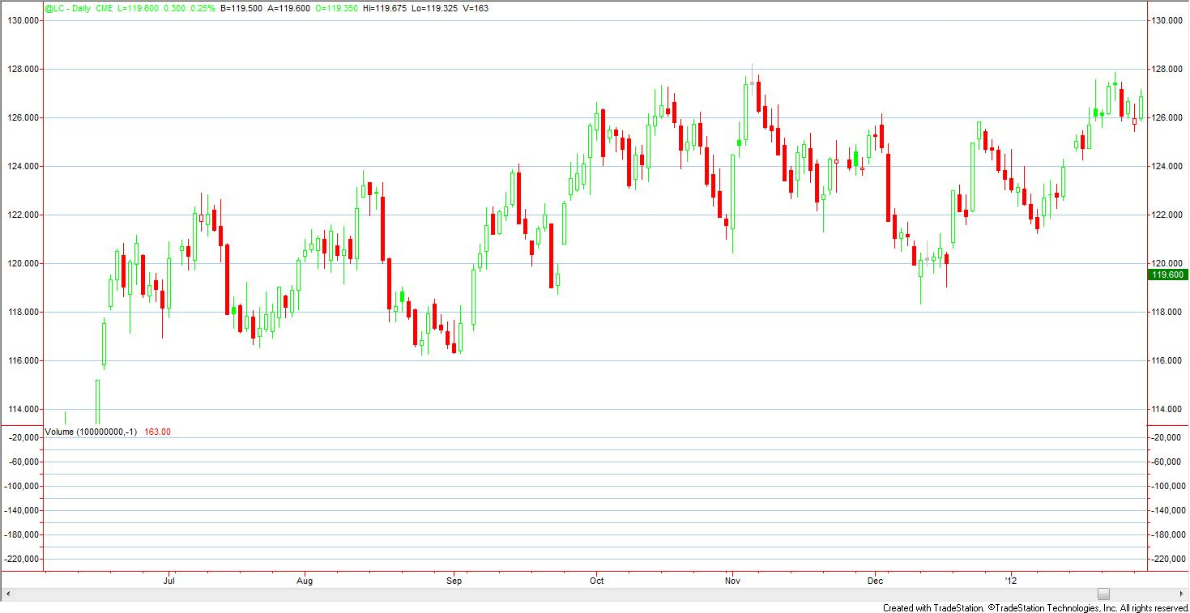

**When to use**:

**When NOT to use**:

### Quick reversal pattern for the extreme topping (PTER-QRXT)

After the first major correction, it recovers a little bit, but it's lower than 0.382 retracement, and it keeps grinding several days then failed to make new rising, the volume is low, then it's setting up a slump.

**When to use**:

**When NOT to use**:

### False breakout major resistance/support (PTER-FBMRS)

The major resistance/support (previous yearly, or multi-month high/low) was broken out at topping/bottoming, most of the time it's false breakout, after 2-5 days, it will set back to retest the resistance/support. So entry at the weakness after the breakout around 2-5 days, and exit at the resistance/support to see if it will resume the trend or not. Tips: when the move come close to the major resistance/support, most of the time the breaking through will happen, and it should be the assumption the trader has in mind, entry before the breaking through is risky, which is called left side entry.

How to identify if it will reversal before the breaking through? One of the hints is a big slump down/rocket happened when it comes close to the resistance/support line, and that price creates a resistance/support clearly. Otherwise, if a slight correction happened, or going flat for several days, it shows the high probability the breaking through will happen.

**When to use**:

**When NOT to use**:

### Two feet or Two horns pattern (PTER-TFTH)

When the price touch the previous major resistance or support level, it's setting up a reversal, for bottoming, it's like two feet; for topping, it's like two horns. The price may breakout the resistance/support a little bit which is better to entry than reversing before breaking out. But both cases are good for a reversal entry.

Example:

**When to use**:

**When NOT to use**:

## Intraday patterns

Candle stick pattern is not good for intraday trading, the Elliot wave patterns are better for intraday moves.

Intraday play is actually the range play most of the time; breakout will fall into inter-day play; don't do breakout play intraday, the assumption for intraday trading is that the breakout is false, otherwise, it should switch to inter-day trading.

Identify the volatility of pre big moves and post big moves, which will help to identify the range of the next day.

Big moves will make the range closed at one side most of the time, and flat moves will make the range open to at least one side, or even two sides; So post big moves is a better time to play intraday trading.

### Round bottom after the last day rally (PTRA-RBALR)

This is a big rally/decline next day pattern, with firm rally or decline the first day, especially the breakout, the next day entry at 40%-50% retracement, then exit on new high or new low.

Example Dollar Index June 12, on May 15, it has a big 3+ waves rally approaching 82, the next day on May 16, it made a new high and failed quickly, the it formed a round bottom intraday, this is a buying point, it will grinding higher approaching previous high then fail again, which is a selling point.

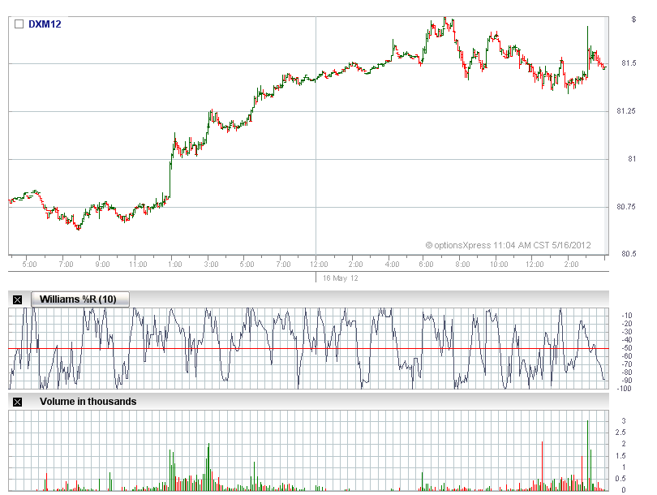

The following is the typical big wick (tombstone) chart the day after a big rally, it will slow down the up move, the resistance normally cannot be breakout within 3 days, it will form a range for 3-10+ days, the range could be the resistance line and the previous big rally bar 's 50% or 61.8% retracement. So any move approaching the resistance could be a selling point, the stop loss could be a little bit over the resistance. The buying can be considered at the bottom of the range, but it needs to be intraday trading, and take profits quickly. The next rally target is 82 or a little bit higher which corresponds to previous major high on Jan 2012. But the top could be formed below 82, which I call it left side topping, selling below 82 could better catch the top if it is, the risk is higher than selling after the breakout 82+ level which I call it right side topping. The risk of right side trading is that could miss the opportunity to catch the top, the advantage is it needs less stop loss deposit, so this is the mean entry strategy. The left side trading is aggressive entry strategy. I prefer right side trading when my stop loss deposit is insufficient, which means I have higher probability to loss the opportunity but has less probability to lose money. ( All the trades I discuss above for this chart is inter-day trading).

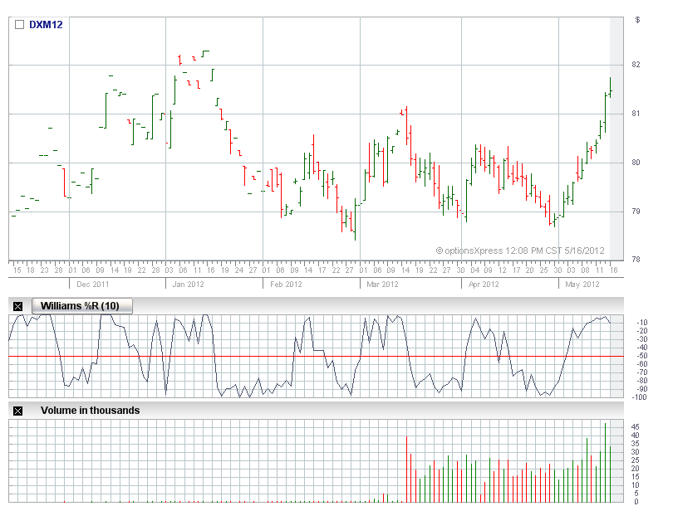

**When to use**:

**When NOT to use**:

### First wave setback pattern (PTRA-FWSB)

The first wave from bottom often times will setback deep, almost down back to the bottom level, like wheat, NG, buy the setback at the close to bottom level when the range is narrow down. Or sell short at the wave stall (five day exhaustion pattern ?)

**When to use**:

**When NOT to use**:

### OOPS pattern (PTRA-OOPS)

The pattern to wait for Hammer or wick being broken out; For rising mode with hammer, breakout the close upwards is the buying point. And vise verse. Or for rising mode with wick, breakout the high of the wick upward is the buying point. And vise verse.

Example from SMN12, on early June, it's setting up a down trend, but the wick three days after the big drop was broke out then rally to 416+ level from 405 level

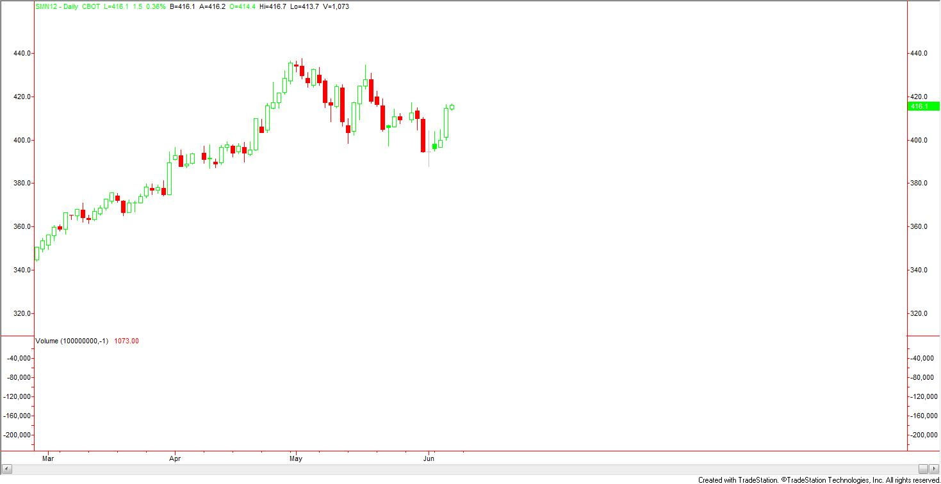

**When to use**:

**When NOT to use**:

### Five days exhaustion pattern (PTRA-FDX)

Continues 3 days rallies with at least one large rally, then stalled two days, sell high at the fifth day, or sell the price of the fourth day high at the fifth day, wait for two days, if no drop, exit.

Example DXM12, on Apr 03, the three rallies, with the fourth day decline, the fifth day sell above the third days close, then seeking buy back next day's low;

Or the three decline bars on middle March with the fourth day recovery, then buy next day's low below the third day's close, seeking sell on next day's high;

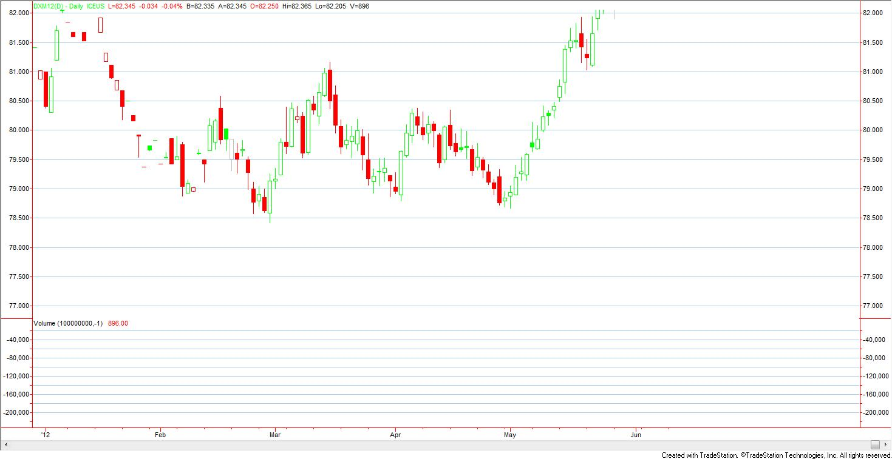

Example Soybean Meal, June 12 2012, is the fifth day,

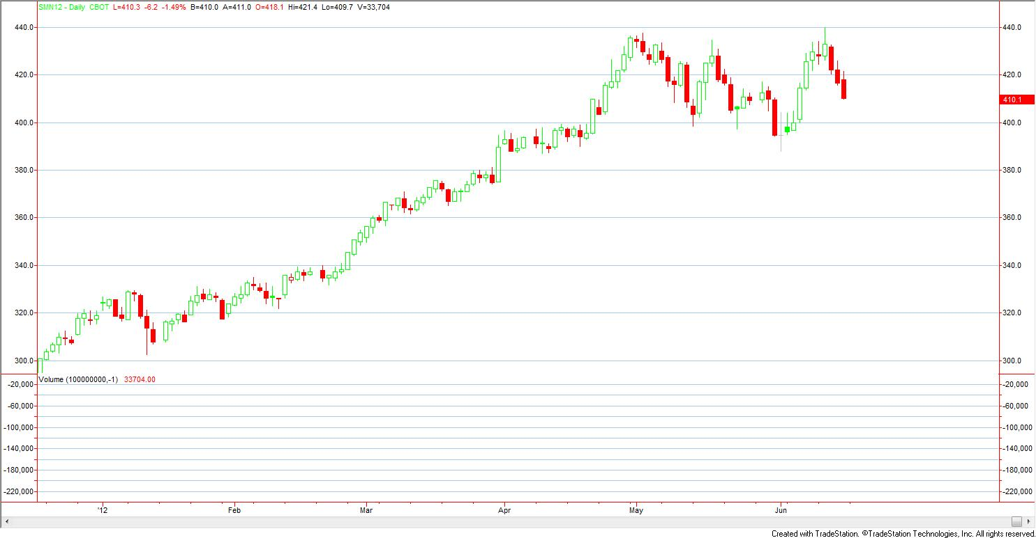

60 minutes chart for May 31-Jun 17

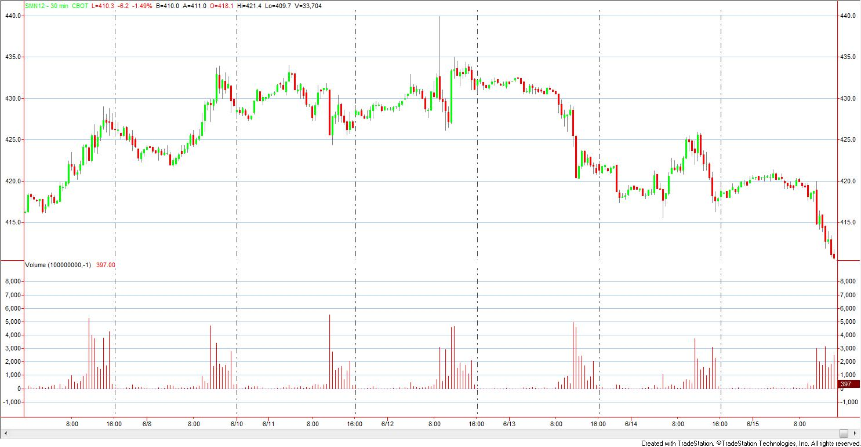

a) Be ready to get a big wick/hammer, especially during the non-active trading hours since the orders are less, it's easy for someone test the market

b) Get in the position from the big wick/hammer is beautiful, at the fifth day, before active trading hours, use very mean order to get in a far price out of range, then if it does not happen, at the active hours, get in when it come to a good price level when the momentum is not so high. Normally the wick/hammer happens at the third day or the fourth day, the third day if it appears, just consider to entry at the fourth day;

c) This pattern usually happens at range play mode, if the uptrend or downtrend is clear, this pattern is not effective. Example as Soybean meal at June 12, 2012, 7:30 AM CST,

**When to use**: the multiple weeks range play is the best place to take this pattern;

**When NOT to use**: in the midway of a clear trend, it will not lead to a correction in high probability.

### Doji entry and exit pattern (PTRA-DJNX)

Three to five or even more continues bars with at least two big bars, entry at the close or low of the doji bar on next day is a good point, wait for the next bar reversal, or stop loss reversal at the next bar from the low of the dojo. assume the bar next to doji is moderate, exit on its daily rally, then entry again to make first profit or avoid risk. If a move that following the trend with continues 3-5 bars including at least two big bars paused at doji, it's an exit point.

Narrow range doji is better than wide range doji. The doji close to the reversal direction is better than close to the underlining trend direction.

From the intraday chart, it's a flat move day or slight reversal move day with quiet volume and waves, which means the balanced mode for buyers and sellers, the underlining trend is possibly facing the reversal direction which is a good hint where the next day move will go. Flat move day means there is not so many up/down waves during the day, most of the time there is only one direction move or flat which are good shapes. More waves during the day means the buyer/seller are still fighting, the doji is not so effective in this situation.

Big wick/hammer is the alternative of this pattern, the doji or wick/hammer will appear in different situations, but they have similar meanings for a continues multi-bars move, wick/hammer normally appear when the market still have momentum, and the seller/buyer were kicked out so no buying/selling orders for the moment when someone is testing the market. wick/hammer normally happen before the active trading hours where orders are less so the testing can easily be done.

There are three shapes when it comes to the end of a series of continues bars,

a) go sharp up/down with wide range bars,

b) go flat with narrow range bars, or

c) go two-way with wide range bars.

Wick/hammer often times appear for a), doji often times appear for b), for c), both of the cases could happen, and wick/hammer will happen more than doji. Doji means both buyer/seller lose momentum to trade at this point, wick/hammer means only one side is active but when it touch the bottom line of the other side, the other side will actively get in because they think that's a good price. Wick/hammer, and doji are effective at reversal points or touching the important resistance/support level or slightly break out the resistance/support (might be a false breakout which will lead the reversal). Weekly wick/hammer is very efficient;

Example Lean Hog 2009, on June 16 2009, the doji is small following a continues decline, then entry at next day's low, wait for reversal.

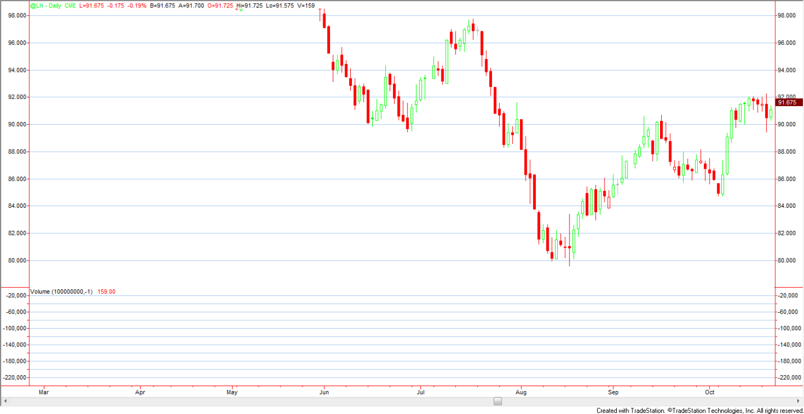

**When to use**: the best place is that after sharp continues rally/decline, and it needs a break or reversal

**When NOT to use**: when it comes to a major resistance/support after a multi-days one way move, the doji normally cannot lead to a high probability reversal, it needs to wait for the breaking through

# Trade cycle

Research/Learn

Design/Plan

Implementation

Execution/Logging

Analysis/Problem Discovering

Optimization

# Computer-Aided Execution

Two purpose:

Research work to verify new ideas with back-testing report

Order execution

# Remarks

Don't scare myself of "losing opportunities to hit a killing shot", losing opportunities in the market equals losing nothing, while losing money in the market equals losing the qualification of catching opportunities. Next opportunity is always better.

No fear of execution if the pattern is identified, which is the only trigger I setup my position

# Trading on 2012 Robbins World Cup Trading Championships

Focus on high frequent moves as well as time compression moves;

Thinking of business model for profits at leveraged markets;

Research products for position size, stop size, profits target, timing spans, measurement of latest average daily range;

Chart Patterns, trend following, corrections measurement;

keep it in mind 3 small moves can equal a big move, big move is low probability event, small moves are high probability events, focus on HP events instead of LP events;

Trade HP is good trade even if it is stopped out, trade LP is bad trade even if it make profits

## Calendar

| Month | Sun | Mon | Tue | Wed | Thu | Fri | Sat |
| --- | --- | --- | --- | --- | --- | --- | --- |
|  | 27 | 28 | 29 | 30 | 31 | 1 | 2 |
| [0](http://www.wincalendar.com/June-Calendar/June-2012-Calendar.html) | 3 | 4 | 5 | 6 | 7 | 8 | 9 |
| 10 | 11 | 12 | 13 | 14 | 15 | 16 |
| 17 | 18 | 19 | 20 | 21 | 22 | 23 |
| 24 | 25 | 26 | 27 | 28 | 29 | 30 |
| [Jul 2012](http://www.wincalendar.com/July-Calendar/July-2012-Calendar.html) | 1 | 2 | 3  Holiday | 4  HOLIDAY | 5  Holiday | 6 | 7 |
| 8 | 9 | 10 | 11 | 12 | 13 | 14 |
| 15 | 16 | 17 | 18 | 19 | 20 | 21 |
| 22 | 23 | 24 | 25 | 26 | 27 | 28 |
| 29 | 30 | 31 | 1 | 2 | 3 | 4 |
| [Aug 2012](http://www.wincalendar.com/August-Calendar/August-2012-Calendar.html) | 5 | 6 | 7 | 8 | 9 | 10 | 11 |
| 12 | 13 | 14 | 15 | 16 | 17 | 18 |
| 19 | 20 | 21 | 22 | 23 | 24 | 25 |
| 26 | 27 | 28 | 29 | 30 | 31  Holiday | 1 |
| [Sep 2012](http://www.wincalendar.com/September-Calendar/September-2012-Calendar.html) | 2 | 3  HOLIDAY | 4 | 5 | 6 | 7 | 8 |
| 9 | 10 | 11 | 12 | 13 | 14 | 15 |
| 16 | 17 | 18 | 19 | 20 | 21 | 22 |
| 23 | 24 | 25 | 26 | 27 | 28 | 29 |
| 30 | 1 | 2 | 3 | 4 | 5  Holiday | 6 |
| [Oct 2012](http://www.wincalendar.com/October-Calendar/October-2012-Calendar.html) | 7 | 8  HOLIDAY | 9 | 10 | 11 | 12 | 13 |
| 14 | 15 | 16 | 17 | 18 | 19 | 20 |
| 21 | 22 | 23 | 24 | 25 | 26 | 27 |
| 28 | 29 | 30 | 31 | 1 | 2 | 3 |
| [Nov 2012](http://www.wincalendar.com/November-Calendar/November-2012-Calendar.html) | 4 | 5 | 6 | 7 | 8 | 9 | 10 |
| 11 | 12  HOLIDAY | 13 | 14 | 15 | 16 | 17 |
| 18 | 19 | 20 | 21 | 22  HOLIDAY | 23  HOLIDAY | 24 |
| 25 | 26 | 27 | 28 | 29 | 30 | 1 |
| [Dec 2012](http://www.wincalendar.com/December-Calendar/December-2012-Calendar.html) | 2 | 3 | 4 | 5 | 6 | 7 | 8 |
| 9 | 10 | 11 | 12 | 13 | 14 | 15 |
| 16 | 17 | 18 | 19 | 20 | 21 | 22 |
| 23 | 24 | 25  HOLIDAY | 26 | 27 | 28 | 29 |
| 30 | 31 | 1 | 2 | 3 | 4 | 5 |

From July 2, 2012 to December 28, 2012, totally 26 weeks, 2*26=52 pink days, 3*26=78 green days, 26 purple days. And two red days (Starting day and ending day of my participation of the competition).

Pink days are limited trading days, Monday normally has volatility to give out the hints what will be the week's starting of direction. Friday normally has no big moves instead of more side way volatility. So intraday trading, especially on Friday, is the way to go for those pink days.

Green days are the days when the major moves appear for most of the markets. Focus on those days with big moves.

Purple days are the weekends, I need to deliver the weekly/monthly summary by those days.

## Markets Research

Pick 3-5 markets as the watch list and trade on them, every two weeks upgrade the list by adding or removing someone to keep it in a well shape.

### Markets to focus on

* setup extreme topping markets: soybean meal
* early down trend markets from extreme topping: soybean,
* late uptrend markets (start to accelerate): feed cattle, Japanese yen,
* regular topping markets: Dollar index
* early uptrend markets (rising from bottom): natural gas, cotton, live cattle, lean hog(50% retracement?), platinum,
* late down trend markets (approaching bottom or forming bottom): coffee, sugar, orange juice, oats, rough rice, wheat( W bottom?), copper, silver(50% retracement?), Australia Dollar, Euro FX, Crude oil, heating oil, gas oil, gasoline

|  |  |  |  |  |  |
| --- | --- | --- | --- | --- | --- |
| **Specification** | **Soybean meal** | **Dollar Index** | **Natural Gas** |  |  |
| Symbol | SM | DX | NG |  |  |
| Months | F, H, K, N, Q, U, V, Z | H, M, U, Z | All |  |  |
| Rollover day | 29--13 | 15 | 25 |  |  |
| Tick | 0.10=$10 | 0.005=5.00 | 0.005 = $12.50 |  |  |
| Margin | 1958/1450 | 1254/1140 | 709/525 |  |  |
| Marginal stop loss | 5.08/$508 | 0.114/$114 | 0.0736/$184 |  |  |
| Minimum intraday stop loss size | 5.1/$510 | 0.115/$115 | 0.075/$187 |  |  |
| Minimum inter-day stop loss size | 15.3/$1530 | 0.345/$345 | 0.225/$562 |  |  |
| Average inter-day range (3, 5, 10, 30, 60, 90) | 12.03, 12.72, 13.12, 11.65, 9.7, 8.38 | 0.69, 0.68, 0.68, 0.58, 0.54, 0.55 | 0.0850, 0.1050, 0.1055, 0.1227, 0.1037, 0.1088 |  |  |
| Active intraday trade time,  Intraday critical time (EDT) | 1:30-6:00  10:00-14:00 | 3:00-6:00  8:00-14:00 | 8:00-9:00  11:00-14:30 |  |  |

### Soybean Meal Characters

Trend: extreme topping on yearly time frame, complex heads formed;

Soybean Meal 10 years Monthly chart

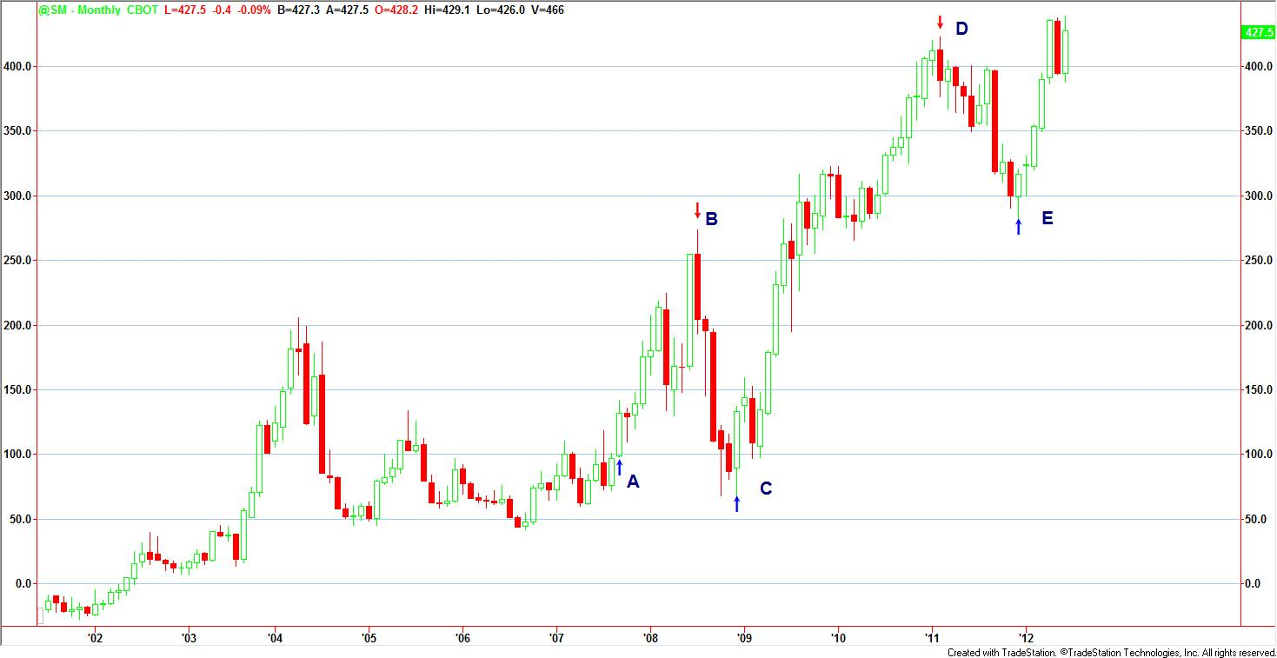

Total four waves can be identified, the fifth wave is on the way. Seasonal tendency did not dominate soybean meal market during the past 5 years, it can been seen selling off at summer, but it did not violate the major trend shown above.

|  |  |  |  |  |  |  |
| --- | --- | --- | --- | --- | --- | --- |
| **Year** | **Yearly high** | | **Major decline starts** | | **Yearly low** | |
| **Date** | **Price** | **Date** | **Price** | **Date** | **Price** |
| 2011 | Feb 11, 422.6 | | Sept 2, 399.8 | | Dec 09, 283.9 | |
| 2010 | Dec 31, 407.3 | | Jan 8, 322.6 | | Mar 12, 265.5 | |
| 2009 | Aug 28, 316.4 | | June 12, 282.1 | | Mar 6, 97.4 | |
| 2008 | July 11, 273.8 | | July 11, 273.8 | | Dec 05, 67.8 | |
| 2007 | Dec 28, 2007 | | July 13, 118.5; Feb 23, 110.4 | | Apr 27, 60.6 | |
| 2006 | Jan 06, 92.5 | | Jan 06, 92.5 | | Sept 15, 41.9 | |

Soybean Meal Range Extension for Wave 5 on Monthly chart

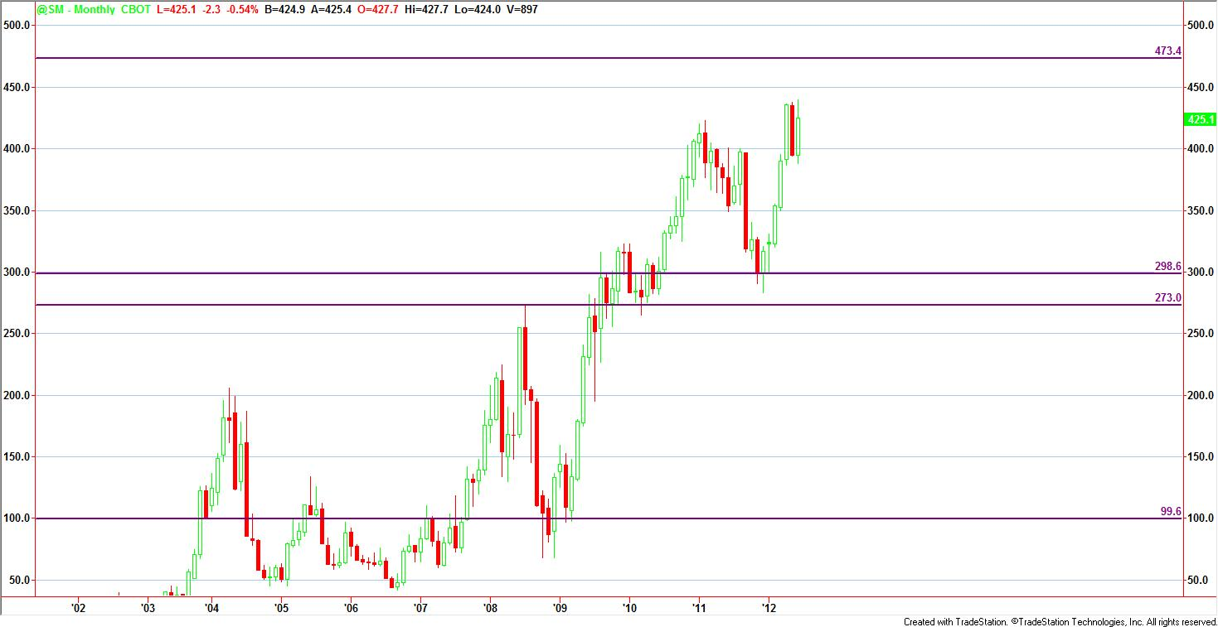

If the range length of wave 5 is the same with the range length of wave 1, the next resistance for wave 5 is 473.

Soybean Meal Fib Extension for Wave 5 on Monthly chart

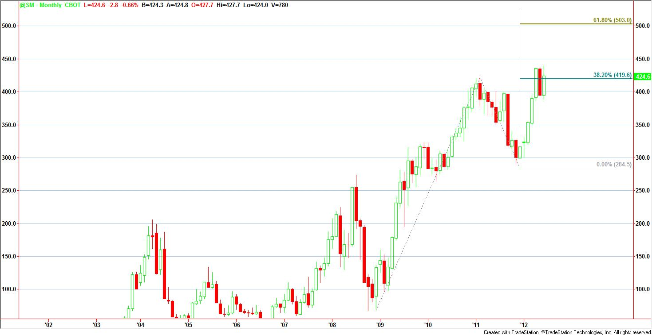

Resistance for Wave 5: 503

So the price zone [473 503] is the perfect selling area if the price will reach that level.

Soybean Meal Fib Retracement for Wave 3 on Monthly chart

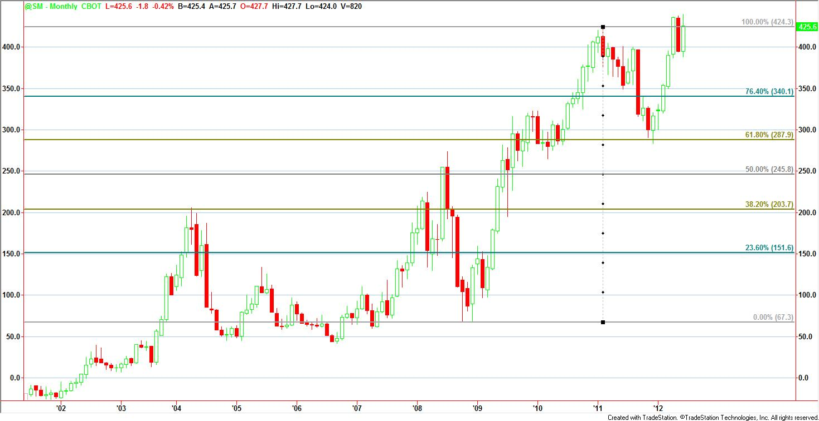

Downtrend targets: 350, 288, 245, 203, within the next 6 months, if the downtrend will be established, 288 and 245 would be the most important targets.

Focus on range patterns for the wave 5 play, before it reaches 473 level, it will be slightly uptrend, after that will be high volatility range play, then it will come to a slightly downtrend , until it breakout the support level of wave 5 (wave 3 high) and then breakout wave 4 support.

After downtrend will be established, focus on downtrend patterns which will be defined later.

Two Patterns for inter-day play before the 473 level

1. **Five days Exhaustion Pattern**

With a short-term trend being developed for 3-10 days, normally around 5 days, I am looking for the hints like doji, wick/hammer and range narrow down moves to entry the reversal move. The big rallies or decline often times has two large range extension days before it went to consolidation mode.

This pattern is effective for the consolidation mode for weekly time frame, the soybean meal just finished a major uptrend move and it's in range consolidation mode from May 2012 till now.

Soybean Meal Five days Exhaustion Pattern 2012

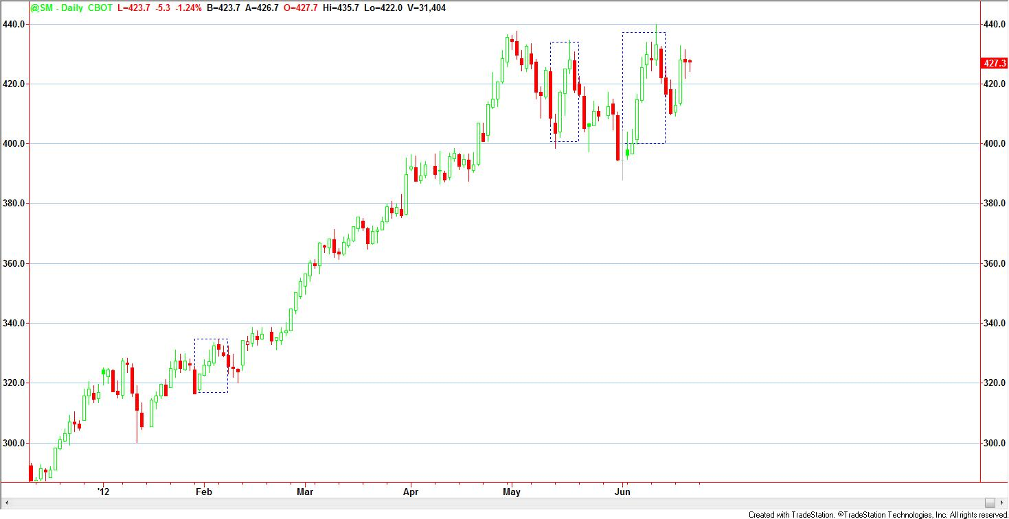

For trend play, it's useful for profits taking or adding to winners. Working on a Five day Exhaustion pattern could help to find the pausing and correction points when the trend is developing.

Soybean Meal Five days Exhaustion Pattern 2008

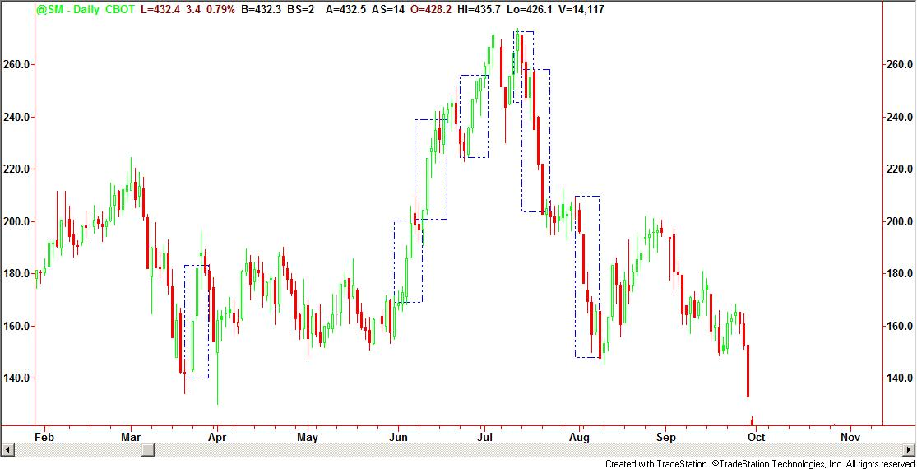

1. **Wick/Hammer for false/failed breakout uptrend**

Soybean Meal False/Failed breakout uptrend with Wick/Hammer on Topping 2008

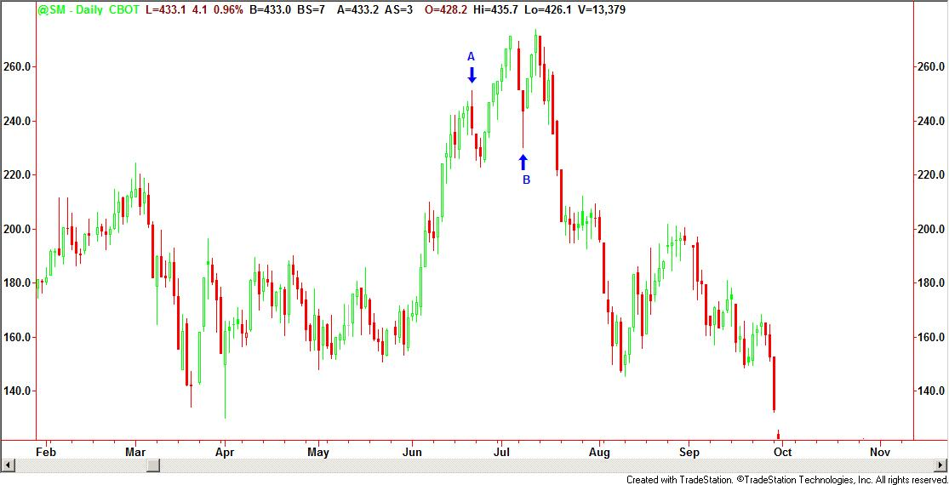

One intraday pattern before the 473 level

1. **High volatility intraday moves**

When the trend is not clear to see, I will work on the big wick/hammer to get in daily play, use Very Mean order seeking the exhaustion level to entry. This status should have high level of range overlaps at daily time frame.

### Dollar Index Characters

Trend: Downtrend on multi-year time frame, the open interest has increased to historic high;

85 level will be next resistance, then 95; 75 will be next support; every 5 can create a resistance/support level for this market;

Dollar Index 2000-2012 Monthly chart

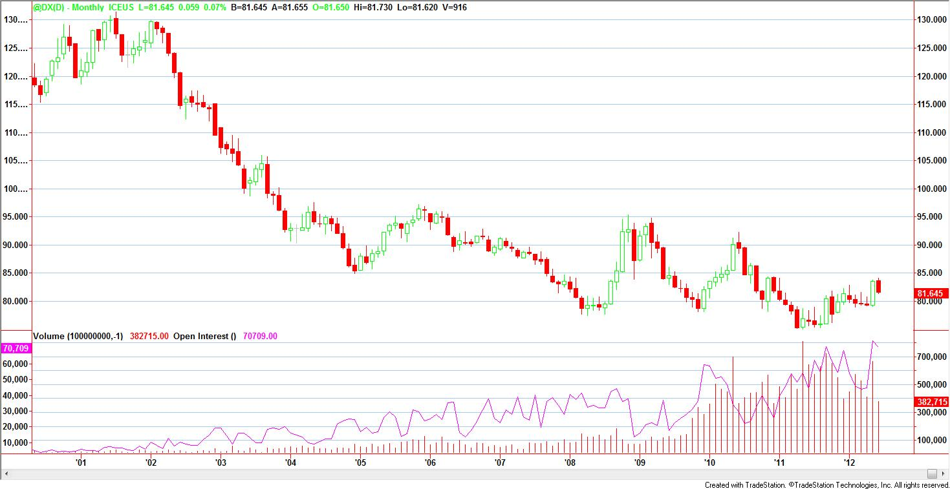

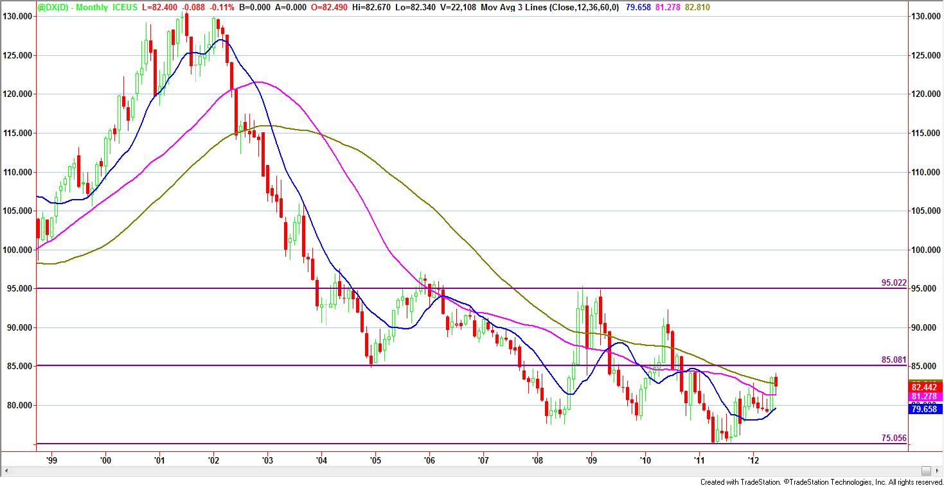

The short-term trend is unclear yet, from early 2012, it went to narrow down monthly move then rally at May, the rebounce is pretty strong (broke out MA 36, 60) that could breakout 85 level in the next few months; after that, it may keep rising to test 90 level or pullback to 79 level or breakout 79 to resume the downtrend; so 79-85 will be the range play for the coming months this year;

Dollar Index 2000-2012 Monthly chart with MA(12, 36, 60)

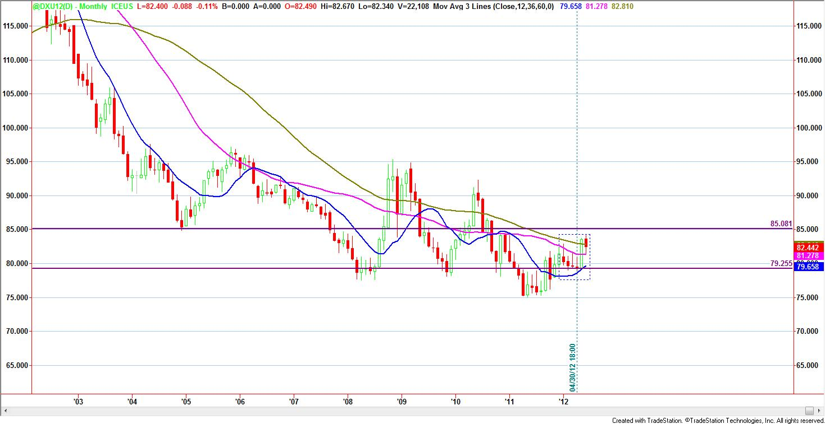

From the regression channel it can be seen the up side possible resistance levels, and the down side support level; Also, this point could be 50% retracement for the last yearly high which appeared at early 2010.

Dollar Index 2000-2012 Monthly chart with Regression channel as Resistance/Support

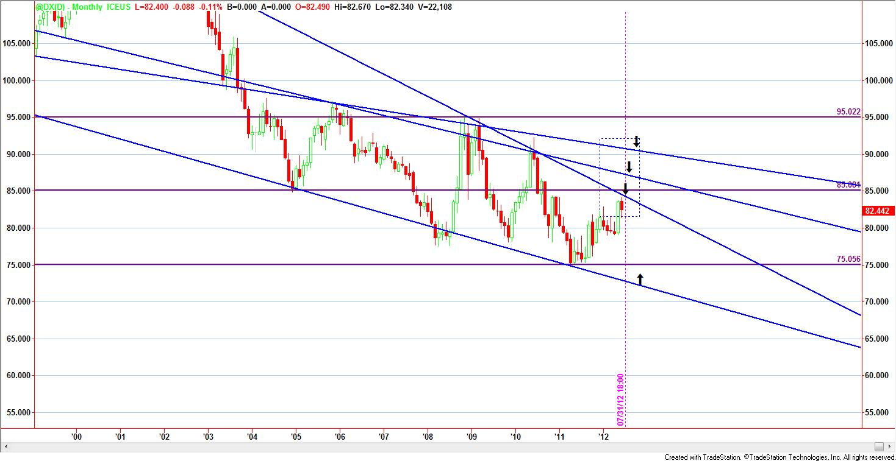

From weekly chart below, it can be seen the Fib 50% retracement for 2010 yearly high, the point A from the end of 2010 to early 2011 is the first 50% retracement of 2010 yearly high. The recent point B is the second 50% retracement. But the weekly chart shows a slightly up side trend, in the next few weeks, if it can keep above 82 level without big decline down to 80 level, it's possible setting up a breakout to 86 level then 88 level. 79 level will be the next support if the pullback will happen in the coming weeks.

Dollar Index 2000-2012 Weekly chart with Fibonacci Retracement

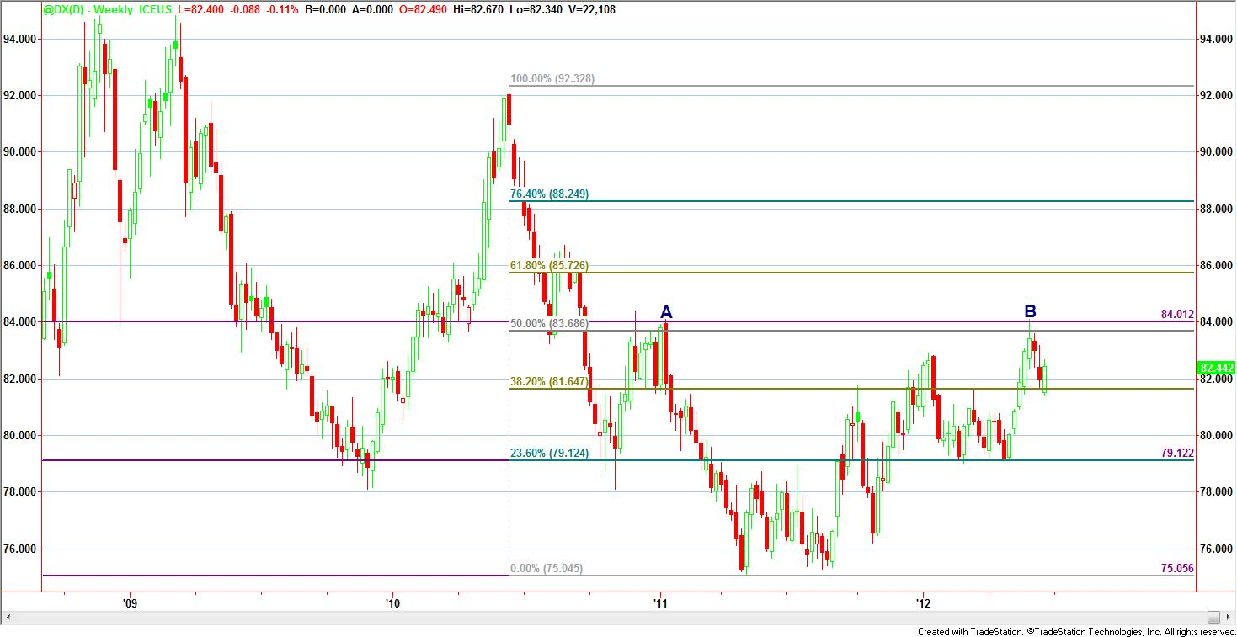

Dollar Index is very sensitive to Fibonacci numbers, especially 50% retracement/extension. So seeking the point of 50% retracement/extension is a significant pattern both for inter-day trading and intraday entry/exit.

Fibonacci 50% Retracement/Extension Pattern

1) For inter-day entry/exit, seeking the points on daily chart, 480 minutes chart for 50% retracement/Extension to get entry and exit point. Combined with one of the other signals include: resistance/support line, or trendline, or MA, or Candlestick doji/wick/hammer.

From the daily chart below, it can be seen the next resistance is close to 83 level which is the previous resistance level A, and the next Fibonacci resistance level for E.

Dollar Index Daily chart with 50% Fibonacci Retracement and previous Resistance

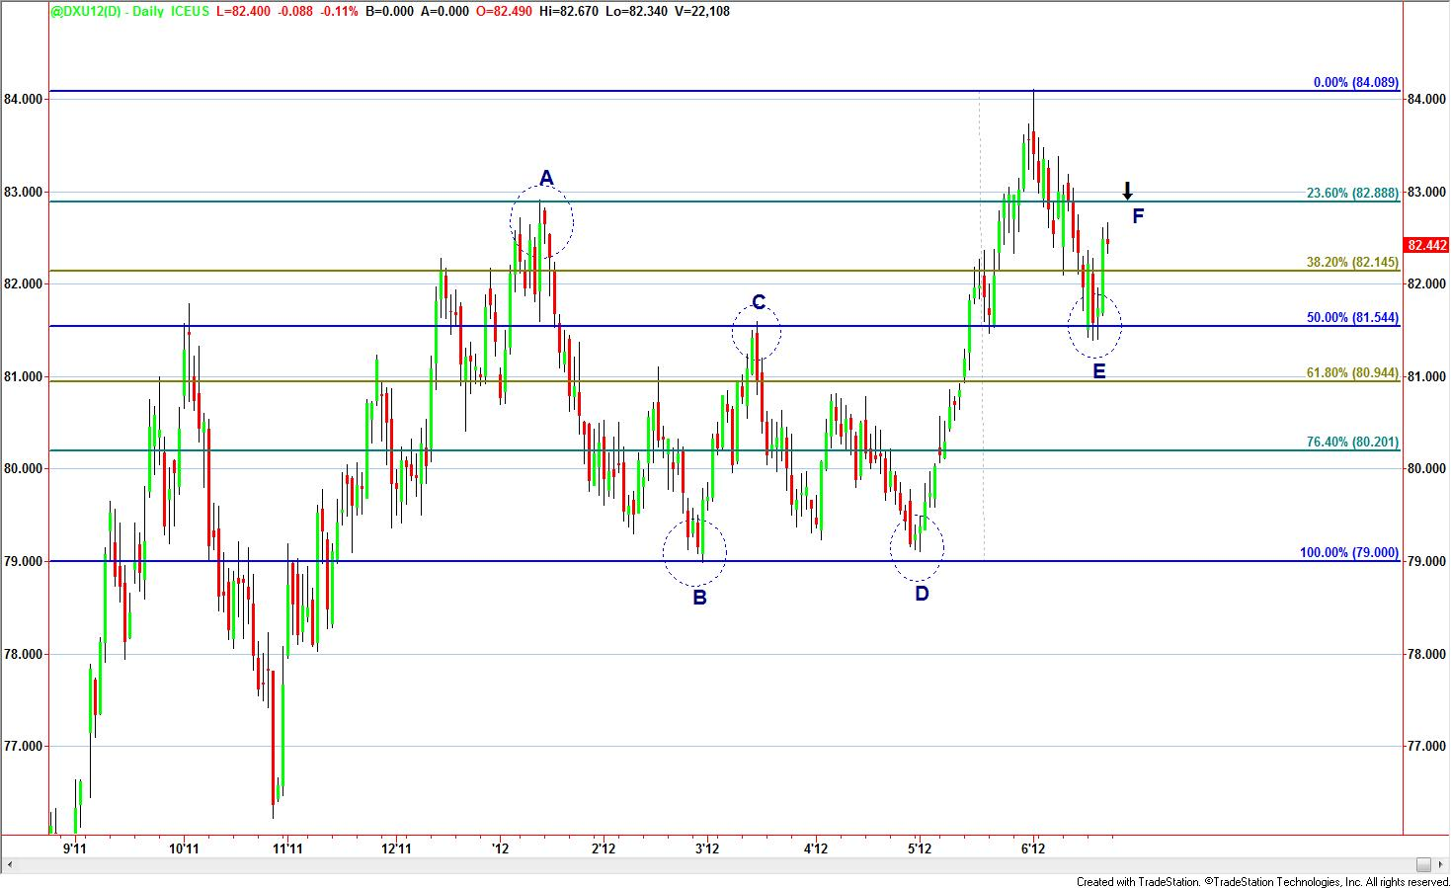

2) For intraday entry/exit, seeking the points on (120, 240, 480) minutes charts for 50% retracement/Extension to get entry/exit. Combined with one of the other signals include: resistance/support line, or trendline, or MA, or Candlestick doji/wick/hammer.

Dollar Index 240-min chart with 50% Fibonacci Retracement and previous support

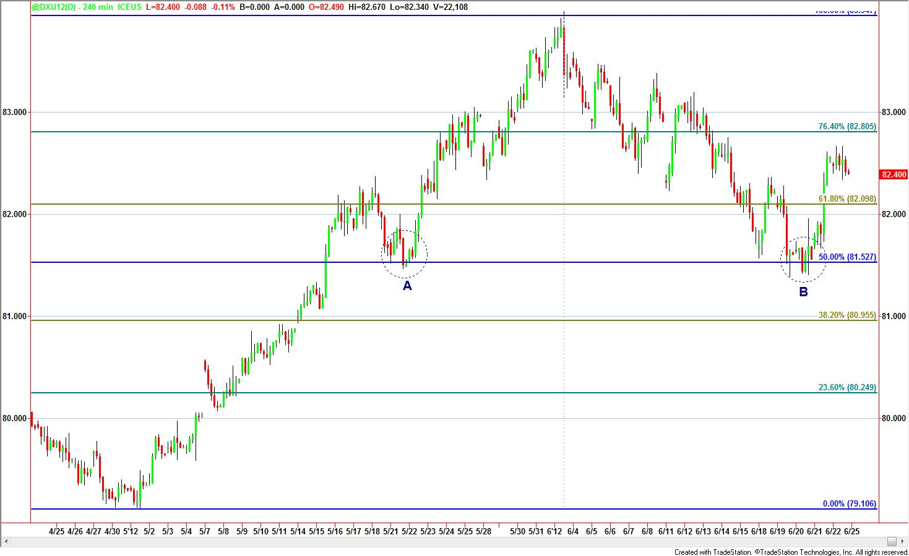

Most of the time doji/wick/hammer will not cause the reversal immediately, it may cause a consolidation (3-10 bars) before it really reversed. So the signal could be, after doji/wick/hammer appeared and consolidation finished without breaking out the doji/wick/hammer Resistance/Support, it is setting up a very good reversal.

Dollar Index 240-min chart with 50% Fibonacci Retracement and Hammer

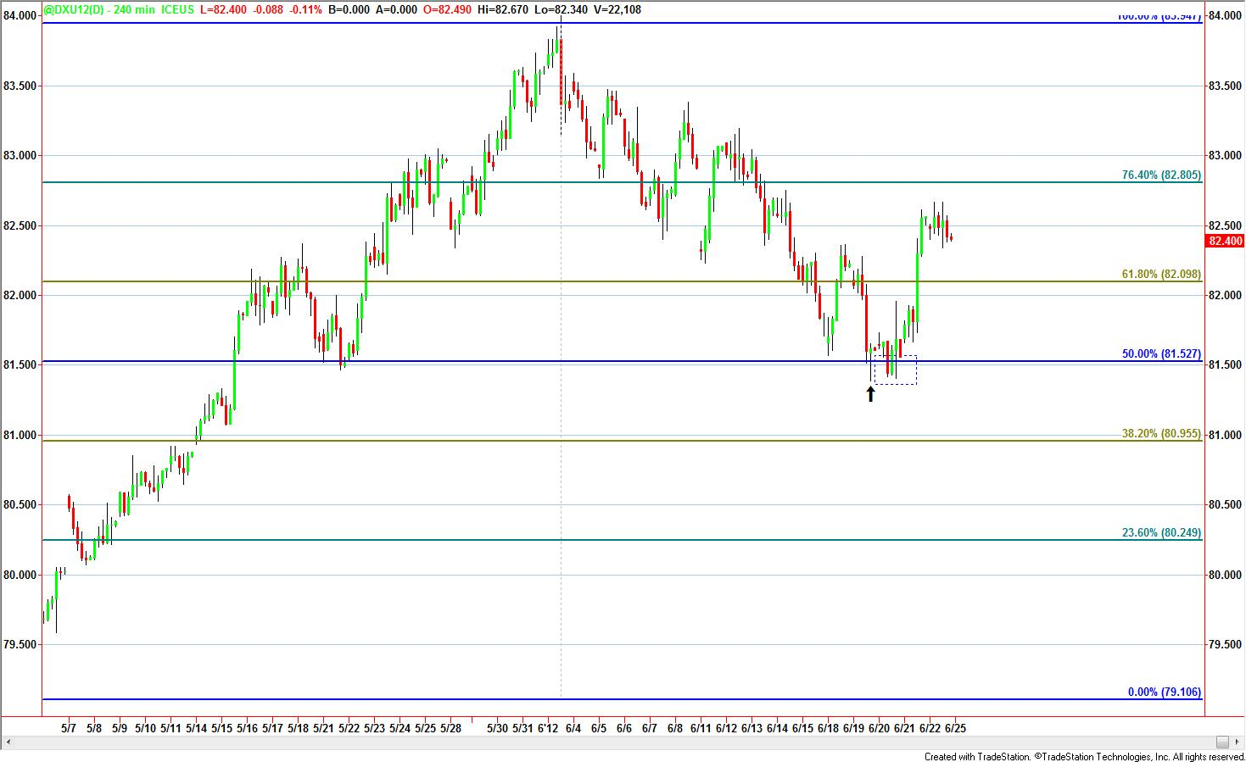

In the 120-min chart below, the breakout from 82 level (also 38.2% Fibonacci retracement) had gone out of track of the trendline, it may breakout the 50% Fibonacci retracement on point A or pullback to the trendline channel again to resume the downtrend.

Dollar Index 120-min chart with Fibonacci Retracement and Trendline

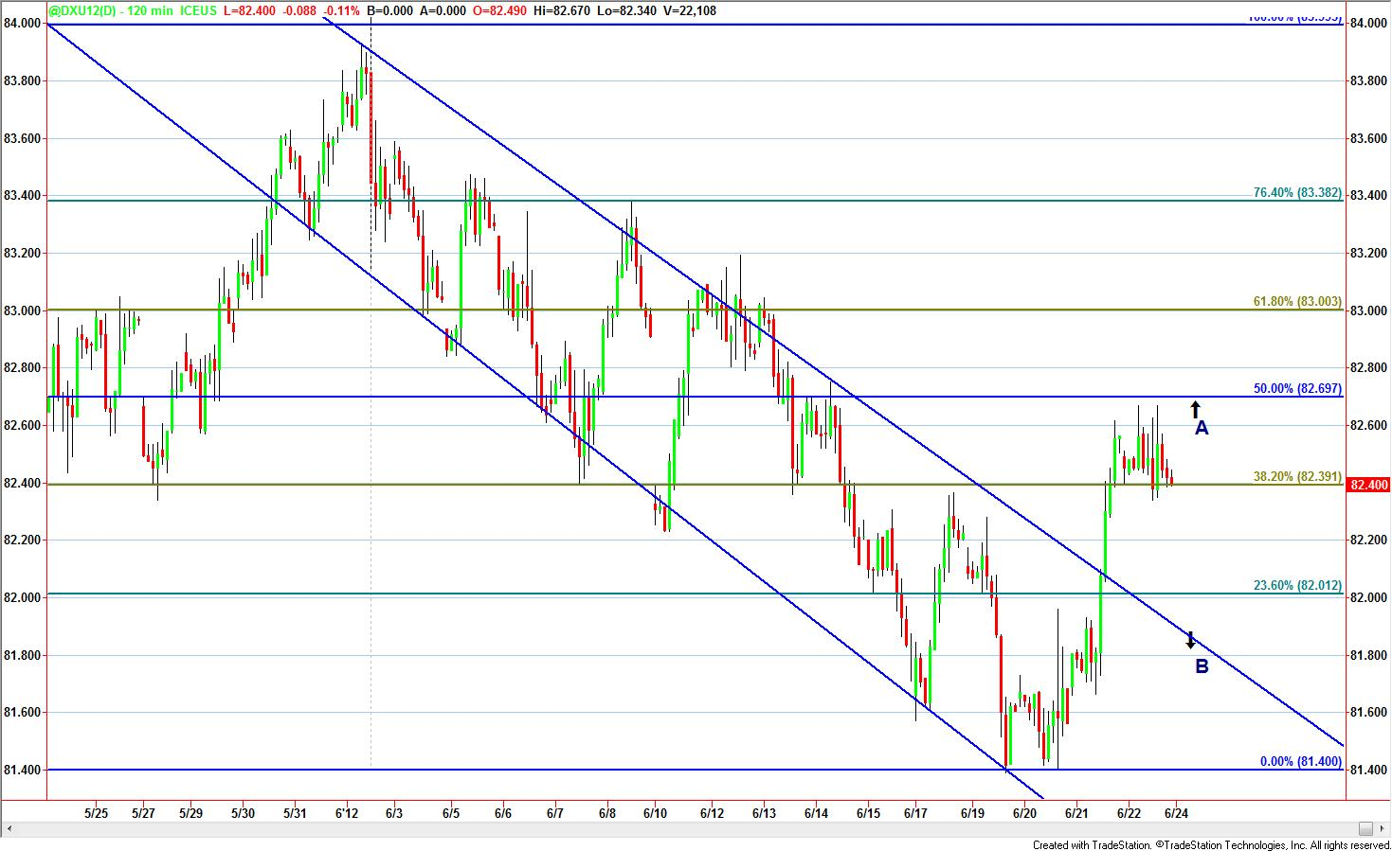

Inter-day open: gap open in this market happens a lot;

### Natural Gas Characters

Trend: Multi-year bottoming formed, the first wave of uptrend has done and the correction is going on.

Keep long and buy dips for this market. Natural gas will have quite day trading after pullback, it's time to buy most of the time.

The uptrend is still in the early stage, the ROC is moderate, the volatility could be more, the rally could be short-term (it may last one or two weeks before a pullback).

The resistance levels such as 4, 6 could lead a deep pullback. The major accelerated wave might not be able to show up within the next 6 months. After a deep pullback or long time consolidation correction for the wave 1, the major wave 3 could be expected. It might take one or two years to develop it.

Natural Gas multi-year (historic) bottom monthly chart

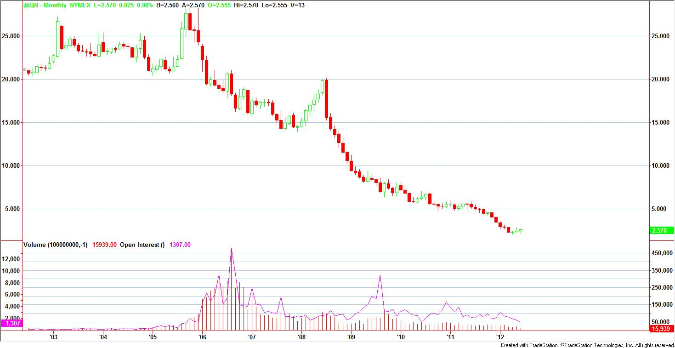

Natural Gas weekly chart with MA 50, MA 100

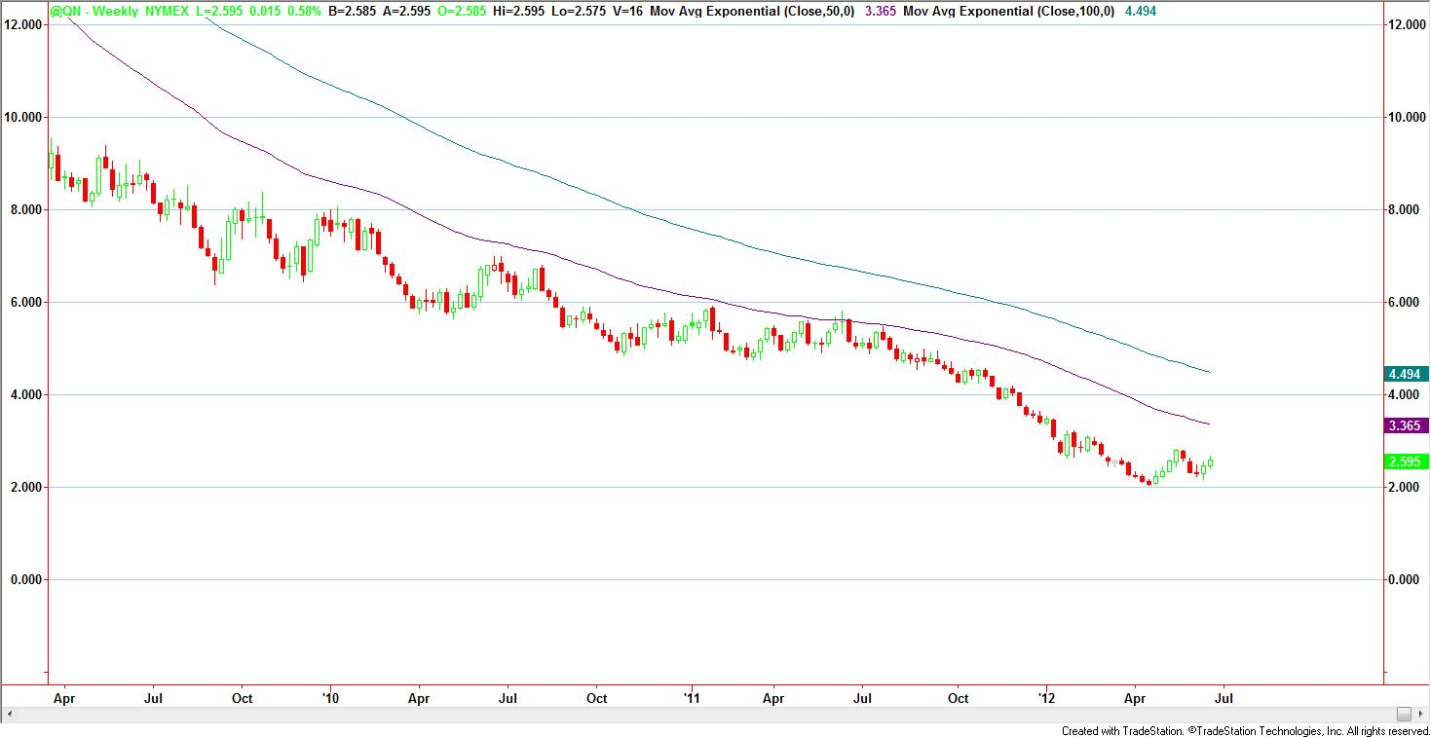

Natural Gas daily chart with MA(50, 100, 200)

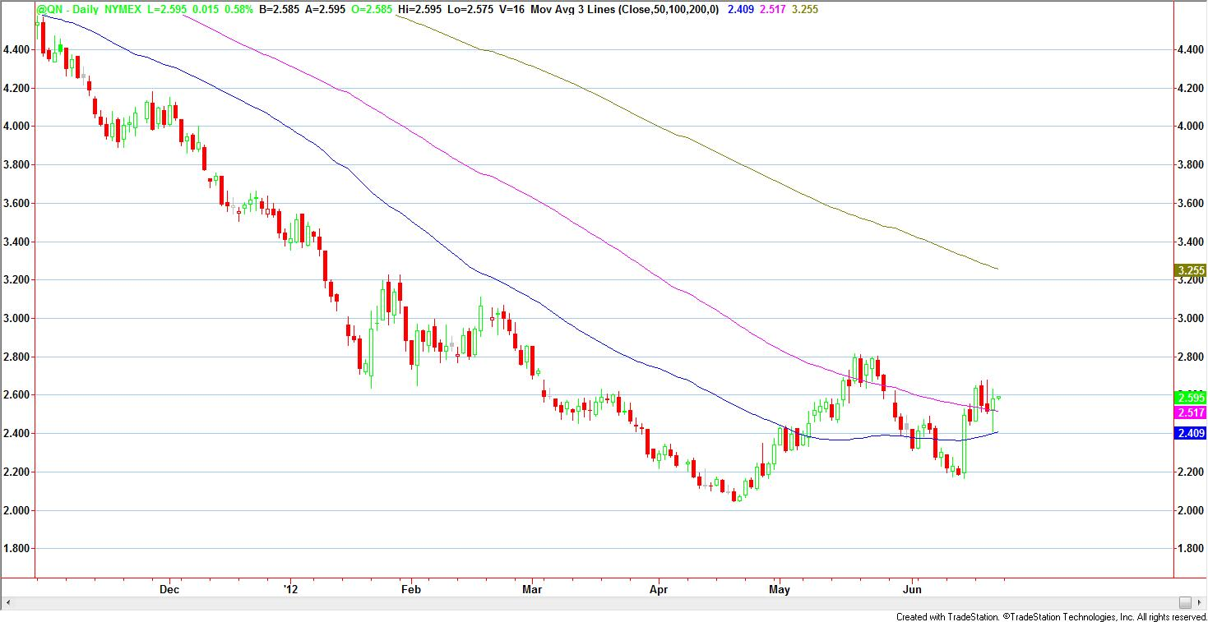

Three patterns to get in the long position to catch an uptrend

* Range narrow down at continues downside corrections (Rect A). The best hint for uptrend resuming is the day(s) after pullback then very quiet trading day with narrow range and no wick/hammer or even no doji appears (wick/hammer, doji appears in previous days).
* Doji/Hammer after continues downside corrections (Rect B). Doji is easy to lead small rallies, hammer is easy to lead larger rallies
* Going flat range consolidation 4-8 days (Rect C), the first breakout bar is the hint where the trend will develop

Natural Gas Entry Patterns for long position

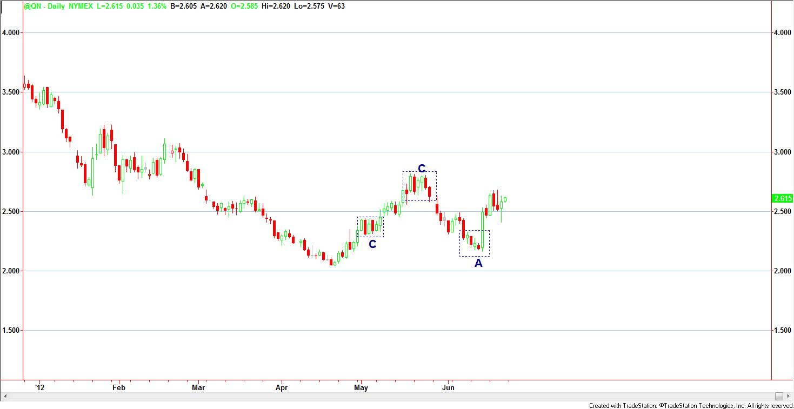

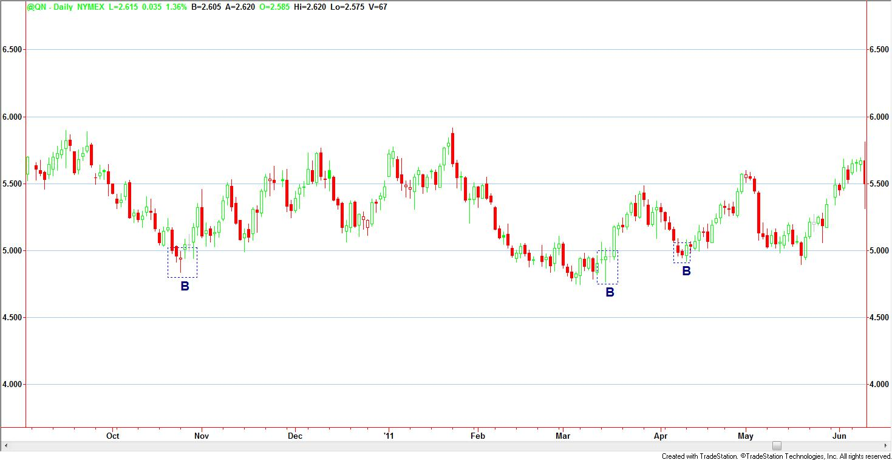

One Intraday pattern (Rect C)

**1) Range play after Trend pausing pattern**

I will intend to play with range consolidation after a trend is pausing (the range could last 4-8 days, be careful being hurt by wick/hammer). The flat range pattern is very easy to find for Natural Gas, the range overlap on daily chart is easy to identify during the range play, the range extension/shrinkage and daily range size are regular in this market, so it's a practical pattern to trade for this market. After a continues trend developed for a while, once the two consecutive high overlap daily move appear, that's a hint the flat range could be formed during the next days. If I am holding the long positions in an uptrend, then it's the time to liquidate part of the positions and switch to intraday play. Or if it's flat in a downtrend, then play intraday and seeking opportunity to get in long position.

Use Very Mean order to trade for range, know where the stop loss is for most traders (play on the edge), and know how to avoid being hurt by wick/hammer, or know how to take advantage of wick/hammer to entry for range play.

## Daily Routine (CST)

Home work: 15:00 -- 16:20 ; 20:00 -- 21:30; 2:30 -- 4:30

Trading: 1:30 -- 5:00; 6:30 -- 7:30; 9:00 -- 14:00

## Trading Strategies and Patterns

**There are only two modes of the market moves I will work on: trend or range.**

**The major profits come from trend riding and position size pyramid, which is inter-day play.**

**The warm-up, the control, and the stop loss deposit come from intraday play. It may entry at the end of the previous day and exits the next day, normally within 48 hours time frame.**

**Inter-day play is seeking for reversal catching and trend riding.**

**Intraday play is seeking for daily exhaustion moves and breakout/false breakout, the gain is small and the risk is small, it’s just preparation of bullets for the coming real battle. This is range play combined with timing.**

**My trading strategy should be flexible and should easily adapt to market changes. (Mark Weinstein)**

**Three steps for catching an opportunity:**

1. **Get in position at range day, warm-up range play with small gain/loss, win stop loss deposit for larger bid**
2. **Get in position at quiet day with wide stop loss to wait for the trend to develop or to reverse**
3. **Hold the position until the winning move being finished or the losing move being stopped out**

### Inter-day patterns

Early trend wave, major trend wave, and late trend wave;

Range narrow down

Five days Exhaustion

Doji and Wick/Hammer appears

### Intraday strategies

Very-Mean entry strategy

**Quiet day**

Quiet day before big moves: those are the days be much alerted, be ready to get in with wide stop loss

Quiet day after big moves: those are the days to take rest and wait/watch

**High volatility day**

Buy dips sell rally, it normally happens after the big rally days or at the reversal point.

Stay as short as possible for one trade, take profits or stop out with one wave move is the best.

**Big rally/decline day**

Stay watch or buy dips/sell recovery at the first correction following the trend;

At the edge set two stop orders for breakout or pull back; figure out which pattern is good for the specific market

## Homework

* Trend, patterns and volatility expected
* Range
* Time points/spans for entry and exit
* Waves
* Profits target and Stop loss

## Trading

### Checklist

Before I put an order, I asked myself two questions:

Question #1: what's the potential risk for this trade?

Question #2: Is this the high probability winning trade?

* Time
* No pattern, no entry
* No edge stops triggered, no entry (VML)
* Stop loss
* Direction
* Price (range)

### Time

The active trading hours are the time when to trade in a market(yellow cells and orange cells),

|  |  |  |  |  |  |  |  |  |  |  |  |  |
| --- | --- | --- | --- | --- | --- | --- | --- | --- | --- | --- | --- | --- |
| Time (EDT) | SM | | | DX | | | | NG | | |  | Time (CST) |
| ECG | AT | Pit | ENY | AT | ELD | ESP | ET | AT | Pit |  |
| 18:00 |  |  |  |  |  |  |  |  |  |  |  | 17:00 |
| 18:30 |  |  |  |  |  |  |  |  |  |  |  | 17:30 |
| 19:00 |  |  |  |  |  |  |  |  |  |  |  | 18:00 |
| 19:30 |  |  |  |  |  |  |  |  |  |  |  | 18:30 |
| 20:00 |  |  |  |  |  |  |  |  |  |  |  | 19:00 |
| 20:30 |  |  |  |  |  |  |  |  |  |  |  | 19:30 |
| 21:00 |  |  |  |  |  |  |  |  |  |  |  | 20:00 |
| 21:30 |  |  |  |  |  |  |  |  |  |  |  | 20:30 |
| 22:00 |  |  |  |  |  |  |  |  |  |  |  | 21:00 |
| 22:30 |  |  |  |  |  |  |  |  |  |  |  | 21:30 |
| 23:00 |  |  |  |  |  |  |  |  |  |  |  | 22:00 |
| 23:30 |  |  |  |  |  |  |  |  |  |  |  | 22:30 |
| 0:00 |  |  |  |  |  |  |  |  |  |  |  | 23:00 |
| 0:30 |  |  |  |  |  |  |  |  |  |  |  | 23:30 |
| 1:00 |  |  |  |  |  |  |  |  |  |  |  | 0:00 |
| 1:30 |  |  |  |  |  |  |  |  |  |  |  | 0:30 |
| 2:00 |  |  |  |  |  |  |  |  |  |  |  | 1:00 |
| 2:30 |  |  |  |  |  |  |  |  |  |  |  | 1:30 |
| 3:00 |  |  |  |  |  |  |  |  |  |  |  | 2:00 |
| 3:30 |  |  |  |  |  |  |  |  |  |  |  | 2:30 |
| 4:00 |  |  |  |  |  |  |  |  |  |  |  | 3:00 |
| 4:30 |  |  |  |  |  |  |  |  |  |  |  | 3:30 |
| 5:00 |  |  |  |  |  |  |  |  |  |  |  | 4:00 |
| 5:30 |  |  |  |  |  |  |  |  |  |  |  | 4:30 |
| 6:00 |  |  |  |  |  |  |  |  |  |  |  | 5:00 |
| 6:30 |  |  |  |  |  |  |  |  |  |  |  | 5:30 |
| 7:00 |  |  |  |  |  |  |  |  |  |  |  | 6:00 |
| 7:30 |  |  |  |  |  |  |  |  |  |  |  | 6:30 |
| 8:00 |  |  |  |  |  |  |  |  |  |  |  | 7:00 |
| 8:30 |  |  |  |  |  |  |  |  |  |  |  | 7:30 |
| 9:00 |  |  |  |  |  |  |  |  |  |  |  | 8:00 |
| 9:30 |  |  |  |  |  |  |  |  |  |  |  | 8:30 |
| 10:00 |  |  |  |  |  |  |  |  |  |  |  | 9:00 |
| 10:30 |  |  |  |  |  |  |  |  |  |  |  | 9:30 |
| 11:00 |  |  |  |  |  |  |  |  |  |  |  | 10:00 |
| 11:30 |  |  |  |  |  |  |  |  |  |  |  | 10:30 |
| 12:00 |  |  |  |  |  |  |  |  |  |  |  | 11:00 |
| 12:30 |  |  |  |  |  |  |  |  |  |  |  | 11:30 |
| 13:00 |  |  |  |  |  |  |  |  |  |  |  | 12:00 |
| 13:30 |  |  |  |  |  |  |  |  |  |  |  | 12:30 |
| 14:00 |  |  |  |  |  |  |  |  |  |  |  | 13:00 |
| 14:30 |  |  |  |  |  |  |  |  |  |  |  | 13:30 |
| 15:00 |  |  |  |  |  |  |  |  |  |  |  | 14:00 |
| 15:30 |  |  |  |  |  |  |  |  |  |  |  | 14:30 |
| 16:00 |  |  |  |  |  |  |  |  |  |  |  | 15:00 |
| 16:30 |  |  |  |  |  |  |  |  |  |  |  | 15:30 |
| 17:00 |  |  |  |  |  |  |  |  |  |  |  | 16:00 |
| 17:30 |  |  |  |  |  |  |  |  |  |  |  | 16:30 |

ECG: e-trade hours for Chicago

AT: active trading hours

Pit: pit session hours

ENY: e-trade hours for New York

ELD: e-trade hours for London

ESP: e-trade hours for Singapore

ET: e-trade hours

**Tips**: End of month or end of season will have significant moves, be ready for that.....

### Pattern and waves

**Quiet day**

If the trend is clear, get entry in quiet; otherwise, stay out.

**High volatility day**

Buy dips sell rally, it happened after the big rally day

**Big rally/decline day**

Stay watch or buy dips/sell recovery at the first correction;

At the edge set two stop orders for breakout or pull back; figure out which pattern is good for the specific market

### Trend

Figure out the major direction of the market for the next day or days; and which pattern I should follow both for inter-day pattern and intraday pattern

### Range

Figure out the L1, L2 range for each market every day, follow the range trading the next day. (Range open/close; Range extension or shrinkage? Range overlap;)

### VML

Increase VML after stop loss, stop loss should fall out of daily range to avoid less hit

### Stop loss

Figure out what size of stop loss should I use based on the expected pattern and range

### Target

Figure out what size of profit should I target on based on the expected pattern and range

### Records

After market time record the trade to TradeLog spreadsheet

### Weekly/Monthly summary and market analysis

The weekend do the summary for the past week and research for next week

## Entry

**Checklist before an entry**

* Time: no inter-day entry on Monday, Friday, especially on Friday, liquidate by the end of the day session
* Is the time interval critical for the destination market ?
* Direction: is trend clear ? Which pattern will be formed ?
* Range:
  + Resistance/support (VML1, VML2, VML3) ?
  + Open/Closed range ?
  + Extension/Shrinkage ?
  + Range alternation, wide or narrow ?
  + Overlap with last day, last 3 days, last 5 days ?
  + Stop loss edges ?
* Wave sequence expected:
  + The sequence of up/down waves
  + The slope (ROC) of each wave ?
  + The starting time for each major wave ? Is now the time critical for the destination market ?
  + The time lasting for each wave ?
* Trade Management (Discipline)  
  If it's inter-day entry, does that exceed 3 times for the market within the month ?  
  If it's inter-day entry, is that stop loss deposit positive and sufficient to cover the losses if it happened? If the stop loss deposit is negative, does that exceed one time inter-day setup only for the market within the month ?  
  If it's intraday entry, does that have two consecutive losses already happened the same day ?  
  If it's intraday entry, is the stop loss out of range ? Or at least out of VML2 range ?

## Exit

**Checklist before an exit**

* Is condition changed after stop loss was defined ? The expected wave does not appears at the time interval expected;
* Profits or loss? if profits is accepted, exit.
* Time: how long the trade I plan to stay, does that hit? how long the underlining move lasted, does that long enough to expected pausing or reversal for that market ? Is now the critical time for the market to make changes ? For intraday trading, is now the time to quit? For inter-day trading, is now the time to quit ?

## Money management

**Checklist weekly and monthly**

1) Split the account balance into 2K units, total 5 units at the beginning. Use (2K*units + 1K) for each phase trading, once 2K profits has been made, then add one more unit to next phase. The trading size will be 3K, 5K, 7K, 9K, 11K,..... if I keep winning; If I keep losing the size of the trading always be 3K.

**Checklist daily**

1) 10% drawn down (account balance less than 9K), take 15 days break

2) 20% drawn down (account balance less than 8K), take 5+ days break

3) 30% drawn down (account balance less than 7K), take 3 days break

4) 40% drawn down (account balance less than 6K), quit the game

5) Any time 50% drawn down, quit the game

6) No more fund will be added to the competition in case receiving the margin call or blow-out.

7) Profits taking intraday: 10% account balance for intraday is a happy rate; 10% of the initial margin of the market is acceptable

8) Profits taking inter-day: 20% account balance for inter-day is a happy rate; 20% of the initial margin of the market is acceptable; Or 72 hrs rally/decline for inter-day; once the trend is developing well, lock the profits by moving stop loss along with the trend

9) Three inter-day setups per-month at most for each market, if it has two consecutive inter-day losses for a market then stop inter-day trading for the rest of the month in that market. Here setup means an entry that fits a pattern, the trade might take several rounds of entries and exits before it ends up, for a specific market, every month it has 1-3 setups is reasonable and those are the inter-day opportunities should be taken

## Records

Each individual market needs to have its own trade log;

Record every stop loss and reason, and the solution to avoid it next time, check if it reaches the ceiling of allowance of losing trades per day, per month;

## Performance

Profits or loss ?

Violate discipline ?

July performance

|  |  |  |  |  |  |  |  |  |
| --- | --- | --- | --- | --- | --- | --- | --- | --- |
| Market | Week #1 (July 2-6) | | | | | | Pattern |  |
|  | Intraday | W/L | P/L | Inter-day | W/L | P/L |  |  |
| SMN2 |  |  |  |  |  |  |  |  |
| DXU2 |  |  |  |  |  |  |  |  |
| NGN2 |  |  |  |  |  |  |  |  |
|  |  |  |  |  |  |  |  |  |
|  |  |  |  |  |  |  |  |  |
|  |  |  |  |  |  |  |  |  |
|  |  |  |  |  |  |  |  |  |
|  |  |  |  |  |  |  |  |  |

## Analysis

How the patterns work ?

Reasons for winning ?

Reasons for losing ?

## Future Work

Research on back-test with programming;

Execute with robots;