**SITE MAP**

**WWW.WHERETOWASH.EE**

**Landing page**

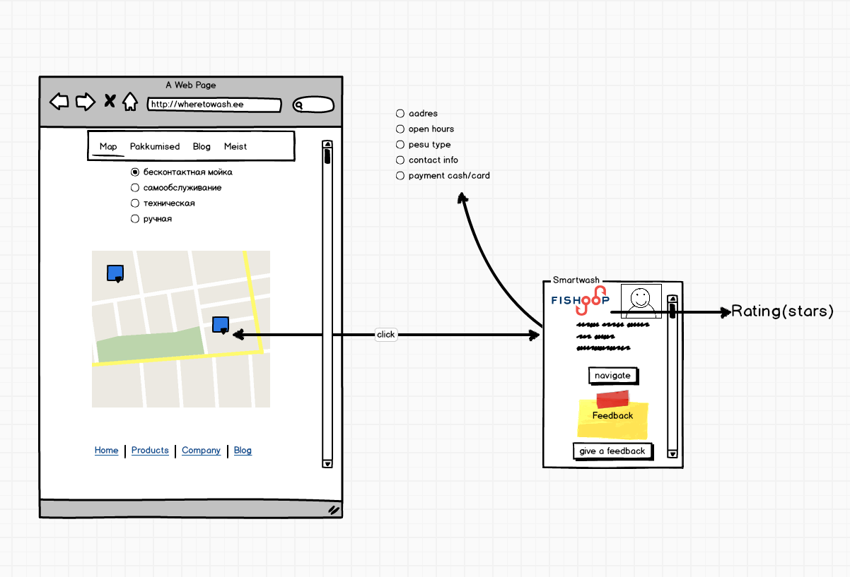

**Pakkumised (2 navbar menu)**

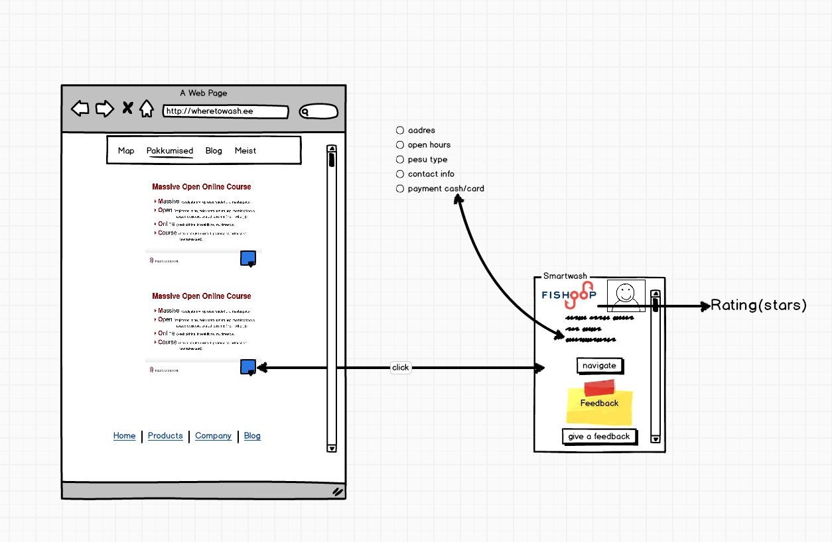

**Blog (3 navbar menu)**

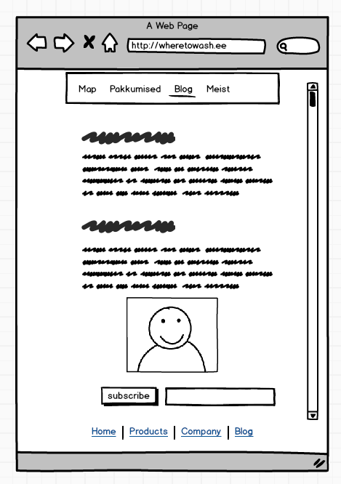

**Meist(4 navbar menu)**

