Preferred locations for a tourism business

# Introduction:

Most major cities are marketed based on their tourism potential. Some of these places are only known by the locals. If a person wants to start a tourism business (or an existing tourism company wants to expand), it would be wise to have a premises in close proximity to tourism venues, so that you can also play the role of tourist guide.

# Data:

1. A website advertising commercial properties for sale in Cape Town is used to obtain information about the location, neighbourhood and selling price.
   1. The website consists of classes that describe different aspects of the properties for sale. One class contains the address and another the price.
   2. The default layout consist of 10 listings, but there could be more. Each listing is contained in a separate class.
   3. The website has multiple pages for the search criteria (already embedded in the URL). All the pages will be read to build the dataframe.
   4. Data Cleansing:
      1. Some addresses contain 4 address lines, but it seems a duplication, thus only 3 address lines are used
      2. Some indicate an intersection of 2 addresses with an “And”, only the first address is used
      3. For some the price is indicated as “POA” – these were set to zero (0)
      4. The price string contains spaces and unreadable characters – these were removed
      5. Blank rows were dropped
      6. Some properties are advertised more than once because of multiple listings with different realtors – the duplicate addresses were removed
2. Taking the centre of Cape Town as a starting point, data is obtained from Foursquare about points of interest near Cape Town within a 50 Km radius. The name, location, distance from city centre and popularity index is obtained.

# Methodology:

1. Map the properties and the points of interest on the same map to get an idea of proximity.
2. Using the venue categories and mean distance from the city centre, highlighted the important points of interest.
3. Using the price of property as a guide, determine the most suitable properties.

# Results:

* As can be seen from the map, the available properties in the city centre are also closest to the most points of interest. (*Figure 2*)
* Most venues are less than 3 Km away from the city centre. (*Figure 3*)
* The average distance to social venues and hotels are closer to the centre (hotels at 2.694 km). (*Figure 4*)
* There are more properties priced towards the lower half (ignoring the 0) than in the higher half. (*Figure 5*)
* The properties in the city centre or priced on the higher end. (*Figure 6*)

# Discussion:

* The commercial properties in the centre of the city are closest to important points of interest, such as hotels (if one needs to meet with the tourists or provide transport).
* As one can expect, the properties in the City Centre are priced higher.
* Of course, aspects such as the size of the property, access to major routes and accessibility for patrons are not taken into account and could be the subject of further analysis.
* If one can arrange transport intelligently (such as collaborating with transportation companies), the proximity of the property should not be a problem.

# Conclusion:

* Based only on these factors: proximity of venues to the city centre, certain venue categories being more important (such as hotels), and the location and price of commercial properties, the following conclusions are made:
* Of interest:
  + Properties available in Wynberg (average price of R 3 710 000) and Rondebosch (average price of R 4 200 000) should be considered first.
  + Properties in Woodstock and Observatory seems a good choice as to their closer proximity to the city centre, but at a higher price (average price of R 8 500 000).
* Possible interest:
  + The properties in Cape Town City Centre comes with a high price tag, but are closer to all the venues. This should be considered last.
  + Property in Plumstead does not have a price (POA), but this could be good for negotiation. Also its proximity to Wynberg may be an indication of a similar price.
* Not of interest:
  + Properties in Westlake, although at a lower average price (R 2 030 000), are further away from the city centre and does not seem to be close to major routes.
  + Properties in Capricorn seem to be an outlier: high price tag and further from the city centre.

Figure 1:

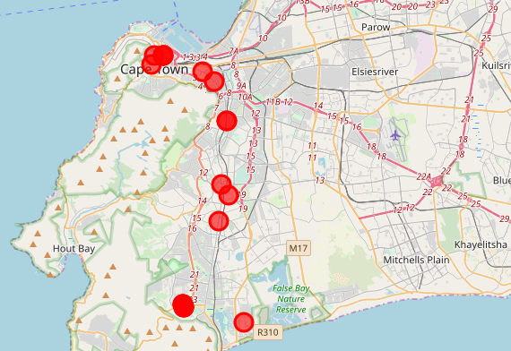

Figure 2:

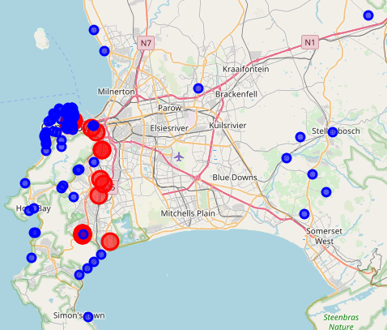

Figure 3:

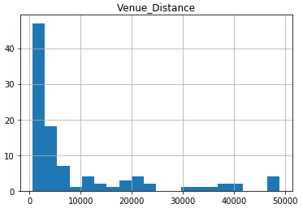

Figure 4:

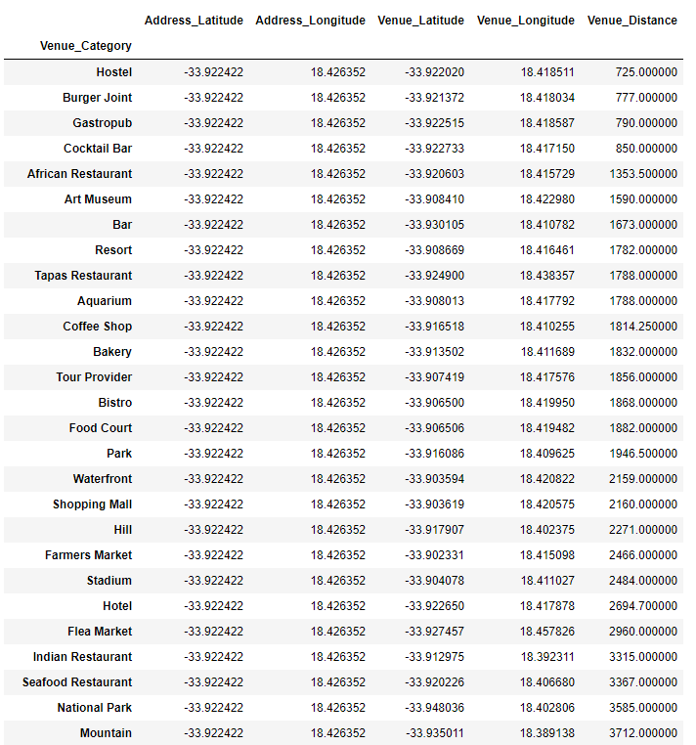

Figure 5:

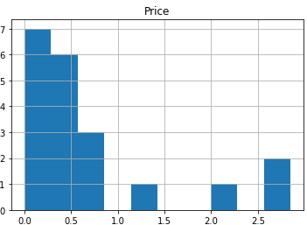

Figure 6:

