Kenneth R. Pondar
BSIT-4D
ITEC 116

Activity 4: Weather Proxy API

The activity teaches how to make a backend that gets weather data from OpenWeatherMap and sends only simple results to the frontend. It helps you learn how to fetch data using a proxy, hide the API key, and show the temperature and condition based on the city the user enters.

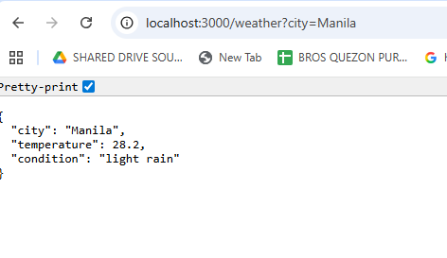
API CALL (SAME METHOD TO THE POSTMAN)
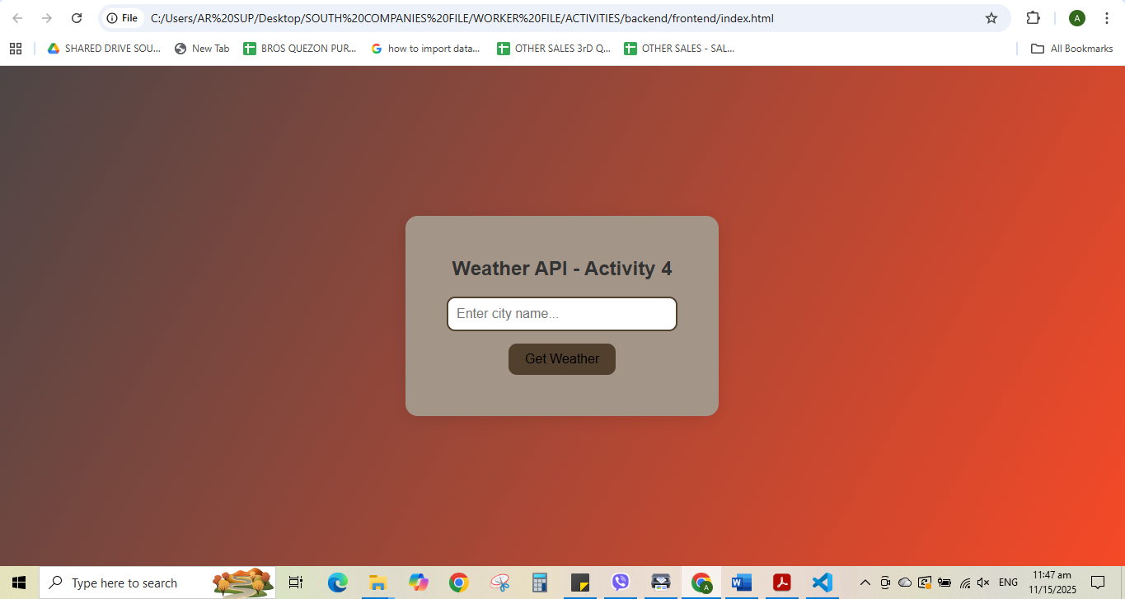
User Interface of the Project

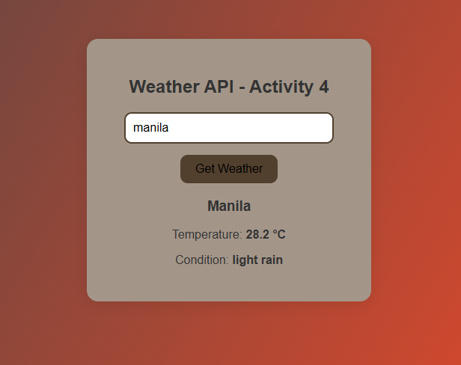

It is command to start or run the project
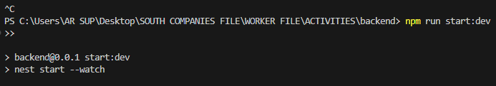
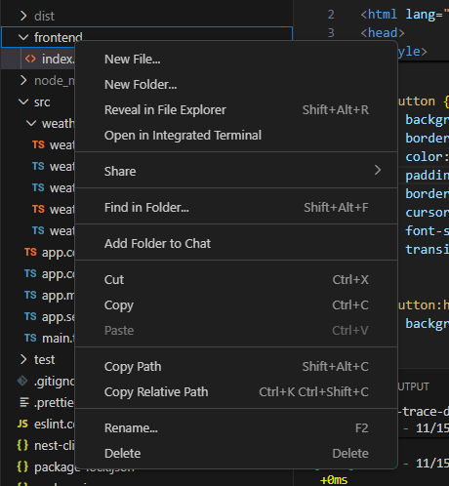
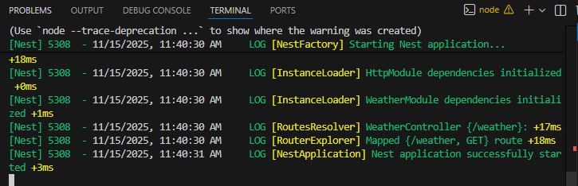
If this is the result, it does not have error while running the project
Click the Left so you will see the other options, then click the reveal in the explorer.

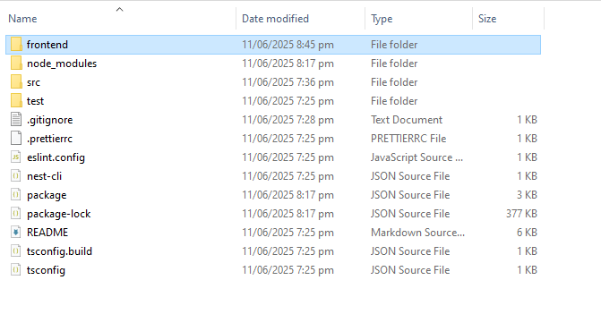
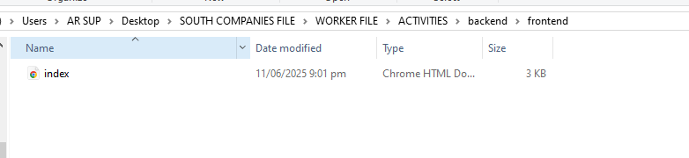
Then click the Frontend, and double click the index.html file
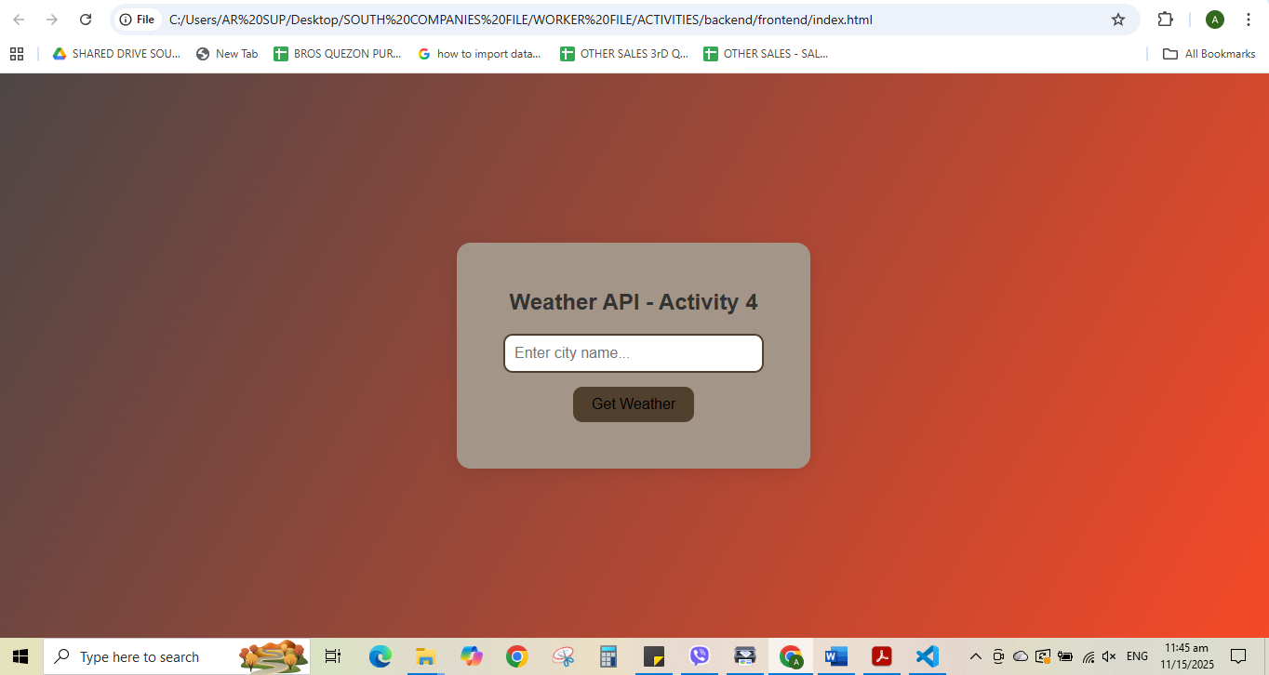
Then this is the UI or the output of the project

