Name: Walid Binsaid L. Dimao
Section: BSIT-4D
Subject: ITEC-116
Repository link: geruel39/ITEC-116-Activities

Title of Activity: Activity 1 (To-Do List)

Short Description:
This app helps users organize their tasks by allowing them to add new tasks, view their list of tasks, update existing ones, and delete tasks they no longer need.

Screenshots of User Interface:

Main Interface of the application showing to the users that can add tasks.

After adding multiple tasks and showing it in a list of view.

Showing the current tasks can be editable and can be saved after editing.

Instruction on how to run the project:
- Open PowerShell
- Change to the activity1 frontend folder and inspect package.json to see which script to run:
Ex: cd C:\Users\Win10\OneDrive\Desktop\frontend\activity1\frontend Get-Content package.json
- Install dependencies (only needed once) and start the dev server. Use the script shown in package.json ("dev" or "start"):

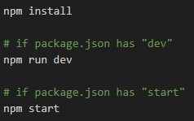

- Open the app in your browser. Vite usually runs on 5173, Create React App on 3000
— use the port printed by the dev server:

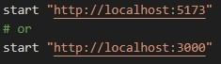

API Documentation
I use Swagger to create clear and interactive API documentation, making it easier for developers to see how each endpoint works.

Method | Description
POST/todos | Create a new task
GET/todos | Get all tasks
GET/todos {id} | Get one task by ID
PUT/todos {id} | Update a task
DELETE/todos{id} | Delete a task

