Repository link: geruel39/ITEC-116-Activities

Avtivity 2: NoTe APP + UI

This project is a personal notes web app with user authentication and private note management. It allows users to register, log in, and manage their own notes through a clean and responsive interface. The system integrates both frontend and backend features, including user authentication and CRUD operations for notes.

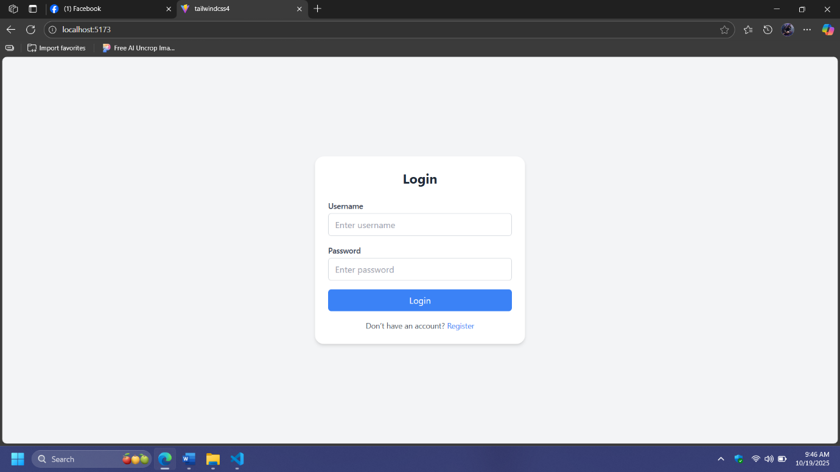
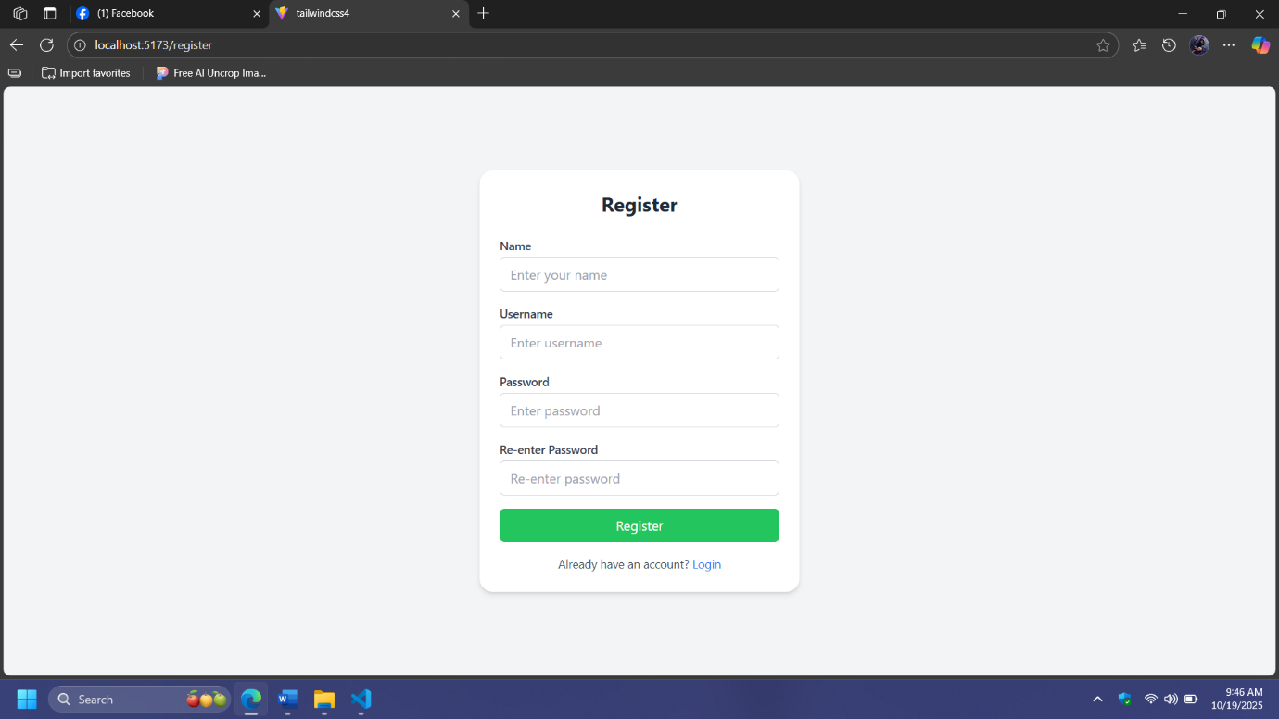

Instruction how to run the project:

Step 1: *Clone or download* the project folder to your local machine.
Step 2: Open the folder in *Visual Studio Code* (or any code editor).
Step 3: Run npm install in the terminal to install all dependencies.
Step 4: Start the development server using npm run dev and copy the link on the terminal.
example. http://localhost:5173/.
Step 5: Open your browser and paste link that you have copy on terminal to view the app.
Step 6: Use the Register page to create a new account, then log in using your credentials to test the authentication system.

