Name: Rosales, Kane Ira M. Date: Nov. 08, 2025
Grade & Section: BSIT-4D Subject: ITEC-116

ACTIVITY 3 – Bookshelf API + UI

A small digital bookshelf that lets you create and manage authors, categories, and books. The backend exposes CRUD API endpoints (NestJS) and the frontend (React + Vite) provides a minimal UI for viewing and managing books. API documentation is available via Swagger.

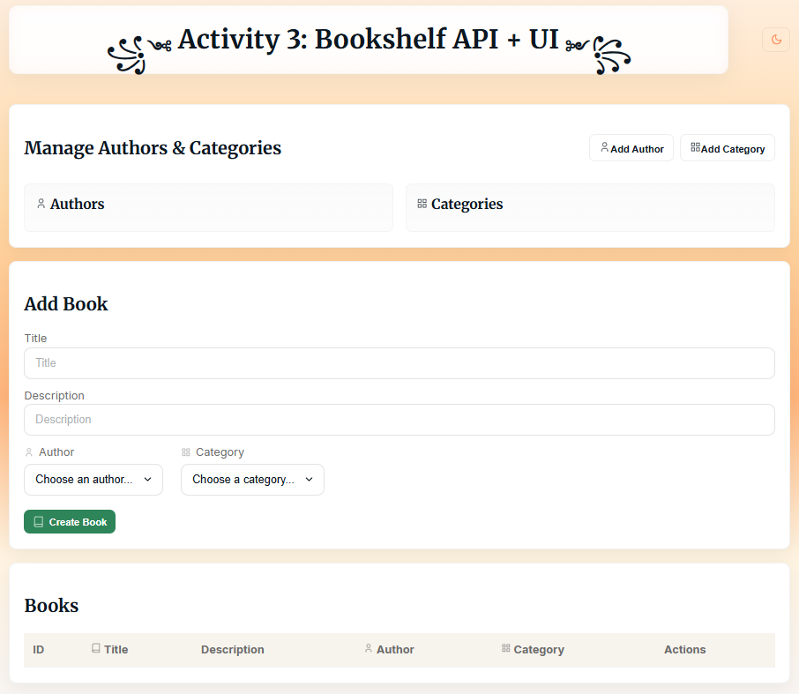

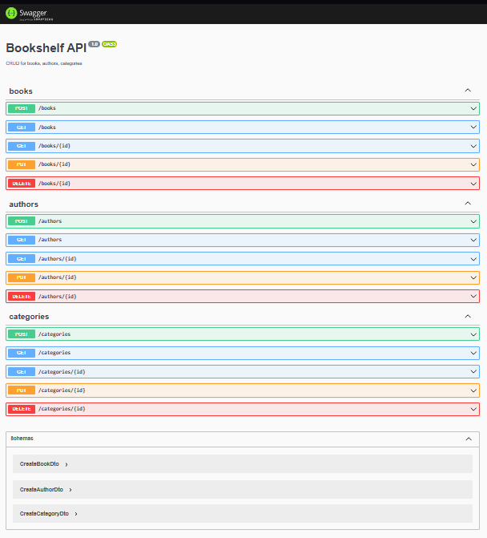

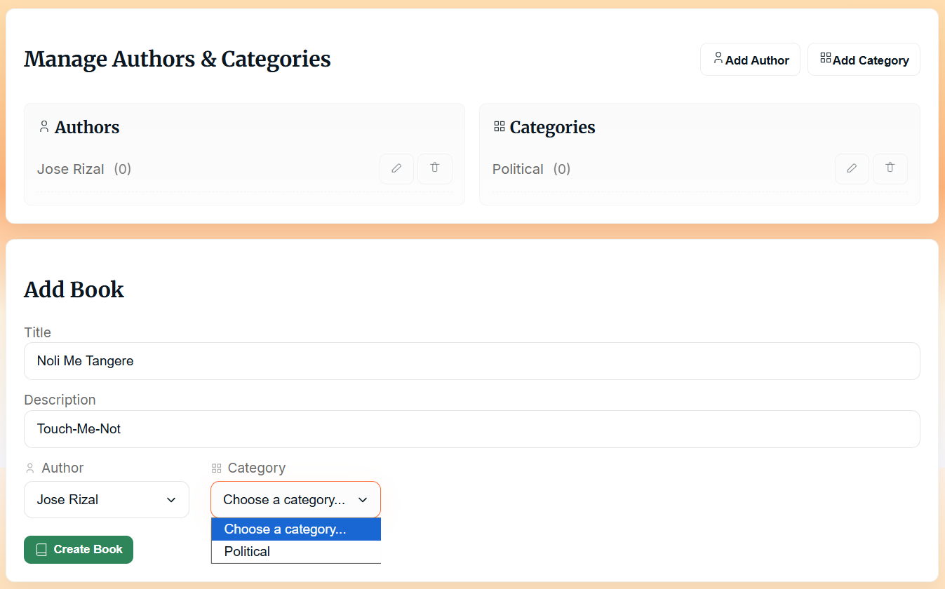

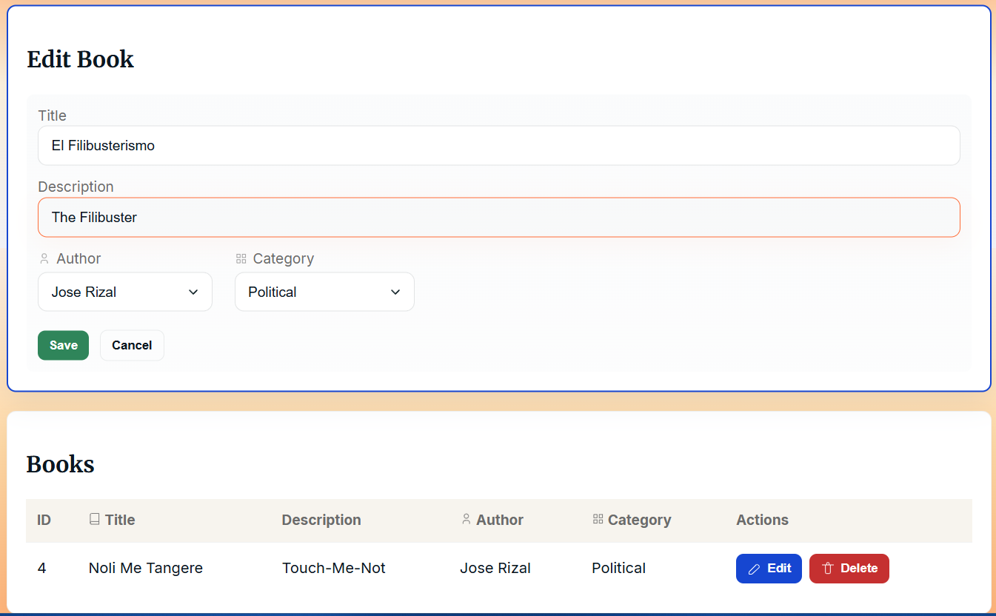
Instruction on How to Run the Project:
- Before running the project, type ‘npm install’ on the main folder, the ‘frontend’, and the ‘backend’ files to ensure all installations are up-to-date.
- No need to both run the ‘frontend’ and ‘backend’ files, just run the main folder (i.e., ‘activity3’ and type in the bash terminal:

Note: the `npm start` command from the `activity3` folder is configured to run both backend and frontend for this activity.

