Repository link: geruel39/ITEC-116-Activities

Avtivity 2: NoTe APP + UI

This project is a personal notes web app with user authentication and private note management. It allows users to register, log in, and manage their own notes through a clean and responsive interface. The system integrates both frontend and backend features, including user authentication and CRUD operations for notes.

The system is built using:
- Backend: NestJS (Node.js Framework)
- Database: Xampp
- Frontend: React + Vite
- API Documentation: Swagger UI

This system demonstrates how a modern full-stack application is structured, including database modeling, API endpoint design, component-based UI development, and end-to-end CRUD operations.
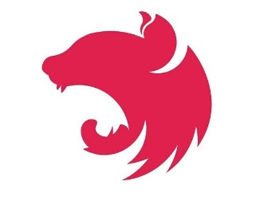


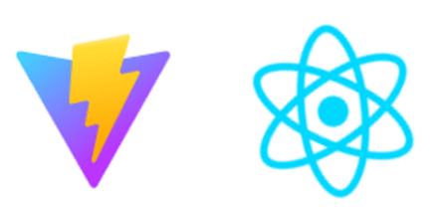

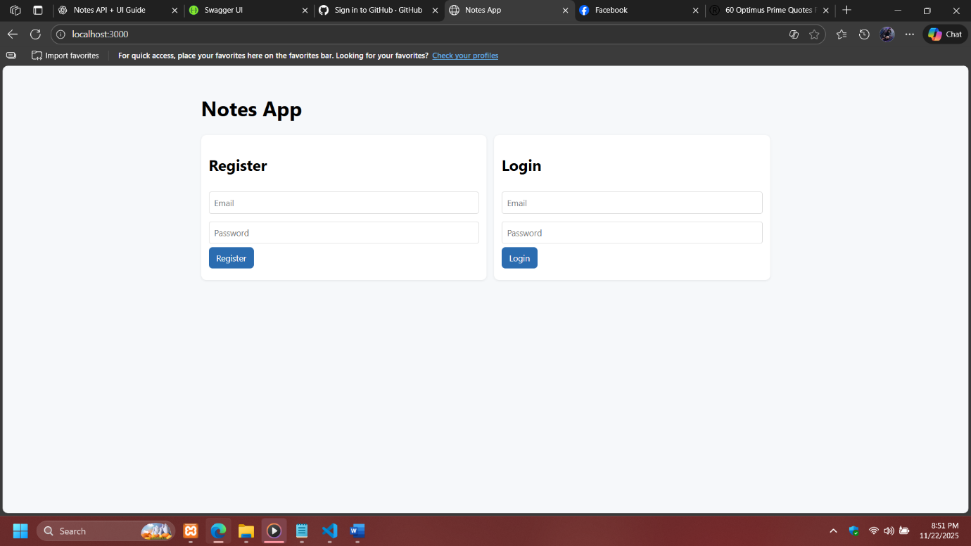
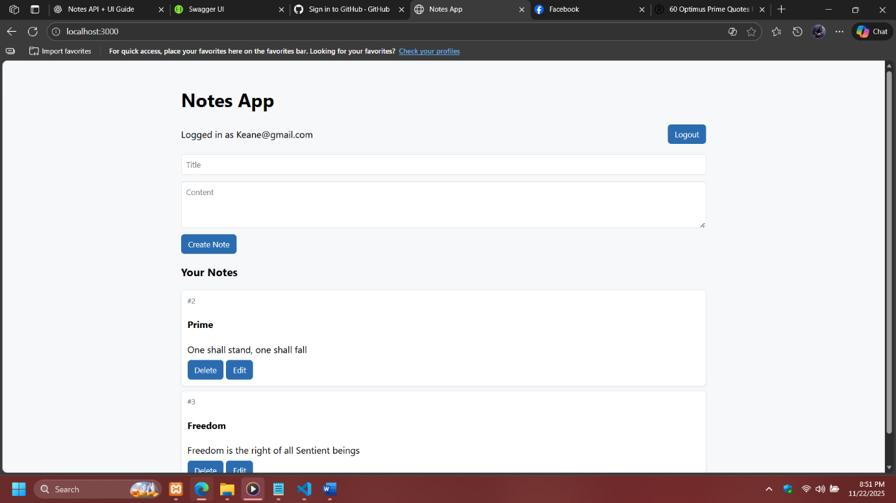

Instruction how to run the project:

Step 1: *Clone or download* the project folder to your local machine.
Step 2: Open the folder in *Visual Studio Code* (or any code editor).

Step 3: Run npm install in the terminal to install all dependencies.
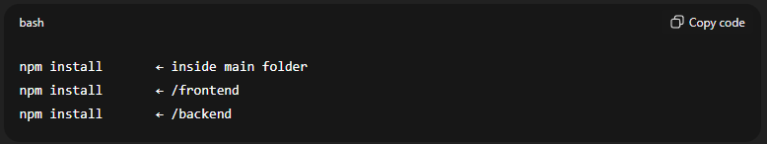
Step 4: Start the development server using npm run dev and copy the link on the terminal.
example. http://localhost:3000. For the app
http://localhost:3000/api. For the swagger
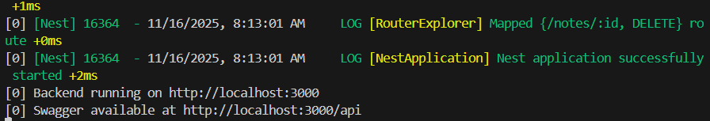
This command automatically launches:
- Backend server (NestJS)
- Frontend (Vite)
- Swagger API documentations
Step 5: Open your browser and paste link that you have copy on terminal to view the app.
Step 6: Use the Register page to create a new account, then log in using your credentials to test the authentication system.

Swagger API Documentation (Backend)
- The Swagger UI displays the complete API used by both the UI and manual testers.

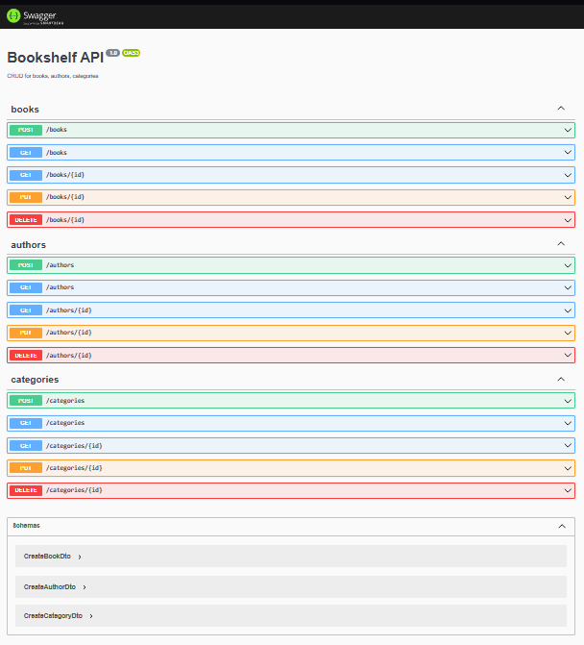

Method | Description
POST /notes | Create new notes
GET /notes (id) | Retrieve notes
GET /notes (id) | Fetch a specific notes
PUT /notes/{id} | Update an existing notes

