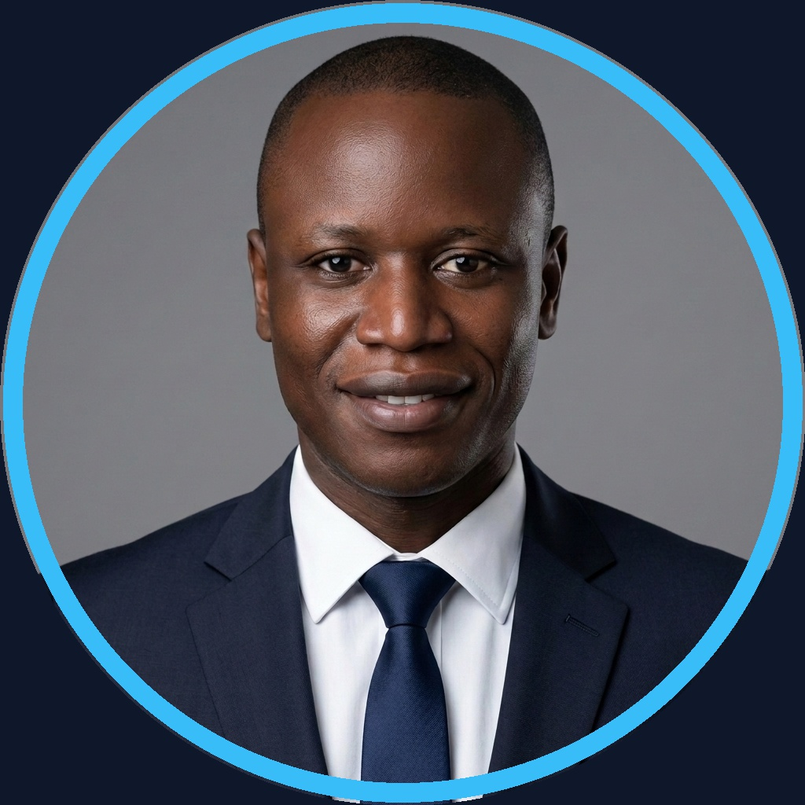  CONTACT  ✉ koagervais85@gmail.com  ✆ +237 695 35 34 02  ⌂ Douala / Ngaoundéré, CM  🌐 github.com/gervais-afk  💼 linkedin.com/in/gervais-koa  AI & LLM STACK  Google Gemma 4 ■ ■ ■ ■ ■  Gemini 1.5 Pro ■ ■ ■ ■ ■  CrewAI/LangGraph ■ ■ ■ ■ ■  Firebase Genkit ■ ■ ■ ■ ■  RAG / GraphRAG ■ ■ ■ ■ ■  DATA & GRAPHS  Neo4j / Cypher ■ ■ ■ ■ ■  PostgreSQL / SQL ■ ■ ■ ■ ■  Supabase ■ ■ ■ ■ □  Firebase Emulator ■ ■ ■ ■ □  Pandas / NumPy ■ ■ ■ ■ ■  DEV & MLOPS  Python (BAEL 91) ■ ■ ■ ■ ■  IfcOpenShell (5D) ■ ■ ■ ■ □  FastAPI / Next.js ■ ■ ■ ■ □  MLflow (MLOps) ■ ■ ■ ■ □  Streamlit / Docker ■ ■ ■ ■ ■  LANGUAGES  French (Native)  English (Professional / Tech)  KEY ASSETS  ◈ Dual Competence AI & Civil Eng.  ◈ Aviation Security & Risk (AVSEC)  ◈ Strict Math Guardrails & 0 Hallucination | KOA MARIE GERVAIS NELLY  Lead AI Engineer & Data Architect │ Founder @ Archi Cam AI  ─── ◈ ────────────────────────────────────────────────────────── ◈ ───  ◈ EXECUTIVE SUMMARY  Lead AI Engineer & Data Architect specializing in sovereign autonomous agents, Neo4j GraphRAG, and deterministic civil engineering software. Founder of Archi Cam AI (official applicant for Google Africa Applied AI Lab), bridging multi-agent orchestration with strict mathematical compliance (BAEL 91, ICAO Annex 17) and production MLOps.  ◈ FLAGSHIP AI PROJECTS  Archi Cam AI – Agentic AI & 5D BIM SaaS  ▸ Official candidate for Google Africa Applied AI Lab (Accra, Ghana). Sovereign 5D BIM & BOQ estimation platform.  ▸ Combines local Google Gemma 4 12B QAT, Gemini 1.5 Pro, and deterministic Python Sandbox (IfcOpenShell, BAEL 91).  ▸ Automates 6-sheet NDA Excel BOQs in <45s (-99.2% time) and synthesizes 3D renders via Imagen 3.0 + ControlNet.  Sovereign.BI Agentic – Enterprise Security & Agentic BI  ▸ Sovereign natural language query engine for complex enterprise SQL & Graph databases.  ▸ TypeScript Orchestrator architecture, Neo4j N10S (GraphRAG), and FastAPI/PostgreSQL backend.  ▸ Enforces dynamic ABAC guardrails and anti-hallucination explainability via SHAP Sentinel.  Dataset Automator & VigieSahel – MLOps Pipeline & Climate AI Impact  ▸ Dataset Automator: Time-series evaluation RAG pipeline (Neo4j, MLflow tracking, Firebase Genkit).  ▸ VigieSahel: Predictive ML platform for agro-climatic sowing optimization & health outbreak tracking (R² > 0.94).  ◈ PROFESSIONAL EXPERIENCE  AI Lead & Data Science Consultant (2025 – Present)  Independent Projects & Enterprises │ Douala, CM  ▸ Guiding enterprises in deploying sovereign local AI agents and private data processing pipelines.  ▸ Exploratory data analysis and preprocessing of high-dimensional complex datasets.  ▸ Knowledge graph modeling (Neo4j Cypher) and end-to-end GraphRAG pipeline development.  ▸ Designing PostgreSQL relational schema and interactive executive reporting dashboards.  Aviation Security Officer (AVSEC) (2018 – Present)  CCAA (Cameroon Civil Aviation Authority)  ▸ Critical threat assessment, security inspections, and access control management (ICAO Annex 17).  ▸ Drafting regulatory security compliance reports and coordinating operational field emergency response.  ◈ EDUCATION & CERTIFICATIONS  Master of Science in Applied Artificial Intelligence (2025 – 2027) [In Progress]  University of Ngaoundéré │ Graph Modeling (Neo4j), MLOps, Prompt Engineering & LLM Architecture  Bachelor of Science in Civil Engineering (Building Option) (2015 – 2016)  ISTDI / IUC Douala │ Structural Calculations (BAEL 91), Quantity Surveying & Construction Project Management

