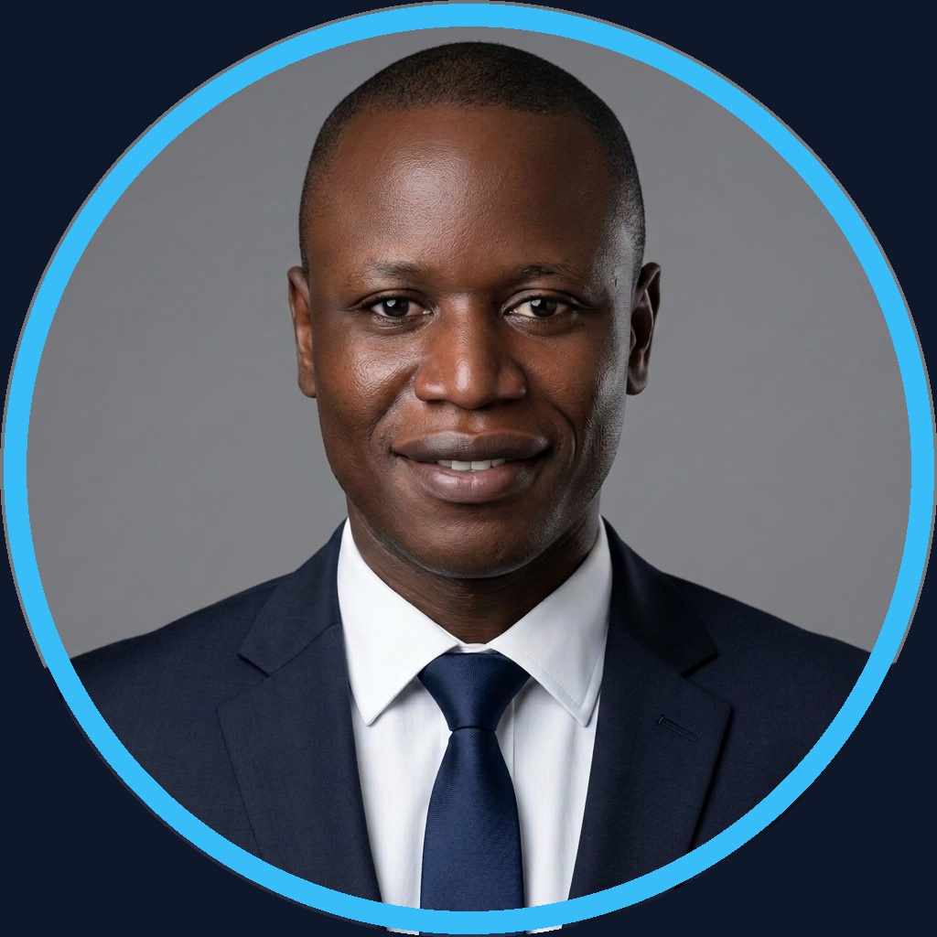  Founder · Archi Cam AI  CONTACT & PROFILES  ━━━━━━━━━━━━━━━━━━  ✉ contact@archicam-ai.com  ✆ +237 695 35 34 02  ⌂ Douala / Ngaoundéré, CM  🐙 github.com/gervais-afk  💼 linkedin.com/in/marie-gervais-koa  AI & LLM STACK  ━━━━━━━━━━━━━━━━━━  Google Antigravity IDE ■ ■ ■ ■ ■  LangGraph & CrewAI ■ ■ ■ ■ ■  Google Gemma 4 (12B) ■ ■ ■ ■ ■  Gemini 2.5 / 1.5 Pro ■ ■ ■ ■ ■  Google TabFM (Tabular) ■ ■ ■ ■ ■  FastMCP & Genkit ■ ■ ■ ■ ■  Neo4j GraphRAG — Agent K1  DATA & GRAPHS  ━━━━━━━━━━━━━━━━━━  Neo4j / Cypher Graph ■ ■ ■ ■ ■  PostgreSQL / pgvector ■ ■ ■ ■ ■  Apache AGE & DuckDB ■ ■ ■ ■ □  BigQuery DataFrames ■ ■ ■ ■ □  Pandas / NumPy ETL ■ ■ ■ ■ ■  DEV & MLOPS  ━━━━━━━━━━━━━━━━━━  Python 3.11+ / MLOps ■ ■ ■ ■ ■  FastAPI / Next.js 14 ■ ■ ■ ■ □  MLflow & Data Drift ■ ■ ■ ■ □  SHAP Sentinel Audit ■ ■ ■ ■ ■  IfcOpenShell & Shapely ■ ■ ■ ■ □  Docker & Pytest ■ ■ ■ ■ ■  ETHICS, SECURITY & AUDIT  ━━━━━━━━━━━━━━━━━━  ◈ CCAA Excellence Attestation '23  ◈ AVSEC Officer (ICAO Annex 17)  ◈ AI Ethics & Anti-Hallucination  ◈ OKF v0.2 SHA-256 No-LLM  ◈ EU AI Act Compliance (RSASSA)  LANGUAGES  ━━━━━━━━━━━━━━━━━━  French — Native / Fluent  English — Tech & Written / Spoken Interm. | KOA MARIE GERVAIS NELLY  Lead AI Engineer & Data Architect │ Founder @ Archi Cam AI  ──────────────────────────────────────────────────────────────────────  ◈ EXECUTIVE SUMMARY  ━━━━━━━━━━━━━━━━━━────────────────────────────────────────────  Applied AI Engineer specializing in autonomous agent architectures, I design deterministic, explainable, and sovereign zero-hallucination systems. Member of the Google Developer Program, I bridge civil engineering rigor with advanced data science to solve complex operational challenges. Founder of Archi Cam AI (5D BIM SaaS & predictive estimation), I build auditable, robust, and high-impact AI solutions.  ◈ FLAGSHIP AI PROJECTS  ━━━━━━━━━━━━━━━━━━────────────────────────────────────────────  Archi Cam AI — Agentic AI & 5D BIM Construction SaaS  ▸ Full automation of construction quantity takeoff and cost estimation: eliminating human error and material waste.  ▸ Instant generation of standardized BOQ estimates in <45s (99.2% time savings) and 3D architectural renders.  ▸ Deterministic zero-hallucination structural concrete validation enforcing strict compliance with urban planning codes.  K1-MATHINFO (v3.2.0) — Sovereign Academic Research & Asset Platform  ▸ Preservation, indexing, and semantic exploration across 28 years of research (471 Ph.D. & Master's docs, 4,494 relations).  ▸ Neuro-symbolic Advisor Matcher, high availability with Circuit Breaker, and 192 automated unit/integration tests (100%).  Sovereign.BI Agentic — Enterprise Business Intelligence & Strategic Decision Engine  ▸ Executive decision enablement: querying complex corporate data warehouses directly in natural language in under 5 seconds.  ▸ Total sovereign enterprise privacy with air-gapped local execution and mathematical explainability for every KPI.  Dataset Automator & VigieSahel — Climate Resilience & Production MLOps Systems  ▸ Dataset Automator: Autonomous data engineering factory for reliable dataset preparation, fairness audits, and compliance.  ▸ VigieSahel: Sahelian resilience system cutting crop sowing failures by 35% and forecasting meningitis epidemics 14 days ahead.  ◈ PROFESSIONAL EXPERIENCE  ━━━━━━━━━━━━━━━━━━────────────────────────────────────────────  AI Lead & Data Science Consultant — March 2026 – Present  Independent Projects & Enterprises │ Douala, CM  ▸ Ethical sovereign AI systems: GraphRAG Neo4j pipelines, high-dimensional EDA, multi-source RAG architectures.  ▸ Executive decision reporting, automated KPI dashboards, and SHAP explainability audits for African SMEs.  Aviation Security Officer (AVSEC) — 2018 – Present  CCAA — Cameroon Civil Aviation Authority │ Douala, CM  ▸ Threat assessment, secure access control, and regulatory compliance audits (ICAO Annex 17).  ▸ Operational crisis management: emergency team coordination, anti-intrusion protocols.  ◈ EDUCATION & CERTIFICATIONS  ━━━━━━━━━━━━━━━━━━────────────────────────────────────────────  M.Sc. in Applied Artificial Intelligence — Dec. 2025 – 2027 [In Progress]  University of Ngaoundéré │ Cameroon  ▸ ML & Bayesian Statistics, Data Engineering & Neo4j, Computer Vision & Robotics, Ethics & Cybersecurity, Production MLOps.  ▸ Research project: K1-MATHINFO v3.2 sovereign system — multi-source agent certified OKF v0.2 (SHA-256 No-LLM, 192 tests).  B.Sc. in Civil Engineering (Building Option) — 2015 – 2016  ISTDI / IUC Douala │ Cameroon  ▸ Structural calculations (BAEL 91), quantity surveying, construction project management — AI-applied estimation base.  ◈ HONORS & APPLIED AI DISTINCTIONS  ━━━━━━━━━━━━━━━━━━────────────────────────────────────────────  ◆ CCAA Attestation of Excellence & Integrity (2023) — Awarded by the Director General for outstanding operational performance & ethics.  ◆ Google Cloud #AllThingsAgentic Hackathon — Dataset Automator v4.0 (Google Antigravity, TabFM, BigQuery DataFrames, WIT).  ◆ Google Developer Program · AICC Accra — Active member · Accra AI Community Centre & Google for Startups Accelerator Network.

