# Openlayers接入pgis注意事项。

西安市局pgis服务的EzMapAPI.js文件中有用参数。（其他相关参数可见附录中的EzMapAPI.js文件）

EzServerClient.GlobeParams.CenterPoint = [108.72265, 34.24023];

EzServerClient.GlobeParams.MapFullExtent = [107.4414,33.75,110.0039,34.73046];

EzServerClient.GlobeParams.MapInitLevel = 12;

EzServerClient.GlobeParams.MapMaxLevel = 20;

EzServerClient.GlobeParams.ZoomOffset = 0;

EPSG:3785

## 分辨率：

分辨率数组或者最大分辨率有一个即可。该参数是确定值，不需要再改动。

### 分辨率数组

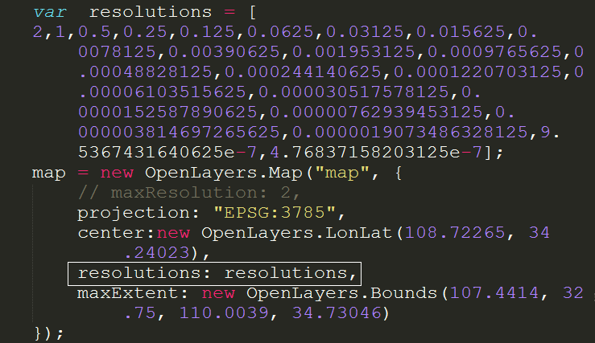

### 最大分辨率maxResolution

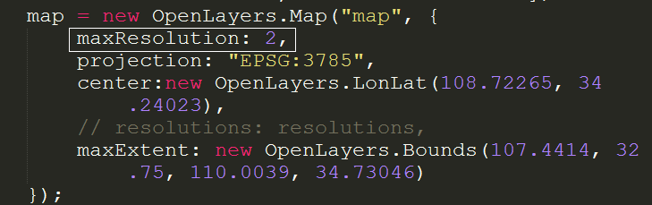

var d = [ { "level": 0, "resolution": 2, "scale": 786432000 },

{ "level": 1, "resolution": 1, "scale": 393216000 },

{ "level": 2, "resolution": 0.5, "scale": 196608000 },

{ "level": 3, "resolution": 0.25, "scale": 98304000 },

{ "level": 4, "resolution": 0.125, "scale": 49152000 },

{ "level": 5, "resolution": 0.0625, "scale": 24576000 },

{ "level": 6, "resolution": 0.03125, "scale": 12288000 },

{ "level": 7, "resolution": 0.015625, "scale": 6144000 },

{ "level": 8, "resolution": 0.0078125, "scale": 3072000 },

{ "level": 9, "resolution": 0.00390625, "scale": 1536000 },

{ "level": 10, "resolution": 0.001953125, "scale": 768000 },

{ "level": 11, "resolution": 0.0009765625, "scale": 384000 },

{ "level": 12, "resolution": 0.00048828125, "scale": 192000 },

{ "level": 13, "resolution": 0.000244140625, "scale": 96000 },

{ "level": 14, "resolution": 0.0001220703125, "scale": 48000 },

{ "level": 15, "resolution": 0.00006103515625, "scale": 24000 },

{ "level": 16, "resolution": 0.000030517578125, "scale": 12000 },

{ "level": 17, "resolution": 0.0000152587890625, "scale": 6000 },

{ "level": 18, "resolution": 0.00000762939453125, "scale": 3000 },

{ "level": 19, "resolution": 0.000003814697265625, "scale": 1500 },

{ "level": 20, "resolution": 0.0000019073486328125, "scale": 750 },

{ "level": 21, "resolution": 9.5367431640625e-7, "scale": 375 },

{ "level": 22, "resolution": 4.76837158203125e-7, "scale": 187.5 }

];

## 地图中心点center

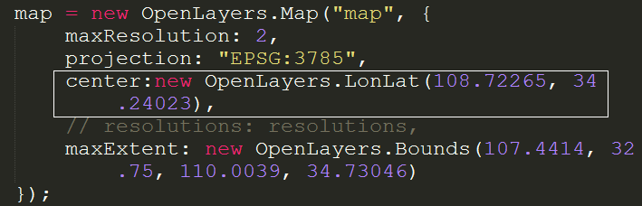

该参数可以在pgis的EzMapAPI.js文件中找到：CenterPoint

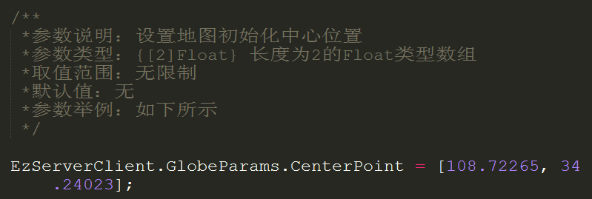

## 切片原点tileOrigin

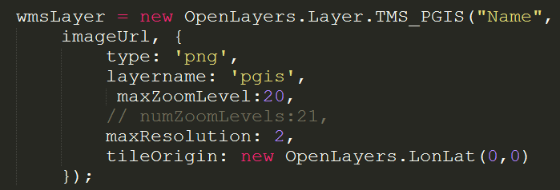

该参数可以在pgis的EzMapAPI.js文件中找到：TileAnchorPoint

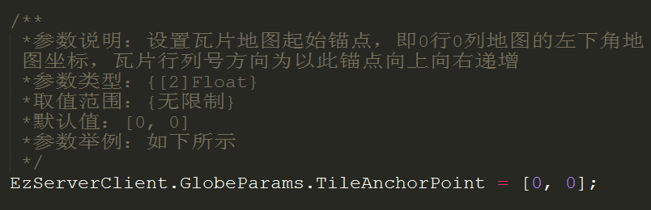

## 最大显示范围MapFullExtent

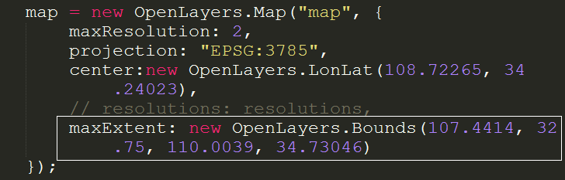

该参数可以在pgis的EzMapAPI.js文件中找到：MapFullExtent

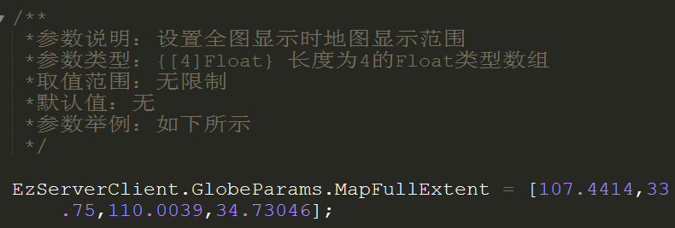

当y的最小值设为33.75时，地图下面被截断，显示不出来，所以将其设置为32.75，扩大其显示范围，使地图完全显示。

# 效果展示图

## Openlayers API接入pgis服务

### 图1 Openlayers API接入pgis服务(zoom=10)

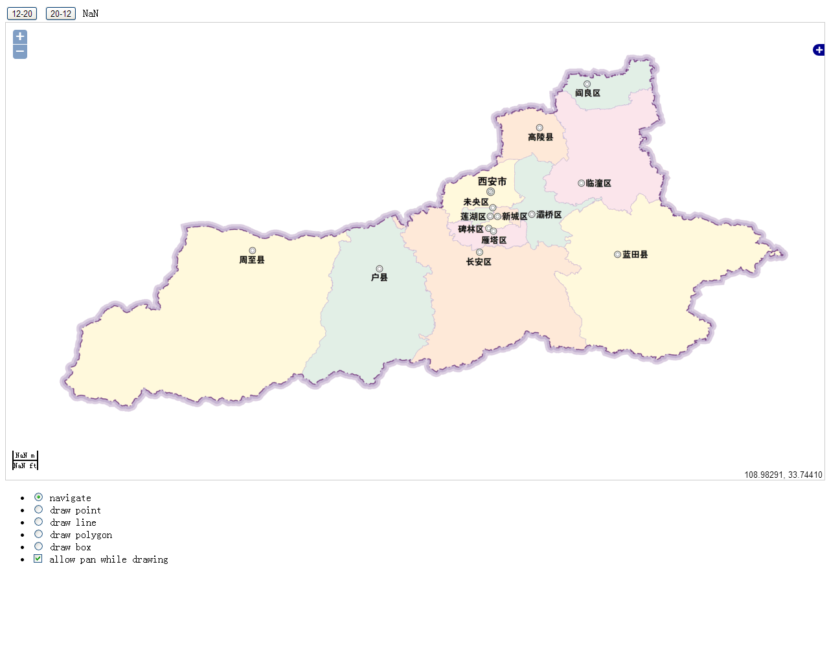

### 图2 Openlayers API接入pgis服务，添加矢量图层（点、线、面、矩形框）

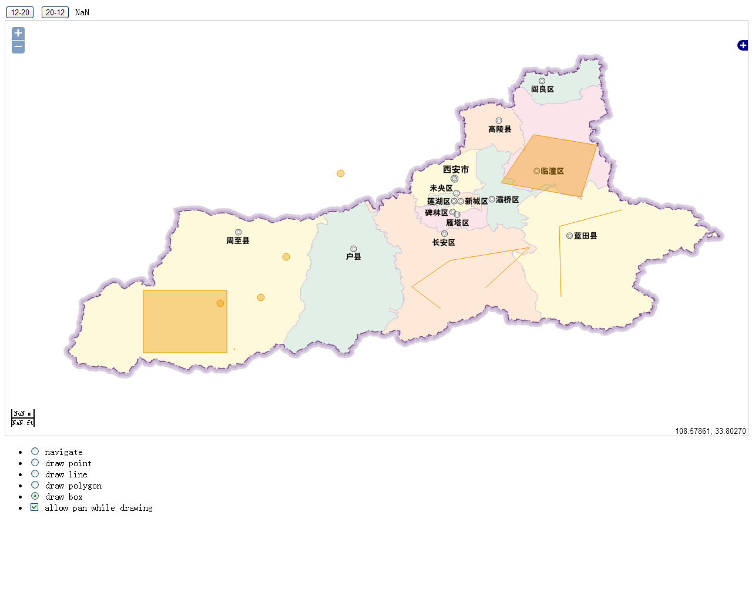

### 图3 Openlayers API接入pgis服务（zoom=12）

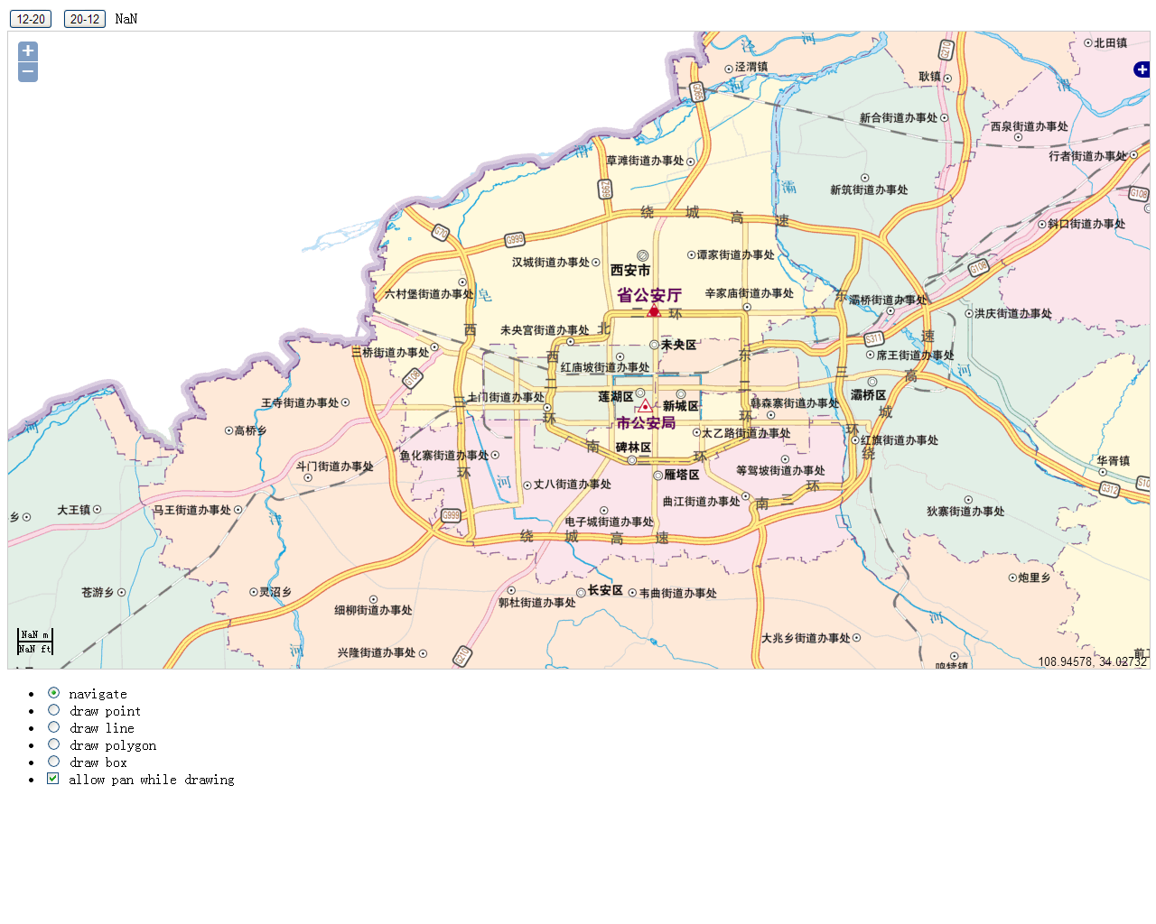

### 图4 Openlayers API接入pgis服务，添加聚合（50000个点，zoom=10）

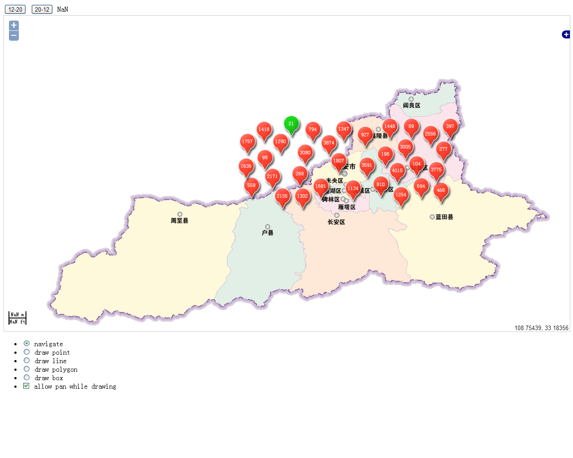

### 图5 Openlayers API接入pgis服务，添加聚合（50000个点，zoom=11）

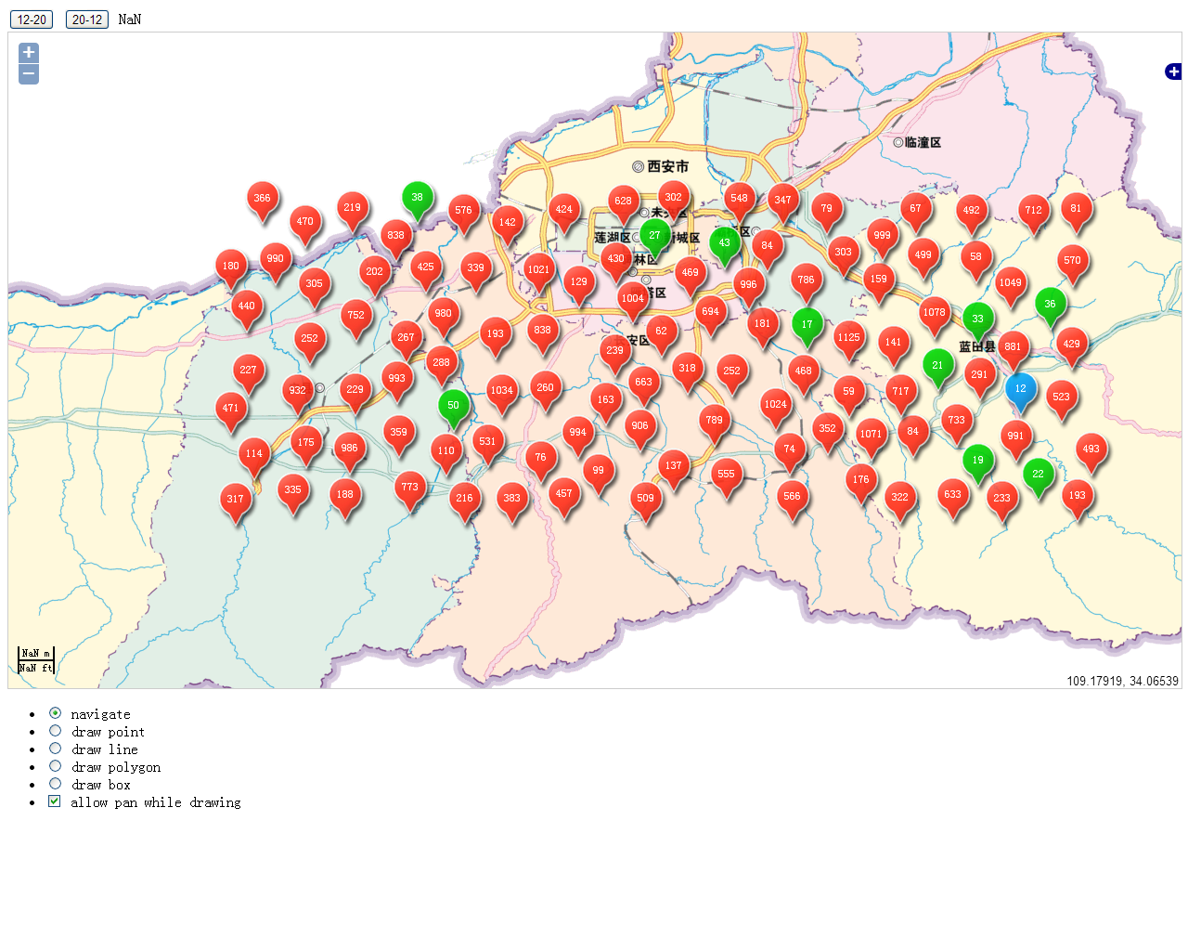

## NPGIS API 接入pgis服务

### 图6 NPGIS API接入pgis服务(zoom=10)

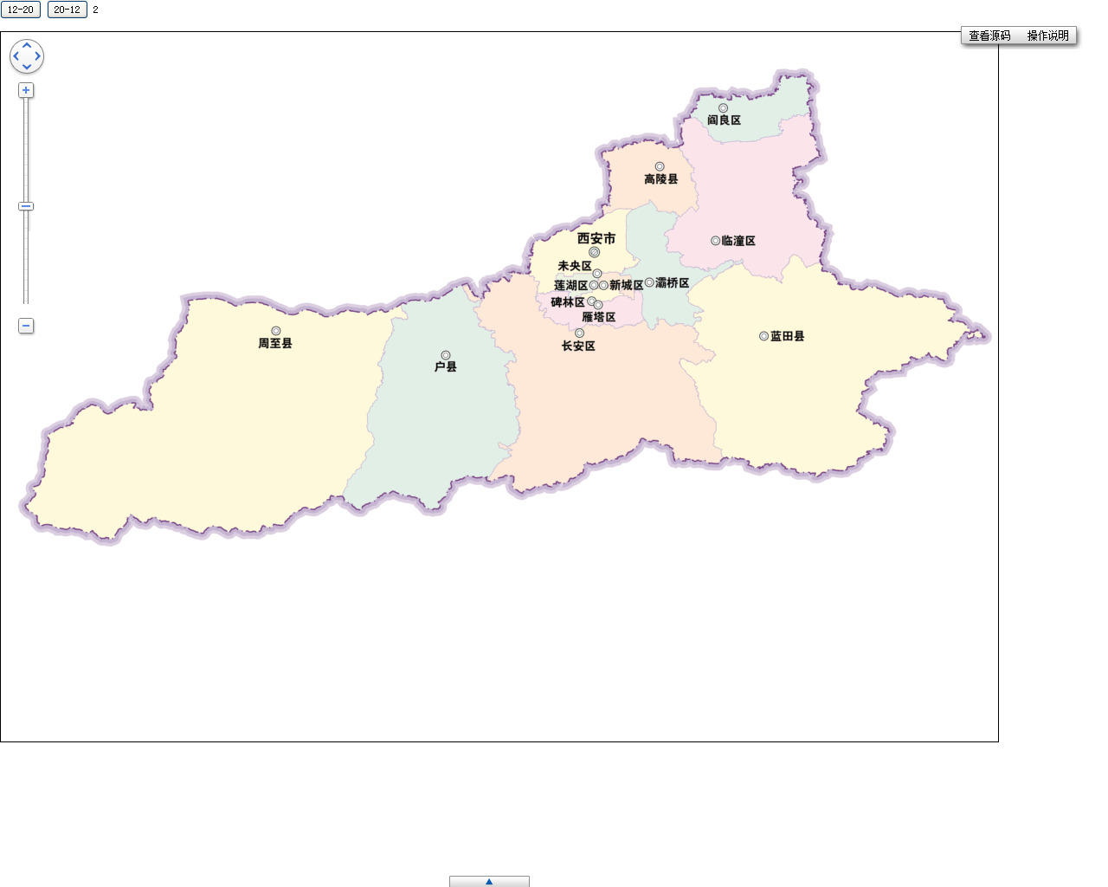

### 图7 NPGIS API接入pgis服务(zoom=12)

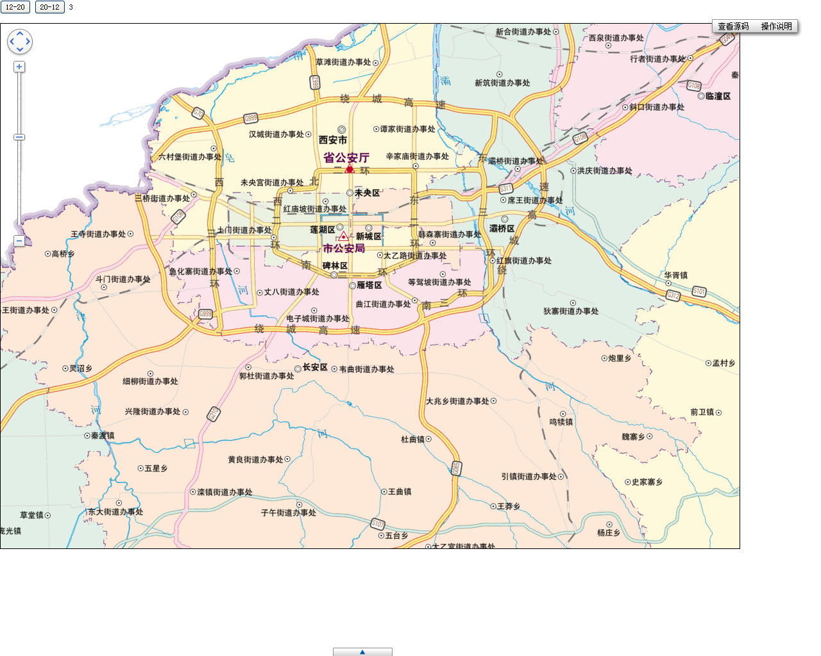

## ArcGIS API 接入PGIS服务

### 图8 ArcGIS API 接入PGIS服务

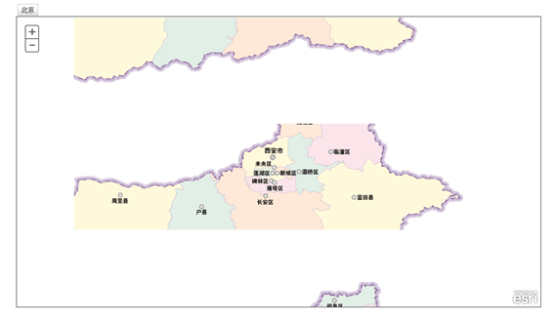

Arcgis Api 接入有问题，有待进步研究。

# 简要代码

var resolutions = [ 2,1,0.5,0.25,0.125,0.0625,0.03125,0.015625,0.0078125,0.00390625,0.001953125,0.0009765625,0.00048828125,0.000244140625,0.0001220703125,0.00006103515625,0.000030517578125,0.0000152587890625,0.00000762939453125,0.000003814697265625,0.0000019073486328125,9.5367431640625e-7,4.76837158203125e-7];

map = new OpenLayers.Map("map", {

maxResolution: 2, // 最大分辨率

projection: "EPSG:3785", // 投影方式

center:new OpenLayers.LonLat(108.72265, 34.24023), // 中心点

//resolutions: resolutions, // 分辨率

maxExtent: new OpenLayers.Bounds(107.4414, 32.75, 110.0039, 34.73046) //区域

});

wmsLayer = new OpenLayers.Layer.TMS_PGIS("Name",

imageUrl, // PGIS 服务地址

{

type: 'png', // 图片格式

layername: 'pgis', // 层名称

maxZoomLevel:20,

maxResolution: 2, // 最大分辨率

tileOrigin: new OpenLayers.LonLat(0,0) // 切片原点

});

map.addLayers([wmsLayer]);