通过API访问HDFS

实验目的：
- 理解HDFS 在HADOOP体系结构中的作用。
- 熟悉通过java API访问HDFS的方法。
实验原理：
- 获取FileSystem实例，通过get()方法。
- 获取输入流FSDataInputStream,通过open()方法。
- 创建输入流FSDataOutStream,通过create()方法。
- 创建目录，通过mkdirs().
- 删除文件，通过delete()方法。
列出子目录或子文件，通过listStates()方法。
- 获取文件扩展属性，通过getXAttr()方法。
实验环境；

配置maven
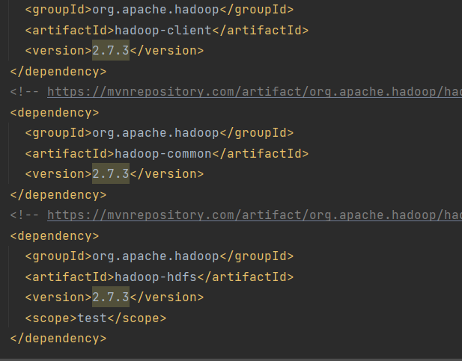

上传文件
package org.example;
import org.apache.hadoop.conf.Configuration;
import org.apache.hadoop.fs.FileSystem;
import org.apache.hadoop.fs.Path;
import org.apache.hadoop.io.IOUtils;
import org.apache.log4j.BasicConfigurator;
import java.io.FileInputStream;
import java.io.InputStream;
import java.io.OutputStream;
import java.net.URI;
public class upload {
public static void main(String[] args) throws Exception{
Configuration conf = new Configuration();
conf.set("fs.hdfs.impl",org.apache.hadoop.hdfs.DistributedFileSystem.class.getName());
//
BasicConfigurator.configure();
URI uri = new URI("hdfs://192.168.30.131:8020");
//
FileSystem fs = FileSystem.get(uri,conf,"hd2005034138");
Path src = new Path("d:\\test.txt");
Path dst = new Path("/mydir/test.txt");
fs.copyFromLocalFile(src,dst);
fs.close();
System.out.println("上传完毕");
}
}

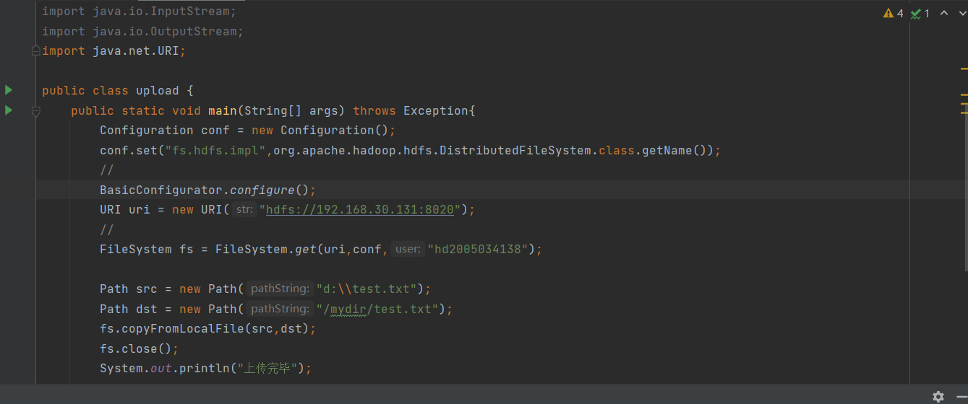
运行结果

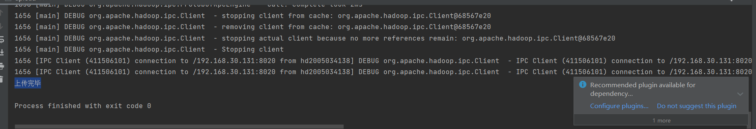
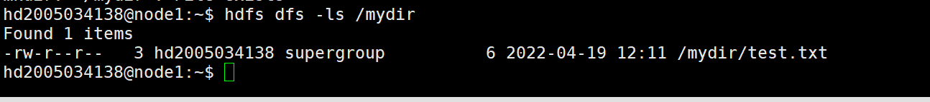

创建文件：
package org.example;
import org.apache.hadoop.conf.Configuration;
import org.apache.hadoop.fs.FSDataOutputStream;
import org.apache.hadoop.fs.FileSystem;
import org.apache.hadoop.fs.Path;
import org.apache.log4j.BasicConfigurator;
import java.net.URI;
public class establish {
public static void main(String[] args) throws Exception{
Configuration conf = new Configuration();
BasicConfigurator.configure();
URI uri = new URI("hdfs://192.168.30.131:8020");
FileSystem fs = FileSystem.get(uri,conf,"hd2005034138");
Path dfs = new Path("/mydir/test2.txt");
FSDataOutputStream os=fs.create(dfs,true);
os.writeBytes("hello,hdfs!");
os.close();
fs.close();
System.out.println("创建成功");
}

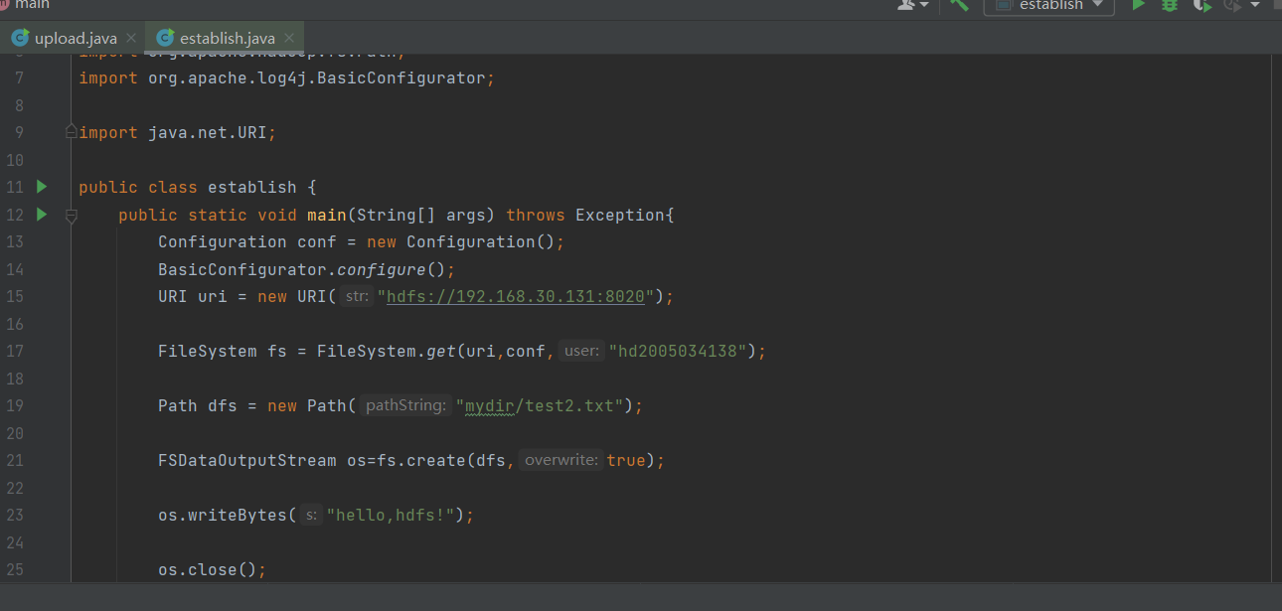

运行结果：
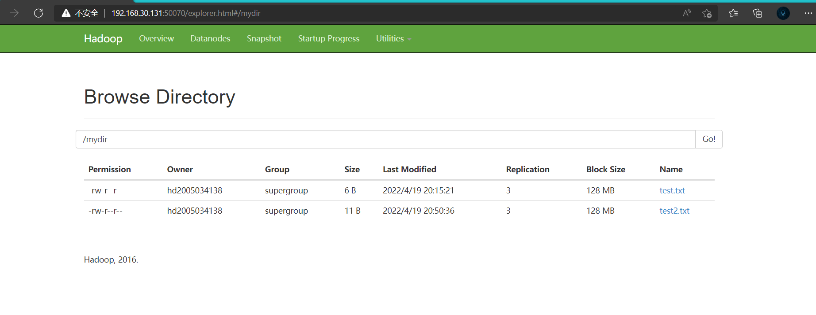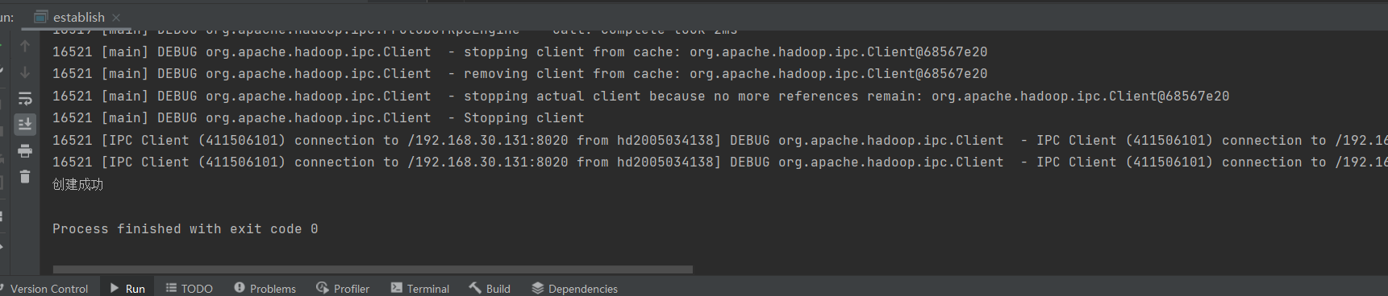

查看文件信息
package org.example;
import org.apache.hadoop.conf.Configuration;
import org.apache.hadoop.fs.FileStatus;
import org.apache.hadoop.fs.FileSystem;
import org.apache.hadoop.fs.Path;
import org.apache.log4j.BasicConfigurator;
import javax.xml.crypto.Data;
import java.net.URI;
import java.text.SimpleDateFormat;
import java.util.Date;
public class look {
public static void main(String[] args) throws Exception{
Configuration conf = new Configuration();
BasicConfigurator.configure();
URI uri = new URI("hdfs://192.168.30.131:8020");
FileSystem fs=FileSystem.get(uri,conf,"hd2005034138");
Path path = new Path("/mydir/test.txt");
FileStatus fileStatus=fs.getFileLinkStatus(path);
long blockSize=fileStatus.getBlockSize();
System.out.println("数据块大小："+blockSize);
long fileSize=fileStatus.getLen();
System.out.println("文件大小："+fileSize);
String fileOwner= fileStatus.getOwner();
System.out.println("fileOwner:"+fileOwner);
SimpleDateFormat sdf=new SimpleDateFormat("yyyy-mm-dd hh:mm:ss");
long accessTime=fileStatus.getAccessTime();
System.out.println("accessTime:"+sdf.format(new Date(accessTime)));
long modifyTime=fileStatus.getModificationTime();
System.out.println("modifyTime:"+sdf.format(new Date(modifyTime)));
fs.close();
}
}
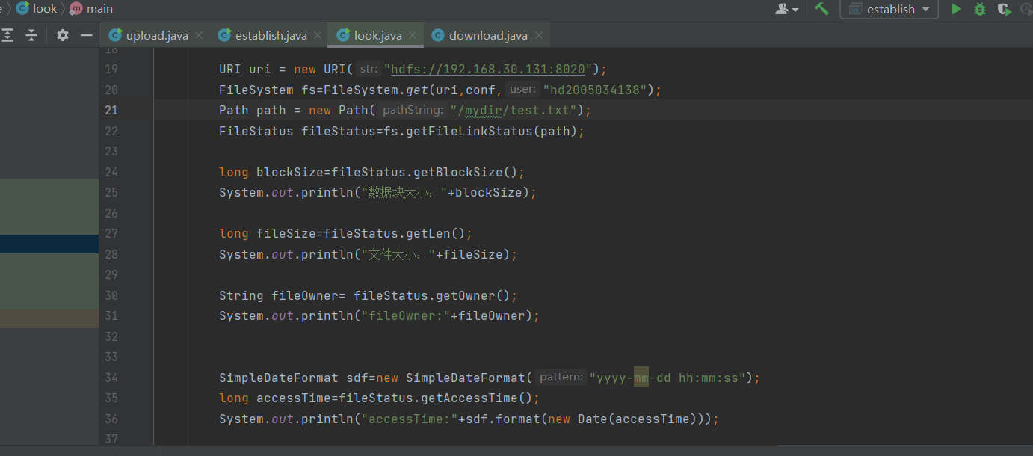

运行结果：

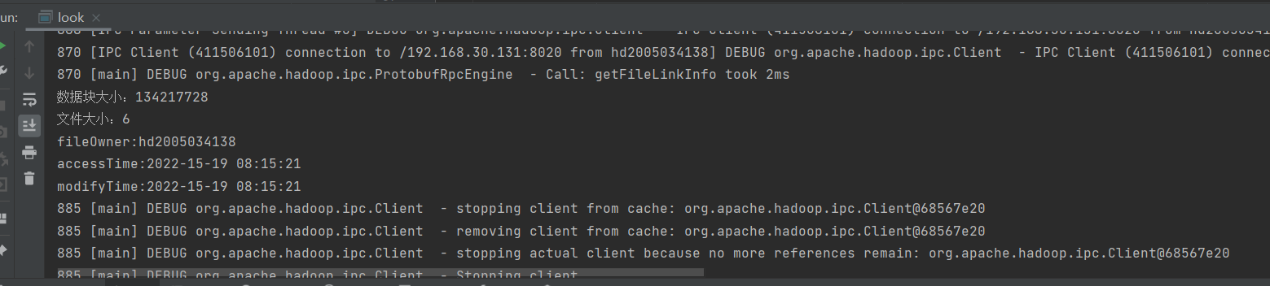

下载文件;
import org.apache.hadoop.conf.Configuration;
import org.apache.hadoop.fs.FileSystem;
import org.apache.hadoop.fs.Path;
import org.apache.log4j.BasicConfigurator;
import java.net.URI;
public class download {
public static void main(String[] args) throws Exception{
Configuration conf = new Configuration();
BasicConfigurator.configure();
URI uri = new URI("hdfs://192.168.30.131:8020");
FileSystem fs=FileSystem.get(uri,conf,"hd200503418");
Path src = new Path("/mydir/test.txt");
Path dst = new Path("d:\\test.txt");
fs.copyToLocalFile(false,src,dst,true);
fs.close();
System.out.println("下载完毕");
}
}
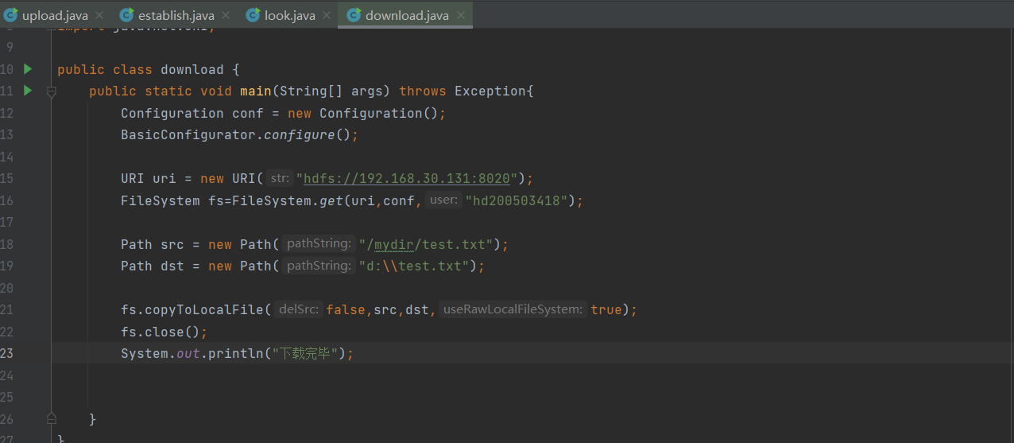

运行结果：
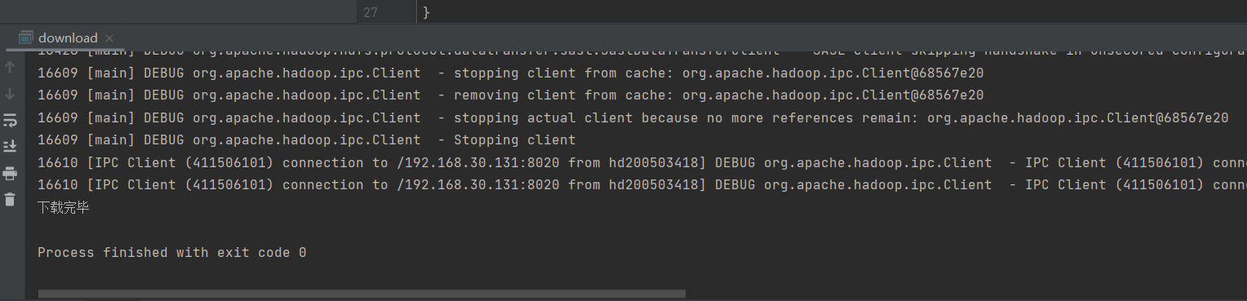

删除文件:

import org.apache.hadoop.conf.Configuration;
import org.apache.hadoop.fs.FileSystem;
import org.apache.hadoop.fs.Path;
import org.apache.log4j.BasicConfigurator;
import java.net.URI;
public class delete {
public static void main(String[] args) throws Exception{
Configuration conf = new Configuration();
BasicConfigurator.configure();
URI uri = new URI("hdfs://192.168.30.131:8020");
FileSystem fs=FileSystem.get(uri,conf,"hd2005034138");
Path path = new Path("/mydir/test2.txt");
fs.delete(path);
fs.close();
System.out.println("删除成功");
}
}

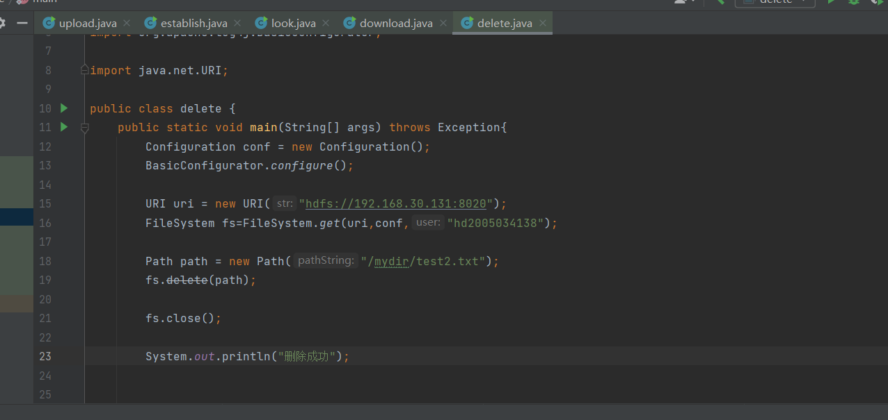

运行结果;
