QUESTION 1 – CONSTRAINTS

Reservation Table Constraints:

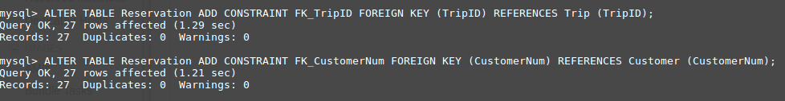

TripGuides Table Constraints:

QUESTION 2 INDEXES

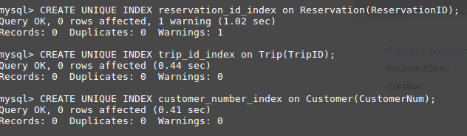
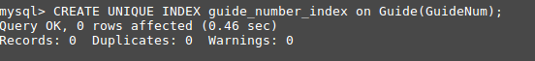

QUESTION 3 USING “NOT IN”, “AND” CONDITION

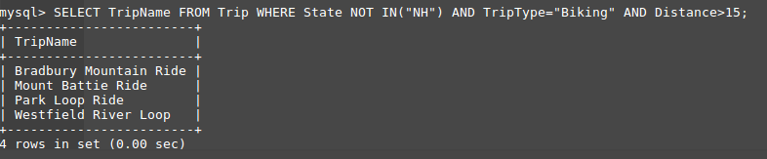

QUESTION 4 USING COUNT

QUESTION 5 USING COUNT function and “BETWEEN” CONDITION

QUESTION 6 – USING SUBQUERY

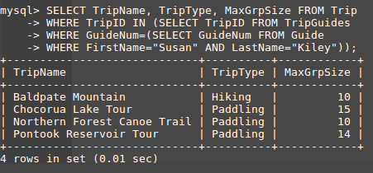

QUESTION 7 - SORTING RESULTS

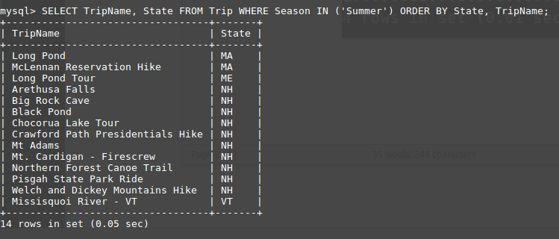

QUESTION 8 SUBQUERY

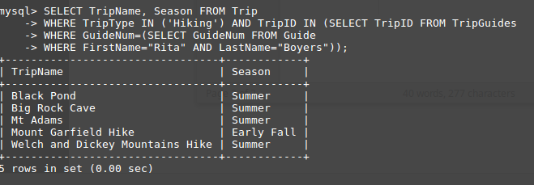
QUESTION 9 JOINING THREE TABLES

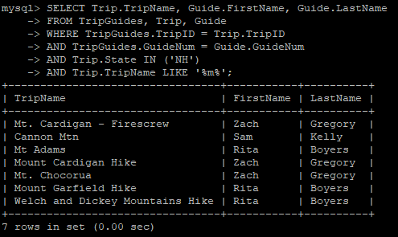

QUESTION 10 JOINING TWO TABLES
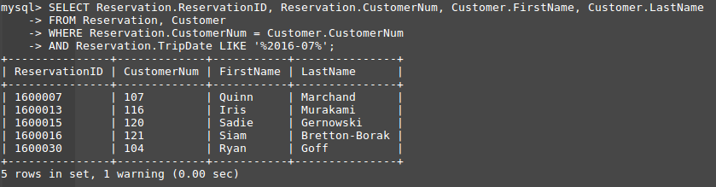

QUESTION 11 CALCULATION BETWEEN TWO COLUMNS
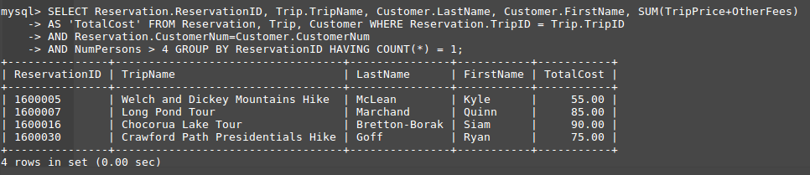

QUESTION 12 – CREATE AND RUN VIEW

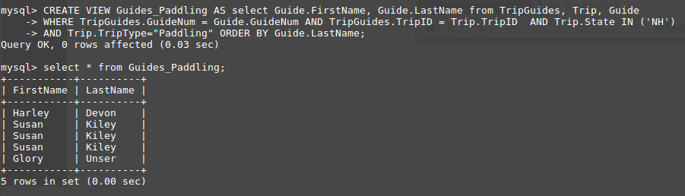
QUESTION 13 – CREATE AND RUN VIEW

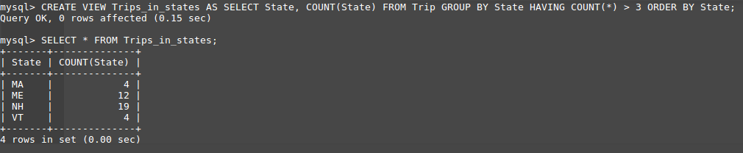

QUESTION 14 – CREATE AND RUN A STORED PROCEDURE

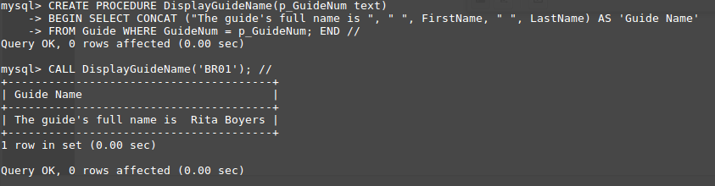
QUESTION 15 – CREATE AND RUN A STORED PROCEDURE

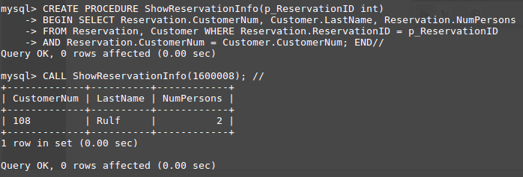

QUESTION 16 - CREATE AND RUN A FUNCTION

CREATING THE FUNCTION
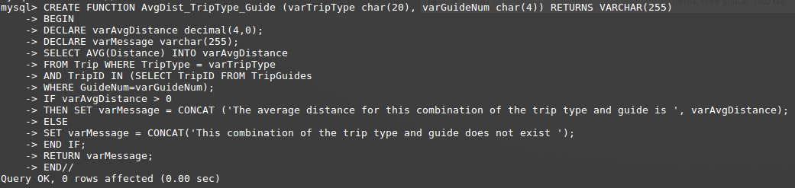
RUN TEST #1
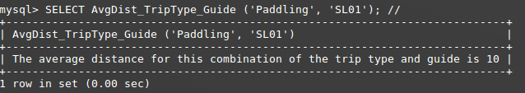
RUN TEST #2
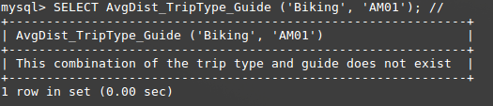

RUN TEST #3

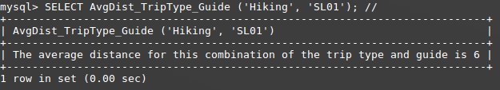

QUESTION 17 – CREATE AND RUN A STORED UPDATE PROCEDURE

Create Procedure
Check before value
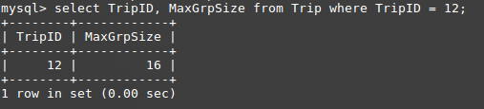

Call Procedure
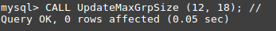

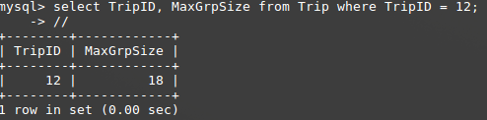
Check after value

