Polio Vaccine Tweet Analysis Report

# 1. Overview

This report analyzes sentiment in tweets related to polio vaccines in Kenya.

# 2. Sentiment Distribution

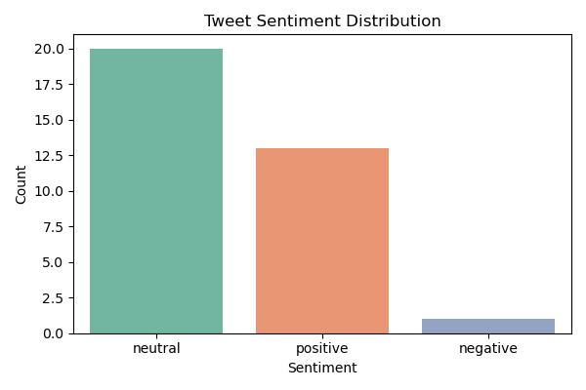

This chart shows the distribution of positive, neutral, and negative tweets.

# 3. Sentiment Over Time

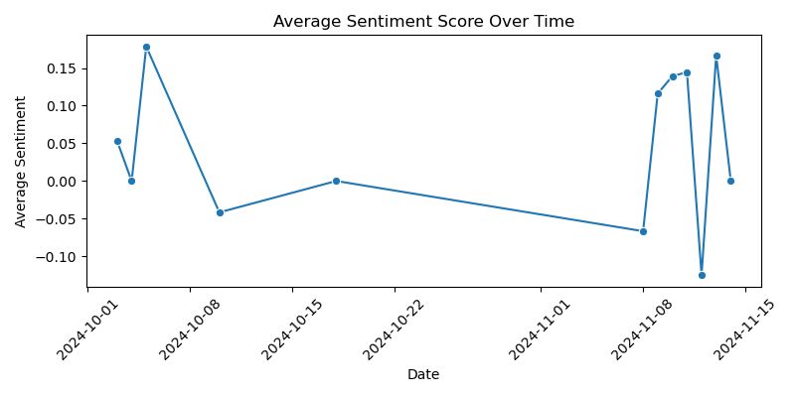

This line chart illustrates how average sentiment changes over time.

# 4. Sample Tweets

- https://t.co/3N0TcjZjJV... (neutral)

- @MOH_Kenya has reassured the public that the recent side effects linked to the polio vaccine are coincidental and unrelated to the vaccine.Any adverse... (neutral)

- The 5-day vaccination campaign against #polio will focus on 9 high risk counties:   
Busia, Bungoma, Trans-Nzoia, West Pokot and Turkana, Nairobi, Kiamb... (positive)

- Coming up…  
Understanding the role of Community Health Promoters in kicking polio out of Kenya  
  
#VaccinesWork  
@UNICEFKenya @MOH_Kenya https://t.co/G9hI... (neutral)

- Eradicating Polio In Kenya.  
  
Join us now for this conversation: https://t.co/G7uPWVugrf  
  
#VaccinesWork @UNICEFKenya @MOH_Kenya https://t.co/t8CdVAklDa... (neutral)